Hearing impairment and vowel production. A comparison between normally hearing, hearing-aided and cochlear implanted Dutch children

Jo Verhoeven†^{1, 2, 3}, Oydis Hide†³, Sven De Maeyer⁴, San Gillis⁵, Steven Gillis³

1. City University London, Division of Language and Communication Science, London, UK.

2. Flemish Academic Centre (Vlaams Academisch Centrum), Advanced Studies Institute of the Royal Flemish Academy of Belgium for Sciences and the Arts, Brussels, Belgium.

3. University of Antwerp, Department of Linguistics, CLIPS Computational Linguistics and Psycholinguistics, Antwerp, Belgium.

4. University of Antwerp, Institute for Eduction and Information Sciences, Research group Edubron, Antwerp, Belgium.

5. University of Antwerp, Department of Physics, Antwerp, Belgium.

† Both authors contributed equally to the manuscript

Abstract
This study investigated the acoustic characteristics of the Belgian Standard Dutch vowels in children with hearing impairment and in children with normal hearing. In a balanced experimental design, the 12 vowels of Belgian Standard Dutch were recorded in three groups of children: a group of children with normal hearing, a group with a conventional hearing aid and a group with a cochlear implant. The formants, the surface area of the vowel space and the acoustic differentiation between the vowels were determined.
The analyses revealed that many of the vowels in hearing-impaired children showed a reduction of the formant values. This reduction was particularly significant with respect to F2. The size of the vowel space was significantly smaller in the hearing-impaired children. Finally, a smaller acoustic differentiation between the vowels was observed in children with hearing impairment. The results show that even after 5 years of device use, the acoustic characteristics of the vowels in hearing-assisted children remain significantly different as compared to their NH peers.
1. Introduction
It is well known that restricted auditory feedback has a negative impact on spoken language. As a result speech production in individuals with hearing impairment is deviant in several respects and appears less intelligible (Abberton, 1990; Monsen, 1976). At a suprasegmental level several prosodic problems have been reported such as a slower speaking rate with laboured articulation, more frequent pauses that are generally longer, monotone intonation with higher than normal pitch levels and the distortion of suprasegmental timing effects (Osberger & McGarr, 1982). At the segmental level, errors in the production of consonants and vowels have been observed. Although these aspects have been well documented for different groups of speakers with hearing impairment separately, careful direct comparisons of the speech characteristics of different groups of speakers with hearing impairment are only beginning to emerge. This study was therefore conceived to investigate the acoustic speech characteristics in three groups of speakers differing in hearing status i.e. a group of children with a conventional hearing aid (HA), a group with a cochlear implant (CI) and a group of children with normal hearing (NH). The focus of this investigation is on the acoustic characteristics of the vowels.
It is now well established that the speech characteristics of hearing impaired speakers differ in various ways from those of listeners without hearing impairment, both in adults and in children. In children with a conventional hearing aids, the segmental level of speech is characterized by the distortion of both vowels and consonants. Common problems in the articulation of consonants involve voicing errors (voiceless sounds become voiced and vice versa) and place of articulation substitution errors typically associated with sounds that are articulated posteriorly in the oral cavity where articulatory gestures are less visible. In addition, consonant omission errors have been documented: in some studies word-initial consonant omission appears most frequently (Hudgins & Numbers, 1942), while in others consonant deletion was predominantly word-final (Nober, 1967; Markides, 1970; Smith, 1975). Furthermore, errors pertaining to consonant clusters have been noted and these mainly resulted in errors within clusters by either the omission of one of the consonants in the cluster or by the insertion of schwa (e.g., Baudonck, Dhooge, D’haeseleer, & Van Lierde, 2010).
The articulation of vowels also seems impaired, be it altogether less frequently than that of consonants. In children with conventional aids several types of errors have been documented. Vowel substitutions are common and the findings suggest that back vowels are produced more correctly than front vowels and open vowels are more often correct than vowels with a closer degree of stricture (Geffner, 1980; Smith, 1975; Slovenian: Ozbic & Kogovsek 2008, 2010). Nevertheless, the fronting of back vowels has also been reported (Stein, 1980). Another frequent error involves the neutralization of the peripheral vowels, i.e. the reduction of vowels to a more schwa-like quality (Markides, 1970; Smith, 1975). Furthermore, there have been reports of inappropriate vowel nasalization (Stevens, Nickerson, Boothroyd, & Rollins, 1976) and the diphthongization of monophthongs (Markides, 1970; Smith, 1975).
From an acoustic point of view, the vowel space of individuals with a conventional hearing aid is often described as reduced and vowel reduction seems to pertain to both formant frequencies F1 and F2. This is consistent with the perception of vowels as more centralized, less differentiated and with a significant degree of overlap between the various vowels in the vowel space (Angelocci, Kopp & Holbrook, 1964; Smith, 1975; Monsen, 1976; Osberger, 1987; Ryalls, Larouche, & Giroux, 2003; Nicolaidis & Sfakiannaki, 2007).
As far as the vowel characteristics in children with a cochlear implant are concerned, it has been found that cochlear implantation leads to a greater differentiation of the vowel inventory (Ertmer, 2001). However, research findings regarding the acoustic characteristics are equivocal. The vowel space of children with a CI has been described as significantly reduced as compared to NH children’s vowel space (Horga & Liker, 2006; Liker, Mildner, & Sindija, 2007; Ibertson, Willstedt-Svensson, Radeborg, & Sahlen, 2008, Neumeyer, Harrington, & Draxler, 2010; Löfqvist, Sahlen, & Ibertsson, 2011). Other reports suggest that the vowel space of CI children is broadly similar to that of NH children (Ertmer, 2001; Uchanski & Geers, 2003). Baudonck, Van Lierde, Dhooge and Corthals (2011) did not find any significant differences in the vowel space delineated by the point vowels of Dutch. The main difference between NH and CI children concerned the significantly larger intrasubject variability in the formant values of the CI children. Thus, individual CI children’s vowel productions are much more variable than those of NH children. A similar significantly larger intrasubject variability in the formant values of CI children has also been found earlier for profoundly hearing-impaired children (Okalidou, 1996).
The contradictory findings with respect to the entire vowel space are also apparent from specific F1 and F2 values of individual vowels. Some reports mention an approximation of CI children’s formant values to those of NH children (Kunisue, Fukushima, Nagayasu, Kawasaki, & Nishizaki, 2006). Uchanski and Geers (2003) specifically studied the F2 values of the English vowels and found that the CI children’s values were in the range of the formant values of NH children. Baudonck et al. (2011) reported similar results for Dutch. However, Liker et al. (2007) measured significant differences for the F2 values of Croatian speaking CI children, resulting in the fronting of the whole vowel space. The latter was not found by Baudonck et al. (2011) in their study of Dutch-speaking children. Findings of different studies on vowel F1 are much less contradictory: CI children’s F1 values are not significantly different from those of NH children (Baudonck et al., 2011) although they tend to be lower (Liker et al., 2007).
Although it can be concluded that vowel production in both hearing-aided and cochlear implanted children is deviant in various respects, it remains difficult to draw valid conclusions about similarities and differences between both groups of children. This requires a careful comparison between cochlear implant and hearing-assisted children with respect to age-matched children with NH. Studies of this kind are presently only beginning to emerge, as exemplified by Baudonck et al. (2011) who investigated the acoustic characteristics of the three point vowels /i/, /u/ and /a/ in Belgian Standard Dutch in a group of prelingually deaf children using a cochlear implant (n=40), a group of severely hearing-impaired children with a conventional hearing aid (n=34) and a group of children with normal hearing (n=42). Children took part in an articulation test and for each child 10 tokens of each point vowel were subjected to an acoustic analysis to provide information about F1 and F2, intrasubject formant variability, intervowel distance along the F1:F2 axis and surface area of the vowel space. The vowels were taken either from monosyllables or from the stressed syllable of disyllabic words. From the results it appeared that the vowel productions in the CI group did not differ significantly from the NH group in terms of any of the formant frequencies. The main difference between the CI and NH group pertained to the intrasubject variability in formant values which is significantly higher in CI children. The results also suggested that the vowels in HA children mainly differed from the NH group producing vowels with lower formant frequencies (particularly F2). This would suggest a slightly posterior articulation.
As far as the size of the vowel surface area is concerned this study found that the vowel space is larger for the CI and HA groups in comparison to the children with NH. This finding is contradictory to previous research and it was hypothesized to relate to articulatory overcompensation resulting from a ‘tendency by therapists and family to exaggerate their articulation movements in order to facilitate speech reading’ (Baudonck et al., 2011: 159).
To the best of our knowledge, the study of Baudonck et al. (2011) is the first attempt to directly compare the acoustic characteristics of vowels between two groups of hearing impaired children and children with NH in a balanced design. Although the results are interesting and thought provoking, the scope of this investigation is limited in several respects. In the first instance, the acoustic analysis was restricted to the three point vowels in Belgian Standard Dutch, a language variety which has a relatively large vowel system with 12 qualitatively different monophthongs (Verhoeven, 2005). Although this may give an approximate indication of the overall vowel space, it does not provide any specific information about the individual characteristics of the remaining 9 vowels and the potential acoustic differences between the three groups of speakers. In addition, it has been shown that calculations of the vowel surface area based on the three point vowels may significantly underestimate the actual size of the vowel space, especially in vowel systems with a large number of vowels such as English and Dutch (Jacewicz, Fox, & Salmons, 2007).
Besides the limitation in scope, the study of Baudonck et al. (2011) has a number of methodological constraints. In the first instance, the participating children in the study were not matched on the basis of their geographical background. In Belgium, like in many other countries, there are substantial differences in the acoustic characteristics of vowels depending on the speaker’s dialect (Verhoeven & Van Bael, 2002). Therefore it is not clear to what extent the vowel differences in the three groups of speakers in Baudonck et al. (2011) reflect differences in regional variety rather than or in addition to hearing impairment. Secondly, it cannot be excluded either that some of the vowel differences between the speaker groups reflect anatomical differences between the speakers in terms of vocal tract size: the ages of the participants in this study ranged between 4;1 and 15;5 so that relatively large differences in vocal tract size can be expected and this requires formant normalization to make meaningful comparisons (Adank, 2003; Verhoeven & Van Bael, 2002; Van der Harst, 2011).
In order to provide a detailed analysis of the vowel acoustics in these three speaker groups a more comprehensive study was carried out which consisted of an acoustic investigation of all the 12 monophthongs of Belgian Standard Dutch in three groups of children. Several methodological considerations were taken into account in terms of speaker matching. The objective of this study was to provide a detailed specification of the vowel acoustics in cochlear implanted, hearing aided and children with NH for all the 12 monophthongs in Belgian Standard Dutch. Furthermore, it was the first time that vowel formant reference data were collected for the full set of Dutch vowels in children without hearing impairment. It is worth mentioning that this study was not designed to investigate the relationship between acoustic differences in speaker groups and speech intelligibility or communicative ability of these speakers.

2. Materials and methods
The materials in this study consisted of vowel productions of the 12 monophthongal vowels of Belgian Standard Dutch (Verhoeven, 2005) by three groups of children differing in hearing status.

2.1. Participants
The participants were three groups of children differing in hearing ability. The first group consisted of 8 congenitally hearing-impaired children who had received a cochlear implant before the age of 2 years. This group will henceforth be referred to as the CI-group (CI = Cochlear Implant). Their median age at implantation was 9.5 months and ranged between 5 and 19 months. The median unaided pure tone average (PTA) in this group was 116 dBHL in the better ear, ranging between 93 and 120 dBHL (= profound loss). The median PTA with a cochlear implant device was 28.5 dBHL in the better ear, ranging from 17 to 37 dBHL. The median time span of cochlear implant experience was 62 months, ranging from 52 to 67 months. The children’s median chronological age was 6.3 years and ranged between 5 and 7.3 years at the moment of testing. The CI-children were selected from their consulting ENT center. All the parents of these children were native speakers of Belgian Standard Dutch. The auditory characteristics of the CI-children are summarized in Table 1:
Table 1: Auditory characteristics of the children with Cochlear Implant (Legend: CI = Cochlear Implant, HA = Conventional Hearing Aid, PTA = Pure Tone Average.)

ID | UN-AIDED PTA  (db) | AGE  AT HA  (months) | PTA  in HA  (db) | AGE  AT CI  (months) | AGE  AT CI FITTING  (months) | PTA  in CI  (db) | DEVICE EXPERIENCE  (months)
RX | 117 | 4 | 107 | 5 | 6 | 17 | 67
AS | 120 | 1 | 120 | 7 | 8 | 27 | 66
MI | 120 | 2 | 107 | 9 | 10 | 37 | 64
YA | 103 | 6 | 63 | 9 | 10 | 32 | 52
EM | 115 | 2 | 113 | 10 | 12 | 25 | 62
BR | 117 | 4 | 103 | 15 | 16 | 27 | 62
KL | 93 | 5 | 47 | 17 | 18 | 35 | 56
TE | 112 | 2 | 58 | 19 | 21 | 30 | 53

The second group consisted of 7 hearing impaired children with a conventional hearing aid. This group will henceforth be referred to as the HA-group (HA = Hearing Aid). The median age at hearing aid activation was 9 months, ranging between 4 and 32 months. The median unaided PTA in this group was 72 dBHL, ranging from 40 to 75 dBHL. The median PTA with support of hearing aid was 35 dBHL, ranging from 25 to 40 dBHL. The median age of hearing aid experience was 63 months, ranging from 40 to 68 months. The median chronological age was 6.4 years and ranged between 6.1 and 7.9 years at the moment of testing. All the parents of these children were native speakers of Standard Belgian Dutch. The auditory characteristics of the individual HA-children are summarized in Table 2:

Table 2: Auditory characteristics of the children with a Conventional Hearing Aid (Legend: CI = Cochlear Implant, HA = Conventional Hearing Aid, PTA = Pure Tone Average.)

ID | UNAIDED PTA  (db) | AGE AT HA  (months) | PTA WITH HA  (db) | DEVICE EXPERIENCE  (months)
GW | 73 | 4 | 40 | 68
RO | 75 | 7 | 28 | 68
FE | 70 | 9 | 35 | 63
WA | 40 | 9 | 25 | 63
EM | 72 | 10 | 40 | 62
AN | 73 | 26 | 40 | 46
SE | 68 | 32 | 35 | 40

The third group consisted of 90 children with NH. These children were chosen to provide matches for the CI children, i.e. for each CI child 10 children with NH were selected who attended the same school and/or lived in the same narrow geographical region (village/town) as the CI child. All the parents of the NH children were native speakers of Belgian Standard Dutch. All children were born in the region where they lived at the time of the recordings. The median chronological age of these children was 6 years, ranging from 5 to 7 years, and all children were enrolled in the first year of primary school. These children were not formally tested for hearing, but informal reports on their hearing status by parents and teachers suggested no abnormalities.

2.2. Stimulus materials
The stimuli for this study were 36 monosyllables, some of which were meaningful words in Dutch while others were pseudowords with a structure in accordance with the rules of the Dutch phonological system. These monosyllables contained the 12 monophthongs of Belgian Standard Dutch, which has 5 ‘long’ vowels (/e, y, ø, o, a/) and 7 ‘short’ vowels (/i, ɪ, ɛ, u, ʏ, ɔ, ɑ/). In the first set of monosyllables, the vowel was preceded by /p/ and followed by /t/. This gave rise to /pet/, /pyt/, /pøt/, /pot/, /pat/, /pit/, /pɪt/, /pɛt/, /put/, /pʏt/, /pɔt/ and /pɑt/. In the second set, the vowel was preceded by /l/ and followed by /t/. This created /let/, /lyt/, /løt/, /lot/, /lat/, /lit/, /lɪt/, /lɛt/, /lut/, /lʏt/, /lɔt/ and /lɑt/. In the monosyllables of the third set the vowel was preceded by /t/ and followed by /r/, which gave rise to /ter/, /tyr/, /tør/, /tor/, /tar/, /tir/, /tɪr/, /tɛr/, /tur/, /tʏr/, /tɔr/ and /tɑr/. These consonantal contexts were chosen because plosives, laterals and trills provide a sharp spectral transition with the adjacent vowel and this considerably facilitates acoustic segmentation.
All these monosyllables were read aloud by a professional female speaker of Belgian Dutch: her realisations were recorded with a TASCAM DAT recorder and a head-mounted MicroMic II in a quiet room. The audio files were transferred from the DAT cassette to WAV files via a TASCAM US 428 Digital Control Surface.

2.3. Vowel imitation task
The above-mentioned recordings were used in a vowel imitation task in which the children were asked to repeat the monosyllables upon aural presentation. Each monosyllable occurred three times in the test so that children had to imitate a total number of 108 stimuli (12 vowels x 3 consonant contexts x 3 repetitions). The stimuli had been grouped in three sets such that each set contained only one presentation of all 36 stimuli. Within each set the stimuli appeared in pseudo-random order: all the monosyllables with the same consonants in the phonetic environment of the vowels were grouped together in the same presentation block. Within each set the monosyllables were ordered randomly.
Although it has been shown that children with hearing impairment perform better when listening to live speech (Geers, Brenner & Davidson 2003, Lachs, Pisoni & Kirk 2001), it was decided to use pre-recorded stimuli in this experiment in order to ensure that all the participants heard exactly the same stimuli. It should also be pointed out that the stimuli were only presented auditorily without participants being able to see the articulation in e.g. a video recording.
The stimuli were randomly presented to the children by the experimenter via a laptop computer and external loudspeakers placed 50 cm from the child. Children were given a new stimulus only when the imitation of the previous one had been fully completed. Between each group of stimuli (n=36) there was a short break. The children were explicitly instructed that they were going hear both existing words and pseudowords, and that it was their task to repeat each word exactly the way they heard it.

2.4. Recording conditions
Children’s imitations were recorded by means of a digital audio recorder (portable DAT recorder Tascam DA-P1) and a head-mounted microphone (AKG-C420). The recordings of the CI-children were made in a quiet room in the ENT center. The researcher and one parent were present during the recording sessions. The recordings of the NH-children were made in a quiet room in the children’s schools. Only the researcher was present with these children. The HA-children were recorded in a quiet room in their homes. During these recording sessions, the researcher and one parent were present. The parents of all children involved had given informed consent prior to the speech recordings.

2.5. Data analysis techniques
2.5.1. Perceptual assessment
The children’s vowel realisations were assessed perceptually by six expert listeners in order to ascertain that the presented vowels had been correctly imitated. For this purpose, all the vowel realizations were divided into three sets and each set was assessed by two listeners. All the judges worked independently of one another, but they were informed about children’s hearing status (NH, CI, HA) and geographical background. The listeners took part in a ‘Multiple Forced Choice’ listening experiment set up in PRAAT (Boersma & Weenink, 2009) in which they were asked to judge whether or not the vowel was a correct imitation of the target vowel. Listeners had three assessment options available, i.e. ‘yes’, ‘no’, or ‘unable to judge’: they were instructed to focus only on the vowel quality and to report whether children’s productions were correct imitations of the target vowel. Erroneous insertion of consonants not adjacent to the vowels (e.g. ‘laar’ pronounced as ‘klaar’) was considered as a correct vowel imitation, because both words contained the same vowel in the same immediate phonetic environment.
The main reason for this perceptual assessment was motivated by the need to allow for natural regional variation in the pronunciation of the vowels. This was very important because such regional variation can be quite substantial in Flanders (Verhoeven, 2005). Furthermore, it was intended to exclude extreme outliers because the source of the error cannot be determined.

2.5.2. Acoustic analysis
All the vowel productions which had received full agreement by the listening panel as correct imitations of the target vowel were analysed acoustically in terms of their formant values (F1 and F2). The spectral analysis was carried out in PRAAT (Boersma & Weeninck, 2010) by means of a Fast Fourier Transform with a Hamming Window of 0.01 s, 1000 time steps and 20 frequency steps. Subsequently, the formants F1 and F2 were tracked by means of PRAAT’s Burg LPC formant tracking algorithm. The formant maximum was set to 5500 Hz and the number of formants was set to 5. All the measurements were inspected visually and in cases of mismatches between the location of the formants on the spectrogram and the results of the formant tracking algorithm the model order of the LPC-analysis was changed manually to obtain a better match between the formant tracking and the spectrogram. Formant values were taken as the mean of the formant measurements in the middle third portion of the vowel. This portion can be assumed to be the best reflection of the articulatory vowel target with minimal influence of the surrounding consonants (Verhoeven & Van Bael, 2002). The vowel formants were measured in Hz, but were normalized by means of a Lobanov-transformation (Lobanov, 1971) to minimize the effects of anatomical differences between the children. This extrinsic numerical normalisation procedure transforms the formant Hz values into z-scores and it was preferred over other types of normalizations because recent research has consistently confirmed that Lobanov normalization works best to eliminate differences in formant values related to anatomical differences between speakers, while at the same time preserving formant differences relating to regional and other articulatory differences (Adank, 2003; Van der Harst, 2010).

2.5.3. Vowel space surface area
The formant measurements for all the vowel realisations were used to calculate the surface area of the vowel space. In this study two different calculation methods were used. In the first instance, the surface area of the vowel space was calculated using the unnormalized formant values in Hz of the three point vowels /i/, /u/ and /a/ by means of Heron’s formula (Jacewicz et al., 2007). This method was used only to enable a direct comparison of the findings in this paper with those of Baudonck et al. (2011).
It should be pointed out that one of the main disadvantages of this method is that the surface area is based on the three point vowels only and this has been shown to effectively underestimate the vowel surface area especially in vowel systems consisting of a large number of vowels (Jacewicz et al, 2007) such as those of English and Dutch. Therefore, a novel method of calculating the vowel surface area was also used in this study: the surface area of the 12-vowel space (i.e. the entire Belgian Dutch vowel space) was computed on the basis of the normalized formant values of the complete set of vowels (n=12). More specifically the Graham scan algorithm (Graham, 1972; De Berg, Cheong, Van Kreveld, & Overmars 2008) was applied to compute the convex hull of the space defined by these 12 vowels. For each participant this computation was repeated 5,000 times, each time with a different random sample of the zF1/F2 values of the twelve vowels. The convex hull is the smallest convex set containing all the datapoints. The Graham scan algorithm is based on three simple rules: (1) Find an extreme point. This point will be the pivot and is guaranteed to be on the hull. It is chosen to be the point with the largest y-coordinate. (2) Sort the points in order of increasing angle about the pivot. This creates a star-shaped polygon (one in which the pivot can “see” the whole polygon). (3) Build the hull by marching around the star-shaped polygon adding edges when a left turn is made and back-tracking when a right turn is made. The Graham scan algorithm was implemented in a Python script.

2.5.4. Estimation of vowel distinctiveness
Besides calculating the surface area of the vowel space, this study also quantified the acoustic differentiation between the vowels in the three groups of children. This was achieved by studying the 95% confidence ellipses which were drawn on the basis of all the tokens for a specific vowel category in each speaker group. The 95% confidence ellipses describe the area of the total vowel space which contains 95% of the vowel realisations for an individual vowel. From these confidence ellipses, two measures of acoustic differentiation were derived. The first measure specifies the number of overlaps between each 95% confidence ellipse and the confidence ellipses of all the other vowels in each speaker group. This measure ranges between 0 (not a single overlap or maximal differentiation) and 11 (there is overlap between a vowel and all the 11 other vowels in the vowel system of Belgian Dutch. As a result there is less differentiation).
The second measure specifies the proportion of overlap between the 95% confidence ellipse of each vowel and that of all the other vowels. Values closer to 0% indicate that there is little overlap between the vowel realisations and that the vowels are highly distinct. Values closer to 100% indicate a large proportion of overlap between the vowel realisations, which indicates a smaller acoustic distinctiveness.
The computation of the 95% confidence ellipses, the number of overlaps and the proportion of overlap was computed by a dedicated Python script. The computation was based on the normalised vowel formant data.

2.5.5. Statistical Analysis
Since the data in this experiment are hierarchical in nature (the children have produced multiple replications of the same vowel), the statistical analysis was carried out by means of multi-level modelling (or more generic mixed-effects modelling). As Quené & van den Bergh (2004) argue, multi-level modelling is able to handle several problems associated with data that include multiple observations nested within individuals which a repeated measurement ANOVA cannot deal with such as violations of the assumption of compound symmetry or sphericity (correlations between observations within individuals should be constant over different conditions) and the consequences of the design effect (neglecting the hierarchical structure results in underestimating the Type 1-error rate).
Children repeated the same stimuli multiple times. This leads to a random-crossed multi-level model (Quené & van den Bergh, 2004): replications are a result of the crossing between children and stimuli. In such a model it is possible to estimate three variances: between children variance (a.k.a. inter-subject variance), between-stimuli variance and residual variance. Preliminary analyses for the data showed that there is no between-stimuli variance in this experiment, which may have to do with the fact that the vowels occurred in identical phonetic environments. Therefore the more parsimonious multi-level model with two levels was used: children (resulting in inter-subject variance estimates) and within children the replications (resulting in intra-subject variance estimates).
The significance of the observed differences in formant values between corresponding vowels in the three groups of children was analyzed by means of the following model:

Model 1
$$\begin{aligned}y_{\text{ij}}= \\ (β_{1}∗{\text{NH}}_{})+(β_{2}∗{\text{NH}}_{{\text{AA}}_{\text{ij}}})+(β_{3}∗{\text{NH}}_{})+(β_{4}∗{\text{NH}}_{{\text{EE}}_{\text{ij}}})+(β_{5}∗{\text{NH}}_{{\text{EU}}_{\text{ij}}}) \\ +(β_{6}∗{\text{NH}}_{})+(β_{7}∗{\text{NH}}_{{\text{IE}}_{\text{ij}}})+(β_{8}∗{\text{NH}}_{})+(β_{9}∗{\text{NH}}_{{\text{OE}}_{\text{ij}}})+(β_{\text{10}}∗{\text{NH}}_{{\text{OO}}_{\text{ij}}}) \\ +(β_{\text{11}}∗{\text{NH}}_{})+(β_{\text{12}}∗{\text{NH}}_{{\text{UU}}_{\text{ij}}})+(β_{\text{13}}∗{\text{CI}}_{})+(β_{\text{14}}∗{\text{CI}}_{{\text{AA}}_{\text{ij}}})+(β_{\text{15}}∗{\text{CI}}_{}) \\ +(β_{\text{16}}∗{\text{CI}}_{{\text{EE}}_{\text{ij}}})+(β_{\text{17}}∗{\text{CI}}_{{\text{EU}}_{\text{ij}}})+(β_{\text{18}}∗{\text{CI}}_{})+(β_{\text{19}}∗{\text{CI}}_{{\text{IE}}_{\text{ij}}})+(β_{\text{20}}∗{\text{CI}}_{}) \\ +(β_{\text{21}}∗{\text{CI}}_{{\text{OE}}_{\text{ij}}})+(β_{\text{22}}∗{\text{CI}}_{{\text{OO}}_{\text{ij}}})+(β_{\text{23}}∗{\text{CI}}_{})+(β_{\text{24}}∗{\text{CI}}_{{\text{UU}}_{\text{ij}}})+(β_{\text{25}}∗{\text{HA}}_{}) \\ +(β_{\text{26}}∗{\text{HA}}_{{\text{AA}}_{\text{ij}}})+(β_{\text{27}}∗{\text{HA}}_{})+(β_{\text{28}}∗{\text{HA}}_{{\text{EE}}_{\text{ij}}})+(β_{\text{29}}∗{\text{HA}}_{{\text{EU}}_{\text{ij}}})+(β_{\text{30}}∗{\text{HA}}_{}) \\ +(β_{\text{31}}∗{\text{HA}}_{{\text{IE}}_{\text{ij}}})+(β_{\text{32}}∗{\text{HA}}_{})+(β_{\text{33}}∗{\text{HA}}_{{\text{OE}}_{\text{ij}}})+(β_{\text{34}}∗{\text{HA}}_{{\text{OO}}_{\text{ij}}})+(β_{\text{35}}∗{\text{HA}}_{}) \\ +(β_{\text{36}}∗{\text{HA}}_{{\text{UU}}_{\text{ij}}}) \\ +({\text{NH}}_{\text{ij}}∗μ_{1j}+{\text{NH}}_{\text{ij}}∗ε_{1\text{ij}})+({\text{CI}}_{\text{ij}}∗μ_{2j}+{\text{CI}}_{\text{ij}}∗ε_{2\text{ij}})+({\text{HA}}_{\text{ij}}∗μ_{3j}+{\text{HA}}_{\text{ij}}∗ε_{3\text{ij}})\end{aligned}$$

In this model y_{ij} denotes the z-score normalized formant values. In the fixed part of the model, it was expected that the formant frequencies are influenced by the child group (NH, CI, HA), i.e. that the children’s F1 and F2 values are related to their hearing status and the specific vowel. The regression weights β₁-β₃₆ estimate the effect of the 36 dummy variables that indicate a specific combination of a vowel and child group. Therefore these regression weights can be interpreted as the estimated averages for F1 and F2 per vowel for each child group (NH, CI, HA). For the random part of the model, the variances of ($m_{1j}−m_{3j}$) estimate the inter-subject variance per child group (NH, CI, HA) and the variances of ($ε_{1\text{ij}}−ε_{3\text{ij}}$) estimate the intra-subject variance per child group (NH, CI, HA). This allows to investigate whether intra- and inter-subject variance is related to the child group and thus to the hearing status. For instance, more variation may be observed in the formant frequency values among CI children and HA children than among NH children.
For the statistical analysis of the surface of the area of the vowel space, the number of overlaps and the proportion of overlap, model 2 was applied:

Model 2
$$\begin{aligned}y_{\text{ij}}=β_{1}∗{\text{CI}}_{\text{ij}}+({\text{CI}}_{\text{ij}}∗μ_{1j}+{\text{CI}}_{\text{ij}}∗ε_{1\text{ij}}) \\ +β_{2}∗{\text{HA}}_{\text{ij}}+({\text{HA}}_{\text{ij}}∗μ_{2j}+{\text{HA}}_{\text{ij}}∗ε_{2\text{ij}}) \\ +β_{3}∗{\text{NH}}_{\text{ij}}+({\text{NH}}_{\text{ij}}∗μ_{3j}+{\text{NH}}_{\text{ij}}∗ε_{3\text{ij}})\end{aligned}$$

In the fixed part of the model, the average of the three child groups are estimated. Furthermore, the random part is composed of three inter-subject variances (one for each child group) and three intra-subject variances (one for each child group).
The statistical analyses were run in MLwiN 2.1 (Rasbash, Charlton, Browne, Healy and Cameron, 2009).

3. Results
In this study, a total number of 7,985 vowel realisations were recorded. After the perceptual assessment by the expert listening panel, there was full agreement about whether the intended vowel had been correctly imitated for 7,261 vowels i.e. in 94 % of the total number of vowels. The acoustic analysis was confined to these correctly imitated vowels only and focused on their spectral characteristics, the surface area of the vowel space and their acoustic differentiation.

3.1. Spectral characteristics of the vowels
The spectral characteristics of the vowels in the different speaker groups are illustrated in Figure 1:
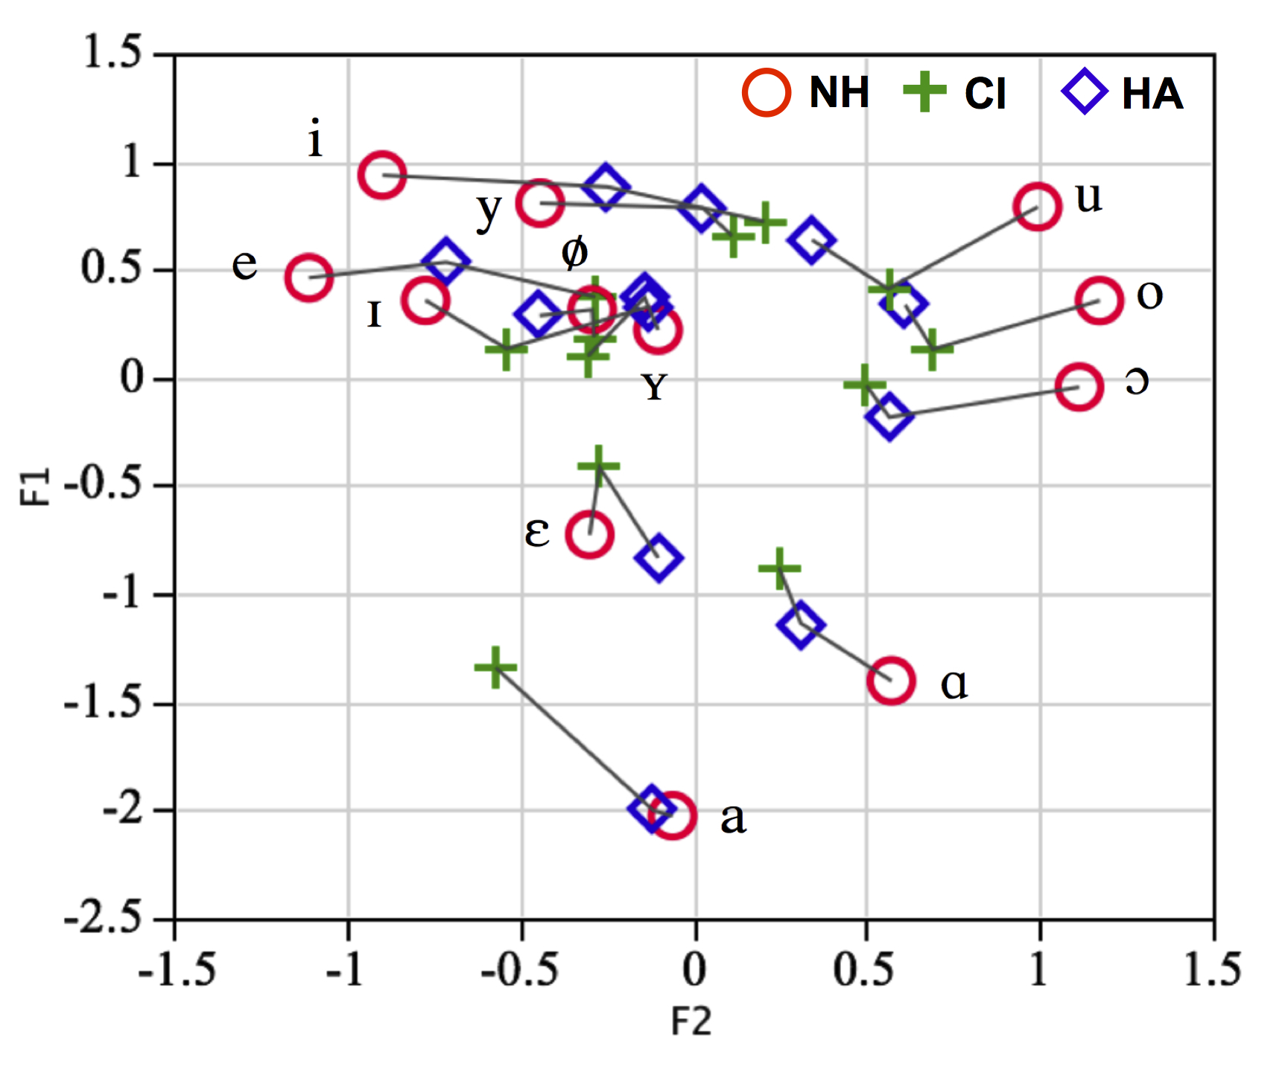
Figure 1: Visual representation of the mean F1 and F2 (z-score normalized values) for the three groups of children (legend: NH = normally hearing, CI = cochlear implant, HA = hearing-assisted). The means for the three groups on the same vowel are connected.

From figure 1 it is clear that there are considerable differences between the three groups of children in the pronunciation of the vowels. Overall, the differences between the groups pertaining to F1 (degree of opening: close vs. open) are less numerous than the groups differences relating to F2 (the place of articulation: front vs. back). The differences appear such that the vowels in children with hearing impairment have spectral characteristics which suggest vowel reduction, i.e. the vowels appear more towards the middle of the vowel chart either on the F1 or F2 scale.
The statistical analysis of F1 and F2 are presented separately. The estimated average values and the standard error for F1 are given in Table 3, presented in Hz per vowel for each child group. The z-score transformed values were used in the statistical analysis.

Table 3. Estimates of the average F1 (in Hz, with standard error of estimate in parentheses) of mixed-effects modelling, fixed and random parts. Significant p-values are underlined.

FIXED | NH-F1 | CI-F1 | HA-F1 | NH-CI  p-value | NH-HA  p-value | CI-HA  p-value
i | 360 (7) | 396 (40) | 360 (25) | .660 | .709 | .553
ɪ | 497 (7) | 560 (41) | 476 (27) | .088 | .465 | .065
e | 480 (8) | 517 (40) | 482 (27) | .780 | .950 | .860
ɛ | 742 (7) | 690 (41) | 731 (27) | .007 | .865 | .040
a | 1044 (7) | 916 (39) | 1027 (24) | .001 | .556 | .001
ɑ | 892 (7) | 799 (39) | 845 (26) | .001 | .191 | .005
ɔ | 578 (7) | 613 (39) | 639 (26) | .553 | .001 | .098
o | 495 (8) | 546 (40) | 512 (26) | .352 | .112 | .816
u | 391 (7) | 467 (39) | 432 (26) | .029 | .033 | .724
y | 386 (7) | 445 (42) | 397 (30) | .239 | .858 | .435
ʏ | 524 (7) | 577 (39) | 526 (26) | .272 | .950 | .366
ø | 501 (7) | 550 (39) | 502 (25) | .290 | .169 | .913

From this analysis it appears that CI children demonstrate significantly lower F1 values than both NH and HA children in the vowels /ɛ/, /a/ and /ɑ/. In the vowel /u/, both CI and HA children produce an F1 which is significantly higher than in the NH group. Finally, for /ɔ/ F1 is significantly higher in the HA group only.
At a more qualitative level of analysis, the values in table 3 suggest a clear and consistent trend which is generally supportive of the observed significant differences. This is to say that all the vowels in the CI group have the smallest distance of the z-score associated with F1 from 0. This indicates that all the CI vowels have a more central point of articulation than those of the HA and NH children.
In the random part of the model, no statistical differences were found between the inter-subject variances for the three child groups. Therefore it can be concluded that the inter-subject variances are similar for NH, CI and HA children. However, for the intra-subject variances, the CI children demonstrated more variance than both the HA children (χ²(1)=81.196, p < 0.0001) and NH children (χ²(1)=83.700, p < 0.0001)). This means that the CI children have been less consistent in their F1 values than the two other groups of children.
Model 1 was also applied to assess the F2-related differences between the child groups. The estimated average values and the standard error for F2 are given in table 4, presented in Hz per vowel for each child group. It can be seen that there are quite a number of significant differences between the two hearing-impaired groups and the children with NH.

Table 4. Estimates of the average F2 (in Hz, with standard error of estimate in parentheses) of mixed-effects modelling, fixed and random parts. Significant p-values are underlined.

VOWEL | NH-F2 | CI-F2 | HA-F2 | NH-CI  p-value | NH-HA  p-value | CI-HA  p-value
i | 2514 (27) | 1524 (82) | 1690 (95) | .001 | .001 | .003
ɪ | 2421 (28) | 2055 (87) | 1721 (104) | .115 | .001 | .094
e | 2647 (28) | 1803 (80) | 2090 (106) | .001 | .046 | .002
ɛ | 2116 (27) | 1822 (85) | 1723 (105) | .558 | .827 | .811
a | 1964 (27) | 1836 (78) | 1628 (91) | .001 | .480 | .008
ɑ | 1582 (27) | 1502 (79) | 1392 (101) | .007 | .068 | .679
ɔ | 1231 (27) | 1377 (79) | 1264 (99) | .001 | .001 | .841
o | 1189 (28) | 1238 (83) | 1296 (98) | .002 | .001 | .841
u | 1288 (27) | 1299 (79) | 1181 (99) | .023 | .014 | .764
y | 2227 (27) | 1576 (89) | 1572 (117) | .001 | .003 | .755
ʏ | 1997 (27) | 1887 (74) | 1649 (98) | .044 | .116 | .882
ø | 2116 (27) | 1887 (81) | 1839 (105) | .709 | .225 | .483

It can be seen in table 4 that the highest number of significant differences relates to the CI group: their F2 differs significantly from the NH children in 9 out of 12 vowels. Vowel F2 in the HA group differs significantly in 7 out of 12 vowels. In addition, there are hardly any significant differences between the two hearing impaired groups themselves (in 3 out of 12 vowels). At a more qualitative level of analysis, it can be seen that the group of CI and HA children have F2 values (expressed a the distance of the z-score to 0) which are smaller than that of the NH group for most of the vowels. This is suggestive of a more central vowel articulation in CI and HA.
Similar as with the analyses for F1 values, the random part of the model indicates no statistical differences between the three child groups concerning inter-subject variances. Again, for the intra-subject variances there are significant differences according to hearing status: both CI and HA children demonstrated more intra-subject variance than NH children. The difference was significant both for CI children (χ²(1)=18.133, p < 0.0001) and for HA children (χ²(1)=10.739, p < 0.0001). No statistical difference was observed between the CI and the HA children’s intra-subject variances (χ²(1)=0.201, p=0.654).

3.2. Surface area of the vowel space
The surface area of the vowel space in the three groups of children was calculated on the basis of two different methods. In the first method, the vowel surface area was calculated using the unnormalized formant values of the three point vowels /i/, /u/ and /a/ in a manner identical to Baudonck et al. (2011). These results are summarized in figure 2:
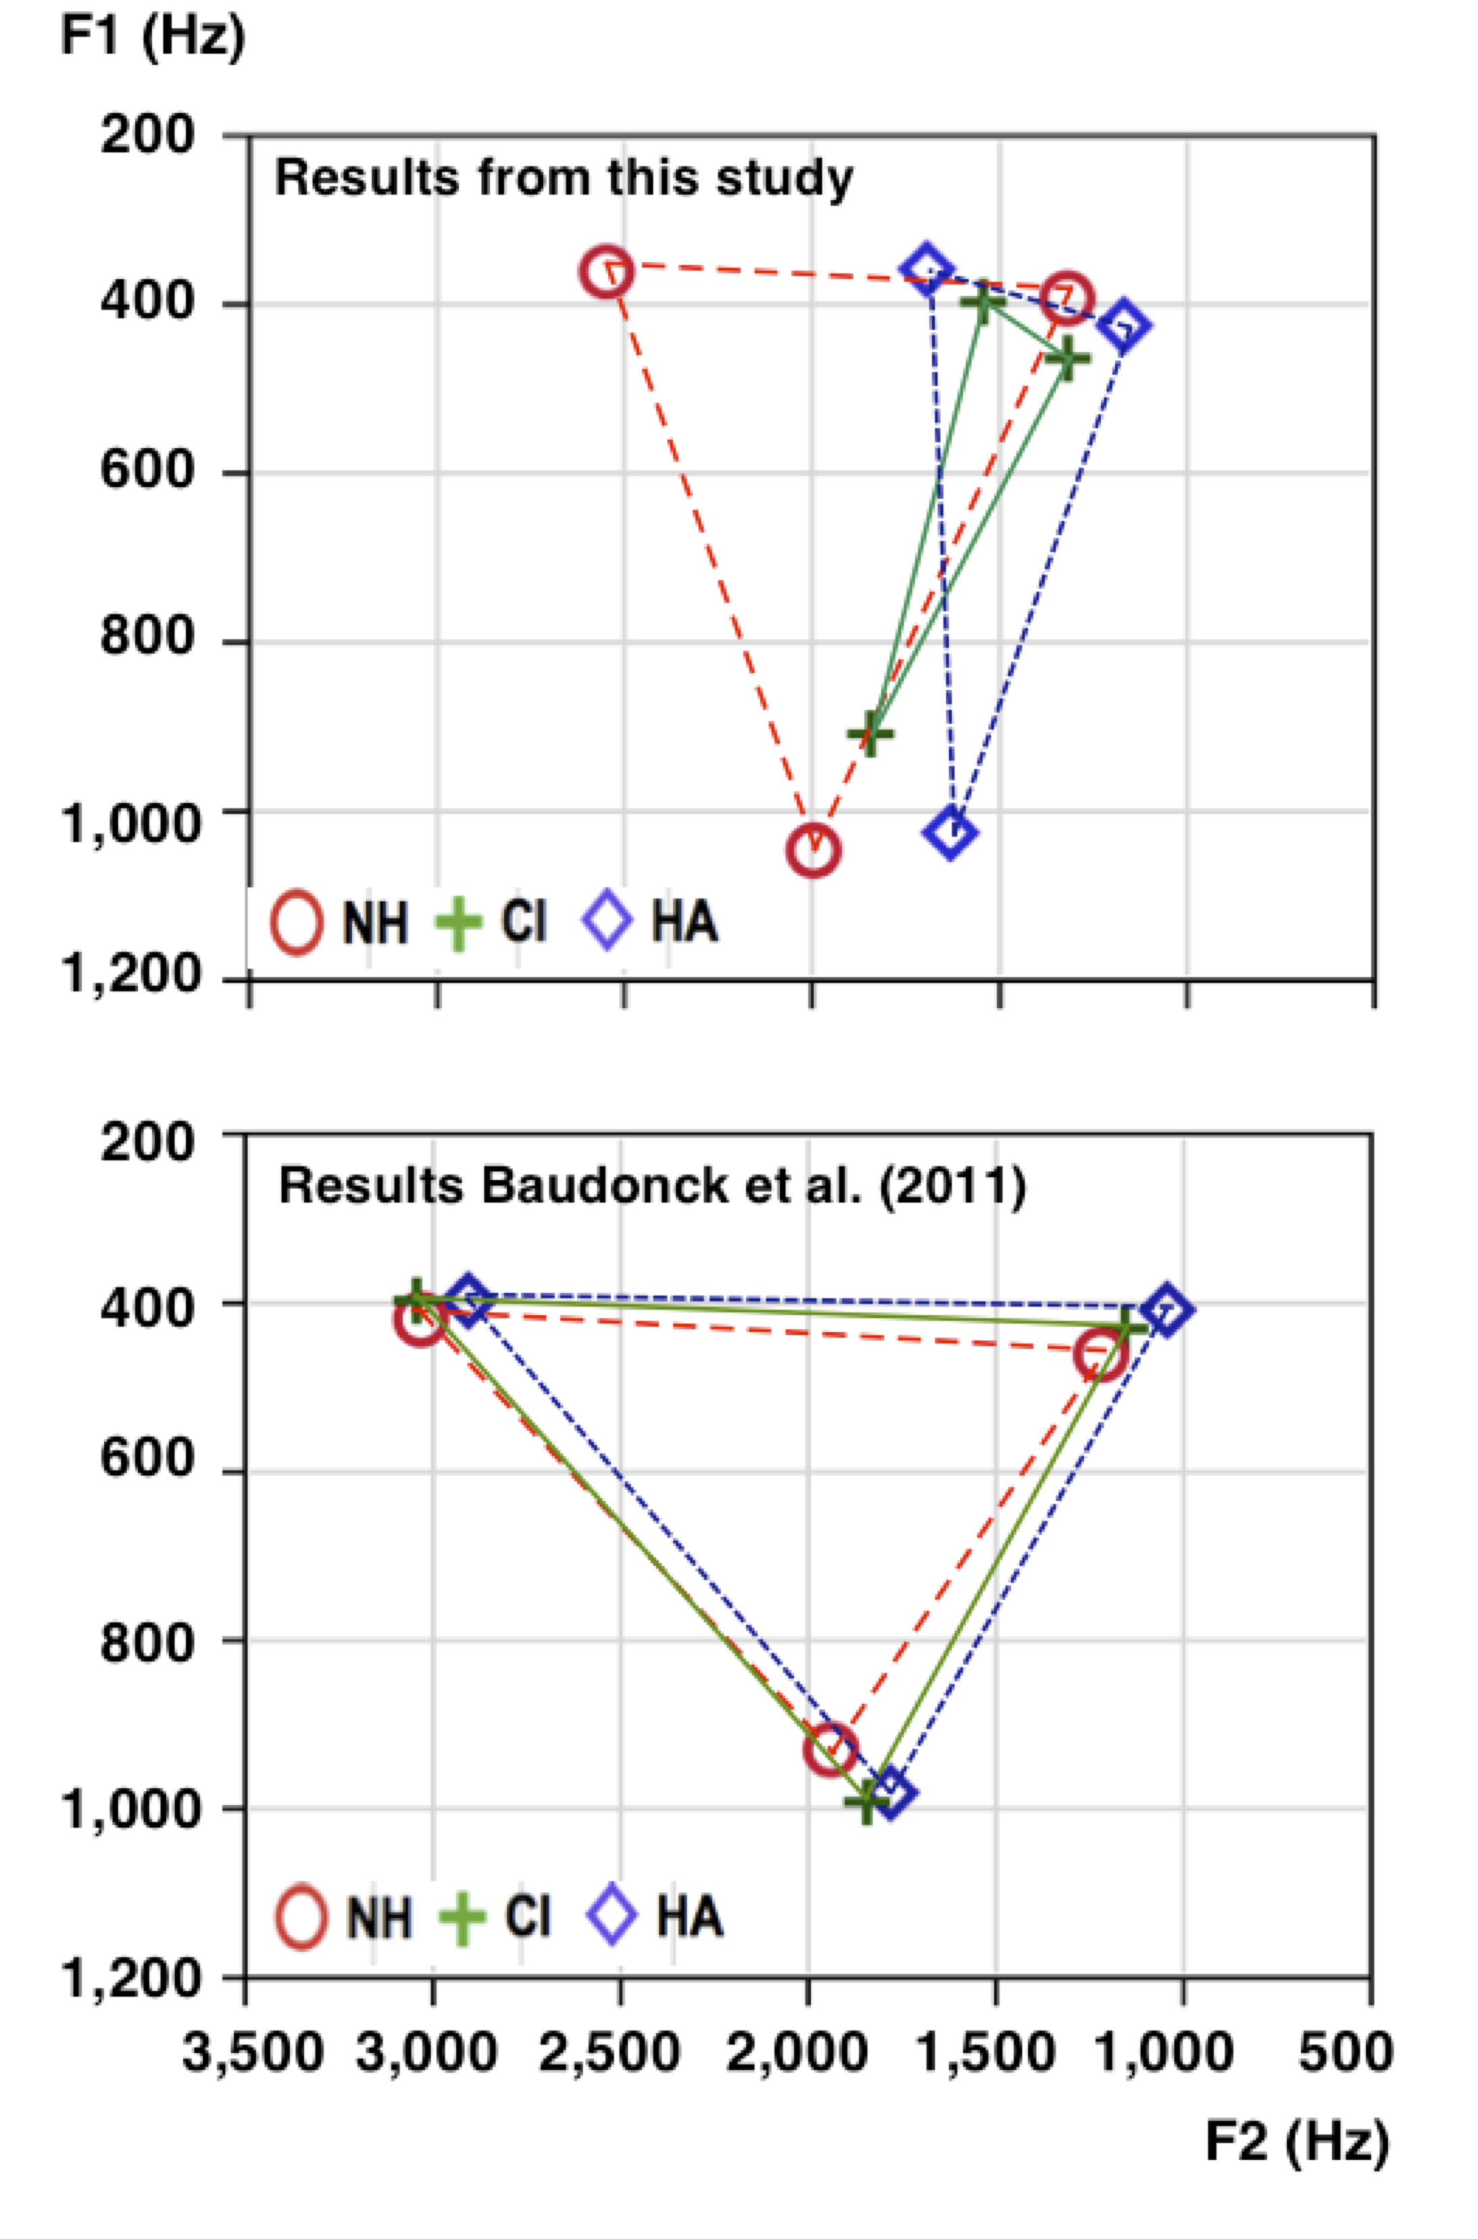
Figure 2: Visualization of the surface area of the vowel space in the three groups of children from this study [top graph] as compared to the results obtained in Baudonck et al. (2011) [bottom graph]. Calculations are in both cases based on the unnormalized formant values for the three point vowels /i/, /a/ and /u/ to enable direct comparison between the two studies.

These differences were analysed in exactly the same manner as in Baudonck et al. (2011). This is to say that the mean formant frequencies, the mean intrasubject SD of the formant frequencies, the mean intervowel distances in the F1/F2-plane, the mean vowel surfaces, and the p-values of the comparisons between the three groups of children were computed. These results are given in Table 5. A Shapiro-Wilk U test was used to determine whether the F1 and F2 values were normally distributed. Since all U-values were highly significant (p < 0.0001) a non-parametric Kruskal-Wallis test was performed in order to find out whether the F1 and F2 values of the three groups of children differed significantly, and if the intrasubject variation – as measured by the standard deviation of the measures – are significantly different. When the Kruskal-Wallis test turned out to be significant, pair-wise comparisons were carried out between the groups of children by means of a Wilcoxon paired analysis test. It turns out that, except for the F1 values of the central vowel [a], all F1 and F2 values differ significantly between the three child groups, while the intrasubject variation does not differ significantly. Subsequently the mean Eucledian distances between the pairs of vowels were computed, and the differences were compared between the three child groups. These analyses show that only the distance between [u] and [a] is significantly different between the three child groups. The post-hoc tests reveal that that the distance u-a is significantly larger in the NH group as compared to the hearing impaired groups. The latter do not differ significantly in this respect. Finally, Heron’s formula was used to compute the vowel surface determined by the three point vowels. From this analysis it appears that the vowel space of the hearing impaired children is significantly smaller than that of the NH children. CI children’s vowel space is smallest and stands at 106 kHz². The vowel space of the NH children in biggest at 395 kHz². The surface area of the vowel space in the HA children is 179 kHz² and this is also much smaller than the normally hearing children.

Table 5: Formant frequencies, intrasubject SD of the formant frequencies, intervowel distances, vowel space of the acoustic analysis and p-values of comparisons between the subgroups of speakers.
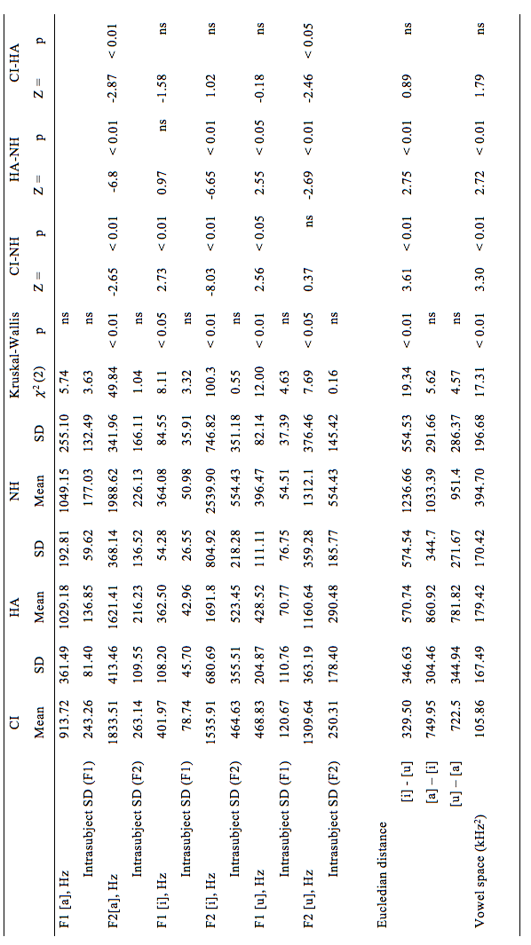

In the second analysis, the surface area of the vowel space in the three groups of children was calculated by estimating the convex hull of the vowel space on the basis of z-score normalized formant values for all the 12 Dutch monophthongs. The result is illustrated in figure 3:

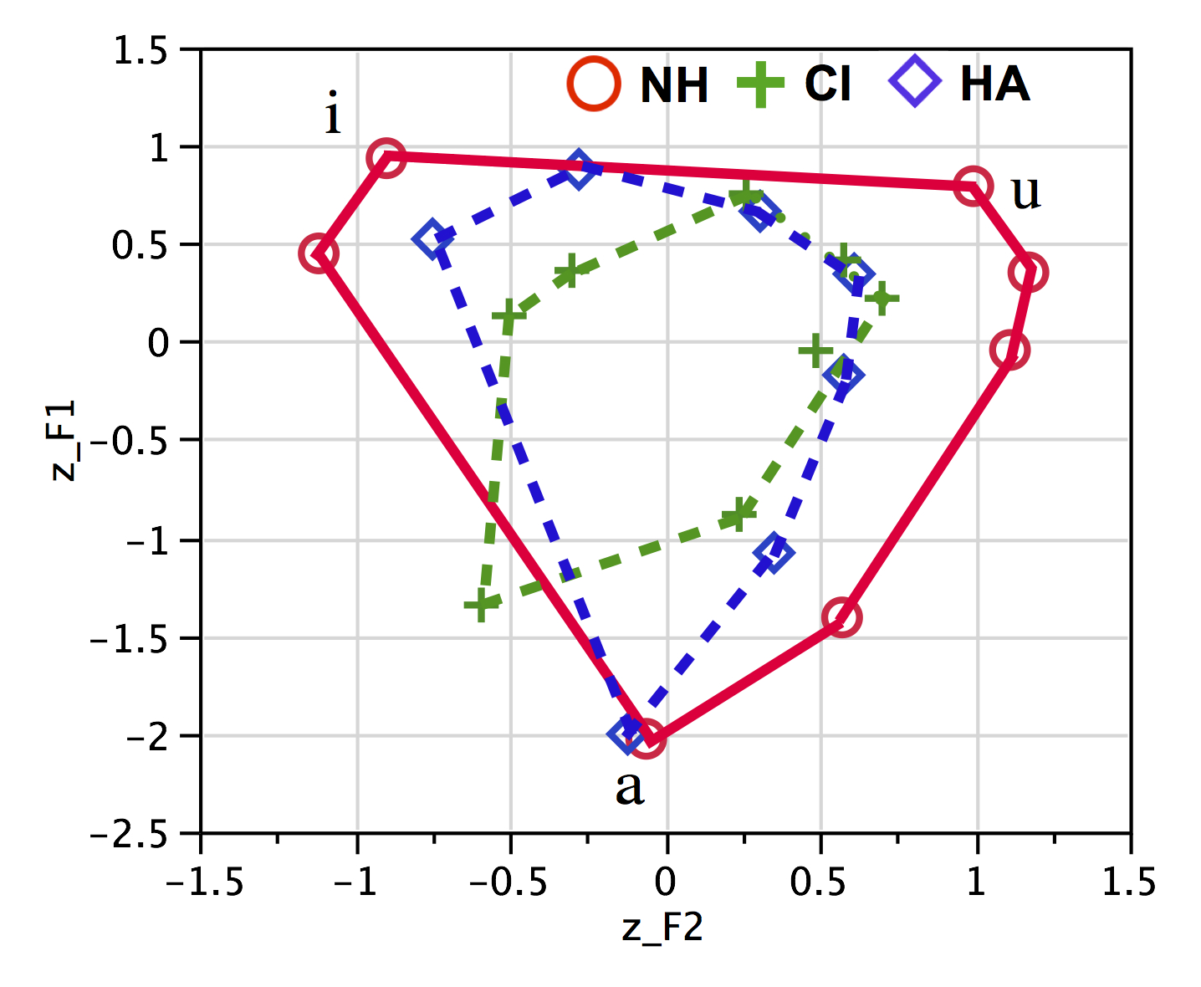
Figure 3: Visual representation of the vowel surface area in the three groups of children (legend: NH = normally hearing, CI = cochlear implant, HA = hearing-aided).

In the fixed part of the model, the CI group has the smallest estimated average surface value (10.515) while the NH group has the highest average surface value (12.755). With a value of 11.518 the HA group has an average surface value that is situated between that of the two other groups. The difference between the CI children and NH children is statistically significant (χ²(1)=10.764, p < 0.001): this means that the vowel surface area of the CI is significantly smaller than that of the NH children. Furthermore, a statistically significant difference was found between the HA and NH children (χ²(1)=18.725, p < 0.0001). A comparison of the CI and HA children did not reveal any significant difference (χ²(1)=1.913, p = 0.167).
No statistical differences were found between the three groups of children in inter-subject variances on the vowel surface areas (CI-NH: (χ2(1)=2.292, p=0.13; CI-HA: χ2(1)=2.922, p=0.0874; HA-NH: χ2(1)=1.622, p=0.318). However, significant differences between the three child groups were found concerning intra-subject variance: both CI children and HA children demonstrated more intra-subject variance than NH children, and the difference was significant for CI children (CI-NH: (χ2(1)=8043.485, p < 0.001) as well as for HA children (HA-NH: χ2(1)=2182.913, p < 0.001). Comparing the two hearing impaired child groups, it was found that CI children demonstrate significantly more intra-subject variance than HA children (χ2(1)=2778.346, p < 0.001). This indicates that both groups of hearing impaired children, and in particular CI children, are less consistent in their productions as compared to children with NH.

3.3. Acoustic differentiation between vowels.
In order to quantify the degree of acoustic distinctiveness between the vowels in the three groups of children, all the vowel realisations were plotted on a scatterplot and for each vowel the 95% confidence ellipse was determined on the basis of all its tokens. This is illustrated in figure 4:
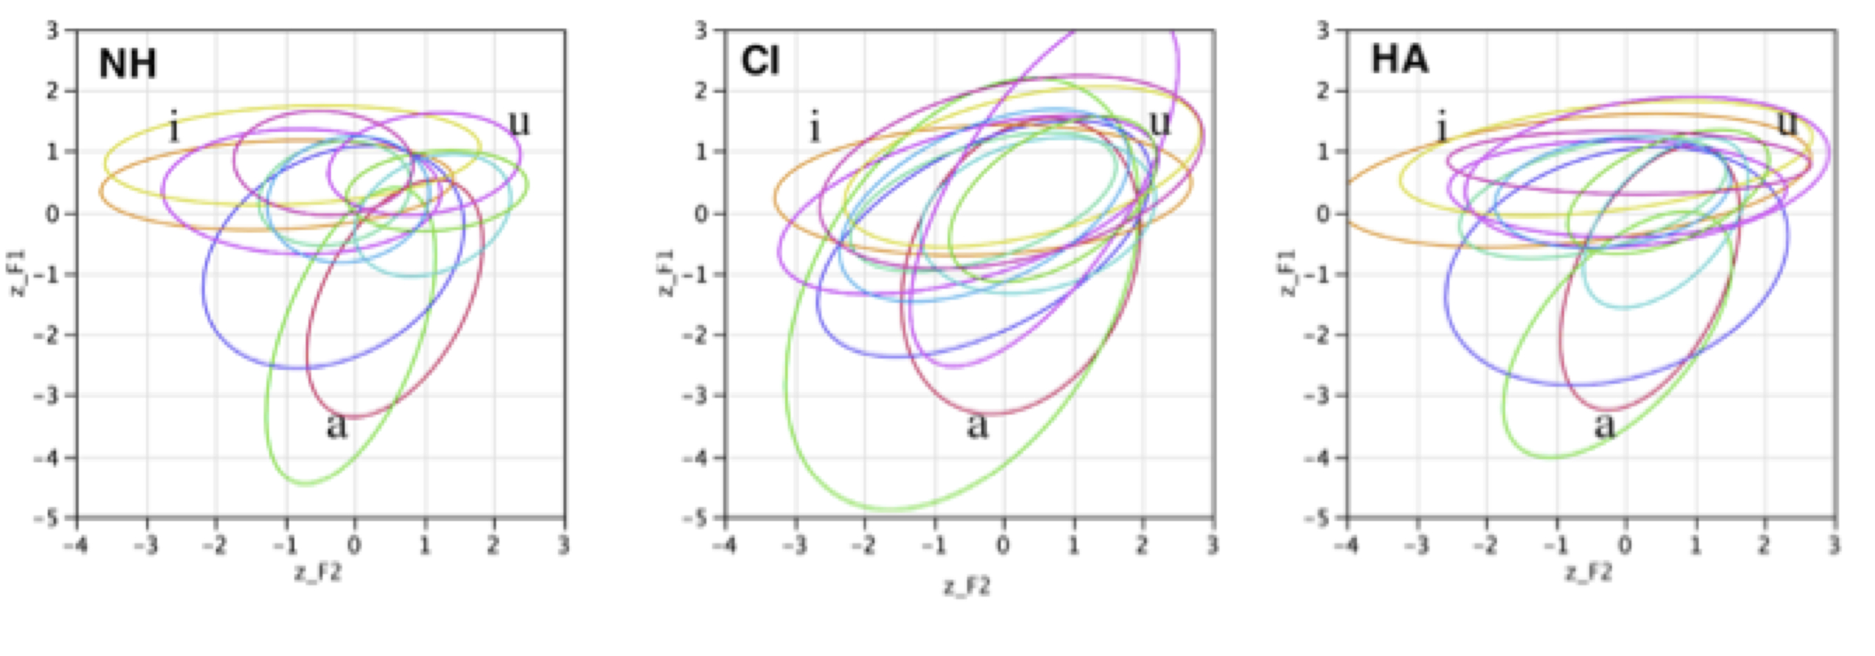
Figure 4: z-score normalized formant values of the 12 Dutch monophthongs in the three speaker groups (Legend: NH= normally hearing, CI=cochlear implant, HA=hearing assisted). The 95% confidence ellipses describe the area of the vowel space which contains 95% of the vowel realisations for each individual vowel. The point vowels are given only for the sake of visual reference.

Figure 4 reveals substantial differences between the three speaker groups in terms of the overlap in vowel realisation represented by the vowel ellipses. A smaller overlap between the ellipses may be taken as indicative of speakers effectively maintaining acoustic distinctions between the vowels in their systems.
As far as the number of overlaps between the confidence ellipses is concerned, the statistical analysis showed that the number of vowel overlaps in the CI group is significantly higher than in the NH group (χ²(1)=44.544, p<0.0001). In addition, the number of vowel overlaps in the HA group is also significantly higher from the NH group (χ²(1)=29.732, p<0.0001). Finally, also vowel overlap in the two hearing impaired groups is significantly different (χ²(1)=5.152, p=0.023). The estimated number of overlaps in each child group and inter- and intra-subject variances based on the multilevel model are given in table 6.

Table 6. Estimated values of the number of overlaps per child group and variance components (with standard error of estimate in parentheses) based on the multilevel model.

 | Fixed | Random
$$β_{1}\text{CI}$$ | 9.729 (0.539)
Var($μ_{1j}$) |  | 2.163 (1.163)
Var($ε_{1\text{ij}}$) |  | 1.951 (0.294)
$$β_{2}\text{HA}$$ | 8.233 (0.379)
Var($μ_{2j}$) |  | 0.221 (0.464)
Var($ε_{2\text{ij}}$) |  | 5.958 (1.136)
$$β_{3}\text{NH}$$ | 5.819 (0.229)
Var($μ_{3j}$) |  | 3.337 (0.629)
Var($ε_{3\text{ij}}$) |  | 5.248 (0.264)

The estimated number of overlaps in the children with NH amounts to 5.819, while the number of overlap in the HA group is bigger and stands at 8.299 overlaps. The CI group has the highest number of overlaps (9.729).
Comparing the proportion of overlap between the confidence ellipses, it is striking that both CI children and HA children have a larger proportion of overlap between their vowel ellipses than NH children (Table 7). The difference between CI children and NH children was statistically significant (χ2(1)=39.998, p < 0.001), as well as the difference between HA children and NH children (χ2(1)= 31.236, p < 0.001). The difference between CI children and HA children was not statistically significant (χ2(1) < 0.0001, p=1.000), indicating that the two child groups did not differ in proportion of overlap.

Table 7. Proportion of overlap (in %) between the 95% vowel ellipses. Estimated values of proportion of overlaps per child group and variance components (with standard error of estimate in parentheses) based on the multilevel model.

 | Fixed | Random
$$β_{1}\text{CI}$$ | 0.893 (0.017)
Var($μ_{1j}$) |  | 0.000 (0.001)
Var($ε_{1\text{ij}}$) |  | 0.023 (0.003)
$$β_{2}\text{HA}$$ | 0.892 (0.021)
Var($μ_{2j}$) |  | 0.000 (0.000)
Var($ε_{2\text{ij}}$) |  | 0.027 (0.005)
$$β_{3}\text{NH}$$ | 0.740 (0.017)
Var($μ_{3j}$) |  | 0.016 (0.004)
Var($ε_{3\text{ij}}$) |  | 0.063 (0.003)

As for the random part of the model, both the CI children and the HA children demonstrated significantly more intersubject variance as compared to the NH children (CI-NH: (χ2(1)=17.475, p < 0.001; HA-NH: χ2(1)=20.434, p < 0.001). However, the difference in interchild variance between the CI children and the HA children was not significant.
Concerning intra-subject variances, significant differences were found between the child groups (CI-NH: (χ2(1)=73.347, p < 0.001; HA-NH: χ2(1)=37.408, p < 0.001). No statistical difference was found between the CI children and the HA children. These results indicate that there is less variance between and within CI children and HA children than between and within NH children.

4. Discussion
The objective of this study was to determine the acoustic characteristics of
the Belgian Standard Dutch vowels in children with hearing impairment and in children with NH. For this purpose the children participated in a vowel imitation task in which they were required to imitate the 12 steady-state vowels of Belgian Dutch. Three groups were compared, i.e. children with a cochlear implant device, children with a conventional hearing aid and children with NH. These vowel productions were analysed acoustically for the spectral characteristics of the individual vowels, the overall surface area of the vowel space and the acoustic differentiation between the vowels. From the results it is clear that there are quite a number of significant differences between the speaker groups.

4.1. Vowel acoustics
As far as the realisation of the individual vowels is concerned, F1 and F2 were measured, normalized for anatomical differences between speakers and analyzed. From the statistical analysis of F1 values it appears that there are only few significant differences in vowel realisation between the groups: it were mainly the open vowels of the CI children which differed from either the HA or the normally hearing group. However, at a more qualitative level of analysis, a highly systematic trend was observed, i.e. the z-scores associated with F1 in the vowels of the CI children are closer to 0 than in the other groups (Table 3). This indicates that vowel F1 in the CI group was reduced as compared to the NH and HA group. Although this reduction is only significant for /ɛ/, /a/, /ɑ/, /ɔ/ and /u/, it is highly systematic at a qualitative level.
From the analysis of F2 many more significant differences between the groups emerged. F2 in the CI group was significantly different from the NH group for all vowels except /ɪ /, /ɛ/ and /ø/. The HA group was significantly different from the NH for all vowels except /ɛ/, /a/, /ɑ/, /ʏ/ and /ø/. In both cases, the direction of the F2 difference is consistent with vowel neutralisation, i.. a lower F2 fr front vowels and a higher F2 for back vowels. Only very few of the differences between the two hearing impaired groups were significant, i.e. for /i/, /e/ and /a/ for which CI children displayed most reduction. Expressed in terms of the distance of the z-scores associated with F2 and 0 (Table 4) it was clear that these values were closer to 0 for the CI and HA group in comparison to the NH children. This suggests that there was vowel reduction to schwa in the children with hearing impairment.
These findings are partly in agreement with Liker at al. (2007) who found a significantly lower F1 value for the vowel /a/ in the CI children, though for the other four Croatian vowels no consistent and significant picture emerged. The results of this study are not in agreement with the findings of Baudonck et al. (2011) who did not report any significant differences between the vowels of the CI children and those of the NH children. Furthermore, the significant differences that did exist between the HA and NH children (F1 in [u], and F2 in [a] and [u]) are not necessarily indicative of vowel reduction.
A second aspect of the formant values investigated in this study was the intrasubject variability in F1 and F2 as an indication of articulation consistency. For F1 there was significantly larger variability in the CI group as compared to both HA and NH. For F2 there was significantly more variability in the two hearing impaired groups in comparison to NH. This indicates that CI children were less consistent in the realisation of the vowels in both degree of opening and the front-back dimension, whereas the HA were less consistent concerning front-back articulation of the vowels. This increased inconsistency concerning vowel articulation in the hearing impaired groups is also reported in Baudonck et al (2011) who also observed increased variability in formant realisation in the CI group.

4.2. Vowel surface area
The vowel surface are of the vowel space in the three groups of children in this study was determined by two different methods, i.e. a method based on the formants of the three point vowels only (Heron’s formula) and one that estimates the vowel surface area on the basis of full 12 vowels in Belgian Dutch (Graham scan). The results of both methods indicate that the vowel space in the CI children is smallest, bigger in children with HA and biggest in NH children (CI: Heron = 105 kHz², Graham = 10.515; HA: Heron = 179 , Graham = 11.518; NH: Heron = 394; Graham = 12.755). The difference between the hearing impaired groups is only significant when using Heron’s formula to determine the surface are of the vowel space based on the three point vowels.
The finding of a significantly reduced vowel space in children with hearing impairment is highly consistent with a number of other studies on both prelingually deaf (Horga and Liker 2006; Liker et al. 2007) and postlingually deaf children (Schenk, Baumgartner, & Hamzavi, 2003). It is also in agreement with Löfqvist et al. (2010) who investigated the vowel space area in 12 Swedish adolescents with a cochlear implant and found it to be significantly smaller than in NH controls. However, it is opposite to the findings of Baudonck et al (2011), who found an expansion of the vowel space in speakers with hearing impairment. Baudonck et al. (2011) argue that this expansion of the vowel space may be indicative of hearing impaired children trying to imitate the exaggerated articulatory movements of speech therapists and carers adopted in speech reading.
Although it is not clear how the conflicting findings in between our study and that of Baudonck et al. (2011) have to be accounted for, there are various potential explanations. In the first instance, it is possible that the contradiction relates to methodological differences between the two studies. While this study used a formant normalization technique to compensate for vocal tract size differences between speakers, Baudonck et al. (2011) have carried out all analyses on formant measurements in Hertz without applying any normalization. Nevertheless, the importance of normalizing formant values in their study cannot be underestimated since the participants’ ages ranged approximately between the ages of 4 and 15. As a result, significant differences in vocal tract size between participants are to be expected. The expansion of the vowel space in Baudonck et al. (2011) may therefore be a reflection of vocal tract size differences between the three groups of participants rather than being related to hearing impairment per se.
A second methodological difference between the two studies is that Baudonck et al. (2011) did not have the vowel realisations of their participants perceptually assessed, although it is not quite clear whether or not this may have had an effect on the compatibility of the results in both studies.
Secondly and most importantly, it cannot be excluded that the contradictory results between Baudonck et al. (2011) and this study are a reflection of differences in the regional background of the NH participants in both studies. All the participants in this study were from the Brabantine and Limburg areas of Belgium, while it can be assumed that the Baudonck reference group was from the East-Flanders region. If it is hypothesized that the vowel space in the Brabantine and Limburg areas of Belgium is naturally substantially bigger than in East Flanders and that the natural vowel space of hearing impaired speakers is invariant, this could lead to a vowel space reduction in the data of this study and an apparent vowel space expansion in Baudonck et al. (2011). This assumption is consistent with the results of an investigation of the surface area of the vowel space in different geographical regions in Belgium (Vandecauter, 2013). This study found that the vowel space in the Brabantine region of Belgium is significantly bigger than in East-Flanders (4.47 vs. 3.73). Nevertheless, a more detailed investigation of the relationship between regional variability in the vowel space area and the traditionally assumed reduction of the vowel space in hearing impairment is required.

4.3. Acoustic differentiation
As a final step in the analysis this study looked at the acoustic differentiation between the vowels in the vowel systems of the three groups of speakers. This was done by calculating the frequency and proportion of overlap between the 95% confidence ellipses associated with each vowel. This analysis revealed that there were significant differences between the three groups of speakers both in terms of frequency and proportion of overlap. The frequency of overlap is smallest in the NH group, bigger in the HA group and bigger still in the CI group. Concerning the proportion of overlap, an identical rank order between the three speaker groups was found: NH < HA < CI. Both findings indicate that the acoustic distinctions between all the vowels in the vowel systems of the hearing impaired speakers are smaller overall than those in speakers with NH. To the best of our knowledge acoustic differentiation has never been investigated before and this constitutes an entirely new finding.
From the three types of analyses that have been carried out in this study, a picture emerges in which there is strong evidence of a reduction of the formant values of F1 and F2 in the children with hearing impairment. The degree of this reduction is greater for F2, suggesting that reduction mainly pertains to the place of articulation of the vowels which is more central in hearing impairment. In addition, there is a significantly reduced space in both groups of children with hearing impairment as compared to NH children. Unlike in some of the previous studies, this observed reduction of the vowel space was based on all the 12 vowels of the Belgian Dutch vowel system. In addition, it was found that there are no statistically significant differences between the two hearing impaired groups in this respect which seems to suggest that the children with a cochlear implant in this study perform equally well as children with a conventional hearing aid. This appears consistent with other studies on children in whom the hearing loss is mild to moderate like in this study. Although there have been no studies which have directly compared performance of cochlear implant children and hearing assisted children with equal hearing loss which was measured with CI/HA, indirect comparison seems to suggest that both groups may indeed perform equally well (Svirsky 2000, Svirski et al. 2000, Eisenberg, L. et al. 2004). However, the equally good performance of the CI and HA children is not consistent with research on populations with severe to profound hearing loss, which has indicated that CI children perform better (Tomblin et al. 1999).
As far as the acoustic differentiation of the vowels within this reduced vowel space is concerned, significant differences between the two groups of children with hearing impairment were found: CI children are less succesful in differentiating the vowels in their vowel system than children with a conventional hearing aid. This is based on calculations of the frequency and the proportion of overlap between the 95% confidence ellipses associated with the vowels in each system. The hearing impaired groups are outperformed by the NH children even after approximately 5 years of device use.

4.5. Limitations of this study
Although this study has shed light on some of the acoustic characteristics of the Dutch vowels in three groups of children differing in hearing status, it may be useful to mention a few limitations of this study which mainly relate to some of the methodological choices which have been made.
Firstly, the children participating in this experiment were instructed to imitate the vowels of a model speaker as accurately as possible. In addition, the recorded vowels occurred in carefully controlled phonetic environments. In short, the data were acquired in laboratory conditions. Although the use of laboratory speech has many advantages over spontaneous speech, such as the degree of control over the experimental variables, it is not always clear to what extent results obtained in laboratory conditions apply to spontaneous speech. Although it has been argued that laboratory speech may be ‘uniformly slow and articulate, unnatural, over planned, monotonous with impoverished prosody, and devoid of communicative functions, interactions and emotions’ (Xu, 2010: 334) , it has been argued convincingly that this is not necessarily the case (Xu, 2010).
Secondly, this study only included those productions which had been considered as acceptable imitations of a model speaker by a listening panel. This approach was motivated by the need to allow for natural regional variation in the pronunciation of the vowels. This was very important because such regional variation can be quite substantial in Flanders (Verhoeven, 2005).
Furthermore, it was intended to exclude extreme outliers because the source of the error cannot be determined. In some cases children may have misheard a vowel as the result of degraded auditory ability and imitated the presented stimulus as a categorically different vowel. In other cases, the appearance of categorically different vowels may be related to other factors such as limitations in working memory: the model vowel may have been heard correctly but was incorrectly matched with the production model. As a result of this approach, the data presented in this article may have appeared slightly cleaner than inclusion of all the data and this may have produced a somewhat conservative picture of the differences between the three groups of children and the effects of hearing impairment.
Thirdly, it should be mentioned that the objective of this investigation was the acoustic analysis of the vowels in these three groups of children. Although this has revealed clear information about the fine phonetic detail of vowel acoustics, it is not clear at this point to what extent the reported differences are relevant in a functional perspective, i.e. to what extent these acoustic differences may relate to the intelligibility of hearing-impaired children in daily conversation. Some research on Mandarin Chinese has suggested that there is only a weak relationship between the e.g. the size of the vowel space and intelligibility (Tseng, Kuei & Tsou, 2011). However, it should be kept in mind that Mandarin Chinese only has 6 vowels, while this of Dutch has 12, which is more than twice as many. As a result, the effect of vowel space differences on intelligibility may well be stronger since more vowels compete for categorization within a smaller space and therefore lose distinctiveness.
Nevertheless, the long and short of the matter is that the relationships between acoustic differences between vowels and intelligibility is an interesting area of investigation which requires a fundamentally different methodological approach than the one used in this study.

5. Conclusion
This study investigated the acoustic characteristics of the full set of vowels of Standard Belgian Dutch in two groups of children with hearing impairment and a group of NH children. The study found significant differences between the three groups. It was found that hearing impaired children reduce their vowels towards a more central schwa-like vowel. Statistically, place of articulation neutralisation is greater than neutralisation in terms of the degree of opening. Furthermore, children with hearing impairment have a significantly reduced vowel space in comparison to the NH children. Within this reduced vowel space the acoustic differentiation between the vowels in children with a cochlear implant is significantly smaller than in children with a conventional hearing aid.
References
Abberton, E., Hazan, V., & Fourcin, A. (1990). The development of contrastiveness in profoundly deaf children's speech. Clinical Linguistic and Phonetics, 4(3), 209-220.
Adank, P. (2003). Vowel normalization: a perceptual-acoustic study of Dutch vowels. (PhD), Katholieke Universiteit Nijmegen.
Angelocci, A., Kopp, G., & Holbrook, A. (1964). The vowel formants of deaf and normal hearing eleven to fourteen year old boys. Journal of Speech and Hearing Disorders, 29, 156-170.
Baayen, H. (2008). Analyzing linguistic data: A practical introduction to statistics. Cambridge: Cambridge University Press.
Bates, M.D. (2010). Lme4: mixed-effects modeling with R. Manuscript.
Baudonck, N., Dhooge, I., D'haeseleer, E., & Van Lierde, K. (2010). A comparison of the consonant production between Dutch children using cochlear implants and children using hearing aids. International Journal of Pediatric Otorhinolaryngology, 74, 416-421.
Baudonck, N., Van Lierde, K., Dhooge, I., & Corthals, P. (2011). A comparison of vowel productions in prelingually deaf children using cochlear implants, severe hearing-impaired children using conventional hearing aids and normal-hearing children. Folia Phoniatrica et Logopaedica, 63, 154-160.
Boersma, P., & Weeninck, D. (2010). PRAAT. Doing phonetics by computer (Version 5.2). Retrieved from http://www.praat.org
De Berg, M., Cheong, O., Van Kreveld, M., & Overmars, M. (2008). Computational Geometry Algorithms and Application. Berlin: Springer.
Eisenberg, L., Kirk, K., Martinez, A., Ying, E., Miyamoto, R. (2004). Communication abilities of children with aided residual hearing. Archives of Otolaryngology – Head and Neck Surgery 130, 563-569.
Ertmer, D. (2001). Emergence of a vowel system in a young cochlear implant recipient. Journal of Speech, Language, and Hearing Research, 44, 803-813.
Geffner, D. (1980). Feature characteristics of spontaneous speech production in young deaf children. Journal of Communication disorders, 13, 443-454.
Graham, R.L. (1972). An efficient algorithm for determining the convex hull of a finite planar set. Information Processing Letters, 1, 132-133.
Horga, D., & Liker, M. (2006). Voice and pronunciation of cochlear implant speakers. Clinical Linguistics & Phonetics, 20, 211-217.
Hudgins, C. V., & Numbers, F. C. (1942). An Investigation of the intelligibility of the speech of the deaf. Genetic Psychology Monogograph, 25, 289-392.
Ibertsson, T. , Willstedt-Svensson, U., Radeborg, K., & Sahlen, B. (2008). A methodological contribution to the assessment of nonword repetition-a comparison between children with specific language impairment and hearing-impaired children with hearing aids or cochlear implants. Logopedics, Phoniatrics, Vocology, 33(4), 168-178.
Jacewicz, E., Fox, R., & Salmons, J. (2007, August 6-10). Vowel space areas across dialects and genders. Paper presented at the ICPhS XVI, Saarbrücken.
Kunisue, K., Fukushima, K., Nagayasu, R., Kawasaki, A., & Nishizaki, K. (2006). Longitudinal formant analysis after cochlear implantation in school-aged children. International Journal of Pediatric Otorhinolaryngology, 70, 2033-2042.
Liker, M., Mildner, V., & Sindija, B. (2007). Acoustic analysis of the speech of children with cochlear implants: A longitudinal study. Clinical Linguistics & Phonetics, 21(1), 1-11.
Löfqvist, A., Sahlen, B., & Ibertsson, T. (2010). Vowel spaces in Swedish adolescents with cochlear implants. Journal of the Acoustical Society of America, 128(5), 3064-3069.
Lovbanov, B. M. (1971). Classification of Russian vowels by different speakers. Journal of the Acoustical Society of America, 49, 606-608.
Markides, A. (1970). The speech of deaf and partially hearing children with special reference to factors affecting intelligibility. British Journal of Disorders of Communication, 5(2), 126-140.
Monsen, R. (1976). Normal and reduced phonological space: The production of English vowels by deaf adolescents. Journal of Phonetics, 4, 189-198.
Monsen, R. B. (1976). Second formant transitions of selected consonant-vowel combinations in the speech of deaf and normal hearing children. Journal of Speech and Hearing Research, 19, 279-289.
Neumeyer, V., Harrington, J., & Draxler, C. (2010). An acoustic analysis of the vowel space in young and old cochlear-implant speakers. Clinical Linguistics & Phonetics, 24(9), 734-741.
Nicolaidis, K., & Sfakiannaki, A. (2007). An acoustic analysis of vowels produced by Greek speakers with hearing impairment Proceedings of 16th International Congress of Phonetic Sciences (pp. 1969-1972). Saarbrücken.
Nober, E.H. (1967). Articulation of the deaf. Exceptional Children, 33(9), 611-621.
Okalidou, A. (1996). Coarticulation in deaf and hearing talkers. (PhD) City University of New York.
Osberger, M. (1987). Training effects on vowel production by two profoundly hearing-impaired speakers. Journal of Speech and Hearing Research, 30(2), 241-251.
Osberger, M., & McGarr, N. (1982). Speech production characteristics of the hearing impaired. In N. Lass (Ed.), Speech and language: Advances in basic research and practice. Volume 8. (pp. 221-283). New York: Academic Press.
Ozbic, M., & Kogovsek, D. (2008). An acoustic comparison of formant frequencies in individuals with normal hearing, profound and severe hearing impairment. Investigationes Linguisticae, 16, 150-162.
Ozbic, M., & Kogovsek, D. (2010). Vowel formant values in hearing and hearing-impaired children: A discriminant analysis. Deafness & Education International, 12(2), 99-128.
Quené, H., & van den Bergh, H. (2004). On multi-level modeling of data from repeated measures designs: A tutorial. Speech Communication, 43, 103-121.
Rasbash, J., Charlton, C., Browne, W.J., Healy, M., Cameron, B. (2009). MlwiN version 2.1. Centre for Multilevel Modelling. University of Bristol.
Ryalls, J., Larouche, A., & Giroux, F. (2003). Acoustic comparison of CV syllables in French-speaking children with normal hearing, moderate-to-severe and profound hearing impairment. Journal of Multilingual Communication Disorders, 1, 94-108.
Schenk, B., Baumgartner, W., & Hamzavi, J. (2003). Effect of the loss of auditory feedback on segmental parameters of vowels of postlingually deafened speakers. Auris Nasus Larynx, 30, 333-339.
Smith, C. (1975). Residual hearing and speech production in deaf children. Journal of Speech and Hearing Research, 18(4), 795-811.
Stein, D. (1980). A study of articulatory characteristics of deaf talkers. (PhD), University of Iowa.
Stevens, K.N., Nickerson, R.S., Boothroyd, A., & Rollins, A.M. (1976). Assessment of nasalization in the speech of deaf children. Journal of Speech and Hearing Research, 19(2), 393-416.
Svirsky, M. (2000). Language development in children with profound and prelingual hearing loss, without cochlear implants. Annals of Otology, Rhinology, and Laryngology 109 (12), 99-100.
Svirsky, M., Robbins, A., Kirk, K., Pisoni, D., Miyamoto, R. (2000). Language Development in profoundly deaf children with cochlear implants. Psychological Science 11, 153-158.
Tomblin, J., Spencer, L., Flock, S., Tyler, R., Gantz, B. (1999). A comparison of language achievement in children with cochlear implants and children using hearing aids. Journal of Speech, Language and Hearing Research 42, 497-511.
Tseng, S.-C., Kuei, K. & Tsou, P.-C. (2011). Acoustic characteristics of vowels and plosives/affricates of Mandarin-speaking hearing-impaired children. Clinical Linguistics & Phonetics, 25, 784-803.
Uchanski, R., & Geers, A. (2003). Acoustic characteristics of the speech ofyoung cochlear implant users: A comparison with normal-hearing age-mates. Ear & Hearing, 24, 90S-105S.
Vandecauter, L. (2013). The surface area of the vowel space in Standard Dutch. Antwerp: unpublished MA dissertation.
Van der Harst, S. (2011). The vowel space paradox. A sociophonetic study on Dutch. Utrecht: LOT.
Verhoeven, J. (2005). Belgian Standard Dutch. Journal of the International Phonetic Association, 35, 243-247.
Verhoeven, J., & Van Bael, C. (2002). Acoustic characteristics of monophtong realisation in southern standard Dutch. In J. Verhoeven (Ed.), Phonetic work in progress (pp. 149-164). Antwerp: University of Antwerp.
Xu, Y. (2010). In defense of lab speech. Journal of Phonetics, 38, 329-336.
Appendix 1: Formant values for the Belgian Dutch vowels in the three speaker groups in this experiment.

Children with Normal Hearing
Vowel | No Obs. | Mean F1 (Hz) | SD (Hz) | Mean F2 (Hz) | SD (Hz)
ɑ | 533 | 896 | 193 | 1607 | 321
a | 532 | 1049 | 255 | 1988 | 341
ɛ | 518 | 746 | 199 | 2140 | 560
e | 448 | 484 | 70 | 2687 | 690
ø | 523 | 505 | 97 | 2142 | 305
ɪ | 480 | 500 | 102 | 2448 | 606
i | 535 | 364 | 84 | 2539 | 746
o | 536 | 582 | 106 | 1256 | 264
u | 523 | 396 | 82 | 1312 | 376
o | 465 | 500 | 65 | 1214 | 321
ʏ | 520 | 528 | 107 | 2020 | 336
y | 516 | 390 | 87 | 2251 | 367

Children with Cochlear Implant
Vowel | No Obs | Mean F1 (Hz) | SD (Hz) | Mean F2 (Hz) | SD (Hz)
ɑ | 59 | 798 | 263 | 1503 | 327
a | 60 | 913 | 361 | 1833 | 413
ɛ | 48 | 688 | 218 | 1832 | 665
e | 56 | 521 | 142 | 1813 | 790
ø | 55 | 543 | 100 | 1882 | 463
ɪ | 45 | 555 | 166 | 2030 | 672
i | 53 | 401 | 108 | 1535 | 680
o | 58 | 608 | 129 | 1374 | 323
u | 58 | 468 | 204 | 1309 | 363
o | 51 | 542 | 141 | 1251 | 301
ʏ | 58 | 570 | 158 | 1904 | 434
y | 43 | 446 | 181 | 1595 | 651

Children with Conventional Hearing Aid
Vowel | No Obs | Mean F1 (Hz) | SD (Hz) | Mean F2 (Hz) | SD (Hz)
ɑ | 41 | 848 | 178 | 1367 | 287
a | 58 | 1029 | 192 | 1621 | 368
ɛ | 36 | 750 | 160 | 1753 | 653
e | 35 | 495 | 89 | 2081 | 911
ø | 35 | 530 | 92 | 1815 | 403
ɪ | 37 | 491 | 77 | 1724 | 616
i | 49 | 362 | 54 | 1691 | 804
o | 44 | 637 | 121 | 1232 | 255
u | 43 | 428 | 111 | 1160 | 359
o | 44 | 530 | 99 | 1269 | 305
ʏ | 40 | 524 | 108 | 1717 | 364
y | 26 | 407 | 70 | 1551 | 610

