Preliminary evidence on the Somatic Marker Hypothesis applied to investment choices

Simona Cantarella and Carola Hillenbrand University of Reading Luke Aldridge-Waddon University of Bath
Ignazio Puzzo City University of London

Words count: 5058
Figures: 5
Tables: 1
Manuscript accepted on the 06/08/2018

Abstract
The somatic marker hypothesis (SMH) is one of the more dominant physiological models of human decision making and yet is seldom applied to decision making in financial investment scenarios. This study provides preliminary evidence about the application of the SMH in investment choices using heart rate (HR) and skin conductance response (SCRs) measures. Twenty undergraduate students were split equally into expert (defined by familiarity with investments) and novice (no familiarity) groups - previous research has associated expertise with cognitive differences in decision making scenarios. Both completed the BART and BIAS - a computerized simulation of real trading scenarios - tasks as assessments of investment decision making in conditions of low vs high uncertainty, as defined by the Bayesian Calculation (level of certainty is more than:(1 – (–300%)) / ((300% – (–300%)) = 66.67% (0.67). Results suggest that, whilst primary inducers (innate physiological responses) support and guide optimal decision making in conditions of uncertainty, secondary inducers (physiological responses dependent on memory/experience) moderate this effect i.e. the stressful thoughts that accompany the task restrict optimal decision making. This study contributes to the current knowledge on why emotions in finance can lead people to suboptimal decisions.

Keywords: somatic marker hypothesis, Behavioral Investment Allocation Strategy, investment, heart rate, skin conductance

Introduction
The relationship between somatic markers and emotions has been empirically illustrated by Damasio, Everitt and Bishop (1996), who developed the SMH. The SMH proposes that when we experience an emotion, before we can consciously process it, our brain triggers somatic markers, such as a raised heart rate (HR) and skin conductance response (SCR), that guide our choices under uncertainty (A. Bechara & Damasio, 2005). The model is said to have an evolutionary foundation (Bechara & Damasio, 2005) and, by guiding us towards optimal decisions when we are uncertain, has played a role in the survival of our species; helping us to anticipate reward and punishment, for example (A Bechara, Damasio, Tranel, & Damasio, 1997). The role of physiology in decision making is represented at neural levels also, with fMRI research finding that specific brain areas are associated with risk-seeking (nucleus accumbens) or risk-averse (anterior insula) behaviour (Kuhnen & Knutson, 2005), and thus suggests that physiological and neural actions support us in optimal decision making. In terms of financial scenarios, somatic markers may facilitate optimal economic decisions that have the greatest financial reward. For example, SCRs guide typically developing individuals towards optimal financial rewards (Zink, Pagnoni, Martin-Skurski, Chappelow, & Berns, 2004). Given that SCR and anterior insula responses are associated with both decision making and emotional processes, it suggests the presence of an emotional component within decision making. This emotional component might enhance or diminish the level of arousal and thus guide people towards optimal or suboptimal (too risk-seeking or too risk-averse) choice making. This is the essence of the SMH.

The SMH posits that somatic markers can be triggered by two types of inducers: “primary” and “secondary” (Bechara, Dolan, & Hindes, 2002). Primary inducers are innate; such as physiological arousal related to pleasure or aversive reactions. For example, when people make investment decisions, primary inducers are triggered as an innate reaction to market news. This contrasts with secondary inducers, triggered by the recall of emotional events, which then trigger reflective and considered, rather than impulsive (Loomes & Sugden, 1982), investment responses (Bechara & Damasio, 2005). This component of the SMH is similar to Affect Heuristic Theory in that it highlights the role of affective processes in decision making (Slovic, Finucane, Peters, & MacGregor, 2007), and it may be that these affective responses facilitate optimal choice-making – particularly in conditions of high uncertainty.

This secondary inducer response is developed by the Appraisal-Tendency Framework (ATF) (Jennifer S Lerner & Kelter, 2000), which captures the importance of emotions in decision making – that is subjective experiences that are relevant to present judgments (Han, Lerner, & Keltner, 2006). For example, Lerner, Gonzalez, Small, & Fischhoff, (2003) found that experimentally induced fear of terrorism significantly increased risk estimation regarding likelihood of further attacks. In essence, the ATF proposes that decisions are influenced more by secondary inducers (our feelings and evaluations during the decision making process e.g. at the prospect of facing the complexity) rather than primary inducers (our innate and initial emotional and physiological responses) (Loewenstein, Hsee, Weber, & Welch, 2001). However, the ATF fails to acknowledge the role of primary inducers and their related physiological changes (which we know occur) and thus the SMH may be a more comprehensive explanation of the relationship between arousal and decision making.

There are however concerns about the internal validity of the SMH. Colombetti (2008) comments that the broad characterisation of somatic markers and the dimensional nature of arousal restricts the extent to which we can tease primary and secondary inducers apart from arousal responses, such as changes in SCRs that are unrelated to the decision making process e.g. appetitive response (Amiez, Procyk, Honoré, Sequeira, & Joseph, 2003). Whilst this might be true, we know that the SMH is fundamental in explaining economic decisions, and therefore should be used as theoretical background for research in neuroeconomics (Bechara & Damasio, 2005). To this end, the present study aims to extend and apply the SMH to investment choice-making.

Moving away from critique of the model itself, there have also been questions raised about how the SMH is investigated, and the methodology of previous experiments (e.g. Bechara & Damasio, 2005); particularly concerning its generalisability to complex investment scenarios. For example, the suggested Iowa gambling task does not account for important characteristics related to the investment context. These include: the level of uncertainty, the possibility to learn from experience, the reverse learning process and updating beliefs observation after observation. This possibility to learn from experience may not be available in investment scenarios, and thus the ecological validity of the Iowa Gambling Task may be limited here (Buelow & Suhr, 2009).

In response, the present study moves away from the norm (the Iowa gambling task) and instead uses the Behavioural Investment Allocation Strategy (BIAS) as an assessment of decision making. The BIAS task is more appropriate for use in the present study because it operationalizes (sub) optimal choice as a choice strictly dependent from the level of uncertainty. A risk neutral agent should maximize his profit based on the level of uncertainty he faces. For example, if the level of uncertainty is high (in this study more than 0.67) a risk neutral agent makes an optimal choice if he chooses a bond rather than a stock. On the contrary, if the level of uncertainty is low (in this study less than 0.67) a risk neutral agent makes an optimal choice if he chooses a stock over a bond. Other gambling tasks (such as the Iowa Gambling Task) define optimal choice as advantageous (Buelow & Suhr. 2009) but, by using the Bayesian rule of updating belief under uncertainty, the BIAS task gives a more sophisticated representation of what it means to choose advantageously. Furthermore, the BIAS task introduces language like “stock” and “bond”, which is investment-style language, and hence it has more ecological validity. Thirdly, unlike the Iowa Gambling Task, the BIAS task facilitates the measurement of anticipatory, as well as concurrent, physiological responses. This allows for more substantial conclusions about the impact of emotion (arousal) on decision-making.

Investment-making requires a degree of expertise. As demonstrated by Perkins and Reyna (1990), expertise and experience reduce preference and typicality in decision making, meaning that those who are more experienced tend to make more incisive and meaningful decisions, rather than novices who tend to default toward normative or biased judgements. Furthermore, experts tend to have superior cognitive functioning and perform better on tasks related to attention and problem solving (Shanteau, 1988); and find solutions faster and in less steps (Larkin, McDermott, Simon, & Simon, 1980) than non-experts. To acknowledge and investigate this difference in expertise and how it affects decision making, this research compares those with financial expertise to novices. Experts and non-experts also completed the Balloon Analogue Risk Task (BART) to account for any baseline differences in decision making style or propensities.

In order to give an empirical contribution about the validity and reliability of the SMH in investment choices, the present preliminary study was conducted to investigate (1) whether or not low and high financial uncertainties function as “primary inducers” and produce a specific pattern of somatic markers that help individuals to decide optimally; (2) whether or not financial knowledge has an effect on somatic markers.
The present study hypothesizes that (1) level of uncertainty will have an effect on state of arousal and subsequent decision making (2) that financial knowledge will help individuals to make more optimal decisions.

Method
Participants
The experiment involved twenty participants divided into two groups. The control group consisted of 10 students with mixed background (SMB) (Mage = 26.30, SD= 2.11) recruited from different departments at the University of Reading; the experimental group consisted of 10 students specializing in finance (SSF) (Mage = 24.90, SD= 3.72) that took and completed at least one graduate course in finance, economics or business. SSF were recruited from the Henley Business School and the International Capital Market Association Centre (ICMA) at the University of Reading. Participants received £5 each for taking part in the experiment and the opportunity to win up to £20 depending on the points collected in the BIAS task (Kuhnen & Knutson, 2005). The study has received favorable consent by the Ethical Committee of the School of Psychology and Language Science (University of Reading).

Materials
The BART Task
The main aim of the BART is to assess participants’ personal attitude towards risk (Lejuez et al., 2002). However, this definition might be controversial and lead to misinterpretation. Precisely, in a financial context the term “risk” is generally used when the probabilities of the various outcomes are known. On the other hand, when probabilities are unknown, the situation is ambiguous and not risky. Hence, since the BART task, as used in this context, does not inform the participants about the probabilities that each balloon has to explode, it follows that in the present study the BART task was used to assess differences between groups in their attitude towards ambiguity and uncertainty. Participants were asked to inflate (through a keyboard press) thirty balloons with different probabilities of exploding. They earned 10 points per pump every time they inflated a balloon without popping it and 0 points if the balloon exploded.

The BIAS task
The BIAS task represents a computerized simulation of the real trading scenario. In this version of the BIAS task participants completed a total of 180 investment decisions, broken down into 18 blocks of 10 trials each. Each trial involved choosing between a bond (represented by a circle with 100% probability of winning £1) and two stocks (represented by a triangle and a square). At the beginning of each block, the computer randomly assigned the triangle and square as either a good stock (50% +£10, 30% £0, and 20% –£10) or a bad stock (50% –£10, 30% £0, 20% +£10). Furthermore, each participant was informed of the above probabilities at the beginning of the task.
The aim of the task was for participants to earn as much money as they could by discovering and betting on the good stock in each block. For each trial, the objective probability and level of uncertainty were computed using Bayesian rule in order to calculate optimal and suboptimal choices (risk-seeking and risk-averse behavior).
A correct answer (or optimal choice) occurs when: 1) if the level of uncertainty on trial_{i} is > 0.67 and the participants chose a bond (otherwise he/she commits a RSM); 2) if the level of uncertainty on trial_{i} is < 0.67 and the participants chose the good stock (otherwise he/she commits a RAM). A confusion mistake occurs if the level of uncertainty on trial_{i} is < 0.67 and the participants chose the bad stock instead of the good stock, because they “confound” the good stock with the bad stock.

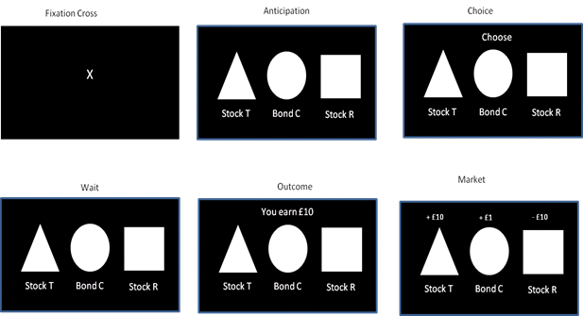
Figure 1. Example of a trial of the Behavioral Investment Allocation Strategy task.

Bayesian certainty calculation
Every time a participant made a choice, it provided them with additional information to assess which stock was the good one in the current block. The Bayesian model is used here as a model of reference, to compare participants’ choices to those of a risk neutral agent. By means of the Bayesian rule, we calculated the level of certainty for each trial. During trial t in each block, a risk neutral agent should pick a stock only if he/she has enough information and so the level of certainty is more than:
(1 – (–300%)) / ((300% – (–300%)) = 66.67% (0.67). Risk-averse participants may not pick a stock even if they have more information that this (i.e. a higher level of certainty). Whereas, risk-seeking participants may select the stock even if the level of certainty does not meet this.

Electrophysiological recordings
During the BIAS task, HR and SCR signals were simultaneously recorded using a data acquisition system (Power Lab model ML-856, ADInstruments, Colorado Springs, USA) and software programme (LabChart 7.0; ADInstruments).

SCR was recorded using two 15 x 20 mm contact area MLT116F GSR finger electrodes attached to the distal phalanges of the index and middle finger on the non-dominant hand. The raw signal was sampled at 1 kHz and digitized with 50 kbits/s precision. The data were selected and filtered on a trial-by-trial basis. SCR refers to the amplitude of the response.

HR was recorded using a 15 mm circular contact area MP100 Pulse transducer attached to the distal phalanges of the ring finger. A raw signal was sampled at 1 kHz and digitized with 24 bit precision. HR variability before and after choices was calculated by identifying R-spikes using automated LabChart 7.0 algorithms.

A resting HR was recorded for all participants over a period of 80s before the BIAS task to establish baseline levels and identify any intrinsic differences (task independent) in arousal between the two groups. HR was monitored 2s before and 2s after each choice. HR responses are typically characterized by an initial cardiac deceleration when the stimuli appear on the screen followed by a consequent acceleration from when the decision is taken to immediately after (Bradley, 2009). Specifically, heart rate typically presents with a deceleration in anticipation of a stimulus followed by an acceleratory recovery to baseline (Jennings & Van Der Molen, 2002). Heart rate changes are a sensitive index of both anticipation and monitoring of the decision taken. In fact, the high temporal resolution of this measure enables the differentiation of these two different cognitive processes (Crone & Van Der Molen, 2007). Based on these previous studies we mainly focused our analysis on the time windows in which the participants see the “anticipation” slide (preparation for action) in which we expect a deceleration and on the “wait” slide in which we expect an acceleration as preparation towards a feedback.

Procedure
Participants were individually invited to take part in a one-hour experiment in a physiological laboratory at the School of Psychology and Language Sciences, University of Reading. All participants read the information sheet and signed the consent form. At the beginning of the session, they performed the BART. The BART task was always conducted first as an assessment of individual differences in their propensity towards ambiguity and uncertainty, and thus only used to establish whether the groups were significantly different from one another in terms of their decision tendencies at baseline. Subsequently, they performed the modified version of the BIAS task (Kuhnen & Knutson, 2005) while skin conductance response and hearth rate were recorded. Participants received instructions of the BIAS task and they were aware of prior probabilities assigned respectively to the good and bad stock.

Data Analysis and Results

Behavioral analysis
BART task
Correlation analysis showed that the number of balloon popping in the BART task strongly correlated with the number of RSM (suboptimal investment) in the BIAS task, r (18) = .48, p = .032. However, no differences were found between groups in the number of balloons popped in the BART task t (18) = .18, p = .858.
BIAS task
A mixed 2 x 2 repeated ANOVA, where uncertainty (level of investment) as calculated by Bayesian rule (low versus high) was the within subject variable and group background (SMB versus SSF) was the between subject variable, was performed on the number of optimal (good stock chosen) and suboptimal choices (RAM, RSM, confusion mistakes) in the two groups.
A significant main effect of uncertainty condition was found in the 2x2 ANOVA (1, 18) = 12.74, p = .002 (Figure 2) ד. The 2x2 ANOVA also showed an interaction between background and uncertainty F (1, 18) = 4.33, p = .05. Bonferroni corrected paired-sample comparisons showed that SSF made a lower number of optimal choices under high than low uncertainty t (9) = 3.96), p = .003, whereas SMB showed no difference in the number of optimal choices under low and high uncertainty, t (9) = 1.06, p = .316 (see Figure2ה).

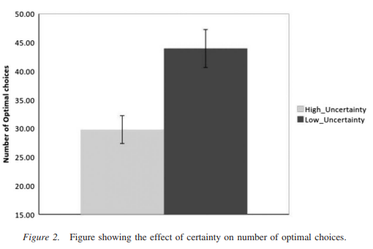

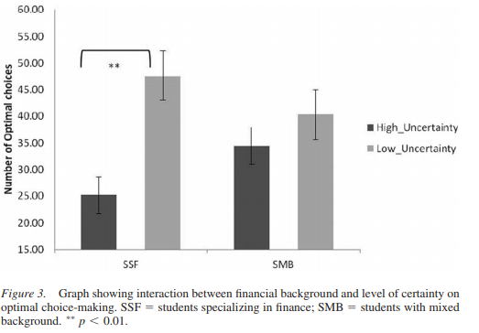

Electrophysiological analysis and results
Heart rate results
Independent sample t-test showed no significant difference in resting HR response (80 seconds prior to start the BIAS task) between the two groups (SSF and SMB).

A 2 x 2 mixed repeated measure ANOVA design was used for the statistical analysis. Uncertainty (low versus high) was the within subject variable, group background (SMB versus SSF) was the between subject variable, and HR response around the choices (2s before and 2s after the choices) as dependent variable.
The analysis revealed a significant interaction between background and uncertainty, F (1, 18) = 6.78, p = .018. Planned paired-sample comparisons indicated that SSF had a significantly higher HR response during choices under high uncertainty, t (9) = 2.24, p = .05. This pattern was not found in the SMB group, who showed no differences in HR between choices under high and low uncertainty t (9) = 1.34, p = .21 Figure 4 ז.

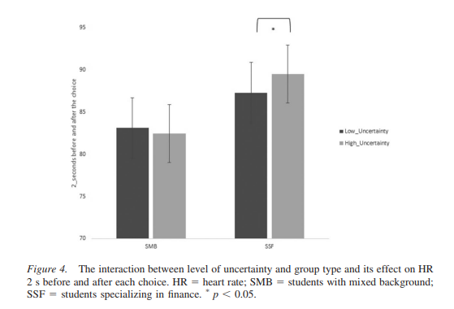

Moreover, given the small sample size used in the study, a non-parametric test was also run on comparison between HR and SCR under high and low uncertainty within the group of SSF.
Wilcoxon signed-ranks test indicates that HR under high uncertainty was significantly higher than HR under low uncertainty in SSF, Z = -1.98, p = 0.047. Furthermore, Wilcoxon signed-ranks test indicates that SCR under high uncertainty was significantly higher than SCR under low uncertainty in SSF, Z = -2.13, p = 0.033.

Skin Conductance Response results
A mixed 2 x 2 mixed repeated measure ANOVA design with uncertainty (low versus high) as within subject variable, group background (SMB versus SSF) as between subject variable, and SCR (4s window prior to choice) during the BIAS task was the dependent variable.
Analysis showed a significant interaction between background and uncertainty, F (1, 18) = 4.52, p = .04. Planned post-hoc paired sample comparisons indicated that SSF had a higher SCR preceding choices under high rather than low uncertainty, t (9) = 2.16, p = .059 (trend of significance) whereas the SMB did not, t (9) = .20, p = .85.
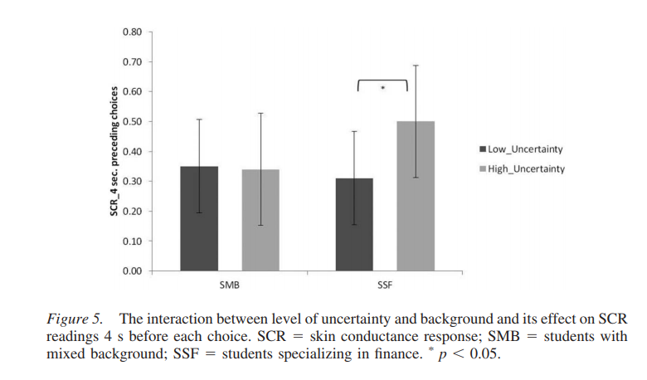

Finally, neither HR nor SCR differed in preceding RSM, RAM, and optimal choices. The only difference found was related to the level of uncertainty reported above.
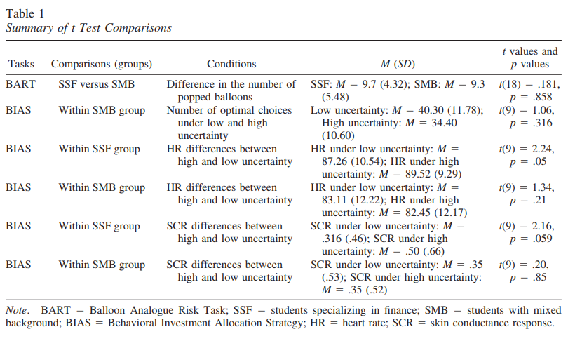

Discussion
The aim of the study was to provide preliminary evidence regarding the application of the SMH in investment choices. Specifically, the study aimed to understand the role of somatic markers elicited by primary inducers (preceding choices in low and high uncertainty) or secondary inducers (emotions elicited by the task per se) in groups of students with different financial knowledge/expertise (SSF versus SMB).
Before describing and interpreting the results, it is worth noting that both groups under investigation – SSF and SMB - did not show any significant behavioral differences in their propensity toward uncertainty and ambiguity measured using the BART task. This suggests that behavioral differences found in the BIAS task between SSF and SMB groups are unlikely to be driven by existing differences in propensity toward ambiguity and uncertainty , nor any arousal responses a product of the BART task but, rather, likely to be induced by somatic markers elicited by financial uncertainty (built in the BIAS). This gives support to the usefulness of the BIAS task within investment scenarios and highlights this as a method of testing for future research. Similarly, in terms of arousal levels, the two groups showed no significant differences in resting heart rate prior to performing the BIAS task, which suggests that arousal differences between SSF and SMB during the BIAS were primarily modulated by the task.
At the behavioral level, the SSF group made a lower number of optimal choices under high than low uncertainty compared to the SMB group; who showed no difference in the number of optimal choices under low and high uncertainty.
Significant differences were found on arousal measures (HR and SCR) between SSF and SMB, depending on the level of uncertainty (low versus high) during investment choice-making.. This suggests that somatic markers and physiological arousal have an impact on decision making, and that somatic markers respond differently in those with and without financial expertise.
Despite their financial knowledge, SSF performed significantly worse than SMB under high financial uncertainty. This result would appear controversial if somatic markers were not recorded, but the difference in physiological activity between SSF and SMB gives an interesting input on data interpretation. Results showed significant interactions between both SCR and HR (under low and high uncertainty) and background (SSF versus SMB) during investment choices. In other words, both groups showed a pattern of behavior strictly related to their own physiological response, and congruent with the level of uncertainty. Specifically, high or low uncertainty functioned as primary inducers that elicited specific somatic markers for each level of uncertainty. According to the SMH, participants’ choices were preceded by unconscious physiological response that facilitated advantageous decision making in conditions of low uncertainty.
However, under high uncertainty SSF did not perform optimally. This finding deserves particular attention. In fact, somatic markers that enabled SSF to distinguish between high and low financial uncertainties worked properly but the expected response was not seen at a behavioral level. One of the plausible reasons why SSF could not decide optimally under high uncertainty could be because of other somatic markers that were elicited by co-occurring secondary inducers (e.g. the demands of the task). It seems that somatic markers elicited by secondary inducers maintained the level of arousal in SSF significantly higher than SMB throughout the whole task. In essence, SSF experienced emotions (probably elicited by the task) that disrupted their ability to maximize their profit.
To expand on this, we speculate that the valence of the emotions experienced was negative (e.g., fear, stress, or anxiety) because of the aversive impact it had. The “dark side” of emotions in investment choices has been found to lead typical individuals to adopt more conservative strategies, and therefore to make decreased number of advantageous decisions (Shiv, Loewenstein, Bechara, Damasio, & Damasio, 2005). Moreover, not all negative emotions exert equal behavioral responses (Raghunathan & Pham, 1999); for example, fear may promote risk aversion (Lerner & Keltner, 2001), as well as anxiety (Maner et al., 2007). On the other hand, acute stress may promote increased risky behavior in the loss-domain and increased conservatism in the gain-domain (Porcelli & Delgado, 2009). In this context, physiological activity suggests that the task per se may have represented a source of arousal (secondary inducer) for SSF and this explains why they made a significantly lower number of optimal choices in conditions of high uncertainty. High levels of stress had disrupted their ability to perform optimal investment choices, even if they could distinguish between high and low uncertainty conditions.
According to Loewenstein and Lerner (2003), emotions that are experienced at the moment of choice activate a number of visceral factors that alter the direction of one’s behavior in a way that is contrary to one’s self-interest. At a sufficient level of intensity, visceral factors cause people to behave against their better judgments (Loewenstein & Lerner, 2003). Classic examples are drug addiction, gambling addiction, or sexual desire in which people are aware of the negative effect of the cravings, but cannot stop their behavior.
An important contribution that this study gives to the SMH is that, during investment choices, somatic markers can be elicited by both primary and secondary inducers. Primary inducers have the adaptive role, and elicit somatic markers that guide individuals’ decisions under different levels of uncertainty. However, the “negative and stressful” thoughts that accompany the task also stimulate the secondary inducers. The present study suggests that secondary inducers may have a stronger impact on decision making (as observed in the SSF psychophysiological measures in comparison to their choice-making).
Whilst the small sample does restrict the strength of these conclusions, like Bechara, Damasio, Tranel, and Damasio (1997), this study can be used as preliminary evidence to support the SMH in investment choices. As a starting point, this study highlights the ways in which future research can investigate the SMH in investment decision making. However, these results must be replicated in larger samples.
To conclude, this research has shown, firstly, that despite the influence of financial knowledge on decision-making, as speculated by Maia and McClelland (2004), the impact of somatic markers is stronger in guiding optimal decisions. Secondly, somatic markers do guide the decision-making process in finance; especially, they enable individuals to understand when the situation implies high or low financial uncertainty. Thirdly, although the effect of somatic markers elicited by primary inducers might be beneficial, their positive impact can be suppressed by secondary inducers.

References
Amiez, C., Procyk, E., Honoré, J., Sequeira, H., & Joseph, J. P. (2003). Reward anticipation, cognition, and electrodermal activity in the conditioned monkey. Experimental Brain Research, 149(3), 267–275. https://doi.org/10.1007/s00221-002-1353-9
Bechara, A., & Damasio, A. R. (2005). The somatic marker hypothesis: A neural theory of economic decision. Games and Economic Behavior, 52(2), 336–372. https://doi.org/10.1016/j.geb.2004.06.010
Bechara, A., Damasio, H., Tranel, D., & Damasio, A. R. (1997). Deciding advantageously before knowing the advantageous strategy. Science (New York, N.Y.), 275(5304), 1293–1295. https://doi.org/10.1126/science.275.5304.1293
Bechara, A., Dolan, S., & Hindes, A. (2002). Decision-making and addiction (part II): myopia for the future or hypersensitivity to reward? Neuropsychologia, 40(10), 1690–1705. https://doi.org/10.1016/S0028-3932(02)00016-7
Bradley, M. M. (2009). Natural selective attention: Orienting and emotion. In Psychophysiology. https://doi.org/10.1111/j.1469-8986.2008.00702.x
Buelow, M. T., & Suhr, J. A. (2009). Construct validity of the Iowa gambling task. Neuropsychology Review, 19(1), 102–114. https://doi.org/10.1007/s11065-009-9083-4
Colombetti, G. (2008). The Somatic Mrker Hypothesis, and what the IOWA gambling task does and does not show. The British Journal for the Philosophy of Science, 59, 51–71.
Crone, E. A., & Van Der Molen, M. W. (2007). Development of decision making in school-aged children and adolescents: Evidence from heart rate and skin conductance analysis. Child Development, 78(4), 1288–1301. https://doi.org/10.1111/j.1467-8624.2007.01066.x
Han, S., Lerner, J., & Keltner, D. (2006). Feelings and consumer decision making: The appraisal-tendency framework. Journal of Consumer Psychology (Vol. 17). https://doi.org/10.1126/science.1125877
Jennings, J. R., & Van Der Molen, M. W. (2002). Cardiac timing and the central regulation of action. Psychological Research, 66(4), 337–349. https://doi.org/10.1007/s00426-002-0106-5
Kuhnen, C. M., & Knutson, B. (2005). The neural basis of financial risk taking. Neuron, 47(5), 763–770. https://doi.org/10.1016/j.neuron.2005.08.008
Larkin, J., McDermott, J., Simon, D. P., & Simon, H. A. (1980). Expert and novice performance in solving physics problems. Science, 208(4450), 1335–1342.
Lejuez, C. W., Read, J. P., Kahler, C. W., Richards, J. B., Ramsey, S. E., Stuart, G. L., … Brown, R. A. (2002). Evaluation of a behavioral measure of risk taking: The Balloon Analogue Risk Task (BART). Journal of Experimental Psychology: Applied, 8(2), 75–84. https://doi.org/10.1037//1076-898x.8.2.75
Lerner, J. S., Gonzalez, R. M., Small, D. a., & Fischhoff, B. (2003). Effects of fear and anger on perceived risks of terrorism: A national field experiment. Psychological Science, 14(2), 144–150. https://doi.org/10.1111/1467-9280.01433
Lerner, J. S., & Kelter, D. (2000). Beyond valence: toward a model of emotion- specific influences on judgement and choice. Cognition and Emotions, 14(4), 473–493.
Lerner, J. S., & Keltner, D. (2001). Fear, anger, and risk. Journal of Personality and Social Psychology, 81(1), 146–159. https://doi.org/10.1037/0022-3514.81.1.146
Loewenstein, G., Hsee, C. K., Weber, E. U., & Welch, N. (2001). Risk as feelings. Psychological Bulletin, 127(2), 267–286.
Loewenstein, G., & Lerner, J. S. (2003). The role of affect in decision making. In R. J. Davidson, K. R. Scherer, & H. H. Goldsmith (Eds.), Handbook of affective science (pp. 619–642). Oxford University Press.
Loomes, G., & Sugden, R. (1982). Regret Theory: An Alternative of Rational Choice Under Uncertainty. The Economic Journal.
Maia, T. V, & McClelland, J. L. (2004). A reexamination of the evidence for the somatic marker hypothesis: what participants really know in the Iowa gambling task. Proceedings of the National Academy of Sciences of the United States of America, 101(45), 16075–16080. https://doi.org/10.1073/pnas.0406666101
Maner, J. K., Richey, J. A., Cromer, K., Mallott, M., Lejuez, C. W., Joiner, T. E., & Schmidt, N. B. (2007). Dispositional anxiety and risk-avoidant decision-making. Personality and Individual Differences, 42(4), 665–675. https://doi.org/10.1016/j.paid.2006.08.016
Perkins, W. S., & Reyna, V. (1990). he effects of expertise on preference and typicality in investment decision making. T ACR North American Advances.
Porcelli, A. J., & Delgado, M. R. (2009). Acute stress modulates risk taking in financial decision making. Psychol Sci, 20(3), 278–283. https://doi.org/10.1111/j.1467-9280.2009.02288.x
Raghunathan, R., & Pham, M. (1999). All Negative Moods Are Not Equal: Motivational Influences of Anxiety and Sadness on Decision Making. Organizational Behavior and Human Decision Processes, 79(1), 56–77. https://doi.org/10.1006/obhd.1999.2838
Shanteau, J. (1988). PSYCHOLOGICAL CHARACTERISTICS AND STRATEGIES OF EXPERT DECISION MAKERS. Acta Psychologica, 68, 203–215.
Shiv, B., Loewenstein, G., Bechara, A., Damasio, H., & Damasio, A. R. (2005). Investment behavior and the negative side of emotion. Psychological Science : A Journal of the American Psychological Society / APS, 16(6), 435–439. https://doi.org/10.1111/j.0956-7976.2005.01553.x
Slovic, P., Finucane, M. L., Peters, E., & MacGregor, D. G. (2007). The affect heuristic. European Journal of Operational Research, 177(3), 1333–1352. https://doi.org/10.1016/j.ejor.2005.04.006
Zink, C. F., Pagnoni, G., Martin-Skurski, M. E., Chappelow, J. C., & Berns, G. S. (2004). Human Striatal Responses to Monetary Reward Depend On Saliency. Neuron, 42(3), 509–517. https://doi.org/10.1016/S0896-6273(04)00183-7

