Monitoring Meaningful Activities using Small Low Cost Devices in a Smart Home

Jordan Tewell1, Dympna O’Sullivan2, Neil Maiden1, James Lockerbie1 and Simone Stumpf1  
1City, University of London, Northampton Square, London EC1V 0HB, UK  
2  Technological University Dublin, City Campus, Kevin Street, Dublin 2, D08 X622, Ireland

Corresponding Author:  
Dympna O’Sullivan  
Email: [dympna.osullivan@dit.ie](mailto:dympna.osullivan@dit.ie)  
Telephone: +447910684153

Acknowledgements:  
We thank the UK Engineering and Physical Sciences Research Council for funding this project.

# 

# Abstract

A challenge associated with an ageing population is increased demand on health and social care, creating a greater need to enable persons to live independently in their own homes. Ambient assistant living technology aims to address this by monitoring occupants’ ‘activities of daily living’ using smart home sensors to alert caregivers to abnormalities in routine tasks and deteriorations in a person’s ability to care for themselves. However, there has been less focus on using sensing technology to monitor a broader scope of so-called ‘meaningful activities’, which promote a person’s emotional, creative, intellectual, and spiritual needs. In this paper, we describe the development of a toolkit comprised of off-the-shelf, affordable sensors to allow persons with dementia and Parkinson’s disease to monitor meaningful activities as well as activities of daily living in order to self-manage their life and wellbeing. We describe two evaluations of the toolkit, firstly a lab-based study to test the installation of the system including the acuity and placement of sensors, and secondly, an in-the-wild study where subjects who were not target users of the toolkit, but who identified as technology enthusiasts evaluated the feasibility of the toolkit to monitor activities in and around real homes. Subjects from the in-the-wild study reported minimal obstructions to installation and were able to carry out and enjoy activities without obstruction from the sensors, revealing that meaningful activities may be monitored remotely using affordable, passive sensors. We propose our toolkit may enhance assistive living systems by monitoring a wider range of activities than activities of daily living.

# Keywords Internet of Things, Smart Homes, Passive Sensors, Passive Health Monitoring, Meaningful Activities

# Introduction

Residential *smart home* is an umbrella term to “refer to any living or working environment that has been carefully constructed to assist people in carrying out required activities” [1]. Most research refers to such activities as *activities of daily living* (ADLs), which are tasks that people undertake routinely in their everyday lives to indicate the status of their health and to measure their independences in everyday living [2]. Previous research, however, has not focused on the monitoring of *meaningful activities*, which are “physical, social, and leisure activities that are tailored to the person's needs and preferences” and can “…provide emotional, creative, intellectual, and spiritual stimulation” [3].

Despite research showing that enabling a sense of purpose through meaningful activities can potentially improve the quality of life of people with a range of conditions [4, 5], meaningful activities are seldom investigated in smart home systems. Rather, the focus to date has been on ADL tasks: basic ADLs such as bathing, dressing, and feeding [2], or instrumental ADLs, such as shopping, using the telephone, preparing a meal, and taking responsibility for one’s own medication [6]. This may be due to the subjective nature of meaningful activities: they are more broadly defined when compared to ADLs in that there are more potential tasks to monitor and no single solution exists which can monitor all possible meaningful activities, of which there are hundreds, compared to the roughly dozen ADLs that are commonly investigated. Thus, a research question remains as to whether such meaningful activities can be monitored using smart home sensors as effectively as ADLs.

To address this we developed a toolkit composed of passive sensors commonly used to monitor ADLs in the home. Our toolkit is further enhanced with beacon sensors that we repurposed specifically to measure meaningful activities. These beacon sensors are small, portable Bluetooth-enabled devices that can measure the context and location of an event, and they can be used to ‘tag’ objects of interest within and around the home so that the objects are identifiable when a user interacts with them. By linking beacon sensors to meaningful activities, along with the passive sensors, we aim to obtain a robust dataset of interactions which can be used to identify a greater range of detailed activities within the home. The development of the sensor toolkit is part of the larger SCAMPI (Self-Care Advice, Monitoring, Planning and Intervention) project whose primary objective is to co-design and develop a new intelligent computer-based toolkit that will help and support people affected by dementia and/or Parkinson’s disease in their daily living. As well as the sensor toolkit, the SCAMPI toolset involves a visual care planning tool that allows people with dementia and/or Parkinson’s and their informal carers to set up and monitor personal plans and goals for ADLs and meaningful activities and to provide advice and recommendations based on the defined plans and tracked data. The sensor toolkit allows users and carers to monitor the achievement of their personal plans via collected data.

This paper will describe the development and architecture of the SCAMPI sensor toolkit including the selection of sensors (Section 3), a lab study (Section 4) to evaluate sensor placements based on rigid test plans, the mapping of meaningful activities to the sensors that forms the basis of an in-the-wild user study (Section 5) with technology enthusiasts which evaluated the viability of the toolkit’s sensors to monitor select meaningful activities in experimental subjects homes. The selected meaningful activities were: *Exercising* (aerobic, strength, and seated exercises, walking, and usage of sports equipment), *Rest/Relaxation* (hobbies, socialising, listening to music, reading, and playing games), *Housework*(making the bed, vacuuming, washing clothes, and laying and clearing the table), and *Gardening* (watering plants, weeding, and mowing). These activities were based on a model of meaningful activities developed within the SCAMPI project inspired by the work of [7, 8]. The results of the study revealed minimal obstructions to installation and subjects were able to carry out their designated activities without any serious obstruction from the sensors, revealing that meaningful activities may be monitored in remote using passive sensor technology.

# Background

The past decade has seen a surge of interest in smart home research, thanks to developments in Internet of Things (IoT) technology, which have drastically increased the viability of retrofitting sensors into existing homes. Significant research in this area has revolved around designing and evaluating smart homes for the elderly with a focus on monitoring ADLs (see [9] for a literature review of these systems). Smart homes also attempt to bridge the gap between monitoring and eHealth, by creating living environments which can monitor and detect behavioural patterns and disease progression of the occupants [1]. The aim of our work in the development of a toolkit comprised of low cost off-the-shelf sensors to allow persons with dementia and Parkinson’s disease to monitor meaningful activities as well as activities of daily living, to self-manage their life and wellbeing. As such we are interested in environments and associated sensing technology that can support monitoring in the home to detect patterns of ADLs and meaningful tasks. Ultimately the analysis of data from these sensors should also give an insight into disease progression as patterns of activities are likely to change with deteriorating health status.

Previous work on monitoring Parkinson’s disease has utilized wearable sensors placed on the wrists, neck, waist, and legs to detect tremors [10], the level of Akinesia [11], gait [12], and sedentary behaviours [13]. Wearable sensors tend to be more expensive, noticeable and invasive but can collect high frequency data that can progressively monitor the disease as the conditions worsen. This also influences battery life, and such sensors need to be charged frequently, an arduous demand especially for patients with cognitive impairments. In addition, the data these sensors collect is often proprietary and difficult to access for monitoring purposes, and depending on the quality of the sensor used, may be unreliable. As such we decided to focus on passive sensors in our toolkit.

Passive sensors, which are not worn and are placed more pervasively within the residents’ home environment, are used to collect information on an occupant’s daily living regimen, such as how often the resident showers, eats, and when they go to bed. Such sensors are widely used to monitor the behaviour and living routines of person with dementia. Algorithms such as Markov Logic Networks [14], Naive Bayes, and Support Vector Machines [15], use the sensor data used to classify ADLs and thus to make inferences on a resident’s ability to care for themselves. Common passive sensors used are:

1. **Passive infrared sensors** to study movements. These are often used to detect activity patterns over time based on where the resident is in the home.
2. **Contact switches** placed on doors to detect when they are opened. They can also be used for other door-like mechanisms such as windows, cabinets, and drawers. These are used to detect activities like opening the wardrobe to indicate dressing.
3. **Pressure sensors** to detect occupancy on beds, chairs, and floors. They are used to detect sitting activities and sleeping.
4. **RFID tags** to detect specific people within the home, like caregivers.
5. **Environmental sensors** to detect temperature, humidity, light pressure, and noise. Temperature and humidity sensors, for example, can be used in bathroom spaces to detect usage of showers.
6. **Multimedia sensors** like cameras and microphones to gather audio-visual information. However, these are not commonly deployed due to surveillance ethical issues.

However, both wearables [10-13] and passive sensing [16-20] as described by the literature do not capture minute details on a resident’s activities. For instance, while most systems can detect the approximate location of an occupant inferred with motion sensors or door sensors [16, 17], these systems cannot pick up more nuanced activities, such as whether the occupant is reading a book, playing a board game, or engaging in social activities outside of their home without the assistance of more intrusive sensing capabilities, such as cameras and microphones [20]. Furthermore, meaningful activities, unlike ADLs, require more pervasive and mobile sensors that can be attached to everyday objects (e.g. a book) to make them identifiable and to capture interactions with these objects. Monitoring these activities may be useful for caregivers to determine not only if the occupant is able to care for themselves, as in the case of monitoring ADLs, but also to know if the occupant is enjoying a decent quality of life. There is therefore, a gap in the literature and an opportunity to study how to monitor these meaningful activities, as well as how to integrate them with traditional, passive sensing technology that is not intrusive, like cameras or wearable devices.

We propose to monitor meaningful activities using beacons – small devices which broadcast packets of data over Bluetooth. Standard beacons broadcast their presence at certain intervals and can be used to track the location and proximity of the object they are attached to, for example, hospital devices [21] and even people [22] within an enclosed space. In addition, commercial ‘sensor beacons’, like estimote [23] and Motion Cookies [24], are outfitted with accelerometers and temperature sensors which capture finer details of how objects are moved within a space. These beacons are designed to be attached to objects and as such are useful for our requirement of measuring fine-grained meaningful activities and can broadcast their information over proprietary protocols.

A study [25] using estimotes demonstrated how accelerometer data captured from these sensors could detect not only the presence of residents interacting with the objects the sensors were attached to, but also the way the objects were moved (e.g. placing a knife on the table vs. using the knife to cut food in its preparation) to provide finer detail about the activities performed. The results showed that simple detection classification on the manipulations of objects was able to provide adequate accuracy (94.5% detection of irrelevant object manipulations and 93% detection of relevant object manipulations, such as drinking from a water bottle or removing pills from their box).

Hossain *et al.* [26] investigated an active learning approach to recognize activities around the home. In addition to PIR and door sensors, the authors also used ‘object sensor tags’, which could be mounted on various objects around the home (e.g. trashcans, brooms, phones, etc.). These sensors consisted of a compass and an accelerometer, which could detect the usage and orientation of the objects when the user resident manipulated them. The authors proposed that such sensors could be of great use in a multi-inhabitant environment as “proper usage data of an object paired with motion sensor and location information can ideally pinpoint the activity” (pg. 319). However, the authors only looked at basic ADLs, such as cooking, cleaning, and eating, and not all activities utilised the object sensors.

Another study by Rafferty *et al* [27] deployed Estimote sensor beacons affixed to objects to detect performance of reaching the goals of making coffee and tea. Beacons were monitored by a smart phone in two real life scenarios: one scenario had the users carry the phone in their pocket, and the other scenario affixed the phone to the users’ forearms to simulate wearing a smart watch. In both cases, an app on the phone measured the users’ proximities to objects along with temperature and acceleration information. Six activities were measured: making black coffee, white coffee, sugary white coffee, green tea, white tea, and sugary white tea. For both scenarios, the accuracy of recognising the goals was measured. The authors found that the smart watch scenario performed the best with 75% - 87.5% accuracies of recognizing the six activities performed.

There are challenges with the use of such small sensors affixed to objects. In addition to the size constraints of the sensors themselves, energy consumption can be a problem, as analysing accelerometer data requires a high transmission rate in order to capture the movements effectively with machine learning techniques. Civitarese *et al*. [25] admitted that the battery life was reduced “to levels not acceptable for a real home deployment” (pg. 781). Furthermore, there are issues with certain home environments: metal objects can cause interference with radio waves, waterproofing is necessary for objects that are dipped in water, and hot temperatures can destroy the sensor’s circuit [25].

Nevertheless the work reported in [25-27] provides an excellent basis for monitoring activities in the home. Accuracy of detection using beacons is high [25, 26] and they are suited to multiple occupancy environments as they can provide specific location accuracy allowing to identify who is interacting with the device [27]. However, given our requirements to monitor fine-grained meaningful activities, other considerations are important. Beacons need to be small enough so they can be affixed to small objects, such as combs and toothbrushes, without getting in the way of the activity. In addition, they should be ‘motion triggered’ – setup to transmit their presence to a system only when the user picks up the beacon. Therefore, beacons should come equipped with accelerometers – but only for transmitting presence information to protect the sensor’s battery life. Lastly, beacons must be easily integrated into existing sensor software solutions, such as openHAB [28] or Home Assistant [29], so that their data could be used in conjunction with other off-the-shelf, passive sensors.

In the next section, we will describe the hardware and software setup of our toolkit according to the criteria described above. We considered how many sensors would be needed to monitor meaningful activities, and the protocols needed to transmit the sensor data to a central hub for storage. Instead of building sensors, which could be cost-prohibitive to manufacture and develop, we selected sensors that could be purchased affordably. In addition, we only looked at open source software, again, to lower the cost of our system, as we were also concerned with maintaining a viable business model.

# Selection and Configuration of Sensors

Typically, in smart homes, sensors are retrofitted within the environment, and then data pertaining to ADLs are transmitted to a hub to be stored [16, 17, 26, 30]. Data is then processed via data mining to identify the inhabitants’ ADLs. By detecting and classifying ADLs, the system can then aid and/or alert the inhabitants or their formal and/or informal caregivers in the event of abnormalities or failures to complete these tasks.

The SCAMPI sensor toolkit was conceived so that it could monitor not only ADLs but also meaningful activities with off-the-shelf, passive sensors, which could be easily procured on the marketplace. While some research has built custom sensors to suit their own needs [16, 30], we alternatively looked at consumer solutions that were already available as they were cheaper (manufacturing would require factory retooling and bulk purchase costs), and already had been built to match rugged standards of use in everyday life. Additionally, this would allow for more flexibility in choosing which sensors the end user would feel comfortable with using, saving further costs in the care sector by reducing redundancy in purchases.

## Sensor Kit Choice

Consumer sensors are usually designed with home automation and security in mind. Many manufacturers not only build standalone sensors (most of which use Wi-Fi or Z-Wave to communicate) but also provide kits which contain a variety of sensors, such as motion and door sensors, and a gateway device, which communicates with the sensors and aggregates the data, usually in a cloud provided by the manufacturer. A supplied app running on a smart phone or tablet can then be used to setup the automation rules for the system, retrieve useful data metrics from the cloud, and monitor the system remotely. Several such kits were considered, such as Samsung’s SmartThings [31], Xiaomi’s Mi Smart Home [32], and Panasonic’s Smart Home [33]. Though these kits do not contain a comprehensive solution for all sensor applications, they do contain the most useful sensors, and could complement a fully featured system which could include more unusual standalone sensors that utilise other wireless protocols.

We decided on the Xiaomi Mi Smart Home [32] as the basis for our system for four reasons. First, the Xiaomi sensors were exceptionally affordable. Second, the Xiaomi kit provided a local area network (LAN) protocol, an API which could be used to query data from the gateway as soon as sensors relay their current statuses to it. Third, the data from the Xiaomi gateway did not need to be passed to a cloud service before being fetched, unlike other kits available on the market. This reduces reliance on the manufacturer to provide the data from their cloud, and it also reduces latency in the system as an Internet connection is not required to fetch the data. Finally, the Xiaomi kit contained a variety of sensors which were useful for the SCAMPI system: motion sensors, door sensors, temperature and humidity sensors, button sensors, and power sensors. These sensors are described in detail in the next subsection.

## Selection of Passive Sensors

Seven sensor types were included in the kit. These sensors, shown in Figure 1 include motion sensors, door sensors, ambient sensors, button sensors, power sensors, pressure sensors, and beacon sensors.

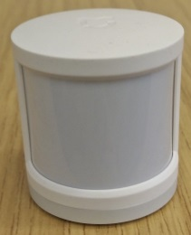 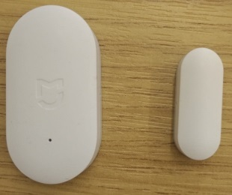 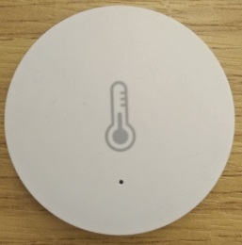 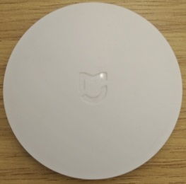

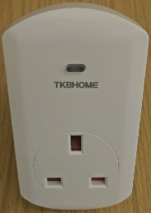 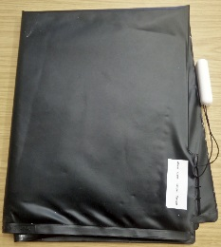 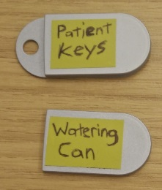

**Fig. 1**: SCAMPI sensors. Top Row (from left to right): motion sensor, door sensor, ambient sensor, button sensor.   
Bottom Row (from left to right): power sensor, pressure sensor, beacon sensors.

**Motion sensors** are used to detect a resident’s presence within a room using with PIR (Passive Infrared) LED light beams which are then triggered when an object moves across the beams. Some motion sensors available on the market are designed to be mounted on ceilings or walls, while others, such as the Xiaomi Mi Smart Home Occupancy Sensor, the motion sensor in our kit [34], are designed to be placed on horizontal surfaces, such as tables and countertops. Motion sensors are classified as binary sensors, in that they can only detect whether (or not) there was movement within the room, but not the specific activity.

**Door sensors** are also binary, in that they can detect whether the door attached to them is either opened or closed. Door sensors are comprised of two pieces that make up a reed switch, which uses a magnetic mechanism to detect when the magnet part of the sensor is moving away (indicating the door is opening) or when it is close to the switch (the door is closed). Door sensors can be appropriated for many kinds of door-like fixtures: cabinets, fridge doors, windows, and drawers, to name a few. As such, these sensors are best at detecting if a person has entered a room with a door and also if they are opening wardrobes, drawers or cabinets containing specific items of interest. Our toolkit uses the Xiaomi Mi Smart Home Door / Window Sensor [35].

An **ambient sensor** is actually comprised of two different sensors: a temperature sensor and a humidity sensor. Both sensors are useful in bathroom and kitchen spaces to detect activities that can change the temperature or humidity of a room: if the oven is on or if the resident is currently in the shower. Our toolkit uses the Xiaomi Mi Smart Home Temperature / Humidity Sensor [36].

**A button sensor** is a large, wireless button that can be placed on any flat surface. It can detect clicks (single press, long press, or double click) and is a more experimental sensor, as not many toolkits in literature use button sensors for activity detection. However, it may be useful for self-reporting, for instance, if the resident wakes up and presses the button to acknowledge that they are ok, or to alert the system of an outsider brought into in the home when they press a button near the front door. Our toolkit uses the Xiaomi Mi Smart Home Wireless Switch [37].

A **power sensor** is a socket that can be plugged into any regular outlet. It is often used in smart home systems to control appliances (turning on and off lamps with an automatized rule, such as when a motion sensor detects the owner has returned home). However, some power sensors also have built-in electrical consumption detectors for home electrical monitoring in mind, which can be appropriated to detect if an appliance like a radio or a PC is in use at a certain time. Our toolkit uses the Z-Wave TKB TZ69E Wall Plug Switch/Meter - GEN5 – UK power sensor [38].

Though standalone wireless **pressure sensors** cannot be easily found on the market, they can be constructed by connecting a pressure mat to a generic binary sensor. In this case, applying pressure to the mat will make the mat act as a normally open switch, completing the circuit which is used to trigger the sensor if the mat is walked or sat on. This allows for an affordable setup to detect pressure applied on floors beside a bed, sofa, or a chair. Our toolkit uses an Arun Electronics Pressure Mat PM3 and Fibaro FGK-10x Door/Window Sensor (with binary/temperature input) [39].

The **beacon sensor** is a unique addition to our toolkit and was selected for its ability to capture fine grained activities and monitor meaningful activities. As was previously discussed, beacons are tiny devices capable of broadcasting small pieces of data using Bluetooth to receiver devices, like smartphones. Beacons can contain sensors that sense environmental conditions, like temperature or movement, and can be placed on an object to detect if the resident picks it up. This can then be used to detect which object the person is currently interacting with in the home, as the accelerometer sensor inside the beacon picks up the movement and triggers the advertisement to the hub. Beacons can also detect vibration, for example, from a washing machine. As such, these sensors are very useful to measure meaningful activities because they can be attached to objects of interest within and around the home. Our toolkit uses the AnkhMaway AKMW-iB001M sensor beacon [40].

## Configuration (HUB)

Figure 2 shows the components of the toolkit. At the centre of the system is a Raspberry Pi 3 Model B. We choose a Raspberry Pi running Raspbian Lite [41] as the central hub due to its affordability and ease of development. The Raspberry Pi connects with the home’s Wi-Fi network via a router (TP-Link TL-WR940N), which communicates with the interface device the resident can use to view the status of the sensors (Lenovo Tab 3 Essential). The Wi-Fi router also connects with the Xiaomi Gateway (Xiaomi Mi Smart Home Gateway 2), which communicates with the Xiaomi sensors via ZigBee. The Raspberry Pi connects directly with the beacons via Bluetooth LE. Finally, the Raspberry Pi interfaces with the two Z-Wave sensors: the power sensor and the pressure mat, via the Z-wave USB dongle (Aeotec Z-Stick Gen5), which is inserted into the Raspberry Pi’s USB port.

On the Raspberry Pi, software programs are used to collect data from the various sensors in the network and store them in a database. We specifically looked at open source software mainly to reduce the cost of the system. Home Assistant [29] was selected as the middleware solution used to interface with the sensors, via the Xiaomi Gateway, the Z-wave stick, and the Raspberry Pi’s internal Bluetooth antenna. Home Assistant was selected over alternatives such as openHAB 2, as it is easy to configure using XAML files and can be extended easily using Python scripts. Home Assistant comes pre-installed with such scripts to interface with many sensors out of the box, including the Xiaomi and Z-Wave sensors. To interface with the beacons, Room Assistant [42] was installed which monitors the status of the beacons and then pushes updates to Home Assistant via MQTT when the beacons are moved. Once received, Home Assistant then stores incoming data into an InfluxDB [43] database instance. InfluxDB was used over other databases, like MySQL, as it is designed for storage of time series data, such as data from IoT sensors.

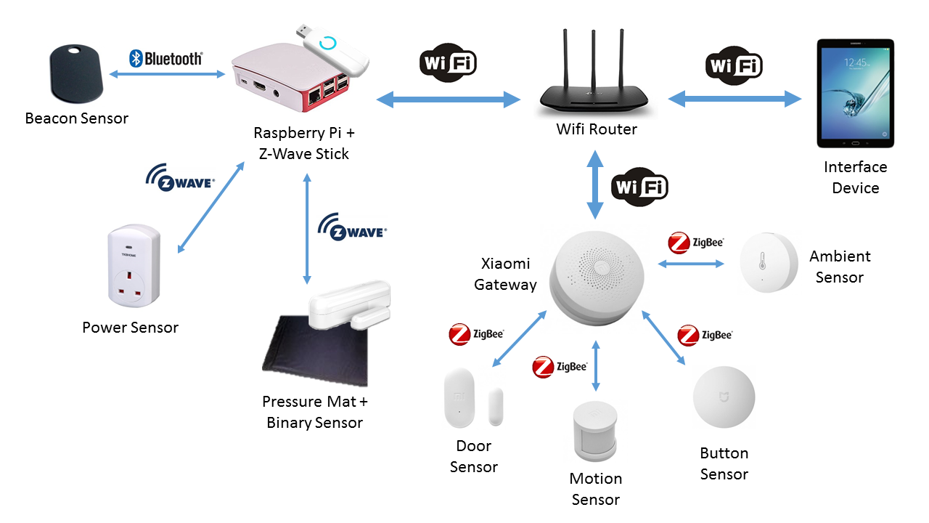

**Fig 2**: SCAMPI toolkit overview.

# Lab-based Study

To assess the installation of the toolkit as well as the acuity and placement of the sensors within an environment, we first performed a lab-based technical evaluation of the sensor toolkit. Through this, we were able to verify correct sensor placements as well as their detectable ranges. This study was carried out by one test user who was also the developer of the system. The toolkit was evaluated in a living lab space at City, University of London, designed to simulate a studio flat (City TECS). The studio space is equipped with a living room area, a kitchen, a bedroom area, and a bathroom, along with appropriate furnishings (sofa, bed, tables, and countertop spaces) and appliances (television, telephone, microwave, toaster, coffee maker, kettle, and oven). Figure 3 shows an overhead diagram of the facility along with arrangements of the furnishings and human markers to show the scale of the space. Figure 4 shows some sample placements of the sensors and devices in the lab.

A total of 12 test cases were created to address the presence of any installation issues, including placements within the environment (such as on the floor or on a specific kind of door), the range of the sensors, and whether they would activate when an activity is performed (such as sitting down or picking up an object). An example of a test case used to assess motion sensor placements within the living lab environment is shown in Figure 5. Each test case had its own set of preconditions, a set of step by step instructions which included the actions the test user would take to install the sensor, the expected system response from the action, a check to indicate whether (or not) the step passed, and a comment section. Each test case finally ended with a post condition.

Test Cases 1 – 5 were used to assess the installation of the hub, sensors, and Android tablet components. Test Case 6 assessed different placements of the motion sensor – on a table, on the floor, and on a high spot near the ceiling. Test Case 7 examined multiple door sensor installations – on the lab’s ‘front door’, on a kitchen cabinet door, the microwave door, the sliding bathroom door, and on the bedroom dresser drawer. Test Case 8 addressed installation of the ambient sensor in the kitchen space. Test Case 9 looked at different placements of the button sensor – horizontally on a flat table’s surface and vertically on a wall. Test Case 10 addressed placements of the pressure sensor in three scenarios – underneath the bed mattress, underneath the sofa mattress, and on top of a chair. Test Case 11 tested the power sensor with different sized appliances in mind – a microwave, a water kettle, a toaster, and a coffee maker. Finally, Test Case 12 examined the acuity and range of the beacon sensors in a variety of placements: on a TV remote, on a phone headset, on both a sink’s tap and on a sink’s downpipe, a tooth brush, a comb, and on a keychain. For all test cases, the user observed the usage of the sensors in a web UI shown on a tablet PC, which displayed whether the sensor activated.

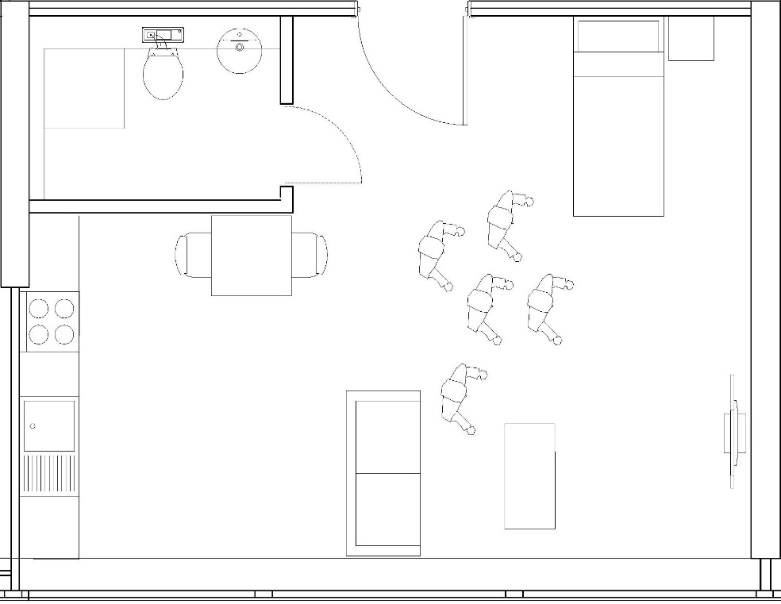

**Fig 3**: City TECS lab diagram, showing the living room area in the bottom right corner, the kitchen in the bottom left corner, the bathroom in the top left corner, and the bedroom area in the top right corner.

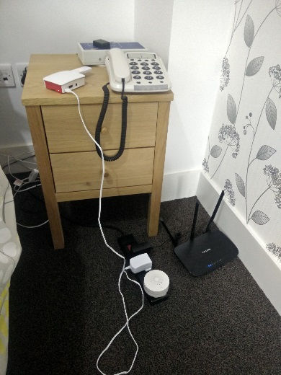 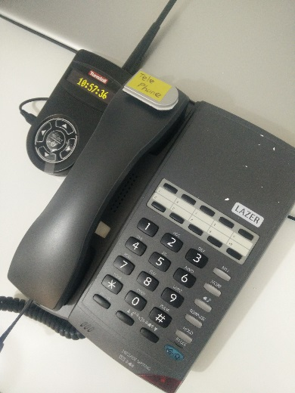 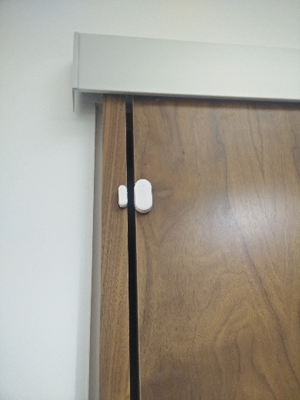

**Fig. 4**: Deployment of some of the SCAMPI devices in the TECS lab.   
Left – Hub devices.   
Middle – Beacon attached to a telephone.   
Right – Door sensor attached to the bathroom door.

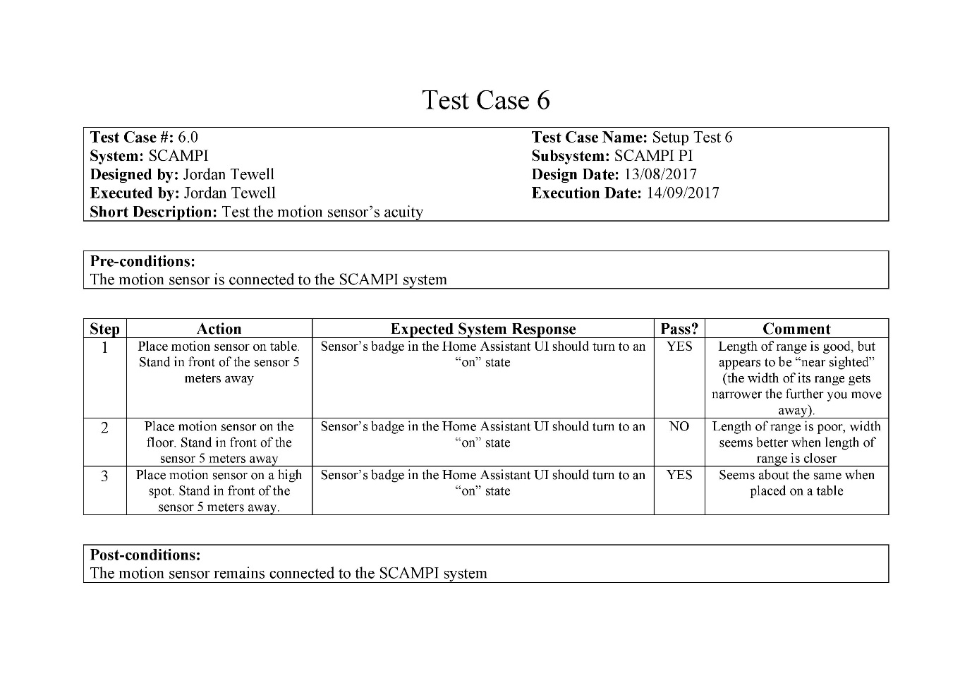

**Fig. 5**: Test case plan for the motion sensor, showing the action steps the test user took when placing the motion sensor in suggested testing locations.

## Lab-based Study Results

Table 1 shows a summary of outcomes for each test case in terms of issues encountered. Apart from Wi-Fi issues, which were resolved by the lab technical staff, no other installation issues were encountered. In addition, the door, button, power, and beacon sensor tests all passed without issues. The door sensor was surprisingly versatile and was able to be mounted upside down and even sideways in some circumstances. Another sensor that was very reliable was the power sensor, which was appropriate for measuring the usage of small to mid-range appliances whenever the power reading exceeded a threshold of zero Watts.

|  |  |  |
| --- | --- | --- |
| **Test Case(s)** | **Description** | **Issues found** |
| 1 – 5 | System installation. | Internet connectivity issues found within the TECS lab space. |
| 6 | Motion sensor tests. | Sensor placement on the floor failed. Width of detectable range decreased the further the user stood away from the sensor. |
| 7 | Door sensor tests. | None. |
| 8 | Ambient sensor tests. | All tests failed. |
| 9 | Button sensor tests. | None. |
| 10 | Pressure sensor tests. | Bed placement failed. Sofa use had some dead zones. |
| 11 | Power sensor tests. | None. |
| 12 | Beacon sensor tests. | None. |

Table 1: Test case descriptions and their outcomes.

Nevertheless, some issues were encountered with the motion, ambient, and pressure sensors. The case where the motion sensor was placed on the floor failed as the length of the presence detection decreased considerably as the user stood further away (for reference, the manufacturer’s instructions states that the maximum detectable range of the motion sensor is about 5 metres). Another observation noted was that the width of the detectable range decreased the further the user stood away from the sensor. This meant that, at the maximum detectable range, the user needed to have stood directly in front of the sensor instead of off to the side. Alternatively, the ambient sensor was surprisingly the least reliable: neither turning the kitchen sink tap to warm or cold water had any effect on the temperature nor humidity reading of the sensor, indicating that the sensor was not sensitive enough to detect sink usage, even when the sensor was installed directly above the sink area. Lastly, the pressure mat could not detect the presence of the user when they were laying down on the bed, as the mattress deformed too much around the sensor and caused their weight to spread out over the mat. The pressure sensor was able to detect sofa usage; however, it was noted that there were some dead zones around the edges of the sofa mattress that could not detect the user when they sat on certain areas.

## Discussion and Lessons Learned from Lab-based Study

Most sensors in the SCAMPI toolkit (barring the ambient sensor) passed most of their cases successfully. In general, the door, button, power, and beacon sensors were most reliable in their detections of the activities the user went through to trigger the sensors, and therefore were more reliable to track meaningful activities in the in-the-wild evaluation (detailed next in Section 5). The motion and pressure sensors required more careful consideration of placement within the environment. Therefore, care was given to instruct users on these sensors in the evaluation. Finally, the ambient sensor was found to be too insensitive of temperature and humidity changes to detect usage of sink activities and would perhaps be more useful in an environment within a tightly enclosed space, like a shower. However, this could not be tested in the TECS lab. As such, this sensor was sparingly considered for usage in the in-the-wild evaluation, only in situations that could not be detected by other sensors.

Specifically, the pressure sensor was found to be inadequate for placement underneath a bed mattress but was able to be used on a chair and under a sofa mattress. However, it may be more advisable to place the pressure mat directly on a hard, flat surface in front of the furnishings instead. A discussion with the manufacturer revealed that without a flat surface, the pressure mat would become damaged over time, especially in a bed where a subject would repeatedly turn over in their sleep. Furthermore, protective covering as per the manufacturer’s recommendations should be used, such as a carpet over the mat, wherever possible. This highlights another issue with bed placement – the subject may accidently wet the bed mattress, causing damage to both the mat and the electric sensor it is attached to, which may additionally pose an electrical hazard. Because of these discussions and findings, floor placement of the pressure mat in front of or beside furniture, such as beds or sofas, was advised in the in-the-wild evaluation. However, chair usage is suitable as long as the seat is hard and flat enough to support both the sensor and the user on top of it, providing that there exists protective covering such as a seat cushion between the two.

The sensor with the most disappointing results was the ambient sensor, barring the limitations of testing in the living lab, as it was not able to detect the fine temperature and moisture differences in the kitchen well enough to measure sink usage. However, the beacon sensor proved reliable enough to detect the slight vibrations of the downpipe when waste water flowed through the pipe, enabling the beacon to be possibly a more suitable means of detecting sink usage, as well as when placed on the tap handle. However, the former method is less invasive and remains out of the user’s way, so it may be a more preferable means of measuring the sink activity. This was evaluated further in the next study.

An interesting result of this study assessed the placements of the motion sensors. Despite being advertised by the manufacture, placing the motion sensors on the floor resulted in the worst detection performances when compared to the table (waist up) and ceiling placements. Its relatively long detection range (5 meters) should be suitable for most interior rooms, though its narrow vision, particularly at longer ranges, should be considered. Thus, it was advised to users in the evaluation to consider installing at least two motion sensors in larger rooms to ensure proper presence detection.

Finally, barring the Internet connectivity issue, installation of the system bore no other issues, and the relative quick time to set up the system (around 5 minutes) may allude to the user friendliness of its installation. This assumes that the user is familiar with the steps and can install the system in the centre of their home with the appropriate outlets and Ethernet connection nearby.

# In-The-Wild Study

To study if meaningful activities could be captured with the sensor toolkit and how users felt about carrying out these activities while being monitored, an in-the-wild evaluation of the toolkit was carried out. Four adult participants, two males and two females aged 30 – 48 (mean = 39.5), who were all technology enthusiasts but not familiar with the smart home technology of the toolkit, nor were target users of the toolkit, were recruited to complete two meaningful activities each by installing the kit into their own homes (Table 2). This study was reviewed by, and received ethics clearance through the Research Ethics Committee, City, University of London.

## Installing the Toolkit

We envision that the final version of the SCAMPI toolkit would be provided as a single, comprehensive kit to customers which would contain all the necessary central hub components (a Raspberry Pi unit and its peripherals), the various outlined sensors (motion, door, temperature, pressure, button, power, and beacon sensors), as well as any tools needed for the sensors’ installation. The kit size would vary depending on the number of ADLs or meaningful activities that needed to be monitored. The basic toolkit would be able to track the most common ADLs and meaningful activities in the user’s bedroom, living room, kitchen, dining room, and bathroom. Larger kits or additional sensor packs would supply more sensors needed to provide coverage of additional rooms/spaces for monitoring, such as patios, basements, and laundry rooms. For the in-the-wild study, users were provided with central hub components and a basic toolkit.

Our expectation is that toolkit should be able to be installed and maintained by either the end user themselves or a friend or close relative. The user would install the kit according to instructions provided by an app they would download from an app store that they could view on their smart phone or tablet as they walked around the home installing the kit. The app would provide useful strategies on attaching the sensors in the environment by recommending where to place the sensor for optimal detection (this is especially true of motion sensors). After the user attaches a sensor in the environment, they would then be instructed by the app invoke the sensor. To aid in this, the instructions would contain a checklist of items that the user would follow to ensure each sensor was connected to the system and was detecting the presence of the user. For instance, “Press and hold the button for a few seconds” or “plug something into the power sensor”. The app would then produce feedback letting the user know that the sensor had been correctly installed. Finally, in the case of some sensors, the range would also be tested to ensure the coverage was ample and that there were no environmental interference issues with the sensor’s wireless signal. Additionally, this app would be also used to monitor the system remotely as well as alert the user in the case a sensor had malfunctioned (for example, if the sensor’s battery needs to be replaced).

The purpose of the in-the-wild study was to capture if sensors could be used to monitor meaningful activities and how users felt about those sensors and so the focus of the study was on users carrying out the activities rather than interacting with an app as described above. For the study we developed a simple app that allowed users to check the statuses of the sensors, e.g. were the in the ‘on’ state after installation and during activities being monitored. Instructions on installing the toolkit including the RaspberryPi, Wifi Router, Xiaomi Gateway and sensors as well as checking that sensors were connected were given on paper to the participants in our study. For example, Figure 6 gives an example of the paper checklist they were given for testing the button, pressure and power sensors. The intention is that these checklists would be digitized in the final app as described above.



**Fig. 6**: Example of a checklist for testing the button, pressure and power sensors.

Several steps on our part would be taken to lessen the burden of installing the system for non-technical users. First each sensor would be pre-paired with the hub before the customer would receive the kit, as our sensors rely on Z-wave, Zigbee, and Bluetooth for connection. Additionally, each sensor would be physically labelled by type and its use (i.e. “Bedroom Motion Sensor 1”), which would also correspond with its label in the app. Furthermore, the toolkit would be designed to integrate with existing home infrastructure, such as the user’s home Wi-Fi network, Ethernet connection, and their regional power sockets. Through the final app, the user could enter their home Wi-Fi credentials to connect the system, which is necessary as many of the sensors (motion, door, ambient, and button) also rely on a Wi-Fi connection. Additionally, Ethernet or Wi-Fi connection with the hub is important as it would allow remote monitoring of the system by a caregiver.

## Using Sensors to Monitor Meaningful Activities

We examined four meaningful activities (gardening, exercise, rest/relaxation, and housework) and which sensors would be appropriate for detecting completion of each task. The following examples describe how we posited meaningful tasks may be measured using sensors; in another deployment, the choice of which sensors to use and their placements will depend heavily on the context of the specific meaningful task as well as the layout of the user’s home.

### Gardening

To go out gardening, a resident would first start by using an external house door (door sensor). Then, if they have a shed, opening the shed door (door sensor) may further indicate gardening is about to happen. (If the user does not have a shed but stores garden equipment elsewhere the use case would need to be modified). As entering the shed is still ambiguous, further sensors are needed to know if the resident had picked up a significant gardening item. Thus, accessing particular items related to gardening activity could be detected via attached beacons. For instance, detecting watering cans, trowels, spades, fork, secateurs, gardening gloves or a lawnmower by attaching beacon sensors. Mowing the lawn could alternatively be sensed via a power sensor the lawn mower is plugged into while charging.

### Relaxation

An assumption with most rest and relaxation activities is that they would take place either in the resident’s bedroom or living room, where their presence would be detectable using either motion and/or door sensors in/to these spaces. Another likely assumption is that the resident would rest or relax on furniture, such as chairs, sofas, and bed mattresses. The most straightforward manner of detecting resting activities on these furnishings would be usage of pressure sensors either underneath or in front of them for resting feet. Additionally, it may also be possible to slip button sensors underneath the arm chair to detect resting posture.

While sitting, a resident may engage in further relaxation activities, such as reading, music listening, watching television or playing games. Picking up a book could be detected with a beacon placed on a bookmark or, if they read on a Kindle, the device itself. If they use a reading light at their preferred sitting spot, the light could be detected with a power sensor. For music listening or television watching, radios, CD players and television use could be measured with power sensors. Furthermore, for television watching a beacon could be attached to the remote control. The resident may also engage in playing puzzle or board games, which could be measured with a beacon placed inside a game box to detect when they are removed from storage.

### Exercise

According to the NHS [44], older adults aged 65 or older, who are generally fit and have no health conditions which limit their mobility, should perform strength exercises on two or more days a week as well as one of the following:

1. Moderate aerobic activity (e.g. cycling or walking) for 150 minutes of the week.
2. 75 minutes of vigorous aerobic activity (e.g. running or singles tennis) every week.
3. Both moderate and vigorous aerobic activity every week.

Strength exercises may be performed in the home using equipment such as yoga mats, dumbbells, and weights. Usage of these could be detected by attaching beacons to the equipment. Moderate aerobic activities such as walking throughout the home could be detected using motion sensors in each room. It is possible that residents could perform vigorous exercise using treadmills or exercise bikes in their home, usage of which could be detected with beacons to detect movements or vibrations. It is also possible to detect exercise outside the home, such as tennis or golf by attaching beacons to racket or golf club bags and detecting when the equipment is brought outside using a front or back door sensor.

### Housework

Housework encompasses a variety of tasks spread across the entire household and could be classified by either a routine or according to personal habits. A daily routine may be laying and clearing away the table before and after eating. The resident would be first expected to collect specific crockery, cutlery, and food items from cupboards (door sensors), place the items on the table, which may be sensed with a pressure sensor underneath the table cloth, and then finally, after eating, the resident would remove the items from the table. A follow up routine activity might then be washing up. The resident could first be detected that they are standing in front of the sink (motion sensor), and then they would proceed to fill the sink with water which could be sensed with beacons on the taps. After washing, the sink would be emptied, and the resident would place the objects back in their cupboards and drawers (door sensors).

Other activities may be completed according to an individual’s habits. An example is vacuuming, which could be done irregularly. The resident would first collect their vacuum from a cupboard or closet space (door sensor), use the vacuum cleaner (beacon), and move about the home (motion sensors). Washing clothes would be expected to happen once or twice a week and would involve collecting clothes, which could be sensed via a beacon sensor on the laundry basket, use of the washing machine (power sensor), drying the clothes either using a tumble dryer (power sensor) or washing line (beacon), and then finally putting clean clothes away, which could be sensed with door sensors placed on cupboards, drawers, and wardrobes.

## Installing the Toolkit

Subjects were given the kit and instructions on setting up the kit as well as an explanation of how each sensor behaved as they interacted with it and instructions on testing the range of each sensor type in their home. They were presented with a questionnaire at the end of the installation section which asked them to rate their experiences on 5-point scales from ‘Strongly Agree’ to ‘Strongly Disagree’:

1. The toolkit was easy to install.
2. The hub was installed at the centre of the home.
3. I did not encounter any range issues.
4. The instructions were easy to understand.
5. I understood the behaviour of the sensors and what each is used for

## Setting up the Sensors to Monitor Activities

Each subject in the in-the-wild study was assigned two of the activity categories as shown in Table 2. The assignment was based on their home environment, for example, if they did not have a garden, they were not assigned this activity.

|  |  |  |
| --- | --- | --- |
| **Participant** | **Meaningful Activity #1** | **Meaningful Activity #2** |
| Participant #1 | Exercise | Housework |
| Participant #2 | Housework | Gardening |
| Participant #3 | Relaxation | Exercise |
| Participant #4 | Gardening | Relaxation |

Table 2: The meaningful activities assigned to each participant.

Each of the four meaningful activity categories (gardening, relaxation, exercise, and housework) described above were broken down into specific individual activities which could be tested. For instance, the ‘housework activity’ category was broken into five distinct, meaningful activities: ‘vacuuming’, making the bed’ ‘washing clothes’, ‘laying and clearing away the table’ and ‘washing up’. Each activity was subsequently broken down into a set of tasks which would need to be completed in a certain order to fulfil successful completion of the meaningful activity. For example, vacuuming consists of doing the following tasks in the order of:

1. Collecting the vacuum cleaner from the closet space (or cupboard).
2. Turning on the vacuum and moving around from room to room.
3. Moving furnishings around to clean underneath them.
4. Turning off the vacuum and putting it back in its original location.

For each activity, subjects were first instructed which sensors they would need to use and setup to monitor the tasks (see an example for vacuuming in Figure 7). For instance, Step 1 from the vacuuming activity “Collecting the vacuum from the closet space” recommended to attach a door sensor to the closet or cupboard space containing the vacuum cleaner so that its opening could be detected. After setting up the sensors and completing the activity they were asked to complete a questionnaire which asked five questions shown in Figure 7.



**Fig. 7**: The questionnaire that followed all activities.

Finally, the subjects were asked 6 questions about which sensors they liked/disliked the most, to assign a grade rating to the kit, to give an overall impression of the system, to discuss a feature or significant change they would have made to the system, and to comment on any other questions or concerns they may have had.

The questions chosen to ask the participants about their experiences with installing the toolkit, using sensors to monitor activities and the final questions about their impressions of the toolkit were inspired by a number of standard instruments as no one existing standard questionnaire covered all these aspects. The questions concerning installation and using the sensors were inspired by the Technology Assessment Model (TAM) [45], with a particular focus on the perceived ease of use, perceived usefulness, perceived enjoyment and self-efficacy constructs. These were measured using a 5 point Likert scale. The questions addressing their impression of the system were inspired by the W3C Usability Testing Questions post-test interview questions [46] and users either selected from provided options or gave unstructured answers.

## In-The-Wild Study Results

### Installing the Toolkit

Table 3 shows the results for installing the toolkit. Only Subject #4 disagreed that they were able to install the hub in the centre of their homes: they commented that figuring out where to put the hub was tricky and that they finally settled at a place near the front of their home where a phone socket was located. Subject #4 also was undecided when asked if they encountered range issues when testing the different sensors, and they reported that beacon #4 was triggering but not when in use. When asked what issues they encountered when setting up the system, Subject #2 reported having an IP address issue with the router. However, once this was fixed (via remote changing of the code), the system was operational in their home. Subject #3 also reported having Wi-Fi issues with the Internet and reported that the motion sensors did not activate when they moved in front of them and presumed this was due to a flat battery. Subject #4 also reported Internet connectivity problems with the Wi-Fi network, which were resolved using a new cable. To summarise, Wi-Fi connectivity was to be the biggest issue subjects had when installing the kit.

|  |  |  |  |  |  |
| --- | --- | --- | --- | --- | --- |
| **Subject** | **Easy to Install?** | **Installed in Home Centre?** | **No Range Issues?** | **Easy to Follow Instructions?** | **Understood Sensors?** |
| 1 | Strongly Agree | Agree | Strongly Agree | Strongly Agree | Strongly Agree |
| 2 | Agree | Agree | Agree | Agree | Agree |
| 3 | Agree | Strongly Agree | Strongly Agree | Strongly Agree | Strongly Agree |
| 4 | Strongly Agree | Disagree | Undecided | Agree | Agree |

Table 3: Toolkit installation questionnaire results.

### Using Sensors to Monitor Meaningful Activities

#### Gardening

The gardening activities involved attaching door sensors to their back door and garden shed door and beacon sensors to gardening equipment including gardening gloves, trowels, watering can and lawnmower. Subjects reported no issues attaching sensors to the doors but Subject #4 found it difficult to install the beacon on smaller items such as gardening gloves. Next, subjects were asked to water their gardens and to perform tasks such as weeding, digging, mowing, and pruning. Beacon sensors attached to gloves and small tools and the broom appeared to be distracting given the relative size of the sensors to the tools. This had a knock on effect on the enjoyment and impairment of activities as they felt that they many damage the beacons when using the tools. In terms of whether the sensors were appropriate, the beacon failed to detect water usage when attached to an outdoor pipe. Both participants understood the use of the sensors for measuring the tasks. Table 6.2 summarises the issues subjects encountered for gardening activities.

|  |  |  |
| --- | --- | --- |
| **Questions** | **Subject #2 Issues** | **Subject #4 Issues** |
| Easy to Install? | Easy for the shed door and gloves. | Not easy to install sensors on the gloves. |
| Distracting? | Undecided for weeding and pruning due to beacon’s size relative to the trowel/secateurs and risk of damage. | Beacon was distracting when attached to the gloves and the broom. |
| Impair Enjoyment? | Undecided as they were aware of the beacon while pruning and were concerned of knocking it off. | Undecided for gloves. Felt beacon was distracting when attached to the broom. |
| Sensors Appropriate? | Beacon did not detect the tap pipe (unless it was close to the tap). | Undecided for gloves. |
| Understood Sensors? | No issues. | No issues. |

Table 4: Issues encountered with the gardening activities.

#### Relaxation

Subjects #3 and #4 were asked to do relaxation activities. They were asked to place various sensors in and around the sofa in their living room, such as a pressure mat sensor in front of the sofa, motion sensors around the area facing them, and button and beacon sensors in or on the sofa to detect finer sitting activities. Afterward, they were left to do activities of their own discretion: Subject #3 completed a reading activity (monitored via a beacon on a book), a musical activity with their CD player (monitored via a power sensor), and a family activity with their child (by placing a beacon inside a game box). Subject #4 decided to relax by drinking herbal tea (monitored via a beacon on cup), watched TV (power sensor on TV set), and then walked their dog (beacon on dog lead). Table 5 shows their responses after performing these activities. In summary, the sensors were quite easy to install and the beacon and power sensors were heavily liked for performing the tasks, however consideration must be made around small children with beacons. In general, the sensors did not impair the activities, however, while the pressure mat worked, but there were some complaints about how it felt while sitting. Additionally, users felt the button sensor was not appropriate to detect arm resting, they felt that its use for that activity was contrived.

|  |  |  |
| --- | --- | --- |
| **Questions** | **Subject #3 Issues** | **Subject #4 Issues** |
| Easy to Install? | No issues. | Not sure if motion sensors worked. |
| Distracting? | Child thought beacon was part of the game. | Pressure mat was slippery and crinkly. |
| Impair Enjoyment? | No issues. | Pressure mat was slippery and crinkly. |
| Sensors Appropriate? | Button sensor was “somewhat contrived” when placed under the armrest. Beacon could be hazardous around young children. | No issues. |
| Understood Sensors? | No issues. | No issues. |

Table 5: Issues encountered with the relaxation activities.

#### Exercise

Subjects #1 and #3 were asked to perform exercise activities. Their first task was to perform an aerobic fitness exercise by attaching a beacon to any of the following items: a bicycle, an exercise bike, treadmill, or boxing gloves and then perform the activity. Then subjects were then asked to perform strengthening activities by installing beacons on small weights and on a yoga mat. Subject #1 performed an additional exercise which involved placing a power sensor next to a CD device and a motion sensor in a room for dancing. Table 6 shows their responses while performing these activities. Few issues were encountered, sensors were not distracting, did not impact on enjoyment of the activity no impair it and the subjects all understood the behaviour of the sensors to monitor the activities. Subject #3 remarked it was difficult to know the optimal place to install beacons on gym equipment considering there are many types of machines including exercise bike, treadmills and rowing machines. They also felt that a beacon sensor would be more appropriate to measure yoga with than the suggested pressure mat.

|  |  |  |
| --- | --- | --- |
| **Questions** | **Subject #1 Issues** | **Subject #3 Issues** |
| Easy to Install? | No issues. | Difficult to use beacon in a gym. Hard to know where to place the beacon on the equipment. |
| Distracting? | No issues. | No issues. |
| Impair Enjoyment? | No issues. | No issues. |
| Sensors Appropriate? | No issues. | Difficult to use beacon in a gym. Hard to know where to place the beacon on the equipment. Beacons, not pressure mat, felt more appropriate to measure yoga. |
| Understood Sensors? | No issues. | No issues. |

Table 6: Issues encountered with the exercise activities.

#### Housework

Subjects #1 and #2 were tasked with completing housework activities. For vacuuming, subjects were recommended to place a sensor on the door to the storage space containing the vacuum cleaner, a beacon on the vacuum itself, beacons on various furnishings which would be moved around while vacuuming, and motion sensors in the rooms that they vacuumed. Next, subjects were instructed to wash clothes by placing a sensor (preferably the power sensor) on the washing machine, a beacon on the clothes basket, another beacon on either their tumbler dryer or washing line, and finally a door sensor on the drawer or wardrobe the clothes would be put in afterwards. Next, subjects were instructed on laying and clearing away the table, and the instructions recommended installing the door sensor on the cupboard space for food items and placing the pressure mat sensor on the table underneath the table cloth. Lastly, subjects were instructed on how to set the sensors up for cleaning after meals. This could involve placing a motion sensor near the sink facing it towards the resident, beacons on the sinks’ up pipe and down pipe, a pressure mat next to the sink, a beacon inside the towel rack, and a door sensor on the storage cupboard. Table 7 show issues subjects encountered as they performed these tasks. While Subject #1 reported minimal obstructions when performing their tasks, Subject #2 reported that drying clothes outside would be problematic with the sensors given, they were concerned about false positive results from the beacon sensor moving in the wind and they also felt that beacon was quite noticeable and thus distracting on the washing line. As also reported for relaxation activities by a different subject, they did not like the pressure mat for housework activities, it was uneven and noticeable and thus distracting as well as not being sensitive to small amounts of pressure. The pressure mat is the largest of the devices in the toolkit and a lesson learned is that it is too noticeable for most users and is best used when it is hidden from view, for example under a mattress or sofa cushions. In such scenarios it will also be subject to larger amounts of pressure such as a person lying or sitting down and thus more sensitive to the pressure exerted. These issues are discussed further in Section 5.4.2.3 below. Subject #2 also reported problems with the sensitivity of beacons in detecting drying dishes activity (under sensitive) and in water pipe activity (over sensitive). Given no such issues were encountered by Subject #1 it would seem that outcomes for housework are not generalizable, dependant on the individual home environment and may require individual configuration to find the right combination of devices and placements to successful monitor activities.

|  |  |  |
| --- | --- | --- |
| **Questions** | **Subject #1 Issues** | **Subject #2 Issues** |
| Easy to Install? | Preferred beacon on the washing machine instead of using power sensor. | Concern of false positive from wind if beacon is placed on washing line. |
| Distracting? | No issues. | Beacon on washing line was too noticeable. Pressure mat was uneven and noticeable – they had to be careful when placing their coffee on certain points that were unstable. |
| Impair Enjoyment? | No issues. | Pressure sensor was not able to detect the items when placed on the table. |
| Sensors Appropriate? | No issues. | Pressure sensor under drying rack could only detect dishes once a lot of were added. Beacons on pipes kept setting off at intermittent intervals. Waste water set off the hot water beacon more than the beacon on the down pipe. Beacon on towel rack did nothing. |
| Understood Sensors? | No issues. | No issues. |

Table 7: Issues encountered with the housework activities.

### General Impressions and Discussion

Table 8 summarises the participants’ overall attitudes to the toolkit. Subject #3 and Subject #4 reported that the power and beacon sensors were liked the most as they were (mostly) easy to install and “didn’t get in the way of the activities” (Subject #4), while Subject #3 argued that the beacon sensors were very versatile and sensitive enough to open many possibilities. Subject #3 also felt that the power sensor was versatile and did not obstruct the activities. Subject #1 also agreed to liking the beacon sensor the most along with the pressure sensor as “they were sensing better the different signals”. Subject #2 also liked the beacon sensor and the door sensor, as the latter was “very effective for detecting important door use e.g. going in/out [of the] home and for cupboards.” They liked the beacon sensor as it “is extremely versatile for detecting important items moving”. Overall it appeared that subjects enjoyed using the beacon, power, door, and pressure sensor the most, and this appears correlated with their ease of installation and sensitivity.

On the other hand, some sensors were disliked. Subject #3 disliked the motion sensor and button sensor, as they felt that the motion sensor didn’t work, and because they did not get to explore using the button sensor much. Subject #4 disliked the motion and pressure sensors the most. They were not sure the motion sensors were put in the right places and that the pressure sensor was too slippery. Subject #2 liked the button sensor and pressure sensor the least, as they were not sure what the button sensor was supposed to be used for, and that the pressure sensor required too much pressure to activate. Subject #1 reported liking the ambient sensor and button sensors the least, though this was because they didn’t use them all at and thus felt they were not very useful. In summary, subject’s assigned lower grades to sensors they did not find much use for, were tricky to install, or were not sensitive enough: button, ambient, motion, and pressure sensors. It is interesting to note that the pressure sensor was liked the most by Subject #1 but disliked the most by Subject #2 even though both subjects performed the housework activities- individual preferences may also play a role in subject’s ratings of the usefulness of the sensor types, especially sensitivity.

|  |  |  |  |  |  |
| --- | --- | --- | --- | --- | --- |
| **Participant** | **Favourite Sensors** | | **Disliked Sensors** | | **System Grade** |
| Participant #1 | Pressure | Beacon | Ambient | Button | C |
| Participant #2 | Door | Beacon | Button | Pressure | B |
| Participant #3 | Power | Beacon | Motion | Button | B |
| Participant #4 | Power | Beacon | Motion | Pressure | C |

Table 8: Participant summary of their two favourite and two disliked sensors as well as their overall grade of the system (between F and A).

Lastly, subjects assigned a letter grade to the system, remarks regarding what they liked and what improvements could be made, and left final commentary. Subject #1 gave the system a C rating, feeling that the system overall was OK, but that they needed to check the range of the sensors over large distances. When asked which significant change they would have made to the system, they remarked that it would be to improve the signal and maybe to improve the appearance of the beacons.

Subject #2 gave the system a B rating. Their overall impressions of the system were that the system gave insight into what is possible. “The potential for these sensors and others is huge. It’s important to think how the data would be used and by whom”. They felt that the toolkit was low cost with potential for more as “it could easily be tailored for an individual’s needs”. When asked about a change to the system, they argued for a more sensitive pressure mat. They left with some final comments: “I was impressed with the range of the signal. It worked at the bottom of the garden and through the three levels of the house”.

Subject #3 gave the system a B rating. They felt that the system was well designed to facilitate a wide range of activities and did not feel intrusive once it was setup. They felt that there was “a certain comfort in having a log of your daily activities in this quantitative fashion”. The reason they did not give the system a perfect score was because of network and motion sensor issues but stated that they really enjoyed using it. When asked what significant change they would have made, they requested if the Ethernet connection was necessary as it interfered with their pre-existing Wi-Fi home network. Lastly they gave some final commentary: “I was surprised how intuitive it felt to have sensors in my house. I forgot about them being there very quickly. I feel they would facilitate very well continuous monitoring without the need for checking in on routine activity and so have most benefits in creating alerts for [alert systems]”.

Subject #4 had some positive impressions of the system but gave it a C grade, as they said that the system needed more explanations on how to set it up (like how to attach the beacon to the gloves). They were also not sure about how well the system worked or what kind of data was recorded. Subject #4 remarked that more thought should be given about which sensors are to work with which activities.

To summarise the results of the evaluation:

* Installation, barring the Wi-Fi connectivity issues which were resolved, was able to be completed with the subjects, implying that our system may be able to be installed by end users or their caregivers without need of technical assistance.
* Beacons were highly valuable and desirable to use to monitor meaningful activities, however, for activities where the beacon remains fixed to small objects, they can be distracting. They were also not appropriate for detecting vibrations well, such as those given from pipes or washing lines. Care should also be given to them around small children, as they can mistake them as part of the activity, such as game pieces.
* In addition to the beacons, few complaints were made regarding the door and power sensor, as they were liked by the subjects for their pervasiveness.
* The ambient and button sensors were hardly used and heavily disliked by subjects.
* There were concerns regarding the motion and pressure sensors- subjects stated they did not work (motion sensor) or were too noticeable and not sensitive enough (pressure sensor).
* In general, there appears to be a relationship between a sensor’s likeability and its sensitivity as well as its ease of installation to monitor a meaningful activity.

# Conclusions

Advancements in IoT technology enable possibilities for the elderly or persons with impairments to live independently at home without constant and intrusive monitoring by formal and informal caregivers. Most research has addressed the need for monitoring resident’s ADLs, however less work has focused on supporting the monitoring of meaningful activities, which promote emotional, creative, intellectual, and spiritual needs of such residents inside and outside of their home using a passive sensor toolkit.

We described the development of a sensor toolkit which supports monitoring meaningful activities and is part of the larger SCAMPI project and is comprised of off-the-shelf and affordable sensors: motion, door, ambient (temperature and humidity), button, pressure, power, and most importantly, beacon sensors, which are not commonly used in previous work to promote monitoring of user activities in and around the home. Our system operates with a variety of different protocols (Wi-Fi, Bluetooth, Zigbee, and Z-wave) using a Raspberry Pi 3 as a cost-effective hub running open source sensor monitoring software (Home Assistant).

We then developed a working model of meaningful activities and used to it to conceptualise several scenarios that persons might perform in and around their home: gardening, rest and relaxation, exercise, and housework. For all activities, several tasks were created which were mapped to these sensors. A lab study was used to whether the sensors could be installed to monitor these tasks. An in-the-wild study was then conducted to monitor tasks associated with four meaningful activities performed in and around real homes with four healthy subjects (not target users of SCAMPI). Our subjects reported minimal obstructions to installation (barring Wi-Fi problems which were resolved), and were able to carry out their designated activities without any serious obstruction from the sensors, revealing that meaningful activities may be monitored in remote using passive sensor technology, especially when using the beacon sensors.

Our findings are in line with results reported by [16-20] who found passive appropriate for capturing ADLs in the home and with [25-27] who successfully used smaller beacon sensors for capturing more fine-grained activities. Nevertheless, we note that some improvements can be made to our toolkit. First, beacons were noted to be appropriate when the objects they were affixed to were large enough – smaller items like secateurs caused the resident user to be distracted. Other objects like gloves were not appropriate, as residents did not want to damage them or the beacon while using them. Measuring water usage with the beacons also proved cumbersome as the beacons were either not sensitive enough or too sensitive to vibrations. More experimentation with placement of the beacons, especially on larger appliances like exercise bikes, needs to be conducted. In addition, there were some safety concerns about beacons around small children. There were also concerns with the other passive sensors. The pressure sensor was considered inappropriate except for situations where the resident sat directly on it – it was considered too slippery, insensitive, and even dangerous in circumstances where it was placed on tables. There were concerns with whether the motion sensors worked, and residents found the ambient and button sensors of little use. As such, we will revaluate these sensors to remedy their future use in our toolkit.

There are several lines of research arising from the studies presented in this paper which we will address in future work. Firstly, we want to scale the toolkit to include dozens of sensors. Secondly we intend to investigate the multiple occupancy issue in the smart home whereby it is often difficult to distinguish which user is performing what activity. This issue is often resolved using cameras however in keeping with our unobtrusive approach we rather want to investigate using beacon receivers and gateways. Beacon receivers may be placed in each room of interest while users could wear individual beacons. The receiver closest to the user would receive their beacon's broadcast when they move about which can then transmit their location and movements to the hub system. Knowing where a specific user is in their home allows to exclude other ongoing activities in other rooms caused by other users. For such a system we will also consider an appropriate design for the beacon worn by the user, one idea is to design the beacon as a piece of jewellery such as a brooch. Thirdly we are using data captured from the in-the-wild study to develop data models that intelligently monitor user behaviour from captured sensor data. We are employing a Bayesian Network approach that makes inferences about what ADLs and meaningful activities have been achieved based on the activation of sensors linked to tasks we defined for completing activities in Section 5.2. The tasks are composed of expected sequences of events and timeframes for these events (for example breakfast is usually eaten in the morning). The Bayesian Network computes a confidence that an activity has been completed or not based on what sensors are activated, in what order and in a particular timeframe. The models can be used to feedback information to residents and/or caregivers about achievement and/or failure of goals as well as information about unexpected events (for example, a resident getting up at night or leaving the house at an unexpected time). Finally, we will evaluate the larger SCAMPI system including the sensor toolkit and data models with persons with dementia and Parkinson’s disease and their caregivers as part of a user trial.

# References

1. Chan M, Estève D, Escriba C, Campo E (2008) A review of smart homes—Present state and future challenges. Comput Methods Programs Biomed 91:55-81
2. Wallace M, Shelkey, M. (2007) Katz index of independence in activities of daily living Urol Nurs:93-94
3. National Institute for Health and Care Excellence (2013) Mental wellbeing of older people in care homes. Quality standard [QS50], p. 17. Available from: <https://www.nice.org.uk/guidance/qs50>. Accessed 12 Jan 2018
4. Roach P, Drummond N (2014) ‘It's nice to have something to do’: early‐onset dementia and maintaining purposeful activity. J. Psychiatr Ment Health Nurs 21:889-895
5. Palacios-Ceña D, Gómez-Calero C, Cachón-Pérez JM, Velarde-García JF, Martínez-Piedrola R, Pérez-De-Heredia M (2016) Is the experience of meaningful activities understood in nursing homes? A qualitative study. Geriatr Nurs 37:110-115
6. Lawton MP, Brody EM (1969) Assessment of older people: self-maintaining and instrumental activities of daily living. Gerontologist 9:179-186
7. Han A, Radel J, McDowd JM, Sabat, D (2016) Perspectives of people with dementia about meaningful activities: a synthesis. Am J Alzheimers Dis Other Demen, 31:115-123
8. Harmer BJ, Orrell M (2008) What is meaningful activity for people with dementia living in care homes? A comparison of the views of older people with dementia, staff and family carers. Aging Ment Health, 12:548-558
9. Morris ME, Adair B, Miller K, Ozanne E, Hansen R, Pearce AJ, Santamaria N, Viega L, Long M Said CM. (2013) Smart-home technologies to assist older people to live well at home. Journal of Aging Science, 1:1-9
10. Mera TO, Heldman DA, Espay AJ, Payne M, Giuffrida JP (2012) Feasibility of home-based automated Parkinson's disease motor assessment. J Neurosci Methods, 203:152-156
11. Pastorino M, Cancela J, Arredondo MT, Pastor-Sanz L, Contardi S, Valzania F (2013) Preliminary results of ON/OFF detection using an integrated system for Parkinson's disease monitoring. In Engineering in Medicine and Biology Society (EMBC), 35th Annual International Conference of the IEEE pp. 941-944
12. Horak F, King L, Mancini M (2015) Role of body-worn movement monitor technology for balance and gait rehabilitation. Phys Ther 95:461-470
13. Hiorth YH, Larsen JP, Lode K, Tysnes OB, Godfrey A, Lord S, Rochester L, Pedersen KF (2016) Impact of falls on physical activity in people with Parkinson’s disease. J Parkinsons Dis, 6:175-182
14. Gayathri KS, Elias S, Ravindran B (2015) Hierarchical activity recognition for dementia care using Markov Logic Network. Pers Ubiquit Comput 19:271-285
15. Nef T, Urwyler P, Büchler M, Tarnanas I, Stucki R, Cazzoli D, Müri R, Mosimann U (2015) Evaluation of three state-of-the-art classifiers for recognition of activities of daily living from smart home ambient data. Sensors 15:11725-11740
16. Bradford D, Zhang Q (2016) How to Save a Life: Could Real-Time Sensor Data Have Saved Mrs Elle? In ACM CHI Conference Extended Abstracts on Human Factors in Computing Systems, pp. 910-920
17. Zhang Q, Karunanithi M, Bradford D, van Kasteren Y (2014) Activity of Daily Living assessment through wireless sensor data. In Engineering in Medicine and Biology Society (EMBC) 36th Annual International Conference of the IEEE, pp. 1752-1755
18. Arcelus A, Jones MH, Goubran R, Knoefel F (2007) Integration of smart home technologies in a health monitoring system for the elderly. In IEE Advanced Information Networking and Applications Workshops, AINAW'07, pp. 820-825
19. Hussain S, Schaffner S, Moseychuck D (2009) Applications of wireless sensor networks and rfid in a smart home environment. In IEEE Communication Networks and Services Research Conference, CNSR'09 pp. 153-157
20. Yamazaki T (2006) Beyond the smart home. In IEEE International Conference on Hybrid Information Technology, ICHIT'06 pp. 350-355
21. Martin PD, Rushanan M, Tantillo T, Lehmann CU, Rubin AD (2016). Applications of Secure Location Sensing in Healthcare. In ACM-BCB 7th ACM Conference on Bioinformatics, Computational Biology, and Health Informatics, pp. 58-67
22. Tsai, HY, Chen, GH, Lee HC (2017) Using low-cost, non-sensor-equipped BLE beacons to track people's movements. In ACM/IEEE International Conference on Information Processing in Sensor Networks, pp. 291-292
23. Estimote, n.d. Estimote. Available from: https://estimote.com. [Accessed 11th Jan 2018]
24. Sense, n.d. Sense. Available from: https://sen.se/store/cookie. [Accessed 11th Jan 2018]
25. Civitarese G, Belfiore S, Bettini C (2016) Let the objects tell what you are doing. In ACM International Joint Conference on Pervasive and Ubiquitous Computing, pp. 773-782
26. Hossain HS, Khan MAAH, Roy N (2017) Active learning enabled activity recognition. Pervasive Mob Comput, 38:312-320
27. Rafferty J, Nugent CD, Liu J, Chen L (2017) From activity recognition to intention recognition for assisted living within smart homes. IEEE T Hum-Mach Syst 47:368-379.
28. openHAB, n.d. openHAB. Available from: <https://www.openhab.org>. [Accessed 11th Jan 2018]
29. Home Assistant, n.d. Home Assistant. Available from: https://home-assistant.io. [Accessed 11th Jan 2018]
30. Cook DJ, Crandall, AS, Thomas BL, Krishnan NC (2013) CASAS: A smart home in a box. Computer 46:62-69
31. Samsung, n.d. Samsung. Available from: <http://www.samsung.com/uk/smartthings>. [Accessed 11th Jan 2018]
32. Xiaomi, n.d. Xiaomi. Available from: https://xiaomi-mi.com/ [Accessed 11th Jan 2018]
33. Panasonic, n.d. Panasonic. Available from: <https://www.panasonic.com/uk/consumer/smart-home.html> [Accessed 11th Jan 2018]
34. Xiaomi Mi Smart Home Occupancy Sensor. Available from: <https://item.mi.com/1164900028.html> [Accessed 8th Feb 2019]
35. Xiaomi Mi Smart Home Door / Window Sensor. Available from: <https://item.mi.com/1164900032.html> [Accessed 8th Feb 2019]
36. Xiaomi Mi Smart Home Temperature/Humidity Sensor. Available from: <https://item.mi.com/1164900031.html>[Accessed 8th Feb 2019]
37. Xiaomi Mi Smart Home Wireless Switch. Available from: <https://item.mi.com/1164900029.html> [Accessed 8th Feb 2019]
38. Z-Wave TKB TZ69E Wall Plug Switch/Meter - GEN5 – UK power sensor. Available from: <http://www.tkbhome.com/Z-Wave-Smart-Energy-Plug-in-with-meter-function_012_123.html> [Accessed 8th Feb 2019]
39. Arun Electronics Pressure Mat PM3 and Fibaro FGK-10x Door/Window Sensor. Available from: <http://www.arun-electronics.co.uk/pressure_mat.htm> [Accessed 8th Feb 2019]
40. AnkhMaway AKMW-iB001M sensor beacon. Available from: https://www.beaconzone.co.uk/ib001m
41. Raspberry Pi, n.d. Raspberry Pi. Available from: https://www.raspberrypi.org/downloads/ raspbian. [Accessed 11th Jan 2018]
42. Room Assistant, n.d. Room Assistant. Available from: <https://github.com/mKeRix/room-assistant>. [Accessed 11th Jan 2018]
43. InfluxData, n.d. InfluxData. Available from: <https://www.influxdata.com> [Accessed 11th Jan 2018]
44. NHS, n.d. “Physical activity guidelines for older adults” Available from: http://www.nhs.uk/Livewell/fitness/Pages/physical-activity-guidelines-for-older-adults.aspx. [Accessed 11th Jan 2018]
45. Davis FD (1989) Perceived Usefulness, Perceived Ease of Use, and User Acceptance of Information Technology. MIS Quarterly 13: 319-40
46. W3C WAI Site Usability Testing Questions. Available from: <https://www.w3.org/WAI/EO/Drafts/UCD/questions.html> [Accessed 8th Feb 2019]