Can listeners hear the difference between children with normal hearing and children with a hearing impairment?

Authors
Nathalie Boonen
Computational Linguistics & Psycholinguistics Research Centre, University of Antwerp,
Belgium
E-mail: nathalie.boonen@uantwerpen.be

Hanne Kloots
Computational Linguistics & Psycholinguistics Research Centre, University of Antwerp, Belgium
E-mail: hanne.kloots@uantwerpen.be

Jo Verhoeven
Computational Linguistics & Psycholinguistics Research Centre, University of Antwerp, Belgium & School of Health Sciences, Phonetics Laboratory, City, University of London, UK
E-mail: jo.verhoeven@uantwerpen.be

Steven Gillis
Computational Linguistics & Psycholinguistics Research Centre, University of Antwerp, Belgium
E-mail: steven.gillis@uantwerpen.be

Abstract
Acoustic measurements have shown that the speech of hearing-impaired (HI) children differs from that of normally hearing (NH) children, even after several years of device use. This study focuses on the perception of HI speech in comparison to NH children’s speech. The purpose of this study was to investigate whether adult listeners can identify the speech of NH and HI children. Moreover, it is studied whether listeners’ experience and the children’s length of device use play a role in that assessment. For this study, short utterances of seven children with a cochlear implant (CI), seven children with an acoustic hearing aid (HA), and seven children with NH were presented to 90 listeners who were required to specify the hearing status of each speech sample. The judges had different degrees of familiarity with hearing disorders: there were 30 audiologists, 30 primary school teachers and 30 inexperienced listeners. The results show that the speech of children with NH and HI can reliably be identified. However, listeners do not manage to distinguish between children with CI and HA. Children with CI are increasingly identified as NH with increasing length of device use. For children with HA there is no similar change with longer device use. Also, experienced listeners seem to display a more lenient attitude towards atypical speech, whereas inexperienced listeners are stricter and generally consider more utterances to be produced by children with HI.

Keywords

Language acquisition
Identification of hearing status
Dutch
Children with a cochlear implant
Children with an acoustic hearing aid

Introduction
Hearing loss affects children’s speech and language development (Osberger & McGarr, 1982). Acoustic hearing aids (HA) and cochlear implants (CI) partially restore hearing, but the speech of hearing-impaired (HI) children is not fully identical to the speech of their normally hearing (NH) peers (see paragraph Acoustic measurements). Even after several years of device use measurable differences in the speech signal remain: HI children have not (yet) fully caught up with their hearing peers.

The differences between NH and HI children’s speech have mainly been studied from a speaker’s perspective (i.e. the acoustic characteristics of children’s speech) rather than from the perspective of the listener (see paragraph Perceptual judgments). The present study has a clear focus on the listener and the main question addressed is whether listeners can distinguish the speech of NH children from the speech of HI children after several years of device use.

A related issue concerns the type of hearing device that was fitted. Depending on the locus and the severity of the hearing loss, a HA or a CI is provided. The second question addressed in this study is whether listeners can reliably distinguish the speech of HI children with HA from the speech of children with CI after several years of device use.

Acoustic measurements
Studies of the speech of children with hearing impairment have identified a wide range of segmental (vowels and consonants) and suprasegmental (pitch, loudness, rhythm and rate) characteristics of HI speech. For instance, the vowels of HI and NH children appear to differ. According to most studies, the acoustic vowel space of HI children is smaller and more centralised, resulting in less differentiated vowels (Bharadwaj & Assmann, 2013; Liker et al., 2007; Nicolaidis & Sfakianaki, 2007; Verhoeven et al., 2016 - but see Baudonck et al., 2011). Also consonants appear to differ in several respects. For instance, the production of fricatives (e.g. [s] and [z]) seems to be less accurate in children with hearing impairment (Bouchard et al., 2007; Liker et al., 2007; Uchanski & Geers, 2003; Van Lierde et al., 2005). In addition to deviant segmental articulation, differences at the suprasegmental level have also been identified. For instance, HI children’s prosody deviates from that of NH peers in that their speech rate is lower and they produce more pauses which are often longer (Osberger & McGarr, 1982; Parkhurst & Levitt, 1978; Vanormelingen et al., 2016). Within the group of HI children, differences in the speech of children with CI and HA are more subtle. For example, the vowel space of children with CI is smaller than that of children with HA (Verhoeven et al., 2016), whereas consonant clusters (Van Lierde et al., 2005) and nasality (Baudonck et al., 2015) are more often defective in children with HA.

Although the speech of HI children has been shown to improve after receiving a hearing aid (Fang et al., 2014; Gillis, 2017; Tomblin et al., 1999; Yoshinaga-Itano et al., 2010), acoustic measurements provide compelling evidence that their speech remains different in fine phonetic detail from the speech of NH children. Nevertheless, it is not known whether these subtle phonetic differences are salient enough for listeners to be able to identify the speech of children with hearing impairment.

Perceptual judgments
Previous research has shown that the speech of every individual contains a wide range of characteristics which – rather than being communicative – provide ‘evidential’ information about the speaker (Abercrombie, 1967; Laver & Trudgill, 1979; Verhoeven, 2002). Laver and Trudgill (1979) make a taxonomical distinction between three types of such markers. Physical markers are those that “mark physical characteristics, such as age, sex, physique and state of health” (p. 3). The second category of psychological markers are those that mark “psychological characteristics of personality and affective state” (p. 3). The third category are social markers which “mark social characteristics, such as regional affiliation, social status, educational status, occupation and social role” (p. 3).

The characteristics of speech can be studied from the perspective of the speaker (the articulation of speech sounds or the acoustics of the speech signal) or from the perspective of the listener (perceptual judgments). In this study, we choose a perceptual perspective to study the physical characteristic “normal hearing vs. hearing impairment” in children’s speech. Examples of commonly used tasks in perceptual studies are the transcription of speech samples, the rating of speech along a specific dimension or the classification of speech samples into a number of predefined categories. In the experiment of the present study, listeners heard speech samples and were required to identify the hearing status of the speaker as HI or NH. For the HI judgments, listeners also had to indicate the type of device used (acoustic hearing aid or a cochlear implant). To the best of our knowledge, it has never been investigated whether adult listeners are able to identify the hearing status of children on the basis of their speech.

In perception studies, the composition of the listening panel is of crucial importance because the experience of the listeners has been shown to influence their judgments. Listeners who are familiar with a specific type of speech have been found to judge speech samples differently than listeners who are not familiar with that type of speech (Flipsen, 1995; Klimacka et al., 2001; McGarr, 1983; Tjaden & Liss, 1995). For instance, experienced listeners in the study of McGarr (1983) systematically provided higher intelligibility ratings than listeners who were unfamiliar with deaf speech. Since experienced listeners are more frequently exposed to a particular type of speech, they are assumed to be more sensitive and more proficient in noticing subtle differences (Beukelman & Yorkston, 1980; Munson et al., 2012). Given the importance of experience in perceptual judgment tasks, a distinction is usually made between experienced and inexperienced listeners. In the present study, three groups of listeners with a different degree of experience with HI speech were included, i.e. audiologists, primary school teachers and inexperienced listeners.

Objectives of the present study
The objective of this study is to investigate whether listeners can reliably distinguish between the speech of primary-school-aged NH children and that of HI peers with seven years of device use. In addition, it is investigated whether listeners can distinguish the speech of children with CI and children with HA. On the basis of acoustic studies which have revealed clear differences between the speech of children with NH and the speech of HI children, it is expected that adult listeners are able to distinguish between the speech of NH and HI children. Since acoustic measurements comparing children with CI and children with HA have only shown very subtle differences (Baudonck et al., 2015; Van Lierde et al., 2005; Verhoeven et al., 2016), it is expected that listeners will find it more difficult to hear the difference between these two groups.

The speech and language skills of HI children (both children with CI and HA) continuously improve over the years after receiving the device (Fang et al., 2014; Gillis, 2017; Tomblin et al., 1999; Yoshinaga-Itano et al., 2010). Therefore, it is hypothesized that the speech of HI children will gradually approximate that of NH children. It is expected then that more HI speech samples will be identified as NH after longer device use.

In order to examine the role of listener experience with HI speech, the participants in the present perception experiment have varying degrees of expertise in children’s speech. It is expected that audiologists will be more successful in identifying the three groups of subjects because of their professional experience with HI children. Primary school teachers have extensive experience with children of the relevant age. Therefore, it is expected that they will be able to identify NH children very well. However, they may be less successful in differentiating between the two groups of HI children. Inexperienced listeners, who are not particularly familiar with the speech of children, are expected to be less accurate in their judgments.

Method
In this experiment, short utterances of children with normal hearing (NH), children with an acoustic hearing aid (HA) and children with a cochlear implant (CI) were presented to three groups of listeners (audiologists, primary school teachers, and inexperienced listeners) who were asked to identify the hearing status of the children.

Stimuli

Audio recordings
The speech samples used in the present study had been recorded as part of an earlier study on the speech of NH and HI children (Hide, 2013) which had collected speech samples of 111 children: 11 CI children, 10 HA children, and 90 NH children. All these children were native speakers of Belgian Dutch (Verhoeven, 2005) attending mainstream schools in Flanders, i.e. the northern Dutch-speaking part of Belgium. The children had been instructed to imitate short sentences of the type ‘Ik heb X gezegd’ (i.e. ‘I have said X’), where the X slot was taken by a disyllabic pseudo-word /lVlV/ (with V=/a/, /e/ or /o/).

Selection of the experimental stimuli
Seven children with CI, seven children with HA and seven NH children were selected from the recordings mentioned above: the children were matched on age, gender and geographical background. For each child, six utterances were randomly selected from the recordings. This resulted in a total of 126 utterances that were used in the perception experiment.

At the time of the recording, the children with CI (four girls, three boys) were on average 7;10 years (years;months) (SD = 1;1 years). They had all been implanted before the age of two (mean age at implantation = 12 months, SD = 6 months). Six children had been implanted bilaterally and had on average 3;11 years of bilateral device experience. At the time of the recording, they had on average 6;9 years of total device experience (SD = 1;5 years). All children had profound bilateral hearing loss (mean = 116 dB, SD = 7 dB) and a mean post-implant PTA of 29 dB hearing loss (SD = 7 dB). Apart from their hearing loss, the children had no additional disabilities. Detailed information about the children with CI is summarized in Table 1.

Child | Age at implantation (years;months) | Age at recording (years;months) | Length of device use (years;months) | PTA unaided (dB HL) | PTA aided  (dB HL)
CI1 | 1;2 (6;3) | 9;4 | 8;2 | 120 | 35
CI2 | 0;7 (4;8) | 8;2 | 7;7 | 120 | 27
CI3 | 0;10 (5;10) | 8;0 | 7;2 | 115 | 25
CI4 | 1;10 | 7;5 | 5;7 | 100 | 30
CI5 | 0;5 (1;3) | 8;8 | 8;3 | 117 | 17
CI6 | 1;3 (3;2) | 5;10 | 4;6 | 120 | 35
CI7 | 1;1 (2;7) | 7;3 | 6;2 | 120 | 35
Table 1: Characteristics of the CI children (between brackets in the second column: age at second implant; dB HL = hearing loss expressed in dB)

At the time of the recording, the children with bilateral HAs (four girls, three boys) had a mean age of 7;9 years (SD = 0;11 years) and this does not differ significantly from the chronological age of the children with CI (Wilcoxon Rank Sum Test: z = 0.00, p = 1.0). Similar to the CI group, all children received a device before the age of two (mean = 11 months, SD = 7 months). They had consistently used their device for at least four years (mean = 6;10, SD = 1;6). Before receiving HAs, they were mildly to severely hearing impaired (mean = 66 dB, SD = 15 dB). Aided PTA levels were between 25 and 40 dB (mean = 33 dB, SD = 7 dB). The CI and HA children’s PTA levels were comparable (Wilcoxon Rank Sum Test: z = 0.91, p = 0.37). No other additional disabilities were reported at the time of the data collection. Detailed information about the children with HA is given in Table 2.

Child | Age receiving HA (years;months) | Age at recording (years;months) | Length of device use (years;months) | PTA unaided  (dB HL) | PTA aided (dB HL)
HA1 | 0;8 | 8;11 | 8;3 | 62 | 30
HA2 | 1;6 | 7;0 | 5;6 | 86 | 40
HA3 | 0;4 | 7;10 | 7;6 | 73 | 40
HA4 | 0;7 | 8;6 | 7;11 | 57 | 28
HA5 | 1;11 | 6;3 | 4;3 | 72 | 40
HA6 | 0;7 | 8;4 | 7;8 | 75 | 28
HA7 | 0;9 | 7;6 | 6;9 | 40 | 25
Table 2: Characteristics of the HA children (dB HL = hearing loss expressed in dB)

All NH children were matched on gender, age and regional background with the HI children: they all attended the same primary schools as the CI children. Their hearing had been tested in the first month of life in the Universal Neonatal Hearing Screening of the Flemish government by means of an automated auditory brainstem response test (AABR) or otoacoustic emissions (OAE). No other health problems were reported during data collection.

Listeners
Three groups of 30 listeners participated in the perception experiment. They were all native speakers of Belgian Dutch (Verhoeven, 2005) living in the same region in the eastern part of Belgium (province of Limburg). They did not report any hearing problems. All listeners were informed about the general goal of the study and gave informed consent.

The first group of listeners consisted of Speech and Language Therapists with a specialisation in audiology, henceforth audiologists (in tables and figures referred to as AU). Their mean age was 33 years (SD = 8 years) and, on average, they had 10 years of experience as an audiologist (SD = 8 years) with the speech of HI children. The second group consisted of primary school teachers (in tables and figures referred to as TE) who interacted with school aged children with NH on a daily basis. On average, they had 17 years of experience as a teacher (SD = 11 years) and were 39 years old (SD = 11 years). The third group consisted of naive listeners (mean age = 42 years, SD = 14 years) with no special professional or other experience with child speech. In addition, they were not familiar with the speech of HI children. Henceforth, the listeners in this group will be referred to as inexperienced listeners (in tables and figures referred to as IE).

Procedure
The listeners participated in a categorisation task which was designed in the software package PRAAT (Boersma & Weenink, 2016). The participants listened to the 126 utterances one by one while wearing high quality headphones (Type: Bowers & Wilkens P5) set to a comfortable listening volume. They were instructed to label each utterance by specifying the hearing status of the speaker as CI, HA or NH. Listeners could specify these labels by clicking the appropriate button on a computer screen (see Supplementary materials 1). The central area of the screen displayed three buttons representing the hearing status and there was also a repeat button by means of which participants could listen to up to three repetitions of each sentence. Immediately after specifying the hearing status of an utterance, the next utterance was presented.

The participating listeners were not informed about the typical characteristics of HI speech. They were only told that the 126 sentences were taken from children with a different hearing status and that a cochlear implant and an acoustic hearing aid are two different assistive devices typically provided to HI children. After this introduction and before the start of the experiment, the listeners were familiarized with the procedure of the experiment by doing three trial items on which they did not receive any feedback.

The stimuli were presented in a pseudo-random order so that one type of speech (HA, CI or NH) was not presented more than three times in a row and the same child was not heard in more than two consecutive utterances. To compensate for order effects there were three presentation orders of the stimuli and each listener was randomly assigned to one of them.

Data analysis
Statistical analyses (multilevel models) were carried out in the open source software R (R Core Team, 2016) using the R library lme4 (Bates et al., 2015). Multilevel models (MLM) can be used for the analysis of hierarchically structured data. In this study the structure of the data is inherently multi-layered, i.e. utterances originate from various children, nested within different hearing statuses. For the listeners, the same structure applies: individual listeners are nested within listener groups. Multilevel models take into account this structure. Building the best fitting model in MLM is an iterative process: starting from a null model without any predicting variables, random and fixed effects are added one after the other. Random effects take into account the nested character of the variables, whereas the fixed effects represent the independent variables (Baayen, 2008). At each step in the construction of the best fitting model, the model fit is assessed in order to determine whether adding a particular variable yields a significantly better model fit. Variables which do not contribute to a better fitting model are not further considered. Only the final, best fitting model will be reported. For each fixed effect in a model, a reference category is assigned. The relevant reference categories are indicated in the tables. For factors with more than two levels, the multcomp library is used for post hoc pairwise comparisons with Bonferroni adjustment (Hothorn et al., 2008).

In all analyses, the random variables were the individual utterances, the individual children whose speech samples were used and the individual listeners. These variables explain a significant portion of the variance in each best fitting model of this study, hence they will not be reported each time. The predicting variables or fixed effects were Length of device use, Hearing status, Listener group and the three different presentation orders of the stimuli. The order of presentation of the stimuli was consistently entered as the first fixed effect in the models. Because this factor did never contribute to a significantly better fit it will not be further considered. The dependent variable in the analyses is binomial: the hearing status of the child saying a particular utterance is correct or not correct. Hence, the results in the tables are expressed in logits. But for the sake of convenience, the logits are converted to probabilities in two steps using formula (1) and (2).

- $odds={e }^{logit}$
- 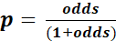

A significance level of p < 0.05 was set.

Results

The first part of this section will analyse whether listeners can reliably identify the speech of normally hearing (NH) and hearing-impaired (HI) children: in this analysis children with a cochlear implant (CI) and children with an acoustic hearing aid (HA) will be considered as a single group of children with hearing impairment. In the second part of this section children with CI and children with HA will be treated as separate groups and it will be investigated whether listeners can reliably identify these two groups. In the last part of this section, the question whether the speech of HI children approximates that of NH children is addressed by investigating the number of utterances classified as NH for children with CI and children with HA.

Analysis 1: Normally hearing vs. hearing-impaired children
In the first instance it is investigated whether listeners can reliably distinguish the speech of NH and HI children. For this purpose, CI and HA children are treated as a single group of children with hearing impairment. The dependent variable in this analysis is binomial: correct/incorrect identification of children’s hearing status as either NH or HI. In other words: labelling an utterance as CI or HA when it did actually originate from a child with HI (= CI or HA) was considered to be correct.

The best fitting model is reported in Table 3. It appears that the utterances of NH children attracted 82% correct identifications while those of HI children only attracted 70% correct identifications. This difference is not statistically significant (p = 0.08) which indicates that the HI children are categorised equally accurately as the NH children. Furthermore, the model shows that the listener groups differ considerably. The accuracy of the categorisations of the three groups of participants (audiologists, primary school teachers and inexperienced listeners) is summarized in Figure 1. The figure shows that audiologists and primary school teachers are less accurate in identifying HI children than inexperienced listeners. On the other hand, audiologists and primary school teachers are more accurate in identifying NH children.

 | Estimate | Std. error | Z-value | P
Intercept | 1.81526 | 0.50495 | 3.595 | < 0.001
Hearing status [HI] | -1.03901 | 0.59831 | -1.737 | 0.0825
Listener group [TE] | 0.04186 | 0.15681 | 0.267 | 0.7895
Listener group [IE] | -0.75415 | 0.15153 | -4.977 | < 0.0001
Hearing status [HI]* Listener group [TE] | -0.24661 | 0.13038 | -1.892 | 0.0586
Hearing status [HI]* Listener group [IE] | 1.23601 | 0.12501 | 9.887 | < 0.0001
Table 3: Accuracy of NH and HI categorisations for the three listener groups (fixed effects = Hearing status (NH (= reference category) or HI), Listener Group (IE = inexperienced listeners, TE = teachers, AU = audiologists (= reference category)) and the interaction between these two)

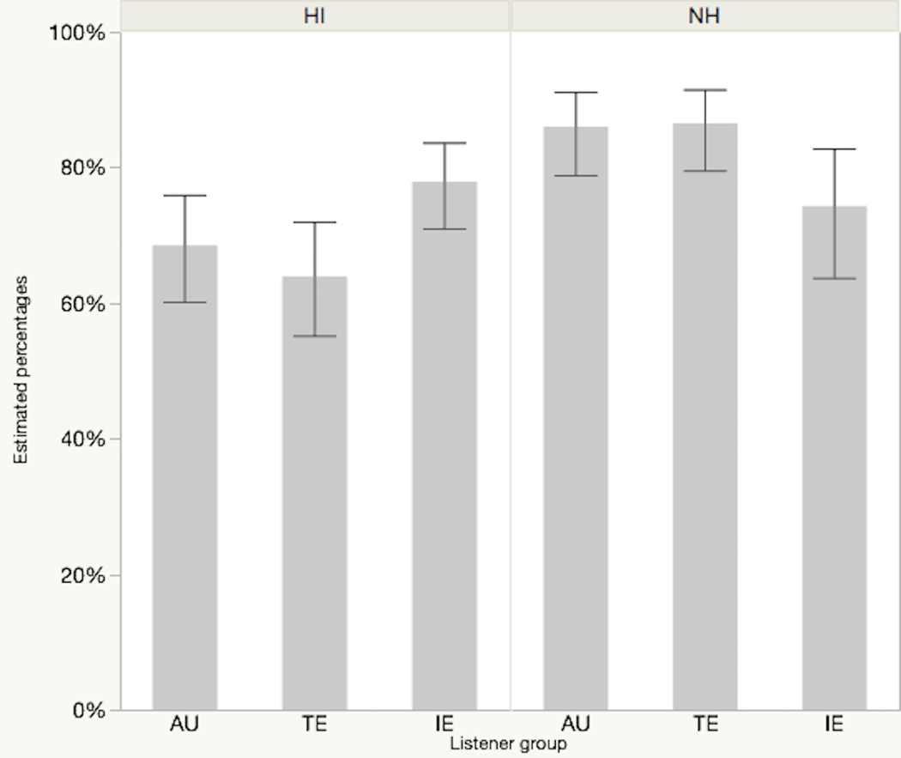
Figure 1: The likelihood of correctly identifying normally hearing (NH) and hearing-impaired (HI) children per listener group: audiologists (AU), primary school teachers (TE) and inexperienced listeners (IE) (estimated values in percentages, error bars indicate standard errors of the mean)

Post hoc pairwise comparisons with Bonferroni adjustment (Supplementary materials 2) reveal that for NH children the categorisations of the audiologists and primary school teachers are significantly (p < 0.0001) more accurate than those of the inexperienced listeners. Audiologists correctly identify NH children in 86%, primary school teachers in 87%, and inexperienced listeners in 74% of the judgments. Inexperienced listeners are significantly (p < 0.005) the most accurate in identifying the utterances of HI children: they correctly identify these children in 78% of the cases, compared to 64% for primary school teachers and 69% for audiologists.

CI-HA labels
The fact that inexperienced listeners are the most successful in accurately identifying the speech of HI children is somewhat surprising. It is however possible that inexperienced listeners simply label more utterances as CI or HA as opposed to NH: as a result the probability of correctly identifying an utterance of a HI child is higher for the inexperienced listeners than for the two other groups of listeners.

In order to investigate this, an additional model was constructed with the number of utterances labelled as CI or HA as the dependent variable and the three listener groups as the predictor. The best fitting model is reported in Table 4. It is clear that inexperienced listeners select the label CI or HA significantly more frequently (and the label NH less frequently) than the audiologists (p = 0.004) and the group of teachers (p = 0.0003). Whereas audiologists (48%) and teachers (44%) identify less than half of the utterances as being CI or HA, inexperienced listeners do so significantly more often (63%).

 | Estimate | Std. error | Z-value | P
Intercept | 0.5232 | 0.4467 | 1.171 | 0.2415
Listener group [AU] | -0.6124 | 0.2135 | -2.868 | 0.0041
Listener group [TE] | -0.7747 | 0.2136 | -3.627 | 0.0003
Table 4: Number of utterances labelled as CI or HA for the three listener groups (fixed effect = Listener group (IE = inexperienced listeners (= reference category), TE = teachers, AU = audiologists))
Inexperienced listeners are more inclined to label utterances as CI or HA, but do they use these labels more often erroneously, i.e. for NH children, than the other listener groups? Table 5 reports the incorrect use of CI or HA labels. Whereas audiologists and primary school teachers use the label CI or HA incorrectly for NH children in 12% of the cases, inexperienced listeners do so in 24%, which is significantly more often (p < 0.0005). Thus, not only is the tendency to label an utterance as CI or HA considerably higher for inexperienced listeners, these listeners also use the labels CI or HA more often incorrectly, i.e. when hearing a NH child.

 | Estimate | Std. error | Z-value | P
Intercept | -1.1657 | 0.4680 | -2.491 | 0.0127
Listener group [AU] | -0.8243 | 0.2237 | -3.685 | 0.0002
Listener group [TE] | -0.8420 | 0.2233 | -3.771 | 0.0002
Table 5: Number of utterances labelled incorrectly as CI or HA for the three listener groups (fixed effect = Listener group (IE = inexperienced listeners (= reference category), TE = teachers, AU = audiologists))

Analysis 2: Normally hearing vs. hearing aided and cochlear implanted children
In the previous section, listeners’ identification of NH and HI children was compared. In this section, children with HA and children with CI will be considered separately. The question is whether listeners correctly identify the speech of children with NH, children with CI and children with HA. The dependent variable in this analysis is binomial: correct/incorrect identification of the respective hearing status (CI, HA or NH).

The best fitting model is provided in Table 6 and contains an interaction of the fixed effects Hearing status and Listener group. NH children are correctly identified in 82% of the cases (as seen in the previous paragraph). Children with HA are identified in 38% and children with CI in 22% of the cases. The best fitting model in Table 6 indicates that children with CI (the reference category in the model) are categorised significantly (p < 0.05) less accurately than children with HA and NH. Moreover the model reveals significant differences between the listener groups and significant interactions between the listener groups and the hearing status of the children who produced the utterances.

 | Estimate | Std. error | Z-value | P
Intercept | -1.462011 | 0.300222 | -4.870 | < 0.0001
Hearing status [HA] | 1.016398 | 0.410201 | 2.478 | < 0.05
Hearing status [NH] | 3.210304 | 0.414084 | 7.753 | < 0.0001
Listener group [TE] | 0.045474 | 0.121145 | 0.375 | 0.7074
Listener group [IE] | 0.524939 | 0.117525 | 4.467 | < 0.0001
Hearing status [HA]* Listener group [TE] | -0.186463 | 0.133700 | -1.395 | 0.1631
Hearing status [NH]* Listener group [TE] | 0.006411 | 0.151140 | 0.042 | 0.9662
Hearing status [HA]* Listener group [IE] | -0.548882 | 0.130118 | -4.218 | < 0.0001
Hearing status [NH]* Listener group [IE] | -1.248038 | 0.142736 | -8.744 | < 0.0001
Table 6: Accuracy of NH, CI and HA categorisations for the three listener groups (fixed effects = Hearing status (CI (= reference category), HA or NH), Listener group (IE = inexperienced listeners, TE = teachers, AU = audiologists (= reference category)) and the interaction of these two)
The accuracy scores are summarized in Figure 2 and they confirm the outcome of the model: NH children are more often identified correctly than children with HA or CI. Moreover identification accuracy depends on the listener group. For CI and NH children, audiologists’ and primary school teachers’ accuracy is comparable and significantly different from inexperienced listeners. For HA children Figure 2 does not show clear differences between the three listener groups.

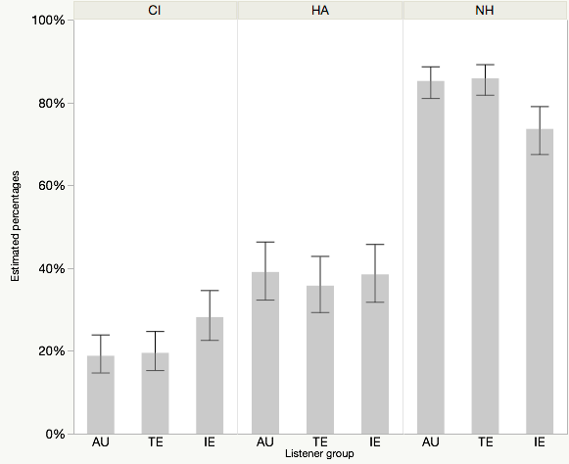
Figure 2: The likelihood of correctly identifying normally hearing children (NH), children with a cochlear implant (CI) and children with an acoustic hearing aid (HA) per listener group: audiologists (AU), primary school teachers (TE) and inexperienced listeners (IE) (estimated values in percentages, error bars indicate standard errors of the mean)

The results of the post hoc pairwise comparisons with Bonferroni adjustment are presented in Supplementary materials 3. The results for NH children are identical to those discussed in the previous section: audiologists (86%) and primary school teachers (87%) identify NH children with almost identical accuracy. Inexperienced listeners are significantly less accurate: 74%. This second analysis, however, is especially interested in the accuracy scores for the CI and the HA group. In identifying CI children, the scores of audiologists (19%) and primary school teachers (20%) are not significantly different (p > 0.05), whereas inexperienced listeners achieve a significantly higher accuracy score of 28% (p < 0.001). However, the results for HA children are comparable (p > 0.05) for all three listener groups: 39% for the audiologists, 36% for the primary school teachers and 39% for the inexperienced listeners. From this it can be concluded that there are no significant differences between the listener groups for children with HA while listeners perform differently for children with CI and NH. Experience with the speech of children seems to positively influence the categorisations of NH children, yet does not lead to more accurate classifications of CI children. On the contrary, children with CI are more accurately identified by inexperienced listeners than the other two listener groups. Irrespective of the listener groups, however, the accuracy of identifying children with CI and HA is very low. The categorisations of children with CI in particular are well below chance level, indicating that these children are very difficult to identify. In the next paragraph, the number of utterances that were categorised as NH are further analysed.

Analysis 3: Hearing-impaired children labelled as NH
The second analysis showed that the speech of children with CI and HA was effectively identified as CI or HA speech in respectively 22% and 38% of the judgments. In this section, the utterances of children with CI or HA that are classified as NH are further analysed. The dependent variable is binomial: (not) labelling of an utterance as NH produced by a child with CI or HA. The best fitting model contains an interaction of the fixed effects Hearing status and Length of device use. The variable Length of device use was included in the model fit since previous research has shown that this variable is relevant in HI children (Fang et al., 2014; Gillis, 2017; Tomblin et al., 1999; Yoshinaga-Itano et al., 2010).

The results indicate that the number of NH categorisations differs considerably for CI and HA children (see Table 7). More specifically, children with CI are significantly more often categorised as NH than children with HA (p < 0.05). At intercept 46% of the utterances of children with CI were categorised as NH, whereas only 20% of the utterances of children with HA received this label. The effect of length of device use is also significant (p < 0.001), indicating that the number of NH categorisations increases as children have more experience with their device.

 | Estimate | Std. error | Z-value | P
Intercept | -0.1546 | 0.45142 | -0.342 | 0.7320
Hearing status [HA] | -1.24234 | 0.59160 | -2.100 | < 0.05
Length of device use | 0.09531 | 0.02701 | 3.528 | < 0.001
Hearing status [HA]* Length of device use | -0.09009 | 0.03721 | -2.421 | < 0.05

Table 7: Effect of length of device use for NH categorisations in children with CI and HA (fixed effects = Hearing status (CI (= reference category) or HA), Length of device use and the interaction of these two)

Moreover, the interaction effect of Hearing status and Length of device use is significant (p < 0.05), which suggests that the influence of length of device use on the number of NH categorisations differs for children with CI and children with HA. In Figure 3, the number of NH classifications of the CI and the HA children are plotted as a function of length of device use, illustrating the significant interaction between the variables Hearing status and Length of device use. As the length of device use increases, the number of NH categorisations increases for both groups but at a different rate. The increase is much steeper for CI children than for HA children. For HA children, the length of device use hardly influences the number of NH categorisations. For children with CI the number of NH categorisations starts at a lower level, but after 64 months they catch up and outperform HA children. Eventually 70% of the speech samples produced by children with CI are categorised as NH.

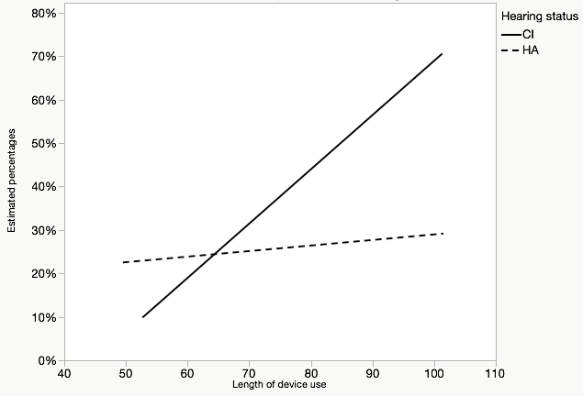
Figure 3: The likelihood of categorising utterances as normally hearing in interaction with the length of device use of children with CI and children with HA (estimated values in percentages; length of device use in months)

Discussion
This study examined whether adult listeners are able to identify the speech of hearing-impaired (HI) children, i.e. children with a cochlear implant (CI) and children with an acoustic hearing aid (HA). This was motivated by the fact that several studies have found the speech of HI children to be acoustically different from the speech of NH children. On this basis it was hypothesized that these characteristics enable adult listeners to identify HI children. Moreover, it was expected that listeners with more extensive experience with the speech of HI children are better at recognising the speech of these children.

Distinguishing the speech of NH and HI children
The results of this study demonstrate that listeners can reliably identify the speech of HI children and the speech of NH children. This result supports the hypothesis that listeners recognise some of the acoustic characteristics of HI speech. This finding is a strong indication that, even after several years of device use, some of the speech characteristics that were found in acoustic studies (Liker et al., 2007; Nicolaidis & Sfakianaki, 2007; Verhoeven et al., 2016) are also salient identification cues for experienced as well as inexperienced listeners. Thus, even if a child has been using an assistive device for quite some time, a range of speech characteristics remain which mark the speech of children with hearing impairment as HI and which enable listeners to recognise it as such.

Of the three listener groups, audiologists and primary school teachers were more accurate in recognising NH children’s speech, whereas inexperienced listeners more accurately recognised HI children. However, the number of utterances that were labelled as CI or HA differed for the three listener groups. Inexperienced listeners were considerably more likely to (erroneously) label an utterance as CI or HA than audiologists and primary school teachers did. This may be the result of the listener groups handling variation in children’s speech differently. Variation and variability is very common in child speech. Audiologists and primary school teachers are familiar with this variability and are at least implicitly aware of the normal deviations in the speech of developing children. This may lead them to be more lenient towards speech differences in comparison to the inexperienced listeners, and this could make them more hesitant to use the labels CI and HA. The inexperienced listeners are not so familiar with the normal variation in children’s speech. Hence in a task in which they have to distinguish typical from atypical speech, they might be more inclined to consider smaller differences as atypical and this gives the impression that they are stricter when it comes to variation. A similar finding was reported in Verhoeven et al. (2013) who used a listening panel consisting of listeners with different degrees of experience with foreign-accented speech in assessing the degree of accentedness in speakers with Foreign Accent Syndrome. In this experiment expert Teachers of Dutch as a Foreign Language were found to be most lenient towards foreign-accented speech in that they were willing to consider speakers as native speakers of Dutch much more often than inexperienced listeners the judgments of whom could be interpreted as reflecting a stricter attitude.

In the present experiment, the amount of variation in HI and NH children was not controlled. Further investigations, in which the amount of variation is taken into account as a predicting factor, should examine whether inexperienced listeners have a different attitude towards phonetic variation in comparison to listeners who are thoroughly familiar with child speech.

Labelling children with CI and children with HA
Correctly labelling children with CI and children with HA appeared to be challenging for listeners. Children with CI as well as children with HA were less accurately identified than children with NH. The number of correct classifications of the latter group was relatively high, whereas correct classifications of both HI groups were extremely low for all listener groups. Although listeners are very able to differentiate the speech of NH and HI children, they can hardly distinguish the speech of children with CI and children with HA.

Comparisons of the three listener groups showed that inexperienced listeners were best at correctly identifying the speech of CI children. For children with HA, no differences between the three listener groups were found. The different degree of experience with HI speech may explain these results. Listeners who do not have any experience with the speech of HI children may lack a clear mental representation of what CI and HA speech sounds like, since they have never heard this type of speech before and this makes it very difficult for them to identify these groups correctly. The fact that inexperienced listeners do better may be due to their generally stricter attitude discussed in the previous paragraph: they simply labelled more utterances as ‘CI’ and ‘HA’. The group that was expected to perform best at differentiating CI and HA children, i.e. audiologists, did not live up to expectations. Possibly, audiologists, and by extension also primary school teachers, may have been expecting more variation between both HI groups. Since the HI groups in our sample were matched on age, geographical background, length of device use and aided PTA, relatively homogeneous groups were created. This may explain why our samples contain less variation than expected by audiologists and primary school teachers.

Differences in the number of NH categorisations in children with CI or HA
Children with CI were categorised as NH considerably more frequently than their HA peers. The length of device use was found to be a predicting factor of the number of NH classifications. This effect was especially strong in children with CI. Longer implant use is associated with higher numbers of NH categorisations. In children with HA, the number of NH categorisations is generally lower and does not show a strong increase with longer device use. These results suggest that children with CI exhibit significantly better speech than children with HA and this is in agreement with other studies (Baudonck et al., 2010; Tomblin et al., 1999).

Theoretical implications
The results of this study are in agreement with the framework of markers in speech (Laver & Trudgill, 1979; Verhoeven, 2002). This framework is based on the idea that the speech of every individual contains characteristics that are salient to the human ear. These characteristics are grouped into three categories of markers in speech: physical, psychological and social markers. The perception results of this study provide evidence that all listeners are able to actively use these speech markers to identify child speakers as hearing impaired and are thus able to infer information about their ‘state of health’, which is a physical marker. It would be interesting in further research to carefully control different types of HI markers in order to assess their importance to the identification of speakers with hearing impairment.

Clinical implications
Parents of HI children are often anxious to know whether their child will catch up with their hearing peers and this question is often addressed to Otorhinolaryngologists and Speech and Language Therapists. This study found strong evidence that the speech of HI children remains atypical even after seven years of device use. However, there are clear differences between children with CI and children with HA. In children with HA, length of device use does not really have an effect on the number of NH classifications: these remain stable at around 30%. For children with CI, as the length of device use increases, up to 70% of the utterances of children with CI are considered as typical. In other words, this study confirms that children with CI are very frequently perceived as children with normal hearing by adult listeners after longer device use. Thus, the outcomes for these children are quite positive. Several studies focusing on the speech production of children with NH and CI also indicated that children with CI catch up with their hearing peers or at least show considerable improvement after implantation (Chin et al., 2003; Ertmer, 2007; Geers & Nicholas, 2013; Uchanski & Geers, 2003).

Limitations
Although the results of this investigation are thought-provoking, it is important to emphasize that the small number of children in this study is a limiting factor. At present, the obtained results need to be considered with some caution since there was a large amount of intragroup variation, especially in both HI groups. Therefore, it would be good to replicate this study with a larger number of speakers. Moreover, the length of device use of the children in the present study was limited to approximately seven years and this seemed to have a larger impact on CI than on HA children. A sample of HI children with longer device use may reveal whether their speech continues to improve beyond the 7-year boundary in this study.

Also to be considered is the influence of listeners’ experience with child speech. This study presented evidence that experienced and inexperienced listeners treat variation in (HI) speech differently. It seemed that audiologists as well as primary school teachers benefitted from their experience. Because experienced listeners have daily contact with children, it is assumed that they have a better (mental) representation of child speech. Because the speech of children is still developing and changing, it is likely to contain deviations from the norm which may not be present in the adult speech signal. As experienced listeners are the ones observing children’s speech on a daily basis, they may weight factors differently and disregard variations which may be significant for inexperienced listeners: it could be said that they take a more lenient approach.

Conclusion
This study shows that listeners are able to distinguish the speech of hearing-impaired (HI) and normally hearing (NH) children irrespective of their degree of experience with the speech of hearing-impaired children. After seven years of device use, the speech signal of HI children still contains acoustic information which enables listeners to accurately discriminate the speech of NH and HI children. Labelling children with CI and HA correctly turned out to be difficult, resulting in scores near or well below chance. Regarding the classifications as NH, robust differences are observed within the group of HI children (CI vs. HA). Children with CI are more often categorised as NH than children with HA, and this number increases with the length of device use. Children with HA are considerably less often classified as NH and length of device use does not influence this result.

This study shows that expert listeners, i.e. audiologists and primary school teachers, are better at recognising the speech of NH children, yet are not better at identifying HI children. The categorisations of these expert listeners suggest that they are more lenient towards variation in child speech, which does not apply to inexperienced listeners, who take a stricter attitude.

Supplementary materials
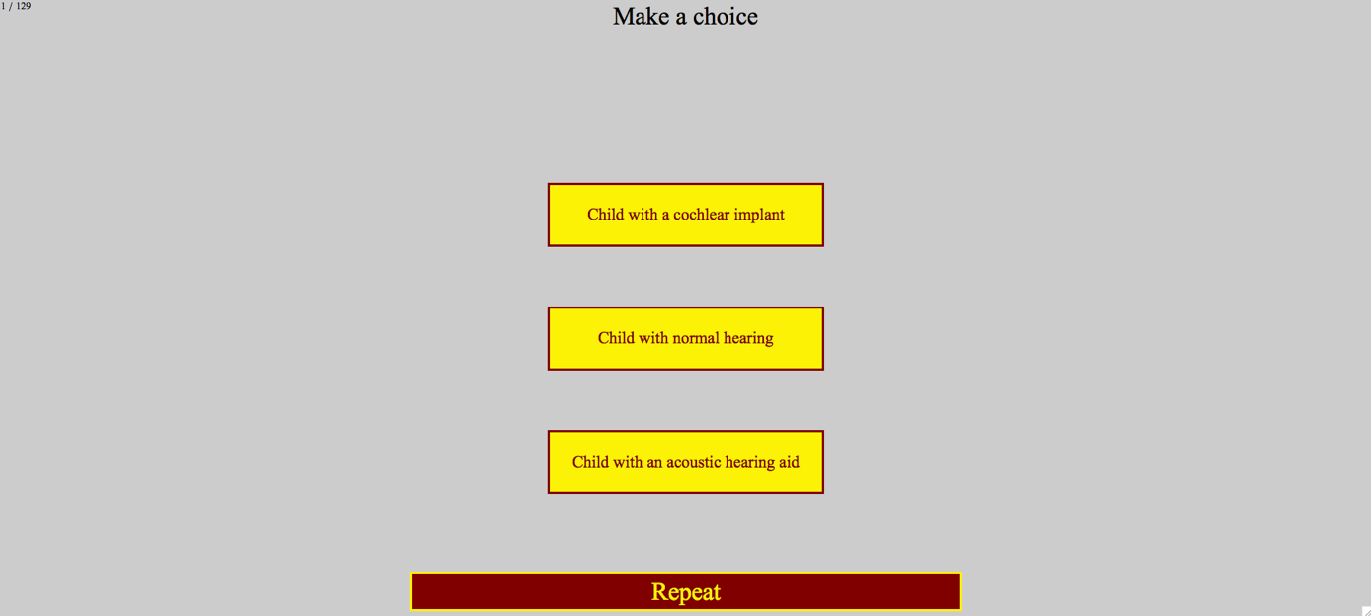
Supplementary materials 1: Printscreen of the interface in the experiment

 | Estimate | Std. error | Z-value | P
NH_IE – NH_AU | -0.75397 | 0.15154 | -4.975 | < 0.0001
NH_IE – NH_TE | -0.79610 | 0.15193 | -5.240 | < 0.0001
NH_TE – NH_AU | 0.04213 | 0.15684 | 0.269 | 1.0000
HI_IE – HI_TE | 0.68656 | 0.13041 | 5.265 | < 0.0001
HI_IE – HI_AU | 0.48193 | 0.13050 | 3.693 | 0.0013
HI_AU – HI_TE | 0.20463 | 0.12951 | 1.580 | 0.6846
Supplementary materials 2: Posthoc pairwise comparison analysis with Bonferroni adjustment of correctly classifying NH and HI children
xx_yy: xx = hearing status (NH or HI), yy = listener group (IE = inexperienced listeners, TE = teachers, AU = audiologists)

 | Estimate | Std. error | Z-value | Pr(>|Z|)
NH_IE – NH_AU | -0.72306 | 0.11954 | -6.049 | < 0.0001
NH_IE – NH_TE | -0.77498 | 0.12024 | -6.445 | < 0.0001
NH_TE – NH_AU | 0.05192 | 0.12607 | 0.412 | 1.0000
HA_IE – HA_TE | 0.11729 | 0.10484 | 1.119 | 1.0000
HA_IE – HA_AU | -0.02388 | 0.10438 | -0.229 | 1.0000
HA_AU – HA_TE | -0.14117 | 0.10478 | -1.347 | 1.0000
CI_IE – CI_AU | 0.52525 | 0.11752 | 4.469 | < 0.0001
CI_IE – CI_TE | 0.47954 | 0.11700 | 4.099 | 0.0004
CI_TE – CI_AU | 0.04572 | 0.12115 | 0.377 | 1.0000
Supplementary materials 3: Posthoc pairwise comparison analysis with Bonferroni adjustment of correctly identifying a hearing status
xx_yy: xx = hearing status (NH, HA or CI), yy = listener group (IE = inexperienced listeners, TE = teachers, AU = audiologists)

Acknowledgments
This project was funded by a predoctoral research grant of the Research Foundation – Flanders (FWO) to the first author (1100316N). This study was approved by the Ethics Committee for the Social Sciences and Humanities (SHW_15_37) of the University of Antwerp.

Declaration of interest
The authors declare no conflict of interest.

References
Abercrombie, D. (1967). Elements of general phonetics. Edinburgh: Edinburgh University Press.
Baayen, H. (2008). Analyzing linguistic data. A practical introduction to statistics using R. Cambridge: Cambridge University Press.
Bates, D., Mächler, M., Bolker, B. M., & Walker, S. C. (2015). Fitting linear mixed-effects models using lme4. Journal of Statistical Software, 67(1), 1-48.
Baudonck, N., Dhooge, I., D'haeseleer, E., & Van Lierde, K. (2010). A comparison of the consonant production between Dutch children using cochlear implants and children using hearing aids. International Journal of Pediatric Otorhinolaryngology, 74(4), 416-421.
Baudonck, N., Van Lierde, K., D’haeseleer, E., & Dhooge, I. (2015). Nasalance and nasality in children with cochlear implants and children with hearing aids. International Journal of Pediatric Otorhinolaryngology, 79(4), 541-545.
Baudonck, N., Van Lierde, K., Dhooge, I., & Corthals, P. (2011). A comparison of vowel productions in prelingually deaf children using cochlear implants, severe hearing-impaired children using conventional hearing aids and normal-hearing children. Folia Phoniatrica et logopaedica, 63(3), 154-160.
Beukelman, D. R., & Yorkston, K. M. (1980). Influence of passage familiarity on intelligibility estimates of dysarthric speech. Journal of Communication Disorders, 13(1), 33-41.
Bharadwaj, S. V., & Assmann, P. F. (2013). Vowel production in children with cochlear implants: implications for evaluating disordered speech. The Volta Review, 113(2), 149-169.
Boersma, P., & Weenink, D. (2016). Praat: doing phonetics by computer (Version 5.3). Retrieved from www.praat.org
Bouchard, M. E. G., Le Normand, M. T., & Cohen, H. (2007). Production of consonants by prelinguistically deaf children with cochlear implants. Clinical Linguistics & Phonetics, 21(11-12), 875-884.
Chin, S. B., Tsai, P. L., & Gao, S. (2003). Connected speech intelligibility of children with cochlear implants and children with normal hearing. American Journal of Speech-Language Pathology, 12(4), 440-451.
Ertmer, D. J. (2007). Speech intelligibility in young cochlear implant recipients: gains during year three. The Volta Review, 107(2), 85-99.
Fang, H.-Y., Ko, H.-C., Wang, N.-M., Fang, T.-J., Chao, W.-C., Tsou, Y.-T., & Wu, C.-M. (2014). Auditory performance and speech intelligibility of Mandarin-speaking children implanted before age 5. International Journal of Pediatric Otorhinolaryngology, 78(5), 799-803.
Flipsen, P. (1995). Speaker-listener familiarity: parents as judges of delayed speech intelligibility. Journal of Communication Disorders, 28(1), 3-19.
Geers, A. E., & Nicholas, J. G. (2013). Enduring advantages of early cochlear implantation for spoken language development. Journal of Speech, Language, and Hearing Research, 56(2), 643-655.
Gillis, S. (2017). Speech and language in congenitally deaf children with a cochlear implant. In A. Bar-On & D. Ravid (Eds.), Handbook of communication disorders: theoretical, empirical, and applied linguistic perspectives (pp. 763-790). Berlin: Mouton De Gruyter.
Hide, Ø. (2013). Acoustic features of speech by young cochlear implant users. A comparison with normal-hearing and hearing-aided age mates. (Unpublished doctoral dissertation), University of Antwerp, Antwerp, Belgium.
Hothorn, T., Bretz, F., & Westfall, P. (2008). Simultaneous inference in general parametric models. Biometrical Journal, 50(3), 346-363.
Klimacka, L., Patterson, A., & Patterson, R. (2001). Listening to deaf speech: does experience count? International Journal of Language & Communication Disorders, 36, 210-215.
Laver, J., & Trudgill, P. (1979). Phonetic and linguistic markers in speech. In K. R. Scherer & H. Giles (Eds.), Social Markers in Speech (pp. 1-32). Cambridge: Cambridge University Press.
Liker, M., Mildner, V., & Sindija, B. (2007). Acoustic analysis of the speech of children with cochlear implants: a longitudinal study. Clinical Linguistics & Phonetics, 21(1), 1-11.
McGarr, N. S. (1983). The intelligibility of deaf speech to experienced and inexperienced listeners. Journal of Speech and Hearing Research, 26(3), 451-458.
Munson, B., Johnson, J. M., & Edwards, J. (2012). The role of experience in the perception of phonetic detail in children's speech: a comparison between speech-language pathologists and clinically untrained listeners. American Journal of Speech-Language Pathology, 21(2), 124-139.
Nicolaidis, K., & Sfakianaki, A. (2007). An acoustic analysis of vowels produced by Greek speakers with hearing impairment. Paper presented at the Proceedings of XVI International Congress of Phonetic Sciences, Saarbrücken.
Osberger, M., & McGarr, N. (1982). Speech production characteristics of the hearing impaired. In N. Lass (Ed.), Speech and Language: Advances in Basic Research and Practice (Vol. 8, pp. 221-283). New York: Academic Press.
Parkhurst, B. G., & Levitt, H. (1978). The effect of selected prosodic errors on the intelligibility of deaf speech. Journal of Communication Disorders, 11(2-3), 249-256.
R Core Team. (2016). R: A language and environment for statistical computing. Retrieved from www.R-project.org
Tjaden, K., & Liss, J. M. (1995). The influence of familiarity on judgments of treated speech. American Journal of Speech-Language Pathology, 4(1), 39-48.
Tomblin, J. B., Spencer, L., Flock, S., Tyler, R., & Gantz, B. (1999). A comparison of language achievement in children with cochlear implants and children using hearing aids. Journal of Speech, Language, and Hearing Research, 42(2), 497-509.
Uchanski, R. M., & Geers, A. E. (2003). Acoustic characteristics of the speech of young cochlear implant users: a comparison with normal-hearing age-mates. Ear & Hearing, 24(S1), S90-S105.
Van Lierde, K. M., Vinck, B. M., Baudonck, N., De Vel, E., & Dhooge, I. (2005). Comparison of the overall intelligibility, articulation, resonance, and voice characteristics between children using cochlear implants and those using bilateral hearing aids: a pilot study. International Journal of Audiology, 44(8), 452-465.
Vanormelingen, L., De Maeyer, S., & Gillis, S. (2016). A comparison of maternal and child language in normally-hearing and hearing-impaired children with cochlear implants. Language, Interaction and Acquisition, 7(2), 145-179.
Verhoeven, J. (2002). The Communicative Setting and Markers in Speech. In J. Verhoeven (Ed.), Phonetic Work in Progress. Antwerp Papers in Linguistics (Vol. 100, pp. 177-190).
Verhoeven, J. (2005). Illustrations of the IPA: Belgian Standard Dutch. Journal of the International Phonetic Association, 35(2), 243-247.
Verhoeven, J., De Pauw, G., Pettinato, M., Hirson, A., Van Borsel, J., & Mariën, P. (2013). Accent attribution in speakers with Foreign Accent Syndrome. Journal of Communication Disorders, 46, 156-168.
Verhoeven, J., Hide, Ø., De Maeyer, S., Gillis, S., & Gillis, S. (2016). Hearing impairment and vowel production. A comparison between normally hearing, hearing-aided and cochlear implanted Dutch children. Journal of Communication Disorders, 59, 24-39.
Yoshinaga-Itano, C., Baca, R. L., & Sedey, A. L. (2010). Describing the trajectory of language development in the presence of severe-to-profound hearing loss: a closer look at children with cochlear implants versus hearing aids. Otology & Neurotology, 31(8), 1268-1274.

