Comparison of Performance and Controlling Schemes of Synchronous and Induction Machines Used in Flywheel Energy Storage Systems

Abid Soomroa, Mustafa E. Amiryara, Keith R. Pullena and Daniel Nankooa

a Schoolof Mathematics, Computer Science and Engineering, City University of London, EC1V0HB, UK

Abstract

For stable operation of the electrical grid, it is vital to maintain a balance between demand and supply of electrical power. Imbalance at any instant between consumption and generation causes voltage and frequency instability. Intermittent generation (wind and solar) in power systems is more likely to cause such imbalances hence the existence of frequency and voltage variations. To address stability issues due to integration of intermittent renewable sources into the grid, a storage device is required which can quickly respond to the power fluctuations. A Flywheel Energy Storage System (FESS) has the capability to respond within a sub-second timescale and is able to address the problems caused by power variations. The performance of FESS is highly dependent on the type of motor/generator (MG) set which is the key component generating or absorbing power from grid. The three main types of electrical machines used in FESS applications are synchronous machine (SM), induction machine (IM) and the switched reluctance machine (SRM). SRM is less commonly used due to high current ripples and complex torque control [1]. SM is used for high speed applications due to its high efficiency and IM is used for high power applications due to its rough construction. This research focuses on the comparison of synchronous and induction machines used in flywheel energy storage systems for microgrid applications [2]. The operation and controlling schemes of each electrical machine has been described as used in the analysis made in the MATLAB/Simulink environment.

Copyright© 2018Elsevier Ltd. All rights reserved.

Selection and peer-review under responsibility of the 3rd Annual Conference in Energy Storage and Its Applications,  
3rd CDT-ESA-AC.

*Keywords:*Flywheel energy storage; Motor/generator;Induction machine; Synchronous machine; DC bus voltage

1. Introduction

Penetration of renewable energy technologies is growing based on the need for carbon dioxide free energy generation plus the reduction in capital cost of these technologies. In order to address the stability problem due to intermittency of renewable power, a storage device is required which can quickly respond to the power variations of the grid. A Flywheel Energy Storage System (FESS) has the capability to respond within a sub second timescale and is able to balance power variations. Developments in reducing capital cost and improving standby losses with longer storage times could make flywheel systems competitive with batteries in microgrid applications. An efficient motor/generator with improved dynamic performance and control is a key component for energy conversion in FESS [3]. An IM running as a generator causes reactive power problems because it does not produce reactive power but absorbs it from power lines. SRM creates electromagnetic drag and has risk of demagnetization. SRM’s ability to produce electric power is dependent on heating within the machine which consequently affects the terminal voltage, armature current and power factor [4]. A disadvantage of the PM machine is the electromagnetic drag torque losses which are due to eddy currents and iron losses in the stator. There are additional challenges given low tensile strength of the magnet, which requires the machine to be contained in a containment structure to reduce demagnetization risks [5]. These issues associated with electrical machines can affect the power flow and DC bus voltage and therefore, can have impact on overall grid stability. Microgrids can be described as building blocks of Smart Grids integrating cluster of loads, storage devices, distributed generation (DG) and monitoring systems [6]. Microgrids are connected to the central/main grid through a point of connection (PC) where they are self-controlled and can operate in islanded or grid-connected mode. [7] A microgrid is a power system at a small level that is not as robust as the main grid. [8] The imbalance between supply and demand, voltage profile, power factor and reactive power play an important role in stability of a micro grid. The role of ESS in microgrid is discussed in [9] and operation of IM based FESS in certain applications is presented in [10] and [11]. Studies and discussions on SM machine based FESS have been presented in [12-13]. SM and IM are the two major electrical machines used in flywheel applications and the way they interact with a microgrid is different to each other in terms of power variations. This paper is focused on comparison of operation and analysis of both machines connected to flywheel system in a microgrid. The next section focuses on description and characteristics of IM and SM followed by their control and modelling. The models of IM and SM connected to the flywheel are built in MATLAB/Simulink and simulated results including charge-discharge states of each machine at the microgrid level is presented in section 4. The results are discussed and analysed in section 5 and the paper is concluded in section 6.

1. Description and characteristics of IM and SM

Energy conversion in a FESS is controlled by an electrical machine operating as an integrated MG. A flywheel extracts energy from the electrical source and stores it as kinetic energy when it accelerates in charging mode. It delivers electric energy back to the source or to an electrical load when it decelerates during discharging mode. Flow of the energy from an electrical source to the flywheel and vice versa is controlled by bidirectional converters acting as inverters and rectifiers. A general schematic diagram of a FESS with a cylindrical type flywheel rotor is shown in Figure 1. The presented control scheme generally applies to both induction and synchronous machine types. A detailed description of each machine type and their respective control method are discussed in the following sections.



Fig. 1: Schematic diagram of simulation model.

* 1. Induction Machines

Torque in induction machine is produced with the interaction of stator and rotor magnetic fields when stator voltage is applied. IM is best used for high power applications as they have high torque, high reliability and high robustness [14-15]. The machine can be established with high strength material with low cost [15] and have no electromagnetic spinning losses due to zero torque in the absence of excitation field [16]. Hence IMs can be an attractive option for low loss FESS with long term energy storage capabilities. As a disadvantage, induction machines inherently have significant rotor heating which would be a major problem for composite flywheels, however, this is much less of an issue in steel flywheel rotors. IM and its associated inverters have been modelled previously for different industrial applications. However, its application in flywheels is different and introduces new challenges to its operation such as, progressive torque requirement due to slow dynamic response of the IM in high inertial flywheels applications.

* 1. Synchronous Machines

The SM with the advantages of high efficiency, high power density and low rotor losses has been widely used for high speed FESS applications [5]. The SM has drawback of accidental demagnetization, their high speed operation is temperature sensitive and they have low tensile strength [1]. In the generating mode of SM operated flywheel systems, there are momentary transients before steady state operation due to load fluctuations or when high torque is applied to the shaft of the generator, and this characteristic of SM may affect DC bus voltage stability [4]. In conventional power systems, SM are mostly used for power generation and their inertia, power factor and voltage profile are taken into considerations during stability studies. During discharging mode of flywheel, SM plays similar role while delivering power to the microgrid. Therefore, factors affecting the stability of microgrid during generator mode of SM should be taken into consideration for better understating of FESS operation.

1. Modelling and control scheme
   1. Mathematical Modelling of Flywheel

Flywheels store kinetic energy in a rotating mass with the amount of stored energy being dependent on the rotational speed and rotor inertia as determined by the mass and geometric form of the rotor. The inertial mass is rotated by electrical machine operating in motor or generator mode. The dynamic operation of the flywheel coupled with MG set is defined by the following equation.

 (1)

where (N.m) is the electromechanical torque,(N.m) is the mechanical losses,(rad/s*)* is the angular velocity of the flywheel,(kg.m2) is the inertia and (N.m.s/rad) is the damping coefficient. In equation 1, is the combined inertia of the machine and flywheel rotor.

 (2)

Equation (2) gives energy stored in a flywheel of mass *m* and rotating at an angular velocity.

* 1. Modelling and control of IM

Simplified equations of the induction machine in *d-q* synchronously rotating reference frame can be written as follow [16]:

 (3)

 (4)

 (5)

 (6)

 (7)

(8)

where, (Ω) and (Ω) are rotor and stator resistances, and  are rotor and stator inductances in Henry, (V) is the stator voltage in *d-q* reference frame,  (Wb) and  (Wb) are rotor and stator flux linkages in *d-q* reference frame,  (A) and  (A) are rotor and stator currents in *d-q* reference frame, and *(*rad/s*)* is the rotor electrical speed. In above, equations 3 and 4 represent flux linkages of the stator and rotor, respectively. Equations 5 and 6 are the stator voltages and rotor voltages are represented by equations 7 and 8. In this paper a squirrel cage induction machine (SCIM) is considered where the rotor bars of SCIM are shorted by end rings [17] and, therefore, the rotor voltage vectors in Equations 7 and 8 are considered zero. Field Oriented Control (FOC) and Direct Torque Control (DTC) are the two high performance and widely used control strategies for induction machines. Both techniques are used to control the torque and machine flux in order to track command values regardless of any disturbances.



Fig. 2. Indirect Vector Control of IM

In this research indirect field oriented control (IFOC) is used. The purpose of the IFOC is to separately control the torque and d-axis component of stator current. With IFOC, induction machine behaves similar to a DC machine with no uncertainty of variations in parameters [18]. Rotor flux angle is calculated after determination of slip frequency (rad/s) and angle of rotor flux vectorwhich is determined indirectly by Equation 10. Similarly, the rotor flux is estimated by Equation 11 and rotor actual flux is determined by Equation 12. A Schematic diagram of a squirrel cage induction machine operated flywheel (SCIM-Flywheel) controlled by IFOC is shown in figure 2.

 (9)

 (10)

 (11)

 (12)

In Equation 10, is the angular displacement of the rotor,is rotor time constant, (V/rad/s) denotes reference flux and (H) is the mutual inductance. Variables  and  are torque-producing and flux-producing components of the stator currents which can be obtained using Equations 13 and 14:

 (13)

 (14)

where is the reference torque generated by outer speed loop PI controller and  is the rotor inductance. Synchronous PI current controllers are used to generate synchronous reference voltages which are then transformed to stationary reference frame for generation of gate pulse using space vector pulse width modulation (SVPWM) technique. SVPWM is used for controlling the switching of the gates of the machine side inverter to produce a smooth output waveform [19].

* 1. Modelling and control of SM

This section describes the modelling and control of the permanent magnet synchronous machine (PMSM) as developed in this research. For ease of analysis and control of the machine, the three-phase voltage and current equations of the PMSM are transformed into two-phase d-q rotating reference frames as shown below [20]:

 (15)

 (16)

Similarly, the torque developed by the motor is given as:

 (17)

The mechanical torque is represented by:

 (18)

where is the direct axis stator current (A), is the quadrature axis stator current (A), is the stator resistance (Ω), is the direct axis inductance (H), is the quadrature axis inductance (H), is the rotor flux constant (V/rad/s), is the rotor’s electrical speed (rad/s) and  is the rotor’s mechanical speed (rad/s).

The operation of the PMSM-Flywheel is controlled using cascaded control structure which follows the changes in position, speed, and torque of the machine, to a set of reference values. Due to its flexibility, it is widely used in industry to control the position and velocity of AC motor drives. It generally consists of segregated control loops with the outermost position loop followed by the inner speed loop, and the inner most current loop. The system charging control is performed based on field oriented control (FOC) using space vector pulse width modulation (SVPWM) [21]. FOC enables controlling of the current and hence the torque and flux of PMSM. Similar to the control of IM, the three-phase system is transformed into a two coordinate (d-q) time invariant system to allow decoupled control of the torque and flux of PMSM. Hence, similar to the analysis and control of IM described earlier, the PMSM can be theoretically controlled as equivalent to a DC machine [22,23]. A block diagram of the controlling scheme of the permanent magnet synchronous machine operated flywheel (PMSM-Flywheel) described above is presented in Figure 3.



Fig. 3. PMSM-Flywheel controlling scheme

During discharge, when the DC-bus voltage drops below a threshold value, a voltage controller is used to adjust and control the system current to maintain the DC-link voltage. The outer speed loop in charging mode is replaced with the outer voltage loop in discharging mode. Similar to the motoring mode where the speed is regulated by the extracting energy from the source, the generating mode allows the DC-link voltage to be measured and regulated by comparing it with the reference voltage. The output of the voltage PI controller is regulated as an input for the current PI controller.

1. Analysis and results

To evaluate the performance of IM and SM operated flywheel systems connected to a microgrid, each machine type is dynamically analysed using simulations at different charge-discharge states. While charging, a constant torque of 100 Nm is applied to charge the flywheel to a desired speed by extracting electrical energy from the electrical source. During the discharge mode, the stored energy is extracted when the applied torque is reversed and the flywheel starts to decelerate. The flywheel system is modelled for a capacity of 100kW within a speed range of 10,000 – 20,000 rpm. With the help of control system and mathematical equations described in section 3, the model of each machine type is implemented in MATLAB/Simulink. The performance and operation of SCIM-Flywheel and PMSM-Flywheel are analysed separately and simulated results are presented for comparison. The simulation is performed for different charge-discharge states for a duration of 20 second so the parameters are clearly visible and the system transient and steady-state conditions are easily analysed. The set of parameters for each machine are presented in Table 1.

Table 1. Parameters of IM and PMSM

|  |  |  |
| --- | --- | --- |
| Parameters | SCIM | PMSM |
| Active Power (kW) | 100 | 100 |
| Rated Torque (Nm) | 100 | 100 |
| Speed range (krpm) | 10 – 20 | 10 – 20 |
| DC bus voltage (V) | 680 | 680 |
| No. of Poles | 2 | 2 |
| Stator Resistance (Ω) | 0.012 | 0.20 |
| Rotor Resistance (Ω) | 0.016 | - |
| Stator Leakage Inductance (H) | 0.059x10-3 | - |
| Combined Inertia--(Kg.m2) | 11 | 11 |
| Synchronous Inductance (H) | 0.26x10-3 | 0.0438 |
| Viscous damping coefficient (B) | 0.3x10-4 | 0.8x10-4 |

**Case 1**: SCIM-Flywheel

Figure 4 shows operation of the SCIM-Flywheel system for different charge, discharge and standby states. Each mode of operation lasts for different time period before transitioning to the next state. When a positive torque of 100 Nm (Figure 5a) is applied, the IM operates as a motor and accelerates the flywheel. Kinetic energy is stored in flywheel during this period and it reaches 11.5krpm before switching into the standby mode. When energy is required by the grid, negative torque is applied on shaft of machine and it runs as generator extracting energy from flywheel and delivering it to the grid.

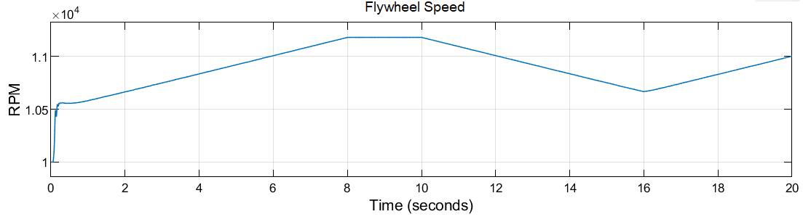

Standby

Charging

Discharging

Charging

Fig. 4. Operation of SCIM-flywheel

Figure 5 shows the applied torque during charge-discharge and the DC link voltage. The flywheel is charged for 8 seconds before switching to standby mode for 2 seconds. Then it is discharged between 10 to16 seconds and charged again for the remaining 4 seconds. The transition between charge, discharge and standby states can be seen in the applied torque in Figure 5a. The initial voltage transients within the first micro seconds is due to high currents drawn by the IM at. The DC voltage stays constant and voltage fluctuations are limited within 5 volts of the rated voltage. It slightly decreases during the charging mode because the IM draws power from the grid. While in standby mode, the DC voltage stays constant.

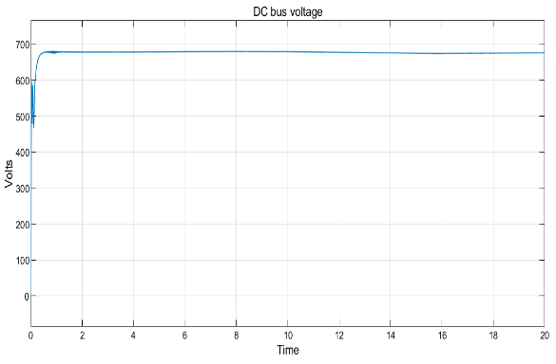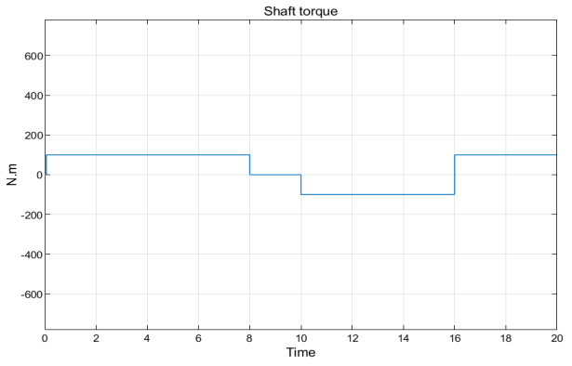

a

b

Charging

Charging

Standby

Discharging

Fig. 5. (a) Torque applied on shaft of IM; (b) Bus voltage as DC link

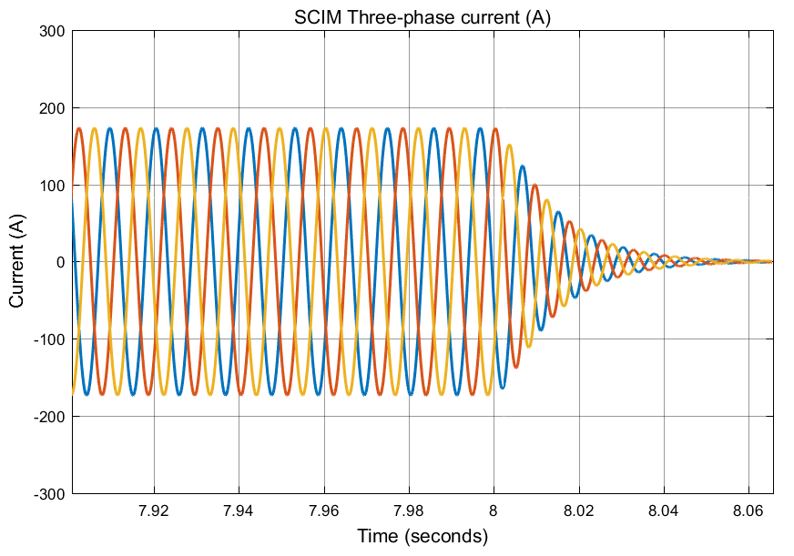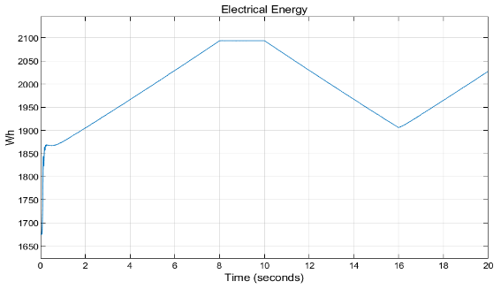

Charging

Standby

Discharging

Charging

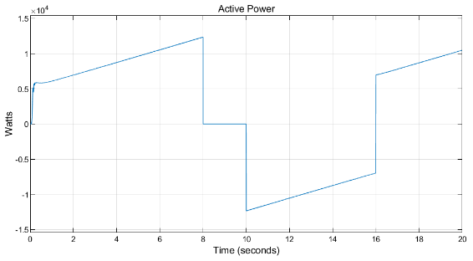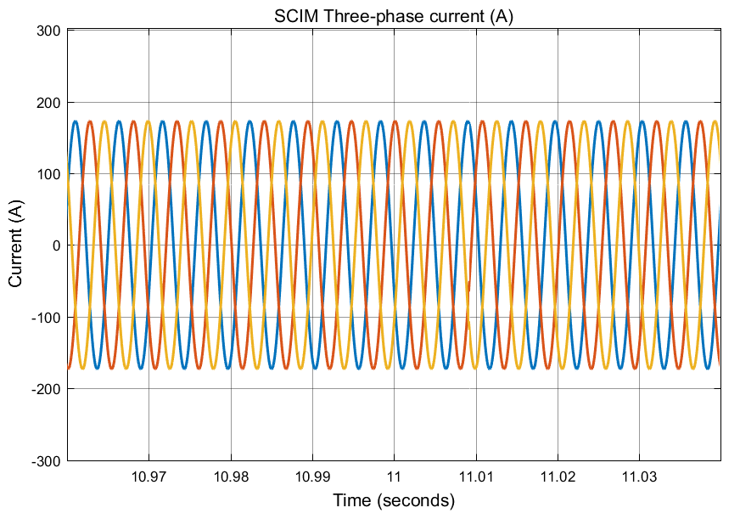

a

b

d

c

Charging

Charging

Standby

Discharging

Fig. 6. (a) IM-flywheel active power flow (b) IM-Flywheel stored energy

(c) IM three-phase steady-state currents (d) IM three-phase currents at transition mode

Figure 6a Shows the active power produced and delivered by the IM-flywheel. Positive power indicates power flow to the flywheel (power drawn from the microgrid) and negative power indicates power flow from the flywheel to microgrid. The active power curve complies with the torque changes during charge-discharge states. Figure 6b shows the energy flow during operation of flywheel. An energy of approximately 2.1kWh is stored by flywheel when it runs for 8seconds in charging mode. As mentioned above, system is designed to store 100kW of power during a course of 2-3 minutes depending on the size of the MG, therefore, energy depicted in figure 6b is not rated energy as the flywheel is only charged for 8 seconds at demonstration level. Figure 6c shows stator currents drawn by the IM during steady-state in discharging mode. Similarly, Figure 6d shows stator currents when flywheel changes mode of operation from charging to standby mode. It can be seen from the figure that the current waveforms are stable during mode changing.

Case 2: PMSM – Flywheel

The operation of PMSM operated flywheel system for different modes of charging, discharging and standby states are shown in Figures 7 and 8. The simulation duration is for 20 seconds with each mode of operation exactly matching with operation of the SCIM-Flywheel for better comparison. The PMSM operates as a motor to charge the flywheel when a positive torque of 100 Nm is applied. When energy is required to be extracted, the torque direction is reversed and a negative torque is applied on the shaft of the machine. It will run as a generator to extract energy from the flywheel and deliver it to the grid. Considering that the flywheel is already at 50% state of charge (SOC) and a positive torque is applied, it starts charging and the speed increases until the applied torque is removed or its direction is reversed. Figures 7a and 7b show the compliance of the applied torque and flywheel charge-discharge cycles respectively. For the first 8 seconds of operation, the flywheel speed increases to 57% and then stays at standby until the mode of operation is switched to discharging at 10 seconds. After staying at standby for a duration of 2 seconds, it starts to discharge again at for 6 seconds and hence the SOC reduces to 52% at the end of 16 seconds. The rate of change of speed is constant since a constant torque is applied at each stage. In real life scenarios this will not be the case and the speed will vary based on the controller command depending on demand and supply. Figure 7c shows PMSM three phase stator currents variations following the changes in applied torque. Due to higher frequency of operation, the current waveforms are not visible and a zoomed in view of the currents is shown in Figure 7d.

c

d

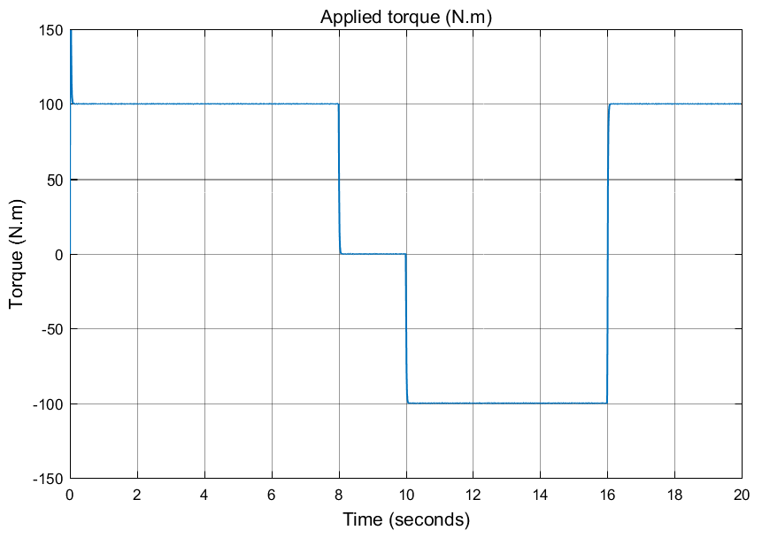

a

Charging

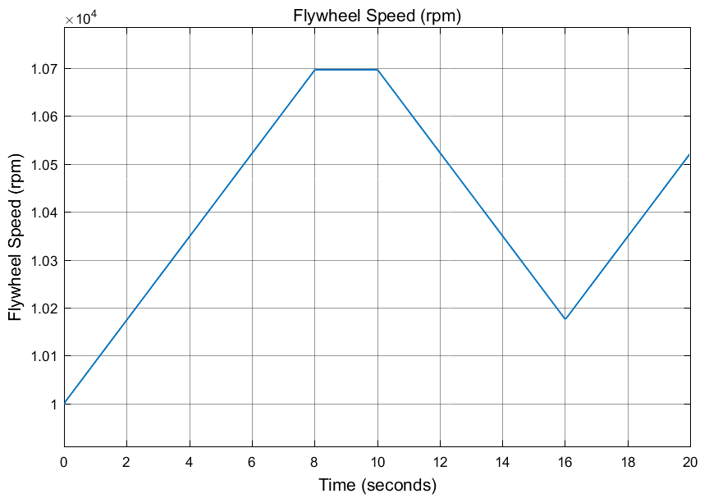

Standby

Discharging

Charging

Charging

b

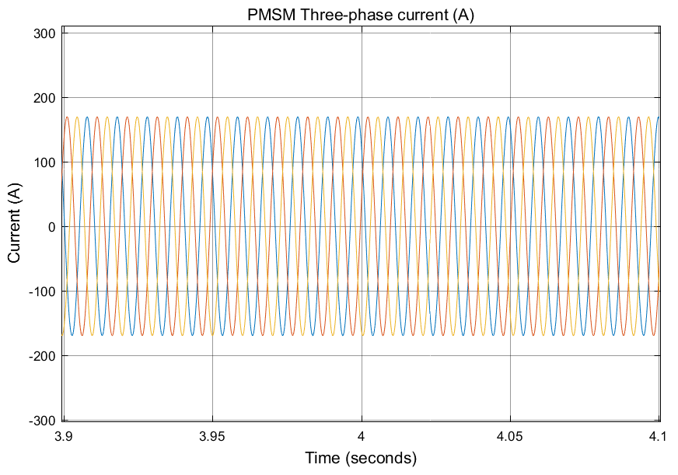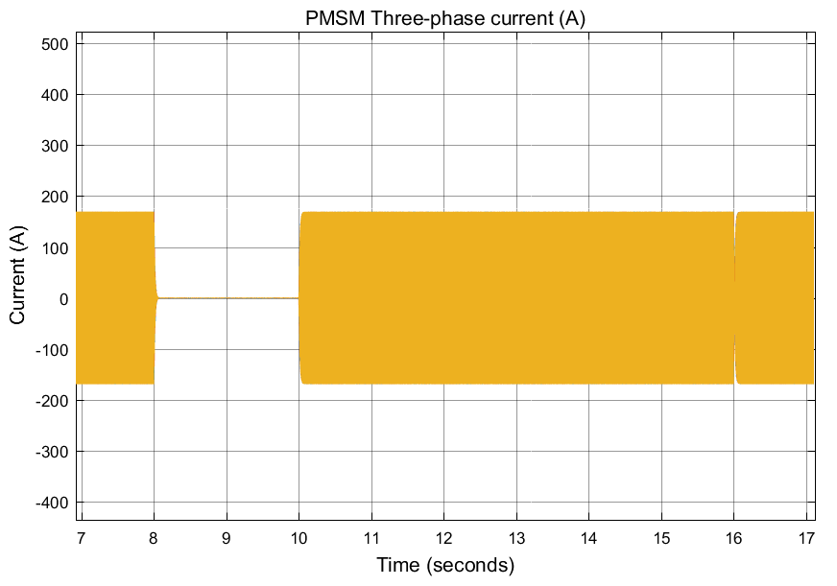

c

d

Charging

Charging

Standby

Discharging

Fig. 7. (a) Torque applied at the shaft of the PMSM-Flywheel; (b) PMSM-Flywheel speed

(c) PMSM three-phase stator currents (d) Zoomed in view of the PMSM three-phase stator currents during steady state

The active power, stored energy, DC-link voltage and current waveforms during the step change are presented in figure 8. Both power and energy waveforms comply with the torque variations during different modes of operations. The transition between charge-discharge states are clearly indicated for each condition. Starting with an initial energy of 1680 Wh, the flywheel stores approximately 300 Wh within the 8 seconds of charging and delivers approximately 180 Wh for the discharging period of 6 seconds. The DC bus voltage for all charge-discharge and standby states is shown in Figure 8c. It complies with the torque and power changes and stays constant independent of states of operation. Lastly, the three-phase stator currents of the PMSM during change of operation from charging to standby mode is shown in Figure 8d. It shows compliance and strength of the controlling scheme with the torque variations during different states of operation.

Charging

Standby

Charging

Discharging

Charging

Charging

Discharging

Standby

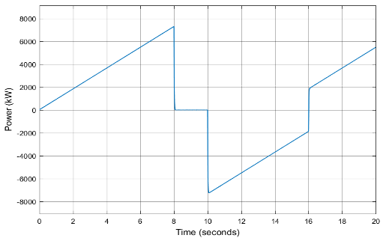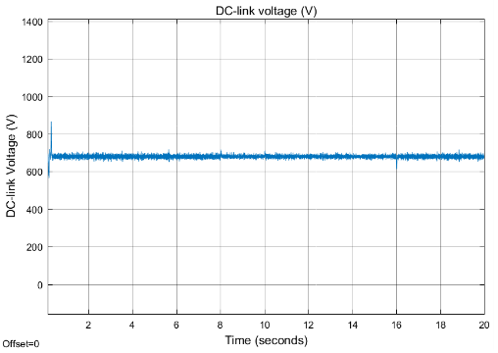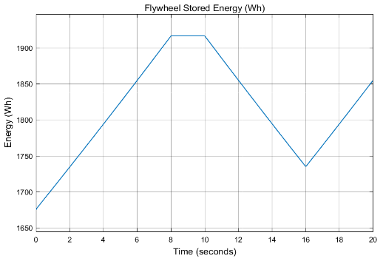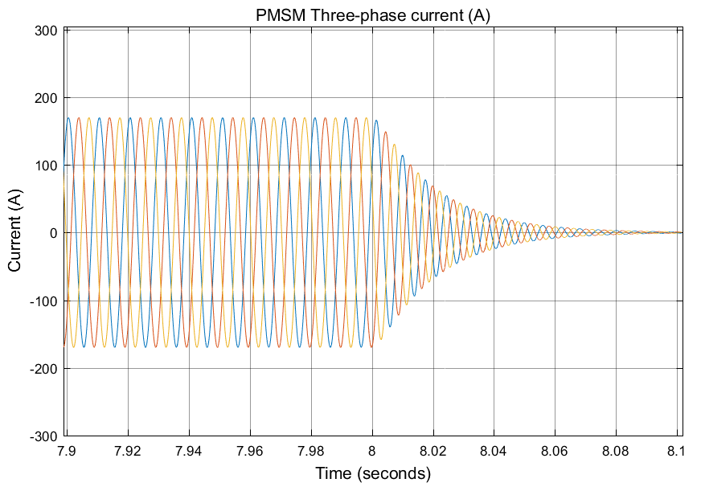

a

d

b

c

Standby

Fig.8. (a) PMSM-flywheel active power flow (b) PMSM-flywheel stored energy

(c) PMSM-Flywheel DC-link voltage; (d) PMSM three-phase currents at transition mode

Figures 9a and 9b show transient current at starting of the operation for SCIM and PMSM, respectively. SCIM causes high starting currents since SCIM works on the principle of transformer with its windings short circuited and it draws high current at constant voltage. This high current through the stator windings produces magnetic field which interact with the rotor conductors. High currents in SCIM can create high losses in the system and higher rating power electronics equipment are required for this reason which increases cost of the system. In contrary, starting currents in PMSM are not high and are within an acceptable limit. Therefore, it generates less heat than SCIM and the losses will be lower as well.

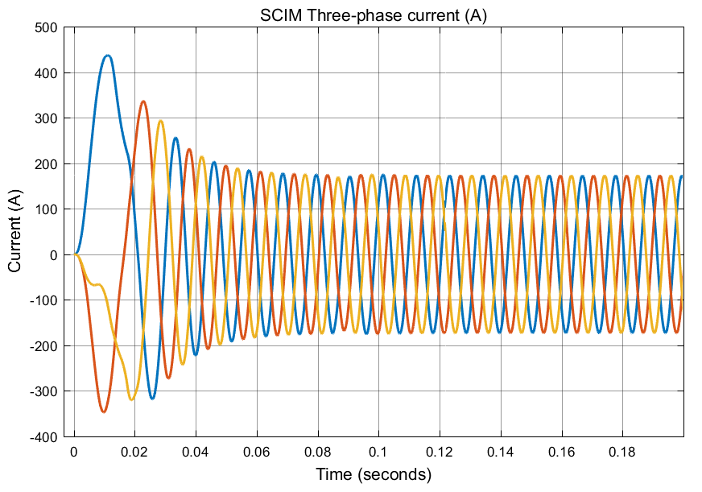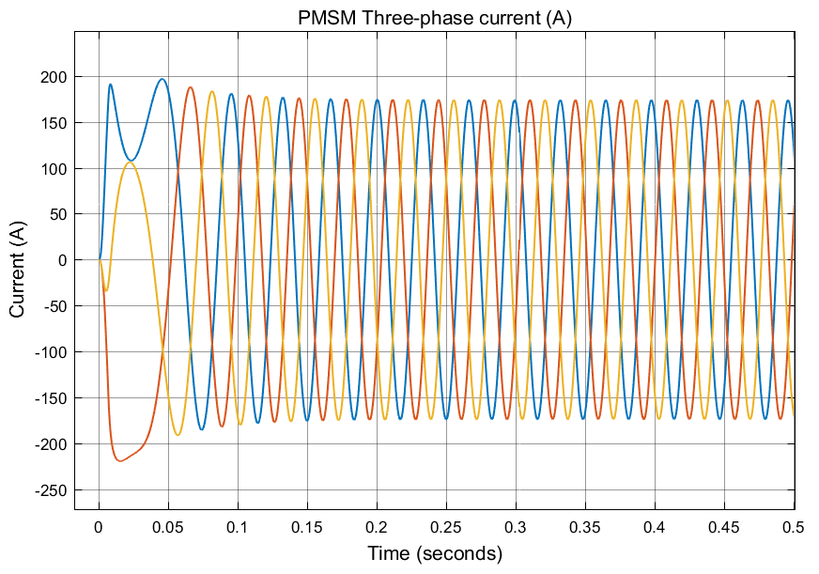

a

b

Fig.9. (a) Transient currents of SCIM at starting (b) Current transients of PMSM at starting

1. Discussion

Based on the simulated results for operation and performance of both IM and PMSM, the dynamic performance of each machine can be analysed. Both machines have operated at different charge-discharge modes and waveforms of three phase stator currents, active power, stored energy and the DC-link voltage have been presented. As the DC-link acts as a bridge between the FESS and microgrid, analysis of the DC bus voltage allows evaluation of the impacts of the FESS on microgrid stability. In both cases, there is no voltage fluctuations at the DC-link and it stays constant irrelevant of the state of the operation of the flywheel. This shows that the operation and communication between the grid side and machine side converters are well controlled by the controllers. Also, due to its nature of operation, the IM draws high inrush current at starting and creates voltage transients at the DC bus. Further, there is a sharp rise in speed curve of the SCIM at the starting, but its charge-discharge cycle turns back to normal after the machine is up and running. Contrary to the case of the IM, the starting currents of the PMSM are not as high as that of induction machine. Importantly, the controllers maintain the DC bus voltage stable as it does not experience voltage transients for longer durations. In addition to DC-bus voltage, the compliance of the applied torque with power flow and three-phase currents show that the models of both IM and SM operated flywheel systems are performing well during transition from one mode to other (charge, discharge and standby) and can be used as testing models for stability analysis. The presented results show that the model of PMSM-Flywheel system shows better performance in comparison to SCIM-Flywheel model with the control systems presented in this research.

1. Conclusions

Energy storage systems have been identified as a key solution for voltage drops, load fluctuations and imbalances between supply and demand. Flywheel energy storage systems with attributes such as fast response time, high depth of discharge and high number of charge-discharge cycles is a strong candidate compared to other storage systems. However, like many other storage systems, FESS may create some stability issues for microgrids due to the type of electrical machine used. This problem must be highlighted and addressed to make a flywheel energy storage system a suitable option for grid applications. In this paper, IM and PMSM operated flywheel systems are discussed, their individual performance during different charging and discharging states are analysed and results are compared. As a general comparison of both machines in FESS charge and discharge cycles, PMSM is relatively better as it has less reactive power requirements, lower starting inrush currents and less dc bus voltage variations in comparison to IM. However, the analytical results indicate that the developed models of both machines show very good performance and can be used for further analysis of FESS. Future work will include developing the IM model for high accuracy performance and addressing the stability and power quality issues of each machine type as well as their impacts on the microgrid beyond the DC link.

References

[1] S.M. Mousavi G, FaramarzFaraji, Abbas Majazi and Kamal Al-Haddad. "A comprehensive review of Flywheel Energy Storage System" *Renewable and Sustainable Energy Reviews, 67: 477-490*.

[2] Amiryar, M.E.; Pullen, K.R. “A Review of Flywheel Energy Storage System Technologies and Their Applications.” *Appl. Sci. 2017, 7, 286*.

[3] Yali Yu, Yuanxi Wang, Guosheng Zhang and Feng Sun. "Analysis of the comprehensive physical field for new flywheel energy storage motor/generator on ships" *Journal of Marine Science and Applications* 26(3) (2015): 407-422.

[4] Stephan J. Chapman. “Induction Motors.”in Stephen W. (ed) *Electric Machinery Fundamentals,*(1991)*.*

[5] Amiryar M.E, Pullen K.R, Nankoo D, “Development of High Fidelity Model for an Electrically Driven Energy Storage Flywheel Suitable for Small Scale Residential Applications”, *Applied Sciences* 8(3), (2018): 453

[6] Francisco Díaz‐González,AndreasSumper,OriolGomis‐Bellmunt.“Introduction to Modern Power Systems”, in*Energy Storage in Power Systems* (2016).

[7] Saeed Teimourzadeh, Farrokh Aminifar, Mahdi Davarpanah. "Microgrid security: Challenged, solution and key considerations." *The Electricity Journal* 30(4) (2017): 43-51.

[9] Jong-Yul Kim, Jin-Hong Jeon, Seul-Ki Kim,Changhee Cho, June Ho Park, Hak-Man Kim, and Kee-Young Nam"Cooperative Control Strategy of Energy Storage System and Mircrosources for Stabiizing the Microgrid during Islanded Operation." *IEEE Transactions on Power Electronics* (2010),25: 12.

[10] Ali AsgharKhodadoostArani, BehroozZaker and Gevork B. Gharehpetian."Induction machine-based flywheel energy storage systems modelling and control for frequency regulation after micro-grid islanding." *International Transactions on Electrical Energy Systems,*27 (2017):2356

[10] G.O Cimuca, C. Saudemont, B.Robyns and M.N.Radulescu. "Control and Performance Evaluation of a Flywheel Energy-Storage System Associated to a Variabel-Speed Wind Generator." *IEEE Transactions on Industrial Electronics*53(4) (2006): 1074-1085

[11] Francisco Díaz‐González,AndreasSumper,OriolGomis‐Bellmunt and Roberto Villafafila-Robles. "Modeling and validation of a flywheel energy storage lab-setup" *In proceedings of3rd IEEE PES Innovative Grid Technologies Europe (ISGT Europe)*(2012)

[23] R. Peña-Alzola, R. Sebastián, J. Quesada, A. Colmenar. "Review of flywheel based energy storage systems" *International Conference on Power Engineering, Energy and Electrical Drives* (2011).

[13] A.A. Khodadoost, Arani, H.Karami, G.B.GharehpetianM.S.A.Hejazi, “Review of Flywheel Energy Storage Systems and application in power system and microgrids”, *Renewable and Sustainable Energy Reviews* 67 (2017):477-490.

[14] Bjorn Bolund, Hand Bernhoff and Mats Leijon, “Flywheel energy and power storage systems”, *Renewable and Sustainable Energy Reviews,*11(2) (2007): 235-258.

[16] Sang-Hoon Kim, “Alternating current motor: Synchronous motor and induction motor” in *Electric Motor Control, DC, AC and BLDC motors* (2017).

[17] Andrzej M. Trzynadlowski, “Dynamic Model of the Induction Motor” in J. David Irwin (ed.) *Control of Induction Motors* (2001)

[18] LuisAmezquita-Brooks ;  Jesus Liceaga-Castro ;  Eduardo Liceaga-Castro, “Speed and Position Controllers Using Indirect Field-Oriented Control: A classical Control Approach”, *IEEE Transactions on Industrial Electronics*, 61(4) (2014):1928-1943.

[19] Kiran Boby, Prof.Acy M Kottalil, N.P.Ananthamoorthy, “Mathematical Modelling of PMSM Vector Control System Based on SVPWM PI Controller Using MATLAB”, *International Journal of Advanced Research in Electrical, Electronics and Instrumentation Engineering*,2 (2013): 689-695.

[20]J. Santiago, J. G. Oliveira, J. Lundin, A. Larsson, H. Bernhoff “Losses in axial-flux permanent-magnet coreless flywheel energy storage systems”*In Proceedings of the200818th International Conference on Electrical Machines* (2008):1–5.

[21] Suresh L, Mahesh K., Janardha M, and Mahesh., “Simulation of Space Vector Pulse Width Modulation for Voltage Source Inverter using MATLAB/Simulink” *Journal of Automation and System Engineering* 8(3) (2014):133-140.

[22] Siva Gangadhara Rao Venna, SnehaVattikonda, SravaniMandarapu “Mathematical Modelling and Simulation of Permanent Magnet Synchronou Motor” *International Journal of Advanced Research in Electrical, Electronics and Instrumentation Engineering* 2(8) (2013): 3720-3726.

[23] Lydia Anu Jose, and K.B.Karthikeyan,”A comparative Study of Sinusoidal PWM and Space Vector PWM of Vector Controlled BLDC Motor” *International Journal of Advanced Research in Electrical, Electronics and Instrumentation Engineering* 2 (2013) 2662-2668.