Interactive impact of severity of childhood maltreatment, depression and age on cortical brain structure: mega-analytic findings from a large multi-site cohort

Leonardo Tozzi, PhD*^{1,2}, Lisa Garczarek*¹, Deborah Janowitz, MD³, Dan J. Stein, PhD⁴, Katharina Wittfeld, PhD^{3,5}, Henrik Dobrowolny¹, Jim Lagopoulos, PhD^{6,42}, Sean N. Hatton, PhD⁶, Ian B. Hickie, MD⁶, Angela Carballedo, MD⁷, Samantha J. Brooks, PhD^{4,40}, Daniella Vuletic, PhD⁴, Anne Uhlmann, PhD^{4,43}, Ilya M. Veer, PhD⁸, Henrik Walter, PhD⁸, Robin Bülow, MD⁹, Henry Völzke, MD¹⁰, Johanna König³, Knut Schnell, PhD^{11,44,45}, Dieter Schoepf, MD, PhD¹², Dominik Grotegerd, PhD¹³, Nils Opel, MD¹³, Udo Dannlowski, PhD¹³, Harald Kugel, PhD¹⁴, Elisabeth Schramm, PhD^{15,16}, Carsten Konrad, MD^{17,18}, Tilo Kircher, MD, PhD¹⁸, Dilara Jueksel, PhD¹⁸, Igor Nenadic, MD¹⁸, Axel Krug, PhD¹⁸, Tim Hahn, PhD¹³, Olaf Steinstraeter, PhD^{18,41}, Ronny Redlich, PhD¹³, Dario Zaremba, MSc¹³, Bartosz Zurowski, MD¹⁹, Cynthia H.Y. Fu, MD, PhD^{20,21}, Danai Dima, PhD^{22,23}, James Cole, PhD²², Hans J. Grabe, MD³, Colm G. Connolly, PhD^{24, 25}, Tony T. Yang, MD, PhD^{24,26}, Tiffany C. Ho, PhD^{24,27}, Kaja Z. LeWinn, ScD^{24,26}, Meng Li⁴⁶, Nynke Groenewold, PhD⁴, Martin Walter, MD^{1,28,46}, Alan N Simmons, PhD^{29,30}, Theo G.M. van Erp, PhD³¹, Neda Jahanshad, PhD³², Bernhard T. Baune, PhD³³, Nic J.A. van der Wee, PhD³⁴, Marie-Jose van Tol, PhD³⁵, Brenda W.J.H. Penninx, PhD³⁶, Derrek P. Hibar, PhD³¹, Paul M. Thompson, PhD³¹, Dick J. Veltman, PhD³⁶, Lianne Schmaal, PhD^{37,38}, Thomas Frodl, MD, PhD^{1,6,39}
*maybe add “for the ENIGMA-MDD Consortium”
*contributed equally

Affiliations
¹Department of Psychiatry and Psychotherapy, Otto von Guericke University, Magdeburg, Germany
2 Stanford University, Department of Psychiatry and Behavioral Sciences, California, USA
³ Department of Psychiatry and Psychotherapy, University Medicine Greifswald, Germany
⁴ MRC Unit on Risk & Resilience in Mental Disorders, Department of Psychiatry and Mental Health, Cape Town, South Africa
5 German Center for Neurodegenerative Diseases (DZNE), Site Rostock/ Greifswald, Germany
⁶ Brain and Mind Centre, University of Sydney, Camperdown, Australia
⁷ Trinity College Institute of Neuroscience, Trinity College Dublin, Ireland
⁸ Division of Mind and Brain Research, Department of Psychiatry and Psychotherapy CCM, Charité - Universitätsmedizin Berlin, corporate member of Freie Universität Berlin, Humboldt-Universität zu Berlin, and Berlin Institute of Health, Berlin, Germany
⁹ Institute for Diagnostic Radiology and Neuroradiology, University Medicine Greifswald, Germany
¹⁰ Institute for Community Medicine, University Medicine Greifswald, Germany and Center of Cardiovascular Research (DZHK), partner site Greifswald
¹¹ Department of General Psychiatry, University Hospital Heidelberg, Germany
¹² Department of Psychiatry and Psychotherapy, University of Bonn, Germany & Department of Psychiatry and Psychotherapy, Vitos Weil-Lahn, Hesse, Germany
¹³ Department of Psychiatry and Psychotherapy, University of Münster, Germany
¹⁴ Institute of Clinical Radiology, University of Münster, Germany
¹⁵ Department of Psychiatry and Psychotherapy, University Medical Center Freiburg, Germany
¹⁶ Psychiatric University Clinic, Basel, Switzerland
¹⁷ Department of Psychiatry and Psychotherapy, Agaplesion Diakoniklinikum, Rotenburg, Germany
¹⁸ Department of Psychiatry and Psychotherapy, Philipps-University Marburg, Germany
¹⁹ Center for Integrative Psychiatry, University of Lübeck, Lübeck, Germany
²⁰ School of Psychology, College of Applied Health and Communities, University of East London, London, UK
²¹ Centre for Affective Disorders, Institute of Psychiatry, Psychology and Neuroscience, King's College London, London, UK
²² Department of Psychology, School of Arts and Social Sciences, City, University of London, London, UK
²³ Department of Neuroimaging, Institute of Psychiatry, Psychology and Neuroscience, King’s College London, London, UK
²⁴ Department of Psychiatry & Langley Porter Psychiatric Institute, UCSF Weill Institute for Neurosciences, University of California, San Francisco, USA
25 Department of Biomedical Sciences Florida State University Tallahassee, FL, USA
26 Department of Psychiatry, Division of Child and Adolescent Psychiatry, University of California, San Francisco (UCSF), USA
27 Department of Psychology and Department of Psychiatry & Behavioral Sciences Stanford University, Stanford CA, USA
²⁸ Department of Psychiatry and Psychotherapy, University of Tuebingen , Germany
29 VA San Diego Healthcare, USA
30 University of California San Diego, USA
³¹ Clinical Translational Neuroscience Laboratory, Department of Psychiatry and Human Behavior, University of California, Irvine, CA, USA
³² Imaging Genetics Center, Mark and Mary Stevens Neuroimaging and Informatics Institute, Keck School of Medicine of University of California, Marina del Rey, CA, USA
³³ Discipline of Psychiatry, School of Medicine, University of Adelaide, SA 5005 Adelaide, Australia
³⁴ Department of Psychiatry, Leiden Institute for Brain and Cognition, Leiden University Medical Center, Leiden, The Netherlands
³⁵ Department of Biomedical Sciences of Cells and Systems, Cognitive Neuroscience Center, University Medical Center Groningen, Groningen, University of Groningen, The Netherlands
³⁶ Department of Psychiatry and Neuroscience Campus Amsterdam, VU University Medical Center, Amsterdam, The Netherlands
³⁷ Orygen, The National Centre of Excellence in Youth Mental Health, Melbourne, Australia
³⁸ Centre for Youth Mental Health, The University of Melbourne, Melbourne, Australia
³⁹ German Center of Neurodegenerative Diseases (DZNE), Site Magdeburg, Germany
⁴⁰ School of Natural Sciences and Psychology, Liverpool John Moores University, Liverpool, UK
⁴¹ Core Facility Brain Imaging, Faculty of Medicine, Philipps-University of Marburg, Germany
⁴² Sunshine Coast Mind and Neuroscience - Thompson Institute, Queensland, Australia
⁴³ Department of Psychiatry, University of Vermont, Burlington, VT, USA
⁴⁴ Department of Psychiatry and Psychotherapy, University Medical Center Göttingen, Göttingen, Germany
⁴⁵ Department of Psychiatry and Psychotherapy, Asklepios Fachklinikum Göttingen, Göttingen, Germany
⁴⁶ Leibniz Institute for Neurobiology, Magdeburg, Germany

Correspondence to:
Thomas Frodl, MD, Department of Psychiatry and Psychotherapy, Otto von Guericke University Magdeburg, Germany, German Centre for Neurodegenerative Diseases, Magdeburg, Tel.: 0049-391-6715029, Email: Thomas.Frodl@med.ovgu.de

Short title: Childhood maltreatment impacts cortical brain structure

Abstract: 237 words, text: 4498, 2 Figures, 2 Tables
Abstract

Background: Childhood maltreatment (CM) plays an important role in the development of major depressive disorder (MDD). Aim of the study was to examine whether CM severity and type are associated with MDD-related brain alterations and how they interact with sex and age.
Methods: Twelve university partner sites within the ENIGMA-MDD network assessed CM and subtypes of CM using the Childhood Trauma Questionnaire and acquired structural magnetic resonance imaging data from patients with MDD and healthy controls (HC) in a mega-analysis comprising a total of 3,872 participants aged between 13 and 89 years. Cortical thickness and surface area were extracted at each site using FreeSurfer.
Results: CM severity was associated with reduced cortical thickness in the banks of the superior temporal sulcus and supramarginal gyrus as well as with reduced surface of the middle temporal lobe. Participants reporting both childhood neglect and abuse had lower cortical thickness in the inferior parietal lobe, middle temporal lobe, and precuneus compared to participants not exposed to CM. In males only, regardless of diagnosis, CM severity was associated with higher cortical thickness of the rostral anterior cingulate cortex. Finally, a significant interaction between CM and age in predicting thickness was seen across several prefrontal, temporal and temporo-parietal regions.
Conclusions: This study represents the largest effort worldwide to identify cortical brain structure differences related to CM in individuals with MDD. Severity and type of CM may impact cortical thickness and surface area. Importantly, CM may influence age-dependent brain maturation, particularly in regions related to the default mode network, perception and theory of mind.

Key Words: major depressive disorder (MDD), cortical thickness, childhood maltreatment, ENIGMA

Introduction

According to the Centers for Disease Control and Prevention, childhood maltreatment (CM) is defined as “any act or series of acts of commission or omission by a parent or other caregiver that results in harm, potential for harm, or threat of harm to a child” (Leeb, 2008). CM may be physical, sexual or emotional and may result in inadequate environmental input (e.g., deprivation or neglect) or excessive harmful input (Sheridan and McLaughlin, 2014). About one quarter of all adults have encountered CM in their life (Butchart and Mikton 2014); this statistic may even be higher as a history of childhood adversity is likely under-reported. In fact, a recent meta-analysis has found that over half of children globally had experienced violence in just the past year alone (Hillis et al., 2016). In a large birth cohort in Brazil, it was found that emotional abuse and exposure to domestic violence predicted increased risk for major depression for females, while CM did not predict depression onset in males (Gallo et al., 2017).
Given the prevalence of CM, this is especially alarming as CM is strongly associated with a wide range of adverse consequences, not only causing suffering in the immediate aftermath, but long-term detrimental effects to mental and physical health. Children with a history of CM are more prone to smoking and obesity, as well as of being perpetrators and victims of violence (WHO, 2016, November). Notably, CM is one of the strongest factors in the development of major depressive disorder (MDD) (Bernet and Stein, 1999), the leading cause of disability worldwide according to the World Health Organization, with increasing rates over the past decade (WHO, 2016, November).
As both CM and MDD have a high incidence in the general population, the interplay between these two phenomena is important to investigate, both for prevention and treatment. Depressed patients with CM, for example, respond more poorly to antidepressant treatment than those without CM (Nanni et al., 2012). CM and MDD may be causally linked, as MDD is a disorder characterized by pathological responses to stress (Frodl et al., 2008). Both prospective and retrospective reports of maltreatment were found to be associated with adult psychiatric problems in a recent study, though the strongest associations were found when maltreatment was retrospectively self-reported (Newbury et al., 2018). In that study, it was also shown that young adults who recall being maltreated have a particularly elevated risk for psychopathology.
In experimental studies, chronic social stress induces glucocorticoid-mediated pyramidal dendrite retraction in the hippocampus and changes in dendrite arborization in the prefrontal cortex (PFC) (Kole et al., 2004, Magarinos et al., 1996, Wellman, 2001, Woolley et al., 1990), which may be associated with the behavioral manifestations of stress-related disorders like MDD (Macqueen and Frodl, 2010).
Based on the extant literature, one hypothesis is that CM in humans acts as a chronic stressor contributing to changes of brain structure and function, which in turn may increase vulnerability to psychiatric disorders such as MDD. Supporting this theory, CM was found to be associated with reduced brain volumes in the amygdala, prefrontal cortex and cerebellum (Dannlowski et al., 2012, Edmiston et al., 2011, Frodl et al., 2010, Teicher et al., 2016) - regions also reported to be affected in MDD. In the largest meta-analysis to date performed by the “Enhancing Neuro Imaging Genetics through Meta-Analysis” (ENIGMA) MDD consortium, we found thinner cortices in the bilateral medial orbitofrontal cortex (OFC), fusiform gyrus, insula, rostral anterior cingulate cortex (rostral ACC) as well as posterior cingulate cortex (PCC) and unilaterally in the left temporal gyrus, right inferior temporal gyrus and right caudal ACC in adult patients with MDD compared to controls (Schmaal et al., 2017). These findings are consistent with a recent large-scale meta-analysis of voxel-based morphometry studies (Wise et al., 2016).
A dose-response relationship of CM on medial prefrontal gray matter volume was also detected irrespective of diagnosis with MDD or anxiety (van Harmelen et al., 2010). Previously, in an ENIGMA-MDD mega-analysis focusing on subcortical structures, CM also was found to be associated with lower caudate volume in females. Those alterations were more strongly associated with emotional and physical neglect than with other forms of CM (Frodl et al., 2017a).
Research in animals and humans also suggests important distinctions between types of CM on brain structure. Specifically, researchers theorized that experiences characterized by deprivation (e.g., emotional and physical neglect) compared with experiences characterized by threat (e.g., emotional abuse and physical violence) lead to different effects on neuronal development (McLaughlin et al., 2014a). A community study in 287 adolescents showed that exposure to threat and violence was associated with automatic emotion regulation deficits, but not cognitive control disturbances. In contrast, exposure to poverty was associated with worse cognitive control, but no deficits automatic emotion regulation. On the other hand, both violence and poverty predicted poor inhibition in an emotional context (Lambert et al., 2017). Interestingly, children exposed to severe deprivation in the form of institutional rearing exhibited widespread cortical thinning in the superior and inferior parietal cortex (McLaughlin et al., 2014b), and children exposed to neglect often have deficits in language abilities (Farah et al., 2006). Individuals with a history of deprivation showed smaller gray matter volumes compared with individuals with a history of abuse in the fusiform gyrus and the middle occipital gyrus (Everaerd et al., 2016). Therefore, exploring effects from different types of CM on brain structure was an important goal of the current study.

In this mega-analysis we first aimed to investigate the association between CM severity and cortical brain structure in MDD patients and healthy subjects. We hypothesized that more severe CM would be related to lower cortical thickness and surface area, especially of the OFC, ACC, medial prefrontal cortex and insula - regions affected in adult MDD (Fischl et al., 2002) and involved in emotion regulation (Desikan et al., 2006). We also explored whether reductions of cortical thickness and surface area would be specifically associated with CM severity, depression or both. We hypothesized that MDD patients with a more severe history of CM would show smaller cortical brain measures than healthy controls with a similar history of CM. Prior studies detected effects of CM on hippocampal volume (Frodl et al., 2017a) and dorsomedial prefrontal cortex volume (Frodl et al., 2017b) irrespective of diagnosis, but did not fully consider the severity of CM. Second, we investigated the associations of CM type with brain structures. Third, we investigated interactions of CM with sex and age. We hypothesized these changes to be more prominent in females than males and thus investigated the interactions between sex and CM on brain structure. Furthermore, given the large sample size and wide age range, we aimed to explore interactive effects of CM with age effects on brain structures
Methods and Materials

Samples
In the current study, twelve international sites participating in the ENIGMA MDD Workgroup with information on CM agreed to participate in the Childhood Adversity Subgroup. Detailed demographics and clinical characteristics for each sample may be found in eTables 1 and 2. Most studies used SCID-1, CIDI or another form of standardized interview (eTable 3). Exclusion criteria for study enrollment are given in eTable 3. In total, we analyzed data from 3,872 participants: 1,284 patients with MDD and 2,588 healthy controls (HC). All participating sites obtained approval from local institutional review boards and ethics committees. In addition, this mega-analysis was approved by the ethics board of the medical faculty of the Otto von Guericke University Magdeburg, Germany. All study participants provided written consent at their local site. In case of adolescent participants, parent/legal guardian provided written consent and the adolescent provided written assent.

Assessment
Severity of CM (CM-severity) was measured across all sites with the Childhood Trauma Questionnaire (CTQ) (Bernstein et al., 1994). The short form of the CTQ is a standardized self-report instrument consisting of 28 items containing five major subscales of childhood maltreatment. Each one also features a cut-off to determine the presence of emotional (>=12), physical (>=10) and sexual abuse (>=8) or emotional (>=15) and physical neglect (>=10). Three additional items remained to provide information on responders’ tendencies toward minimization and denial. For our analyses, we assessed CM in two ways. First, based on a score above the cut-off for at least one of the abuse or neglect subscales we divided our participants into 4 groups (CM-type): no CM, neglect (no abuse), abuse (no neglect), abuse+neglect. In a second analysis, we explored the effect of CTQ total sum score as a continuous variable (CM-severity).
Severity of depressive symptoms at time of scanning was measured in some sites with the Hamilton Depression Questionnaire (HDRS-17), in others the Beck Depression Inventory (BDI-II) or Inventory of Depressive Symptomatology-Self Report (IDS-SR) was used. Age of onset and antidepressant medication use at the time of scan were also recorded in 11 and 12 sites respectively.

Image processing and analysis
Participants all underwent structural T1-weighted MRI brain scans locally at each site, where scans were analyzed using the fully-automated and validated segmentation software FreeSurfer (version 5.0 or higher) (Fischl et al., 2002). Image acquisition parameters and software descriptions for each sample are given in eTable 4. Deep brain structure volumes were extracted and visually inspected for segmentation accuracy. Parcellations for cortical thickness and surface area of 68 (34 left and 34 right) regions based on the Desikan-Killiany atlas (Desikan et al., 2006) and left and right hemisphere measures were derived and visually inspected for accuracy following protocol designed to facilitate harmonized image analysis across multiple sites (http://enigma.ini.usc.edu/protocols/imaging-protocols/). Association between CM and subcortical measures were previously published (Frodl et al., 2017a).

Statistical framework of mega-analysis
Statistical analyses were performed using SPSS statistics (version 24).
We performed ANOVAs, or Kruskal-Wallis tests as appropriate, to compare at scan, age at MDD onset, clinical severity of depression and CTQ scores between groups and cohorts. Chi-squared tests were used to analyze differences between frequencies of males and females.
Then, we built generalized estimating equations (GEE) models with thickness or surface area of each region as the dependent variable. Our models had a linear scale response. All participants were included, irrespective of diagnosis. The independent between-subject variable CM was defined in two ways: as the factor CM-type (0=no CM, 1=neglect, 2=abuse, 3=neglect+abuse) or as CM-severity (continuous: total CTQ). Each of these variables was included in separate models. In all models we included the between-subjects factors diagnosis (factor: 1=patients, 0=healthy controls), sex (factor: 0=males, 1=females) and the within-subject factor hemisphere (left, right). Age (continuous), neuroimaging cohort (factor) and total intracranial volume (continuous) were used as between-subject covariates. FreeSurfer version and scanner type were comprised in the factor neuroimaging cohort. As we did not expect CM-severity effects to be lateralized, hemisphere was only included as a main effect. Our prior research showed differential effects of CM-severity in predicting the volume of subcortical structures depending on sex and MDD diagnosis (Frodl et al., 2017b). Therefore, we explored in our models all possible interactions between CM, sex and diagnosis for both surface and thickness. To assess the effect of CM across all brain areas, we first ran analyses on the total thickness and surface across all regions respectively, adding region as a within-subject factor. Then, we repeated the process for each region individually. Finally, we explored the interaction between age and severity of CM while keeping all other terms in the model as main effects.
In all models, Wald chi-squared tests were used to assess the significance of each term. To account for multiple tests (34 regions), a false discovery rate (FDR) correction was computed on the resulting p-values. Findings were considered significant if p_{FDR}<0.05. Any significant interactive effects resulting from the models described above were followed up with post-hoc testing.

Investigation of clinical confounds
A subset of our MDD cohort (N=965) had more detailed clinical information and allowed us to explore additional potential confounding effects. Therefore, we investigated if thickness or surface of all regions were significantly predicted by clinical severity (continuous: BDI total score, since HAM-D was available only for a minor subset of participants), recurrence (factor: 0=first episode, 1=recurrent episode), current antidepressant use (factor: 0=no, 1=yes), remission (factor: 0=currently remitted, 1=currently depressed), age of depression onset (continuous). We did so by building GEE models that featured these measures as predictors (main effects), together with age, sex, site, hemisphere and total intracranial volume. Detailed information on this subsample is presented in eTable 14.

Results

Demographics
For details on participant’s demographics and clinical features, see Table 1. Overall, data significantly differed between centers with respect to sex, age, CTQ scores and clinical features (see eTable 5). Frequency of co-occurrence between abuse and neglect is 12.7%. CM severity of influenced by abuse and neglect to a similar extend (beta=0.41 and beta=0.42, respectively).

Cortical Thickness
Main effects of CM-severity
A summary of all significant findings is reported in Table 2. For an overview of the results of the models run on each region, see eTable 6.
We detected a significant main effect showing an inverse relation between CM-severity and thickness of the banks of the superior temporal sulcus (Wald chi-squared=14.583, p_{FDR}=0.033, B=-0.001, Figure 1). A significant main effect of CM was also present on thickness of the supramarginal gyrus (Wald chi-squared=8.889, p_{FDR}=0.049, B=-0.001, Figure 1).

CM-severity and sex interaction
When considering all regions, the interaction between CM-severity and sex was significant (Wald chi-squared=5.220, p=0.022). Dividing the data by sex, post-hoc analyses showed a significant negative effect of CM-severity on cortical thickness in females (Wald chi-squared=4.861, p=0.027, B=-0.000649), but not in males (Wald-chi-square=1.287, p=0.257, B=-0.000136).
When running models for each region separately, we found a significant interaction between CM-severity and sex on cortical thickness of the rostral anterior cingulate cortex (Wald chi-squared=13.556, p_{FDR}=0.008). Post-hoc analysis revealed a significant positive effect of CM-severity on cortical thickness of this region in males (Wald chi-squared=14.426, p<0.001, B=0.002, Figure 1) but not in females (Wald chi-squared=3.174, p=0.075, B=-0.0006).

CM-severity and age interaction
When considering all regions, a significant interaction between age and severity of CM was detected (Wald chi-squared=11.105, p=0.001, B=-0.000035).
Models ran for each region separately indicated that this interaction between age and severity of CM was significant across all participants in the rostral anterior cingulate, isthmus of the cingulate, posterior cingulate, lateral orbitofrontal gyrus, parahippocampal gyrus, inferior frontal gyrus (IFG) pars opercularis, IFG pars triangularis, superior frontal gyrus, banks of the superior temporal sulcus, cuneus, fusiform gyrus, insula, precentral gyrus, precuneus, supramarginal gyrus and transverse temporal gyrus (see Table 3, eTable 7, Figure 3). Similar results were found when using CM type in the analysis (see Table 3, eTable 11, Figure 3).

Main effects of CM-type
We found a significant main effect of CM type (eTable 10) in the banks of the superior temporal sulcus (Wald chi-squared=19.888, p_{FDR}=0.006), inferior parietal lobe (Wald chi-square=15.273, p_{FDR}=0.023), middle temporal lobe (Wald chi-squared=12.123, p_{FDR}=0.048), precuneus (Wald chi-squared=15.325, p_{FDR}=0.023) and supramarginal gyrus (Wald chi-squared=13.990, p_{FDR}=0.026). In all cases, the neglect+abuse group had lower mean thickness values compared to the no CM group (all p<0.01, Figure 1) and there was no difference between the abuse only as well as neglect only CM types and the no CM group.

CM-type and age interaction
The interaction between age and type of CM was significant across all participants for most regions (see Table 3, eTable 11). In all cases, the effects of age were more negative in the neglect+abuse group compared to the CM group (all p<0.05).

Cortical Surface
A summary of all significant findings is reported in Table 2. For an overview of the results of the models run on each region, see eTable 8.

Main effects of CM-severity
Across all regions, a negative main effect of CM-severity on cortical surface area was observed (Wald chi-squared=4.413, p=0.036, B= -0.414). When running separate models for each region (eTable 8), we detected a significant inverse main effect of CM-severity on surface area of the middle temporal gyrus (Wald chi-squared=12.368, p_{FDR}=0.015, B=-1.504, Figure 2).

CM-type diagnosis and sex interaction
We found a significant interaction between CM type, diagnosis and sex (eTable 12) in the caudal anterior cingulate (Wald chi-squared=17.807, p_{FDR}<0.001). Post-hoc testing revealed that, in depressed males, those having suffered from either abuse or neglect had lower average cortical surface of the caudal anterior cingulate cortex than those who had no history of CM (p=0.003 and p=0.017 respectively, Figure 2).

Investigation of clinical confounds
Our post-hoc investigation in a subset of patients with detailed information showed no significant effects of clinical variables on thickness or surface (all p>0.05). See eTable 15 and eTable 16 for the model effects.

Discussion
In the present study, we investigated the association between CM and cortical brain structure in a large sample of MDD patients and healthy subjects. We show that CM has a subtle but widespread effect on cortical thickness and surface, which is likely influenced by sex and age.
Two procedures of describing CM were used. First, the continuous measure of CM severity allowed for a continuous analysis and the second classification in no CM, only neglect, only abuse and both abuse and neglect allowed for an analysis of type of CM. It should be highlighted that participants exposed to both neglect and abuse also had higher total CM values.
Severity of CM was associated with lower mean cortical surface area regardless of region across all MDD patients and healthy controls. In women, higher severity of CM was also associated with thinner thickness across all regions. These findings are consistent with prior research showing widespread effects of severity of CM on the brain irrespective of psychopathological status (Chaney et al., 2014).
Regardless of diagnosis, when individual regions were investigated this effect of CM severity survived correction for multiple testing in temporal and temporo-parietal regions. Specifically, participants with higher CM severity had significantly thinner cortex in the banks of the superior temporal sulcus and the supramarginal gyrus. When considering type of abuse, high severity of CM, represented by concurrent childhood neglect and abuse, was once again associated with reduced thickness in these two areas and additionally in the precuneus, middle temporal lobe and inferior parietal cortex. Moreover, participants with higher severity of CM also showed smaller surface area of the middle temporal gyrus. The magnitude of these negative effects on thickness and surface area pointed towards a reduction around 0.001 mm of thickness and around 1.5-5.1 mm² of surface with each one-point increase in CTQ score depending on the brain region. This means that an increase of 100 points in the CTQ scale is associated with a 0.1mm (or 4 %) decrease of cortical thickness e.g. in the banks of the superior temporal sulcus. The middle temporal lobe is thought to be essential for our ability to understand actions and semantic associations (Davey et al., 2016). One possibility is that CM may lead to difficulties in semantic retrieval through alterations in regions of temporal cortex and the default mode network. Indeed, other studies have also demonstrated that individuals with higher severity of CM showed reduced cortical surface on the left middle temporal area and lingual gyrus (Kelly et al., 2013). In contrast, in a study of adolescents and young adults exposed to CM, increased cortical volume was observed in the left inferior and middle temporal gyri relative to healthy controls (Lim et al., 2018). In the present study, the other regions we report showing an impact from CM type are located in the temporo-parietal area and around the temporo-parietal junction; both of these regions play a role in theory of mind processing which is important during daily social interactions (Saxe and Kanwisher, 2003). Deficits in these areas might suggest a disadvantage for subjects with a history of CM, in particular those with increased severity and more types of CM. No significant main effects of severity of CM were detected for other regions we hypothesized to be vulnerable. For example, prior studies found a significant main effect of CM in different regions such as fronto-limbic areas, visual cortex, and cerebellum (Kelly et al., 2013, Yang et al., 2017). This might be due to smaller sample sizes and more homogeneity in prior studies: in our analysis, which features a larger sample size of N=3,872, we detected an overall effect of severity of CM on the whole cortex with some prominence in the temporal and temporo-parietal regions.
Another interesting finding was that males, but not females, with a more severe history of CM, regardless of diagnosis, showed distinctly thicker rostral anterior cingulate cortices. These results suggest sex differences in the effects of CM on the structure of this region (Canu et al., 2015, Fallucca et al., 2011). The anterior cingulate cortex is involved in emotional and inhibitory processes (Garavan et al., 2006, Steele et al., 2013). Thus, males seem to be particularly sensitive to CM with regards to thickness in a region relevant for emotion regulation and might show a reactive increase of thickness. Whether this thickness increase of the rostral ACC is adaptive cannot be effectively addressed in the current sample, as longitudinal data and resiliency measures were not available for the bulk of the cohort. In this context, it is interesting that male patients with a history of neglect and abuse had significantly smaller surface areas of the caudal ACC compared to those without CM, pointing towards a negative effect of CM in the caudal ACC in participants who developed MDD. In healthy subjects such an effect of CM was not seen in the caudal ACC and we could tentatively ascribe to resilience (Feder et al., 2009).

Childhood Maltreatment by Age Interaction
A novel finding detected in our secondary analysis was that CM severity and age interacted regardless of diagnosis to predict both the thickness and surface area of several regions involved in emotional processing, such as portions of the cingulate, orbitofrontal, insular, dorsolateral prefrontal and medial prefrontal cortices. In these areas, older people including patients and controls with higher CM severity had lower cortical thickness. The orbitofrontal and dorsomedial prefrontal cortices can be seen as separate networks interacting closely with limbic structures, but also showing cortico-cortical interconnections with each other (Ongur and Price, 2000, Phillips et al., 2008). These regions allow the brain to process emotionally salient information and help with the regulation of emotional behavior (Phillips et al., 2008). The insula is closely interconnected with the orbitofrontal cortex and is involved in emotion and executive processing as well as working memory (Levens and Phelps, 2010). The cingulate cortex is also well known to have cognitive and emotional functions: its dorsal parts are involved in emotion evaluation, whereas the ventral parts and the dorsomedial prefrontal cortex are involved in emotion regulation (Etkin et al., 2011). Overall, these results are consistent with previous studies showing that CM-severity impacts regions involved in emotion regulation, including the insula (Teicher et al., 2014).
Our cross-sectional data suggests that cortical thickness might decrease more rapidly with age in individuals with a more severe history of CM. although this still needs to be confirmed by longitudinal analyses. It will be critical for future studies to assess the effects of abuse across multiple timepoints and to put it in relation to the age of participants.

Diagnosis and CM interactions
In the present study, no effect of diagnosis was detected and we also did not find a significant interaction between diagnosis and CM. It is possible that we could not replicate the main effect of MDD diagnosis on OFC and ACC thickness because of the smaller sample size of the current study (overall N=3,872) compared to the sample size in our previous ENIGMA MDD meta-analysis that focused on the effects of MDD (overall N=10,105, Schmaal et al., 2017). However, since this is the largest joint mega-analysis concerning cortical thickness and CM to date, this null finding could also suggest that the effects of MDD commonly reported in studies and meta-analyses could be the result of the interaction of several underlying variables. For example, different effects of MDD depending on age and onset were already highlighted in Schmaal et al., 2017. Our findings suggest that CM could be another factor that accounts for part of the structural differences between depressed patients and healthy controls.

Strengths and Limitations
A major strength of the study is the large sample size with a relevant control sample allowing inclusion of all 34 left and right cortical brain regions in the analyses. However, a larger sample from different sites also limits the common information collected, since not all sites used the same assessments. Not all patients were drug free and, further, the history of antidepressants use as well as duration, type and dosage of antidepressant treatment was not assessed completely during the lifetime, so we cannot rule out effects of antidepressant exposure influencing our results. Additionally, psychopathology was assessed with different ratings, so that it was not possible to use depression severity as a single covariate in the analysis. Overall, the datasets from the different samples included in the mega-analysis were significantly heterogeneous regarding demographics and clinical features. This is a common limitation of multi-site analyses and we accounted for this effect by adding site as a covariate to all of our models. It is worth noting that we were able to analyze the influence of clinical confounds in a subset of our MDD cohort, where we did not find any significant effect of recurrence, antidepressant medication, remission, severity or age of depression onset in predicting cortical thickness or surface. In particular, currently remitted patients represented only 13.5% of this subset and we consider the impact of their inclusion at some sites negligible. However, measures of socioeconomic status and education have been shown to play a role in brain structure (Ritchie et al. 2018), but were unfortunately unavailable in our sample. Finally, we considered hemisphere as a within-subject effect in our dataset. Our hypothesis was that CM would affect anatomically distinct regions differently rather than be selective for a specific region on a specific hemisphere. Therefore, we believed that including all possible interactions between regions and hemisphere would lead to an unnecessarily complex model. However, it is possible that besides the bilateral effects we report, subtler lateralized effects of CM might exist in specific areas.

Even if our investigation features the broad variation of “real life” clinical populations, future studies are needed to confirm our findings in carefully controlled datasets. Here, we explored the effect of CM in a sample of healthy participants and patients with MDD. Because it is not clear how the severity or type of CM may affect the development of structural brain measures, it will be important to consider the onset and timing of CM in future (Ho et al., 2018). In addition, future longitudinal data are required to establish whether cortical thickness might decrease more rapidly with age in individuals with a more severe history of CM, as our current cross-sectional data may suggest. For this analysis, while it was possible to use extracted cortical measures from specific regions of interest, it was not possible to retrospectively analyze the original MRI datasets to perform a whole-cortex analysis with FreeSurfer. A surface-based analysis across the entire cortex may afford more sensitivity in detecting effects of CM and thus could be a future step.

Conclusions
The results of our study support the idea that CM-severity appears to affect the structure of temporal and parietal regions in particular. Thus, there are effects in the default mode network and in regions related to the theory of mind as well as to perception. Interestingly, CM may interact with the effect of age on cortical thickness in regions involved in emotion regulation, theory of mind as well as belonging to the default mode network. Thus, future studies should investigate if subjects with a history of CM may be more prone to cortical thinning during ageing or if CM results in changes that mimic ageing.

Acknowledgments:

The ENIGMA-Major Depressive Disorder working group gratefully acknowledges support from the NIH BD2K award, U54 EB020403. The infrastructure for the NESDA study (www.nesda.nl) is funded through the Geestkracht program of the Netherlands Organisation for Health Research and Development (Zon-Mw, grant number 10-000-1002) and is supported by participating universities (VU University Medical Center, GGZ inGeest, Arkin, Leiden University Medical Center, GGZ Rivierduinen, University Medical Center Groningen) and mental health care organizations, see www.nesda.nl. Lianne Schmaal is supported by The Netherlands Brain Foundation Grant number F2014(1)-24 and the Neuroscience Campus Amsterdam Scientific Excellence grant (IPB-SE-15-PSYCH-Schmaal).

The Münster Neuroimaging Cohort was funded by the German Research Foundation (SFB-TRR58, Projects C09 and Z02 to UD) and the Interdisciplinary Center for Clinical Research (IZKF) of the medical faculty of Münster (grant Dan3/012/17 to UD).

FOR2107-Marburg was funded by the German Research Foundation (DFG, grant FOR2107 KI588/14-1, KI588/15-1, KI588/14-2, KI588/15-2 to TK, KR3822/5-1 to AK).

FOR2107-Münster was funded by the German Research Foundation (DFG, grant FOR2107 HA 7070/2-2 to TH; DA1151/5-1 and DA1151/5-2 to UD).

ENIGMA was supported in part by a Consortium grant (U54 EB020403 to PMT, DPH, NJ) from the NIH Institutes contributing to the Big Data to Knowledge (BD2K) Initiative, and by R01 MH116147 and R56 AG058854. Moreover, an NIH BD2K award, U54EB020403 to T.G.M. van Erp.

London: This paper represents independent research [part] funded by the National Institute for Health Research (NIHR) Biomedical Research Centre at South London and Maudsley NHS Foundation Trust and King’s College London. The views expressed are those of the author(s) and not necessarily those of the NHS, the NIHR or the Department of Health and Social Care.

SHIP: The Study of Health in Pomerania (SHIP) is supported by the German Federal Ministry of Education and Research (grants 01ZZ9603, 01ZZ0103 and 01ZZ0403) the Ministry of Cultural Affairs as well as the Social Ministry of the Federal State of Mecklenburg-West Pomerania. MRI scans were supported by Siemens Healthcare, Erlangen, Germany. SHIP-LEGEND was supported by the German Research Foundation (GR1912/5-1).

Dublin: The study was supported by an Science Foundation Ireland (SFI) Stokes Professorship Grant to Thomas Frodl

San Francisco: This work was supported by the Brain and Behavior Research Foundation (formerly NARSAD) to T.T.Y.; the National Institute of Mental Health (R01MH085734 to T.T.Y.; K01MH097978 to K.Z.L.; K01MH117442 to T.C.H.) and by the American Foundation for Suicide Prevention (PDF-1-064-13) to T.C.H.
Disclosures:

Nic van der Wee has consulted for Lilly, Wyeth, Servier, Pfizer and GlaxoSmithKline
Thomas Frodl has received fees for presentations for educational programs with Servier, Janssen and Lundbeck
Hans Grabe has consulted for Fresenius Medical Care
Carsten Konrad received fees for an educational program from Aristo Pharma, Janssen-Cilag, Lilly, MagVenture, Servier, and Trommsdorff as well as travel support and speakers honoraria from Aristo Pharma, Janssen-Cilag, Lundbeck, Neuraxpharm and Servier.
Theo G.M. van Erp has consulted for Roche Pharmaceuticals, Ltd., and has a contract with Otsuka Phamaceutical Co., Ltd (OPCJ).
Knut Schnell has consulted for Roche Pharmaceuticals and Servier Pharmaceuticals

Legends

Figure 1: Effect of CM predicting predicting cortical thickness. Coefficients for the GEE model term CM severity or those for the neglect+abuse group compared to the no-CM group are plotted on an inflated left brain hemisphere (effects were bilateral). Only the neglect+abuse group was different from the no-CM group. CM=childhood maltreatment, GEE=generalized estimating equations.

Figure 2: Effect of CM predicting cortical surface. Coefficients for the GEE model term CM severity or those for the abuse only group compared to the no-CM group are plotted on an inflated left brain hemisphere (effects were bilateral). The neglect group showed a similar result in the same region. CM=childhood maltreatment, GEE=generalized estimating equations.

Figure 3: Effect of CM*Age predicting cortical thickness. Coefficients for the GEE model term CM severity*Age or those for Age in the abuse + neglect group compared to the no-CM group are plotted on an inflated left brain hemisphere (effects were bilateral). CM=childhood maltreatment, GEE=generalized estimating equations.

Table 1: Demographic and clinical Data. CTQ = Childhood trauma questionnaire. ICV= total intracranial volume. BDI#= Beck Depression Inventory. HDRS-17#= Hamilton Depression Rating Scale. Shown are mean values +- standard deviation. †Mann Whitney U test used, #From sites that used these ratings.

Table 2: Main findings derived from the GEE models not including the interaction of childhood maltreatment and age. Only significant effects of interest are shown, for all effects see supplemental tables. Coefficients are listed for the model term CM severity or those for the neglect+abuse group, with the exception of †neglect group. CM=childhood maltreatment, FDR=false discovery rate.

Table 3: Main findings derived from the GEE models predicting cortical thickness and including the interaction of childhood maltreatment with age. Only significant effects of the interaction are shown, for all effects see supplemental tables. Coefficients are listed for the model term CM severity*Age or those for the neglect+abuse group*Age. CM=childhood maltreatment, FDR=false discovery rate.

References

Bernet, C. Z. & Stein, M. B. (1999). Relationship of childhood maltreatment to the onset and course of major depression in adulthood. Depress Anxiety 9, 169-74.
Bernstein, D. P., Fink, L., Handelsman, L., Foote, J., Lovejoy, M., Wenzel, K., Sapareto, E. & Ruggiero, J. (1994). Initial reliability and validity of a new retrospective measure of child abuse and neglect. Am J Psychiatry 151, 1132-6.
Butchart, A., and C. Mikton. 2014. “Global Status Report on Violence Prevention, 2014.” Report or Working Paper. 2014. http://www.who.int/violence_injury_prevention/violence/status_report/2014/en/.
Canu, E., Kostic, M., Agosta, F., Munjiza, A., Ferraro, P. M., Pesic, D., Copetti, M., Peljto, A., Lecic Tosevski, D. & Filippi, M. (2015). Brain structural abnormalities in patients with major depression with or without generalized anxiety disorder comorbidity. J Neurol 262, 1255-65.
Chaney, A., Carballedo, A., Amico, F., Fagan, A., Skokauskas, N., Meaney, J. & Frodl, T. (2014). Effect of childhood maltreatment on brain structure in adult patients with major depressive disorder and healthy participants. J Psychiatry Neurosci 39, 50-9.
Dannlowski, U., Stuhrmann, A., Beutelmann, V., Zwanzger, P., Lenzen, T., Grotegerd, D., Domschke, K., Hohoff, C., Ohrmann, P., Bauer, J., Lindner, C., Postert, C., Konrad, C., Arolt, V., Heindel, W., Suslow, T. & Kugel, H. (2012). Limbic scars: long-term consequences of childhood maltreatment revealed by functional and structural magnetic resonance imaging. Biol Psychiatry 71, 286-93.
Davey, J., Thompson, H. E., Hallam, G., Karapanagiotidis, T., Murphy, C., De Caso, I., Krieger-Redwood, K., Bernhardt, B. C., Smallwood, J. & Jefferies, E. (2016). Exploring the role of the posterior middle temporal gyrus in semantic cognition: Integration of anterior temporal lobe with executive processes. Neuroimage 137, 165-177.
Desikan, R. S., Segonne, F., Fischl, B., Quinn, B. T., Dickerson, B. C., Blacker, D., Buckner, R. L., Dale, A. M., Maguire, R. P., Hyman, B. T., Albert, M. S. & Killiany, R. J. (2006). An automated labeling system for subdividing the human cerebral cortex on MRI scans into gyral based regions of interest. Neuroimage 31, 968-80.
Edmiston, E. E., Wang, F., Mazure, C. M., Guiney, J., Sinha, R., Mayes, L. C. & Blumberg, H. P. (2011). Corticostriatal-limbic gray matter morphology in adolescents with self-reported exposure to childhood maltreatment. Arch Pediatr Adolesc Med 165, 1069-77.
Etkin, A., Egner, T. & Kalisch, R. (2011). Emotional processing in anterior cingulate and medial prefrontal cortex. Trends Cogn Sci 15, 85-93.
Everaerd, D., Klumpers, F., Zwiers, M., Guadalupe, T., Franke, B., van Oostrom, I., Schene, A., Fernandez, G. & Tendolkar, I. (2016). Childhood abuse and deprivation are associated with distinct sex-dependent differences in brain morphology. Neuropsychopharmacology 41, 1716-23.
Fallucca, E., MacMaster, F. P., Haddad, J., Easter, P., Dick, R., May, G., Stanley, J. A., Rix, C. & Rosenberg, D. R. (2011). Distinguishing between major depressive disorder and obsessive-compulsive disorder in children by measuring regional cortical thickness. Arch Gen Psychiatry 68, 527-33.
Farah, M. J., Shera, D. M., Savage, J. H., Betancourt, L., Giannetta, J. M., Brodsky, N. L., Malmud, E. K. & Hurt, H. (2006). Childhood poverty: specific associations with neurocognitive development. Brain Res 1110, 166-74.
Feder, A., Nestler, E. J. & Charney, D. S. (2009). Psychobiology and molecular genetics of resilience. Nat Rev Neurosci 10, 446-57.
Fischl, B., Salat, D. H., Busa, E., Albert, M., Dieterich, M., Haselgrove, C., van der Kouwe, A., Killiany, R., Kennedy, D., Klaveness, S., Montillo, A., Makris, N., Rosen, B. & Dale, A. M. (2002). Whole brain segmentation: automated labeling of neuroanatomical structures in the human brain. Neuron 33, 341-55.
Frodl, T., Janowitz, D., Schmaal, L., Tozzi, L., Dobrowolny, H., Stein, D. J., Veltman, D. J., Wittfeld, K., van Erp, T. G., Jahanshad, N., Block, A., Hegenscheid, K., Volzke, H., Lagopoulos, J., Hatton, S. N., Hickie, I. B., Frey, E. M., Carballedo, A., Brooks, S. J., Vuletic, D., Uhlmann, A., Veer, I. M., Walter, H., Schnell, K., Grotegerd, D., Arolt, V., Kugel, H., Schramm, E., Konrad, C., Zurowski, B., Baune, B. T., van der Wee, N. J., van Tol, M. J., Penninx, B. W., Thompson, P. M., Hibar, D. P., Dannlowski, U. & Grabe, H. J. (2017a). Childhood adversity impacts on brain subcortical structures relevant to depression. J Psychiatr Res 86, 58-65.
Frodl, T., Janowitz, D., Schmaal, L., Tozzi, L., Dobrowolny, H., Stein, D. J., Veltman, D. J., Wittfeld, K., van Erp, T. G. M., Jahanshad, N., Block, A., Hegenscheid, K., Volzke, H., Lagopoulos, J., Hatton, S. N., Hickie, I. B., Frey, E. M., Carballedo, A., Brooks, S. J., Vuletic, D., Uhlmann, A., Veer, I. M., Walter, H., Schnell, K., Grotegerd, D., Arolt, V., Kugel, H., Schramm, E., Konrad, C., Zurowski, B., Baune, B. T., van der Wee, N. J. A., van Tol, M. J., Penninx, B., Thompson, P. M., Hibar, D. P., Dannlowski, U. & Grabe, H. J. (2017b). Childhood adversity impacts on brain subcortical structures relevant to depression. J Psychiatr Res 86, 58-65.
Frodl, T., Reinhold, E., Koutsouleris, N., Reiser, M. & Meisenzahl, E. M. (2010). Interaction of childhood stress with hippocampus and prefrontal cortex volume reduction in major depression. J Psychiatr Res 44, 799-807.
Frodl, T. S., Koutsouleris, N., Bottlender, R., Born, C., Jager, M., Scupin, I., Reiser, M., Moller, H. J. & Meisenzahl, E. M. (2008). Depression-related variation in brain morphology over 3 years: effects of stress? Arch Gen Psychiatry 65, 1156-65.
Gallo, E. A. G., De Mola, C. L., Wehrmeister, F., Goncalves, H., Kieling, C. & Murray, J. (2017). Childhood maltreatment preceding depressive disorder at age 18 years: A prospective Brazilian birth cohort study. J Affect Disord 217, 218-224.
Garavan, H., Hester, R., Murphy, K., Fassbender, C. & Kelly, C. (2006). Individual differences in the functional neuroanatomy of inhibitory control. Brain Res 1105, 130-42.
Hillis, S., Mercy, J., Amobi, A. & Kress, H. (2016). Global Prevalence of Past-year Violence Against Children: A Systematic Review and Minimum Estimates. Pediatrics 137, e20154079.
Ho, T. C., Dennis, E. L., Thompson, P. M. & Gotlib, I. H. (2018). Network-based approaches to examining stress in the adolescent brain. Neurobiol Stress 8, 147-157.
Kelly, P. A., Viding, E., Wallace, G. L., Schaer, M., De Brito, S. A., Robustelli, B. & McCrory, E. J. (2013). Cortical thickness, surface area, and gyrification abnormalities in children exposed to maltreatment: neural markers of vulnerability? Biol Psychiatry 74, 845-52.
Kole, M. H., Czeh, B. & Fuchs, E. (2004). Homeostatic maintenance in excitability of tree shrew hippocampal CA3 pyramidal neurons after chronic stress. Hippocampus 14, 742-51.
Lambert, H. K., King, K. M., Monahan, K. C. & McLaughlin, K. A. (2017). Differential associations of threat and deprivation with emotion regulation and cognitive control in adolescence. Dev Psychopathol 29, 929-940.
Leeb, R. T., Paulozzi, L., Melanson, C., Simon, T., Arias, I. (2008). Child Maltreatment Surveillance: Uniform Definitions for Public Health and Recommended Data Elements. Centers for Disease Control and Prevention, National Center for Injury Prevention and Control;: Atlanta.
Levens, S. M. & Phelps, E. A. (2010). Insula and orbital frontal cortex activity underlying emotion interference resolution in working memory. J Cogn Neurosci 22, 2790-803.
Lim, L., Hart, H., Mehta, M., Worker, A., Simmons, A., Mirza, K. & Rubia, K. (2018). Grey matter volume and thickness abnormalities in young people with a history of childhood abuse. Psychol Med 48, 1034-1046.
Macqueen, G. & Frodl, T. (2010). The hippocampus in major depression: evidence for the convergence of the bench and bedside in psychiatric research? Mol Psychiatry.
Magarinos, A. M., McEwen, B. S., Flugge, G. & Fuchs, E. (1996). Chronic psychosocial stress causes apical dendritic atrophy of hippocampal CA3 pyramidal neurons in subordinate tree shrews. J Neurosci 16, 3534-40.
McGloin, J. M. & Widom, C. S. (2001). Resilience among abused and neglected children grown up. Dev Psychopathol 13, 1021-38.
McLaughlin, K. A., Sheridan, M. A. & Lambert, H. K. (2014a). Childhood adversity and neural development: deprivation and threat as distinct dimensions of early experience. Neurosci Biobehav Rev 47, 578-91.
McLaughlin, K. A., Sheridan, M. A., Winter, W., Fox, N. A., Zeanah, C. H. & Nelson, C. A. (2014b). Widespread reductions in cortical thickness following severe early-life deprivation: a neurodevelopmental pathway to attention-deficit/hyperactivity disorder. Biol Psychiatry 76, 629-38.
Nanni, V., Uher, R. & Danese, A. (2012). Childhood maltreatment predicts unfavorable course of illness and treatment outcome in depression: a meta-analysis. Am J Psychiatry 169, 141-51.
Newbury, J. B., Arseneault, L., Moffitt, T. E., Caspi, A., Danese, A., Baldwin, J. R. & Fisher, H. L. (2018). Measuring childhood maltreatment to predict early-adult psychopathology: Comparison of prospective informant-reports and retrospective self-reports. J Psychiatr Res 96, 57-64.
Ongur, D. & Price, J. L. (2000). The organization of networks within the orbital and medial prefrontal cortex of rats, monkeys and humans. Cereb Cortex 10, 206-19.
Phillips, M. L., Ladouceur, C. D. & Drevets, W. C. (2008). A neural model of voluntary and automatic emotion regulation: implications for understanding the pathophysiology and neurodevelopment of bipolar disorder. Mol Psychiatry 13, 829, 833-57.
Ritchie, Stuart J, Simon R Cox, Xueyi Shen, Michael V Lombardo, Lianne M Reus, Clara Alloza, Mathew A Harris, et al. 2018. “Sex Differences in the Adult Human Brain: Evidence from 5216 UK Biobank Participants.” Cerebral Cortex (New York, NY) 28 (8): 2959–75. https://doi.org/10.1093/cercor/bhy109.
Samplin, E., Ikuta, T., Malhotra, A. K., Szeszko, P. R. & Derosse, P. (2013). Sex differences in resilience to childhood maltreatment: effects of trauma history on hippocampal volume, general cognition and subclinical psychosis in healthy adults. J Psychiatr Res 47, 1174-9.
Saxe, R. & Kanwisher, N. (2003). People thinking about thinking people. The role of the temporo-parietal junction in "theory of mind". Neuroimage 19, 1835-42.
Schmaal, L., Hibar, D. P., Samann, P. G., Hall, G. B., Baune, B. T., Jahanshad, N., Cheung, J. W., van Erp, T. G. M., Bos, D., Ikram, M. A., Vernooij, M. W., Niessen, W. J., Tiemeier, H., Hofman, A., Wittfeld, K., Grabe, H. J., Janowitz, D., Bulow, R., Selonke, M., Volzke, H., Grotegerd, D., Dannlowski, U., Arolt, V., Opel, N., Heindel, W., Kugel, H., Hoehn, D., Czisch, M., Couvy-Duchesne, B., Renteria, M. E., Strike, L. T., Wright, M. J., Mills, N. T., de Zubicaray, G. I., McMahon, K. L., Medland, S. E., Martin, N. G., Gillespie, N. A., Goya-Maldonado, R., Gruber, O., Kramer, B., Hatton, S. N., Lagopoulos, J., Hickie, I. B., Frodl, T., Carballedo, A., Frey, E. M., van Velzen, L. S., Penninx, B., van Tol, M. J., van der Wee, N. J., Davey, C. G., Harrison, B. J., Mwangi, B., Cao, B., Soares, J. C., Veer, I. M., Walter, H., Schoepf, D., Zurowski, B., Konrad, C., Schramm, E., Normann, C., Schnell, K., Sacchet, M. D., Gotlib, I. H., MacQueen, G. M., Godlewska, B. R., Nickson, T., McIntosh, A. M., Papmeyer, M., Whalley, H. C., Hall, J., Sussmann, J. E., Li, M., Walter, M., Aftanas, L., Brack, I., Bokhan, N. A., Thompson, P. M. & Veltman, D. J. (2017). Cortical abnormalities in adults and adolescents with major depression based on brain scans from 20 cohorts worldwide in the ENIGMA Major Depressive Disorder Working Group. Mol Psychiatry 22, 900-909.
Sheridan, M. A. & McLaughlin, K. A. (2014). Dimensions of early experience and neural development: deprivation and threat. Trends Cogn Sci 18, 580-585.
Steele, V. R., Aharoni, E., Munro, G. E., Calhoun, V. D., Nyalakanti, P., Stevens, M. C., Pearlson, G. & Kiehl, K. A. (2013). A large scale (N=102) functional neuroimaging study of response inhibition in a Go/NoGo task. Behav Brain Res 256, 529-36.
Teicher, M. H., Anderson, C. M., Ohashi, K. & Polcari, A. (2014). Childhood maltreatment: altered network centrality of cingulate, precuneus, temporal pole and insula. Biol Psychiatry 76, 297-305.
Teicher, M. H., Samson, J. A., Anderson, C. M. & Ohashi, K. (2016). The effects of childhood maltreatment on brain structure, function and connectivity. Nat Rev Neurosci 17, 652-66.
van Harmelen, A. L., van Tol, M. J., van der Wee, N. J., Veltman, D. J., Aleman, A., Spinhoven, P., van Buchem, M. A., Zitman, F. G., Penninx, B. W. & Elzinga, B. M. (2010). Reduced medial prefrontal cortex volume in adults reporting childhood emotional maltreatment. Biol Psychiatry 68, 832-8.
Walsh, W. A., Dawson, J. & Mattingly, M. J. (2010). How are we measuring resilience following childhood maltreatment? Is the research adequate and consistent? What is the impact on research, practice, and policy? Trauma Violence Abuse 11, 27-41.
Wellman, C. L. (2001). Dendritic reorganization in pyramidal neurons in medial prefrontal cortex after chronic corticosterone administration. ournal of Neurobiology 49, 245-53.
Wise, T., Radua, J., Via, E., Cardoner, N., Abe, O., Adams, T. M., Amico, F., Cheng, Y., Cole, J. H., de Azevedo Marques Perico, C., Dickstein, D. P., Farrow, T. F., Frodl, T., Wagner, G., Gotlib, I. H., Gruber, O., Ham, B. J., Job, D. E., Kempton, M. J., Kim, M. J., Koolschijn, P. C., Malhi, G. S., Mataix-Cols, D., McIntosh, A. M., Nugent, A. C., O'Brien, J. T., Pezzoli, S., Phillips, M. L., Sachdev, P. S., Salvadore, G., Selvaraj, S., Stanfield, A. C., Thomas, A. J., van Tol, M. J., van der Wee, N. J., Veltman, D. J., Young, A. H., Fu, C. H., Cleare, A. J. & Arnone, D. (2016). Common and distinct patterns of grey-matter volume alteration in major depression and bipolar disorder: evidence from voxel-based meta-analysis. Mol Psychiatry.
Woolley, C. S., Gould, E., Frankfurt, M. & McEwen, B. S. (1990). Naturally occurring fluctuation in dendritic spine density on adult hippocampal pyramidal neurons. Journal of Neuroscience 10, 4035-9.
Yang, S., Cheng, Y., Mo, Y., Bai, Y., Shen, Z., Liu, F., Li, N., Jiang, L., Chen, W., Lu, Y., Sun, X. & Xu, X. (2017). Childhood maltreatment is associated with gray matter volume abnormalities in patients with first-episode depression. Psychiatry Res Neuroimaging 268, 27-34.

Figure 1: Effect of CM predicting predicting cortical thickness. Coefficients for the GEE model term CM severity or those for the neglect+abuse group compared to the no-CM group are plotted on an inflated left brain hemisphere (effects were bilateral). Only the neglect+abuse group was different from the no-CM group. CM=childhood maltreatment, GEE=generalized estimating equations.

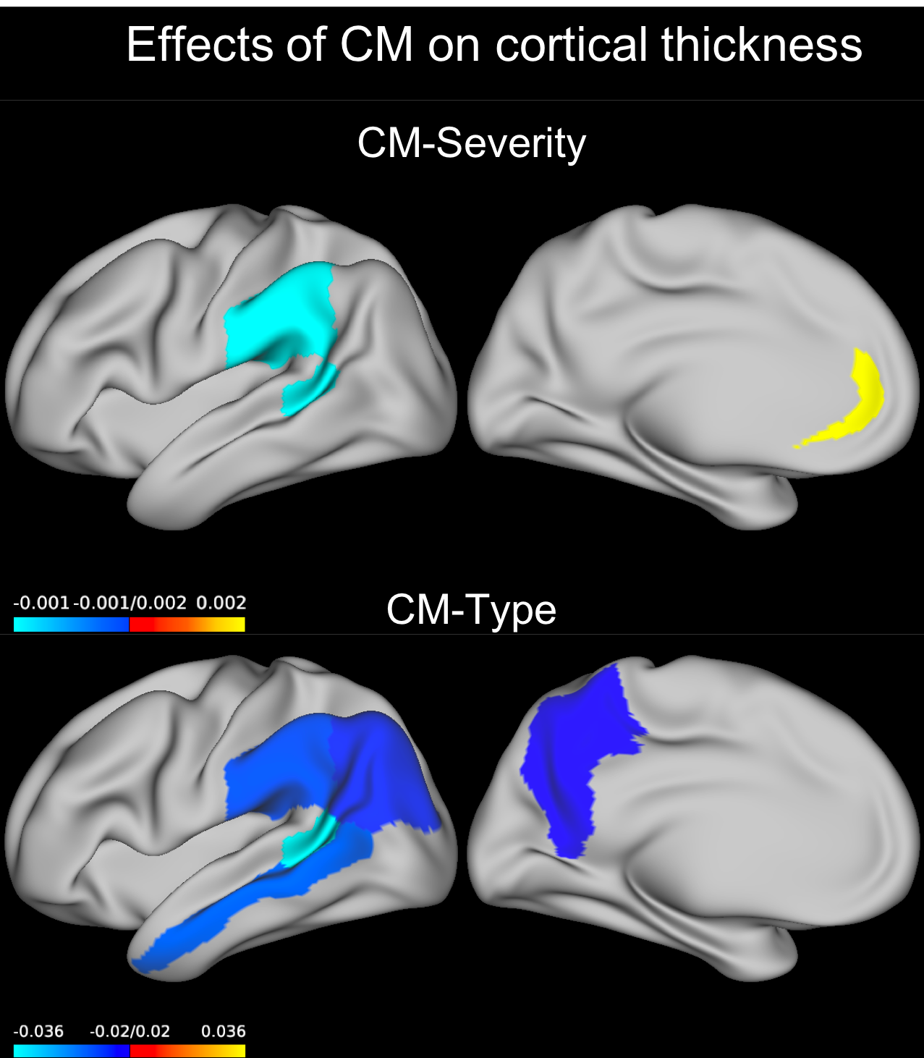
Figure 2: Effect of CM predicting cortical surface. Coefficients for the GEE model term CM severity or those for the abuse only group compared to the no-CM group are plotted on an inflated left brain hemisphere (effects were bilateral). The neglect group showed a similar result in the same region. CM=childhood maltreatment, GEE=generalized estimating equations.
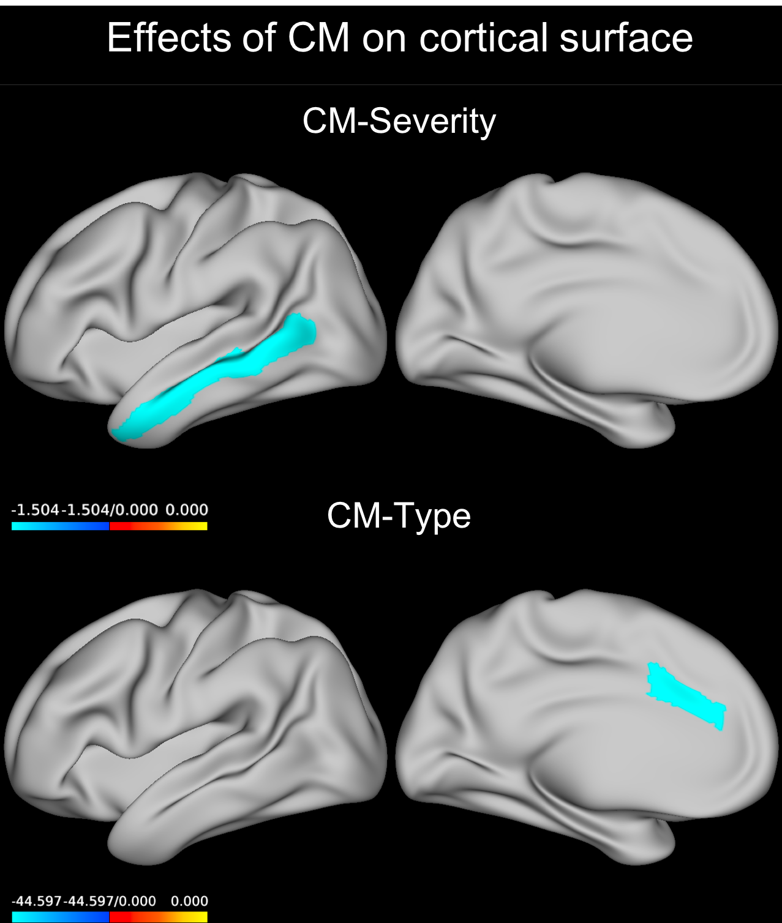
Figure 3: Effect of CM*Age predicting cortical thickness. Coefficients for the GEE model term CM severity*Age or those for Age in the abuse + neglect group compared to the no-CM group are plotted on an inflated left brain hemisphere (effects were bilateral). CM=childhood maltreatment, GEE=generalized estimating equations.
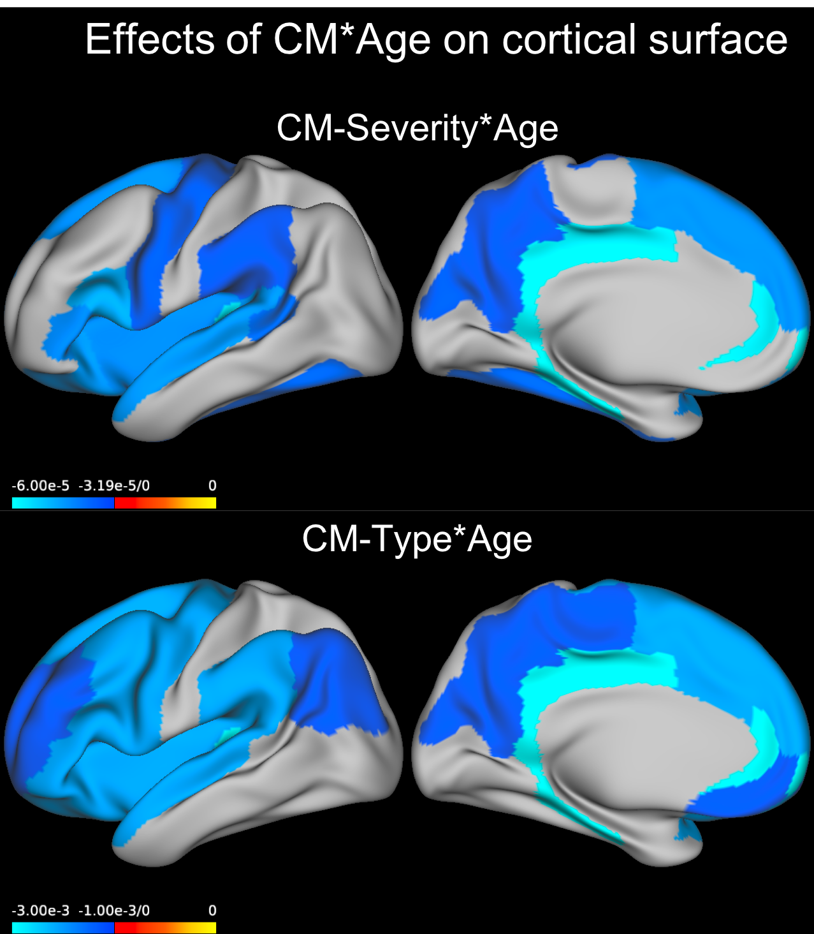
Table 1: Demographic and clinical Data. CTQ = Childhood trauma questionnaire. ICV= total intracranial volume. BDI#= Beck Depression Inventory. HDRS-17#= Hamilton Depression Rating Scale. Shown are mean values +- standard deviation. For CTQ subscales, number of subjects above the cut-off are given in brackets. †Mann Whitney U test used, #From sites that used these ratings.

 | All subjects  (n=3872) | Controls  (N=2588) | Patients (N=1284) | Group difference
Females | 2116 (54.6%) | 1303 (50.3%) | 813 (63.3%)
Males | 1756 (45.4%) | 1285 (49.7%) | 471 (36.7%) | χ²=58.2, p<0.001
Age (years) | 42.5 ± 15.5 | 43.3 ± 15.9 | 40.9 ±14.6 | t=4.6, p<0.001
Age of onset (years) | - | - | 29.4 ± 14.0 | -
Total CTQ | 36.3 ± 12.7 | 32.6 ± 8.5 | 43.6 ± 16.1 | p<0.001†
Sexual abuse | 5.5 ± 2.2 (233) | 5.2 ± 1.2 (75) | 6.2 ± 3.3 (158) | p<0.001†
Physical abuse | 6.1 ± 2.5 (297) | 5.6 ± 1.7 (91) | 6.9 ± 3.4 (206) | p<0.001†
Emotional abuse | 7.6 ± 4.0 (770) | 6.5 ± 2.5 (246) | 10.0 ± 5.1 (522) | p<0.001†
Physical neglect | 7.0 ± 2.6 (243) | 6.6 ± 2.2 (86) | 8.0 ± 3.1 (157) | p<0.001†
Emotional neglect | 9.9 ± 4.8 (646) | 8.6 ± 3.8 (202) | 12.5 ± 5.5 (444) | p<0.001†
BDI-II# | - | 5.2 ± 4.4 | 18.6 ± 12.1 | p<0.001†
HDRS# | - | 2.9 ± 3.1 | 15.6 ± 9.8 | p<0.001†
ICV (in mm³) | (1.53±0.19)*10⁶ | (1.54 ± 0.18)*10⁶ | (1.527 ± 0.2)*10⁶ | t=2.7, p=0.007

Table 2: Main findings derived from the GEE models not including the interaction of childhood maltreatment and age. Wald χ² and p values of CM severity and type are shown for the regions where they were significant. For all effects see supplemental tables. Effects are coefficients for the model term CM severity or the estimates of the indicated contrast for CM type. CM=childhood maltreatment, FDR=false discovery rate.

 | Participants | Wald χ² | p_{FDR} | Effect
Thickness
CM severity
Overall thickness | Females | 4.861 | 0.027 | -0.001
Rostral anterior cingulate cortex | Males | 14.426 | <0.001 | 0.002
Banks of the superior temporal sulcus | All | 14.583 | 0.004 | -0.001
Supramarginal gyrus | All | 8.889 | 0.049 | -0.001
CM type
Banks of the superior temporal sulcus | Neglect+Abuse > no CM | 19.888 | 0.006 | -0.036
Inferior parietal lobe | Neglect+Abuse > no CM | 15.273 | 0.023 | -0.022
Middle temporal lobe | Neglect+Abuse > no CM | 12.123 | 0.048 | -0.025
Precuneus | Neglect+Abuse > no CM | 15.325 | 0.023 | -0.020
Supramarginal gyrus | Neglect+Abuse > no CM | 13.990 | 0.026 | -0.024
Surface
CM severity
Overall surface | All | 4.413 | 0.036 | -0.414
Middle temporal lobe | All | 12.368 | 0.015 | -1.504
CM type
Caudal anterior cingulate | Depressed males, Neglect > no CM | 17.807 | 0.003 | -44.597
 | Depressed males, Abuse > no CM | 5.647 | 0.017 | -51.396

Table 3: Main findings derived from the GEE models predicting cortical thickness and including the interaction of childhood maltreatment with age. Wald χ² and p values of CM severity*Age and CM type*Age are shown for the regions where they were significant. For all effects see supplemental tables. Effect sizes are coefficients for the model term CM severity*Age or those for Age in the Neglect+Abuse group versus the no-CM group. CM=childhood maltreatment, FDR=false discovery rate.

 | Wald χ² | p_{FDR} | Effect size
CM severity*Age
Overall thickness | 11.105 | 0.001 | -3.50*10⁻⁵
Banks of superior temporal sulcus | 4.997 | 0.047 | -3.59*10⁻⁵
Cuneus | 7.373 | 0.020 | -3.32*10⁻⁵
Frontal pole | 10.448 | 0.007 | -8.03*10⁻⁵
Fusiform | 6.714 | 0.026 | -3.50*10⁻⁵
Insula | 8.214 | 0.014 | -4.16*10⁻⁵
Isthmus of cingulate | 11.149 | 0.007 | -5.87*10⁻⁵
Lateral orbitofrontal | 8.952 | 0.011 | -4.37*10⁻⁵
Parahippocampal | 6.031 | 0.032 | -6.00*10⁻⁵
IFG pars opercularis | 11.014 | 0.007 | -4.70*10⁻⁵
IFG pars triangularis | 8.583 | 0.011 | -4.14*10⁻⁵
Posterior cingulate | 17.682 | 0.001 | -5.78*10⁻⁵
Precentral | 5.188 | 0.046 | -3.34*10⁻⁵
Precuneus | 6.272 | 0.029 | -3.19*10⁻⁵
Rostral anteriorcingulate | 10.262 | 0.007 | -5.83*10⁻⁵
Superior frontal | 7.301 | 0.020 | -4.22*10⁻⁵
Superior temporal | 8.774 | 0.011 | -4.35*10⁻⁵
Supramarginal | 5.189 | 0.046 | -3.22*10⁻⁵
Transverse temporal | 8.941 | 0.011 | -5.75*10⁻⁵
CM type*Age
Caudal anterior cingulate | 10.155 | 0.030 | -0.002
Caudal middle frontal | 16.297 | 0.002 | -0.002
Cuneus | 15.442 | 0.002 | -0.001
Frontal pole | 16.065 | 0.002 | -0.003
Inferior parietal | 9.848 | 0.034 | -0.001
Insula | 22.037 | <0.001 | -0.002
Isthmus of cingulate | 23.710 | <0.001 | -0.003
Lateral orbitofrontal | 17.174 | 0.002 | -0.002
Medial orbitofrontal | 13.542 | 0.008 | -0.001
Paracentral | 9.383 | 0.039 | -0.001
Parahippocampal | 16.405 | 0.002 | -0.003
IFG pars opercularis | 27.556 | <0.001 | -0.002
IFG pars orbitalis | 8.785 | 0.047 | -0.002
IFG pars triangularis | 20.837 | <0.001 | -0.002
Posterior cingulate | 35.357 | <0.001 | -0.003
Precentral | 17.291 | 0.002 | -0.002
Precuneus | 13.794 | 0.006 | -0.001
Rostral anteriorcingulate | 27.847 | <0.001 | -0.003
Rostral middlefrontal | 9.544 | 0.037 | -0.001
Superior frontal | 28.174 | <0.001 | -0.002
Superior temporal | 22.270 | <0.001 | -0.002
Supramarginal | 17.641 | 0.002 | -0.002
Transverse temporal | 22.386 | <0.001 | -0.003

