Declarative memory and structural language impairment in autistic children and adolescents

Running title: Declarative memory and structural language impairment in autism

Authors

Sophie Anns¹, Sebastian B Gaigg², James A. Hampton³, Dermot M. Bowler² & Jill Boucher²

Authors’ Institutional affiliations

¹ University of Sussex, UK

²Autism Research Group, City, University of London, UK

³ Dept. of Psychology, City, University of London, UK

Correspondence to: Sophie Anns, Department of Psychology, University of Sussex, Falmer, East Sussex, BN1 9QH. T: +44 (0)1273 876638 E: s.anns@sussex.ac.uk

Acknowledgements: The first author was funded by a PhD Bursary from City, University of London. The authors are extremely grateful to all the children, parents and teachers that were involved in this study.

Conflict of interest statement: The authors declare that there are no competing or potential conflicts of interest.

Lay Summary
Language impairment and learning disability affect 45% of the autistic population yet the factors that may be contributing to them is remarkably under-researched. To date there are no explanations of the lexical semantic (word meaning) abnormalities observed in ASD. We found that declarative memory is associated with lexical semantic knowledge in autism and learning disability but not in typical development. Difficulties with declarative memory may also be compensated for using visual-perceptual abilities by autistic and learning-disabled adolescents which has positive implications for educationalists.

Abstract
Two experiments tested the hypothesis that a plausible contributory factor of structural language impairment in Autism Spectrum Disorder (ASD) is impaired declarative memory. We hypothesised that familiarity and recollection (subserving semantic and episodic memory, respectively) are both impaired in autistic individuals with clinically significant language impairment and learning disability (ASD^{LI/LD}); whereas recollection is selectively impaired in autistic individuals with typical language (ASD^{TL}). Teenagers with ASD^{LI/LD} (n = 19) and primary school age children with ASD^{TL} (n = 26) were compared with teenagers with learning disability (LD) (n = 26) without autism, and primary school aged typically developing (TD) children (n = 32). Both experiments provided strong support for the hypothesised links between declarative memory processes and lexical-semantic facets of language in the two autistic groups, but not in the TD group. Additional findings of interest were that declarative memory processes and lexical-semantic knowledge were also linked in the LD group and that the ASD groups –and to a lesser extent the LD group – may have compensated for declarative memory impairments using spared visual-perceptual abilities, a finding with potential educational implications. Relative difficulties with familiarity and recollection in ASD^{LI/LD} and LD may help explain structural language impairment, as investigated here, but also the broader learning disabilities found in these populations.

Keywords: Autism Spectrum Disorder, Language Impairment, Memory, Familiarity, Recollection

Introduction
Approximately 45% of individuals with Autism Spectrum Disorder (ASD) have significant language impairments (LI) or learning disability (LD) in addition to their clinically defining social communication impairments and repetitive behaviours (Baird et al., 2006; Charman et al., 2011). Around 30% remain minimally verbal even following targeted interventions (Tager-Flusberg & Kasari, 2013). The causes of LI and LD in autism have been little researched and are poorly understood. The two experiments reported here tested the hypothesis that a correlate of LI in people with what we refer to as ASD^{LI/LD}, is impaired declarative memory.
Reviews of language development in ASD (Rapin et al., 2009; Eigsti et al., 2011; Kelley, 2011; Boucher, 2012; Kim et al., 2014) indicate that despite considerable inter-individual heterogeneity, ASD^{LI/LD} is most commonly characterized by a profile of linguistic strengths and weaknesses that emerges from age 7;0 – 8;0 years and persists into adulthood. Key features of this profile are that speech (phonology and articulation) and grammar (syntax and morphosyntax) are mental-age appropriate; whereas lexical semantics, comprising vocabulary and meaning, is characterised by impaired comprehension and a narrowed, denotative, and sometimes idiosyncratic use of meanings of words and phrases in expressive language. Although autistic individuals with typical language (hereafter ASD^{TL}) have no clinically significant language impairments, their language is nevertheless also often described as ‘idiosyncratic’ and ‘pedantic’ (Asperger, 1994, translated in Frith, 1991; Tantam, 1988; Volden & Lord, 1991; Mayes & Calhoun, 2001) and there are differences in how individuals relate word meanings to one another to constitute higher-order concepts (Bowler, Matthews & Gardiner, 1997; Minshew, Meyer & Goldstein, 2002; Dunn & Bates, 2005; Bowler, Gaigg & Gardiner, 2008). These characteristic abnormalities in lexical semantics appear to be unique to autism: specific language impairment (SLI) is predominantly characterized by grammatical and phonological abnormalities (Williams, Botting & Boucher, 2008; Leonard, 2014); and language impairments in individuals with LD without autism tend to be global (Dockrell et al., 2012a; Dockrell et al.,2012b). It is noteworthy, however, that both SLI and also LD of socio-cultural or syndromic origin can co-occur with ASD, complicating the linguistic profile in a minority of cases (Boucher, 2012).
Attempts to explain LI in autism focused initially on co-morbid SLI (Bartak et al., 1975, 1977; Cantwell, Baker & Rutter, 1978) and later on the role of impaired ’theory of mind’ (Bloom, 2000). Co-morbid SLI is undoubtedly a contributory factor in a minority of cases and it is equally uncontroversial that diminished socio-cognitive abilities will have some specific effects on language acquisition. As noted by Bloom, however, these hypotheses cannot individually or jointly explain the syndrome-specific profile of significant lexical-semantic abnormalities observed in ASD^{LI/LD}. This argument led Mayes and Boucher (2008) to propose impaired declarative memory as an additional and critical explanation of LI and LD in what was then termed ‘lower-functioning autism’. This hypothesis was based on the dual-systems model of language acquisition as proposed by Chomsky (1965) and Pinker (1994), and later argued for by Ullman (2001). According to this model, declarative memory is critically involved in the acquisition of a ‘mental lexicon’ whereas non-declarative memory is critically involved in the acquisition of a ‘mental grammar’.
Declarative memory encompasses two partially distinct processes – recollection and familiarity (Aggleton & Brown, 1999; Yonelinas et al., 2005; Migo et al., 2009). ’Recollection’ is the process of remembering past experiences including rich contextual detail (where, when, how etc.), whereas ‘familiarity’ describes the feeling of having experienced a stimulus before without necessarily recalling any contextual information. Mayes and Boucher (2008; see also Boucher & Mayes, 2011; Boucher, 2012; Boucher & Anns, 2018) argued that evidence of selectively impaired recollection in ASD^{TL} (BenShalom, 2003; Bowler, Gaigg, & Lind, 2011; Boucher, Mayes & Bigham, 2012; Bigham, Boucher, Mayes & Anns, 2010; Cooper & Simons, 2018) is consistent with the mild lexical-semantic anomalies noted by Asperger and others; whereas more pervasive declarative memory impairments in ASD^{LI/LD} affecting both recollection and familiarity could explain the increasingly severe lexical-semantic impairments in this group. It was further argued that the substantial body of evidence indicating mental-age appropriate procedural memory across the spectrum (Foti et al., 2015; Obeid et al., 2016; Clark & Lum, 2017) is consistent with evidence of mental-age-appropriate phonology and grammar across the spectrum (Boucher & Anns, 2018).
A preliminary test of the impaired declarative memory hypothesis confirmed that recognition memory was indeed associated with measures of lexical semantics in autism. However, the ASD groups performed more similarly than expected (Boucher, Bigham, Mayes & Muskett, 2008). In addition, the recognition memory test used was not designed to distinguish between the unique contributions of recollection and familiarity to performance. The aim of the experiments reported here was to extend this earlier work by assessing both recollection and familiarity in groups of participants with ASD^{TL} and with ASD^{LI/LD}, predicting that the results would show the following:

1) (a) impairments in ASD^{LI/LD} teenagers on tests of familiarity and recollection relative to primary-school-aged TD children; and (b) relative to teenagers with LD (following Ni Chuileann & Quigley, 2013).
2) impairments in ASD^{TL} children relative to TD children only on tests of recollection, demonstrating superior familiarity compared to teenagers with ASD^{LI/LD}.
3) familiarity and recollection scores will correlate with measures of lexical-semantic knowledge in the ASD^{LI/LD} and ASD^{TL} groups but not the TD or LD groups.

Experiment 1 – Shape Recognition and Action Recall

Method

Participants
Four participant groups were recruited from mainstream and specialist schools/units in southern England: 19 ASD^{LI/LD} teenagers; 26 primary school age ASD^{TL} children; 32 primary school age TD children, and 26 LD teenagers. Participants in the two ASD groups had confirmation of their diagnosis in their Statements of Special Educational Needs (SSENs). SSENs of children in the LD group were reviewed to confirm no mention of autism and that learning disability was named as their core difficulty. Children in the TD group were described by their teachers as having ‘no significant difficulties’. The two teenage groups (ASD^{LI/LD} and LD) were matched for age and VIQ as assessed by the Wechsler Abbreviated Scale of Intelligence (WASI, Wechsler, 1999), with maximum VIQ of 75. The two younger groups (ASD^{TL} and TD) were also matched for age and VIQ, with minimum VIQ of 90. Mean verbal ages for all four groups were between 9.0 and 10.0 years. Non-verbal IQ (NVIQ) was assessed using Raven’s Coloured Progressive Matrices (CPM; Raven et al., 1998), and visual-perceptual ability was assessed by the Children’s Embedded Figures Test (CEFT; Witkin et al.,1971). Summary statistics are shown in Table 1.

(Table 1 about here)

Ethical Considerations
Parental consent was obtained for all participants in both experiments and the participants’ assent was confirmed throughout the session. No participant declined at any point and study methods were approved by City, University of London’s Senate Ethics Committee.

Materials
For the shape recognition (SR) task, all shape materials were identical to those described in a pilot study by Bigham et al. (2010, experiment 2) and stimulus examples are shown in Figure 1 (a). For the action recall (AR) task, stimuli were identical to Bigham et al., (2010, experiment 3), although 3 hand actions were altered to be more stimulus directed to ensure cued- recall; examples are shown in Figure 1 (b).

(Figure 1 about here)

In line with Bigham et al., the Pyramids and Palm Trees Test (PPT) (Howard & Patterson, 1992) was used as a measure of lexical semantic knowledge. The PPT is a 40-item forced-choice test that asks participants to point out which of two pictures relates most closely to a target picture. Since it requires no overt language it is considered a relatively pure measure of conceptual semantic processing.

Procedure
All procedures for the shape recognition (SR) and action recall (AR) tasks strictly followed those described in Bigham et al. (2010). Very briefly, for SR, 16 shapes were presented one-by-one at a rate of 3 seconds per picture before presenting a four-alternative-forced choice recognition test in which children were asked to point out the pictures they had just seen. For AR 10 shapes were presented with accompanying hand gestures that children were subsequently asked to reproduce when cued with the shapes (the procedure ensured that shape memory here was at ceiling for all children).

Results
Figure 2 shows average proportions of correct responses for the two memory tests in both participant groups. In line with prediction 1(a), the ASD^{LI/LD} group performed worse than the TD group on shape recognition (SR) (t = 2.82; df = 49; p = 0.007; Cohen’s d = 0.78) and on action recall (AR) (t = 2.38; df = 49; p = 0.021; Cohen’s d = .64). Contrary to prediction 1(b), however, differences between ASD^{LI/LD} and LD groups were not significant (SR: t = 1.37; df = 43; p = 0.178; Cohen’s d = 0.41; AR: t = 0.46; df = 43; p = 0.645; Cohen’s d = 0.14).

(Figure 2 about here)

Prediction 2 was not confirmed in that there was no difference between the ASD^{TL} and TD groups on the action recall (AR) task (t = 1.08; df = 56; p = 0.283; Cohen’s d = 0.25). Instead, the ASD^{TL} group performed worse than the TD group on shape recognition (SR) (t = 2.02; df = 56; p = 0.048; Cohen’s d = 0.57), indicating impaired familiarity. Moreover, although the ASD^{TL} group scored higher than the ASD^{LI/LD} group on SR, as predicted, the difference was not significant (t = 0.66; df = 43; p = 0.510; Cohen’s d = 0.21).
For prediction 3, Figure 3 illustrates and Table 2 summarises the correlations between the SR/AR measures and the PPT measure of lexical semantic knowledge. The pattern of results was generally as predicted. Performance on both memory tests correlated positively with the PPT in the two ASD groups but not the TD group although the association between AR and PPT in the ASD^{LI/LD} group was not quite significant (r(19) = 0.42; p = .071). Unexpectedly, PPT also correlated with SR in the LD group although AR did not.
(Figure 3 about here)
As Table 2 indicates, visual-perceptual ability (measured by the CEFT), and fluid intelligence (Ravens CPM score) consistently correlated with shape recognition (SR) in all groups except TD. To identify any unique contribution of familiarity to lexical semantics across the autism spectrum, a multiple regression was carried out with PPT as the dependent variable and SR, CEFT and CPM as predictors. For the combined ASD group, the resulting model was significant (F(3,41) = 6.06; p = .002) with an R² of 0.31, and only SR (β = 0.35; t = 1.97; p = 0.055) as a reliable predictor. Neither CEFT (β = 0.22; t = 1.21; p = 0.235) nor CPM (β = 0.05; t = .31; p = 0.755) were independent predictors. By contrast, the same analysis in the combined TD and LD group yielded a significant model (F(3,54) = 12.20; p < 001) with an R² of .40 but, here CEFT (β = 0.30; t = 1.99; p = 0.051) and CPM (β = 0.30; t = 1.93; p = 0.059) rather than SR (β = 0.14; t = 1.11; p = 0.274) were the most significant predictors.
(Table 2 about here)

Summary and Discussion of Experiment 1
Experiment 1 employed a shape-recognition (SR)/action recall (AR) paradigm previously piloted by Bigham et al., (2010) to tease apart familiarity and recollection components of declarative memory, and to examine their role in lexical semantic language function in ASD. In line with predictions, ASD^{LI/LD} teenagers were relatively impaired to TD children on measures of familiarity and recollection. Contrary to the prediction, however, they were not impaired relative to LD teenagers. Unexpectedly, the ASD^{TL} group were impaired on the SR measure of familiarity rather than on the AR measure of recollection, contradicting much of the existing literature. Nonetheless, SR performance was the major predictor of PPT in the combined ASD groups, whereas in the non-autistic groups visual-perceptual skills (CEFT) and fluid intelligence (CPM) were the strongest predictors of PPT. Experiment 2 extended these findings to another paradigm that employs more closely matched procedures to assess familiarity and recollection.

Experiment 2 – Forced Choice Recognition in Two Contrasting Conditions

This experiment was based on Migo et al. (2009; 2013), who showed that the specific conditions under which forced choice recognition decisions are made dictate to what extent familiarity and recollection contribute to retrieval success. In a ‘forced choice corresponding’ (FCC) condition, foils used at test differ from target stimuli only in visual detail (e.g., a target apple needs to be discriminated from 3 foil apples). Performance in this condition depends disproportionately on familiarity because there is little unique contextual detail that could help discriminate the target from the foils on the basis of recollection; one item, however, would look more familiar than the others. By contrast in a ‘forced choice non-corresponding’ (FCNC) condition, the foils used at test closely resemble three of the target stimuli presented on other trials (e.g., a target apple needs to be discriminated from a shoe, guitar and aeroplane that are similar to items that had been studied). Performance here depends disproportionately on recollection because, without a direct contrast of the different exemplars of the same object (i.e., the four apples), each of the test items will appear similarly familiar. The FCNC task of recollection is therefore considered to be relatively more difficult than the familiarity task of FCC.

Method

Participants
Eighteen ASD^{LI/LD} teenagers, 26 primary school age ASD^{TL} children, 24 primary school age TD children, and 23 LD teenagers took part in this experiment. All but one of the participants (in the LD group) also participated in Experiment 1 and were tested on the additional Experiment 2 tasks within one month. Groups in Experiment 2 were slightly smaller than in the previous experiment, because not all those previously tested were available at the later date. Inclusion criteria were the same as those reported for Experiment 1 and summary descriptive statistics for participant groups are shown in Table 3.

(Table 3 about here)

Materials
Stimuli used in both the ‘forced choice corresponding’ (FCC) and the ‘forced choice non-corresponding’ (FCNC) conditions were taken from the picture sets used by Migo et al., (2013) with adults. Twenty-eight of Migo et al.’s sets – 14 for use in the FCC condition, 14 for use in the FCNC condition - were selected on the basis of their appropriateness for use with young children and learning-disabled teenagers. In each condition, twelve sets were used as test material, and two sets were used for practice. Each picture set consisted of a target stimulus to be shown at study, and a quartet consisting of the target stimulus and three foils to be used at test. In the FCC (familiarity) condition, the 3 foils were representations of the same everyday object as the target stimulus but differing in minor details (see Figure 4). In the FCNC (recollection) condition, the foils were representations of three of the everyday objects that had appeared as target stimuli on other FCNC trials but differing from the originals in certain details (see Figure 4). In the study phases, target stimuli measuring 40 x 40mm were presented individually in the centre of a 15-inch screen on a white background. In the test phases, target and foil items measuring 40mm each were presented as a 2 x 2 grid centre screen on a white background. Within the grid, the position of the target was randomised across trials with the constraint that it would appear equally often in each of the four possible locations. A pack of playing cards was used for a ‘filler task’ (see below). Pre-prepared score sheets were used to record responses and the Pyramids and Palm Trees Test (PPT) was again used as the measure of lexical semantic knowledge.

(Figure 4 about here)

Pilot testing with learning disabled children not included as participants in this study indicated the need to familiarise participants with the procedures over and above the two practice trials immediately preceding experimental testing in each condition. We wanted to ensure that participants understood that their memory would be tested in two different ways, so that any incorrect responses would not simply reflect a participant’s uncertainty as to what was expected of them. Two sets of supplementary material were therefore prepared, to be used in an introductory training phase for each condition, in which 3 laminated A4 cards with coloured pictures of a single item (such as a bird or a shirt) constituted the to-be-remembered target stimuli and laminated test cards were prepared as described above.

Procedure
Participants were assessed individually over two sessions on different days in a quiet room in their school. Each session lasted 20-30 minutes. In each of the two sessions, recognition was assessed in one of the experimental conditions (FCC or FCNC), preceded by the appropriate training/practice stage. The order of conditions across the testing sessions was counterbalanced across participants.
In the training phase, participants were told that they would be given some memory tests, preceded by practice. The training coloured picture-cards were presented singly with the instruction to look carefully at the picture and try to remember it. After a short interval during which the Tester explained that they were going to see how many of the pictures the child could remember, the relevant test cards were presented one at a time, with the request to point to the picture they had just seen. Help was given if necessary, and the Tester commented on why that was the correct picture to point to, whereas pointing to any of the foils would have been incorrect. None of the participants had difficulty with this stage.
The study phase for each recognition test consisted of two successive presentations of each target stimulus. On the first presentation (Study Phase 1) pictures of the 12 target stimuli were presented for 3 seconds one by one in a pre-determined order followed by the question ‘Could you eat that?’ Participants were instructed to answer ‘yes’ or ‘no’. This was done to ensure that attention was paid to each target stimulus. On the second presentation (Study Phase 2) stimuli were presented one by one in the same order as previously, and for 3 seconds each, but without the attention-directing question. In Study Phase 2, participants were instructed to look at each picture carefully, because their memory would be tested later.
In the filler task which immediately followed the study phase, the pack of playing cards was introduced, and children were encouraged to play a game of ‘Snap’ with the Tester for a timed interval of 5 minutes. In the test phase which immediately followed the filler task, participants were presented with the 12 test quartets for that experimental condition, one at a time in a predetermined different order to presentation and were instructed to point to the picture that they had seen before. If the participant failed to respond, they were encouraged to ‘Have a guess’. Testing did not proceed until a response had been made.

Results
Figure 5 shows the mean performance on the two memory tests for each group.
(Figure 5 about here)
Unlike in Experiment 1, where the ASD^{LI/LD} group showed the expected reduced performance on measures of familiarity and recollection in comparison to the TD but not the LD group, performance by the ASD^{LI/LD} group in the current experiment was only compromised vis-à-vis the TD group on the ‘forced choice non-corresponding’ (FCNC) measure of recollection (t = 2.45; df = 40; p = 0.019; Cohen’s d = 0.76). On the ‘forced choice corresponding’ (FCC) measure of familiarity, they actually tended to perform better than TD participants (t = 1.74; df = 40; p = 0.090; Cohen’s d = 0.53). Compared to the LD group, ASD^{LI/LD} children also performed significantly higher on the familiarity measure (t = 2.96; df = 39; p = 0.005; Cohen’s d = 0.93) and marginally also on the recollection measure (t = 1.77; df = 39; p = 0.085; Cohen’s d = 0.55). Thus, instead of showing diminished familiarity and recollection, ASD^{LI/LD} children demonstrated the kind of circumscribed recollection difficulty in this experiment that we predicted for the ASD^{TL} group. If anything, familiarity appeared to be an area of strength for this group.
The second prediction, that ASD^{TL} participants would demonstrate selective difficulties in recollection as compared to the TD group, was confirmed with nearly identical performance between these groups on the FCC measure of familiarity (t = 0.01; df = 48; p = 0.996; Cohen’s d = 0.00) but significantly lower performance by the ASD^{TL} group on the FCNC measure of recollection (t = 2.36; df = 48; p = 0.022; Cohen’s d = 0.67).
As for Experiment 1, the final set of analyses examined the associations between the memory tests and the PPT test of lexical semantic knowledge, along with other relevant measures (VIQ, Ravens (CPM) and CEFT (visual-perceptual ability)). Table 4 summarises, and Figure 6 illustrates, the relevant bivariate correlations between the measures of familiarity (FCC) / recollection (FCNC) and PPT which are of most interest within each participant group. Consistent with predictions and with the observations of Experiment 1, both memory measures correlated significantly with the PPT in the two ASD groups, whereas no such correlations were observed in the TD group. However, the familiarity measure (FCC) but not the recollection measure (FCNC) was associated with PPT in the LD group.

(Figure 6 about here)

Inspection of Table 4 shows that fluid intelligence (CPM) and visual-perceptual skills (CEFT) correlated with memory performance, particularly familiarity. Consequently, multiple regression was carried out with PPT as the dependent variable and FCC (familiarity), CEFT and CPM as predictors. The results in the combined ASD group, replicated the findings of Experiment 1 with an overall significant model (F(3,40) = 8.12; p < .001 R² = 0.38) in which only the FCC measure of familiarity (β = 0.62; t = 3.56; p = 0.001) but not CEFT (β = 0.01; t = 0.04; p = 0.971) or CPM (β = -0.02; t = 0.15; p = 0.884) was a reliable predictor of PPT. By contrast, and as in Experiment 1, the combined TD and LD group yielded a significant model (F(3,43) = 5.18; p = .004; R² = .26) in which CEFT was the most reliable predictor of PPT (β = 0.32; t = 1.88; p = 0.067) rather than FCC (β = 0.05; t = 0.34; p = 0.734). However, in this experiment, CPM was not a major predictor of PPT in the combined non-autistic groups. (β = 0.21; t = 1.23; p = 0.226).

(Table 4 about here)

General Discussion
Two experiments tested predictions concerning the role of declarative memory in the lexical semantic language anomalies co-occurring with ASD. We predicted that ASD^{LI/LD} children would be impaired on measures of both familiarity and recollection vis-a-vis TD children (prediction 1a), and also vis-à-vis teenagers with LD (prediction 1b); whereas ASD^{TL} children would demonstrate impairments only on measures of recollection when compared with TD children (prediction 2). Most importantly, the memory difficulties predicted for the ASD group were expected to correlate reliably with their lexical semantic abilities, as assessed by the PPT, whereas no such associations were predicted for TD or LD children (prediction 3).
Regarding prediction (1a), the two experiments yielded conflicting results. In Experiment 1 the ASD^{LI/LD} group performed worse than the TD group on the measures of familiarity and recollection, as predicted. By contrast, in Experiment 2 the ASD^{LI/LD} group was impaired on recollection but not familiarity, where they tended to outperform the TD group. This discrepancy is surprising considering that the measures of familiarity in the two experiments both required participants to discriminate a previously studied stimulus from 3 foils. However, in both experiments the measures of familiarity correlated highly with the measure of visual-perceptual skills (CEFT) in the ASD^{LILD} group, which was not the case for the TD group (see Tables 2 and 4). This suggests that the ASD^{LILD} group, but not the TD group, relied heavily on their visual-perceptual abilities to tackle the task demands. Such reliance on visual-perceptual skills would confer a particular advantage in the FCC familiarity test of Experiment 2 but not in the SR familiarity test of Experiment 1, because in the SR condition target and foils on any trial were abstract shapes that did not closely resemble each other (see Figure 1), whereas in the FCC condition target and foils on any trial were pictures of the same common object differing only in some small detail (see Figure 4). The enhanced discrimination abilities of autistic individuals are well known (Plaisted et al., 1998; Mottron et al., 2006), and can explain the unexpectedly good performance of the ASD^{LILD} group on the FCC task. Regarding prediction (1a) it may be concluded, therefore, that familiarity is probably impaired in ASD^{LILD} but is masked in circumstances where superior visual-perceptual abilities can be used compensatorily.
Regarding prediction (1b), this was not supported. Both groups showed similar performance on tests of familiarity and of recollection in Experiment 1. And in Experiment 2, the ASD^{LI/LD} group performed significantly better – not worse - than the LD group on the familiarity measure, (probably because their enhanced visual-perceptual abilities boosted performance). Furthermore, the ASD^{LI/LD} group performed marginally better than the LD group on the recollection measure. These findings are interesting because they suggest that LI in ASD^{LI/LD} and in LD without autism may share a contributory cause, namely impairments of declarative memory.
Performance by the LD group partly resembled performance by both ASD groups in that CEFT and familiarity scores correlated significantly in both experiments. However, as the LD group scored significantly lower on CEFT than all other groups it is more likely that they are unable to rely on visual-perceptual abilities to compensate for impaired familiarity which shows a different pattern of learning to the ASD groups. By contrast, the TD group - whose performance on tests of familiarity did not correlate with CEFT scores - performed significantly worse on FCC than on shape recognition.
Regarding prediction 2, the findings across both experiments were inconsistent. Whilst in Experiment 2 the ASD^{TL} group performed worse than the TD group on the FCNC measure of recollection, as predicted; in Experiment 1 the groups did not differ on the action recall measure of recollection. Instead the ASD^{TL} group performed worse than the TD group on the shape recognition measure of familiarity. The unexpectedly competent performance by the ASD^{TL} group on the AR test of recollection is difficult to explain, given the very well-established problems with episodic memory and recollection in ASD^{TL}. A likely explanation is, however, that well-preserved implicit memory (see Boucher & Anns, 2018) that subserves inter alia the acquisition of associations, was utilized instead of explicit recollection.
The unexpectedly poor performance by the ASD^{TL} group on the SR test of familiarity similarly conflicts with unassailable evidence of intact semantic memory in this group, and by implication with familiarity. The likely explanation of this anomalous finding lies in the dissimilarity between the target and foil shapes used in the SR test. The lack of close resemblance has two relevant consequences. First, enhanced visual-perceptual processing cannot be used to the same extent to boost performance as seen in FCC. Second, the dissimilarity between the target shape and foils leaves open the possibility that recollection (of the study event and of the target stimulus presented therein) was utilized by the TD group – but not, in line with our hypothesis, by the ASD^{TL} group. Both of these proposed explanations of unexpected findings relating to the ASD^{TL} group would have to be tested.
Regarding prediction 3, the predicted contrast between correlations in the two ASD groups when compared with the TD group was supported in both experiments. Both bivariate correlations and multiple regressions confirmed that individual differences in measures of familiarity were reliably and uniquely associated with lexical semantic knowledge in both ASD groups, which was not the case in TD children. This lends strong support to Boucher et al.’s hypothesis that impaired declarative memory and especially semantic memory is a contributory factor of LI in ASD^{LILD}.
However, contrary to that prediction, familiarity also correlated with lexical semantic knowledge in the LD group in both experiments, albeit not as strongly as in the two ASD groups. Moreover, the pattern of performance in the ASD^{LI/LD} and LD groups was similar in terms of the group differences vis-à-vis the TD group, as well as in terms of some facets of the inter-correlations among measures. These observations suggest that impairments in certain memory domains (particularly familiarity/semantic memory), contribute to LI in people with LD without autism, as well as in people with ASD^{LILD}. Moreover, our finding that relatively spared visual-perceptual abilities were used by our LD participants as well as by our ASD participants to compensate for impaired familiarity has practical implications for educational strategies, as in the case of autism.
The demonstration of impaired declarative memory in people with LD without autism has potentially important implications for understanding not only the wider learning impairments in people with LD, but also for understanding why LI and LD are so commonly linked when co-occurring with ASD. Briefly: semantic memory, and by implication familiarity, is critically involved in the acquisition of decontextualised factual knowledge of all kinds – i.e. in crystallized intelligence (Cattell, 1971). The impairments of declarative memory in both the ASD-LI/LD and the LD groups, as reported here, may thus help to explain the wider learning disabilities in these two groups which are relevant for educational and interventional practices (as argued by Mayes & Boucher, 2008).

Conclusions
The experiments reported here confirm the predicted link between declarative memory processes and lexical semantic knowledge in people with ASD, a link that does not occur in individuals with typical development. Moreover, although the predicted differences between the ASD^{LILD} and the ASD^{TL} groups on tests of familiarity and recollection were not unambiguously demonstrated, familiarity and lexical-semantic knowledge were particularly strongly associated in the ASD^{LILD} group, whereas in the ASD^{TL} group, recollection was more strongly associated with lexical semantic knowledge than was familiarity. Further confirmation of these group differences on familiarity and recollection would strengthen this research by replicating the existing shape recognition – action recall paradigm and inventing novel non-verbal experimental paradigms. Additional tests of structural language would also paint a richer picture of language outcome to be tested in both ASD and LD populations. As per Boucher & Anns (2018) further work should investigate the potential See-Saw effect between declarative and procedural memory in ASD as well as LD. This has potential for educationalists to target children’s learning by capitalising on their abilities.
An unpredicted finding of particular interest was the demonstration of a link between declarative memory and lexical semantic knowledge in the learning-disabled group. This finding should be further investigated, preferably in research in which LD participants constitute the target group, rather than acting as a control/comparison group in investigations of ASD.
A further unpredicted finding concerns the extent to which the ASD used enhanced or relatively spared visual-perceptual abilities to compensate for their impaired declarative memory. This observation has positive practical implications for educationalists and future work should explicitly address this potential compensatory ability in autistic populations. However, for researchers it underlines the very considerable difficulties of devising tests of declarative memory that are suitable for use with learning disabled or young children but also yield clear-cut findings.

References
Aggleton, J. P., & Brown, M. W. (2006). Interleaving brain systems for episodic and recognition memory. Trends in Cognitive Sciences, 10 (10), 455 - 463.

APA (1994). Diagnostic and Statistical Manual of Mental Disorders. American Psychiatric Association, 535.

Asperger, H.. (1944/1991). ‘Autistic psychopathy’ in childhood. Translated in U. Frith (Ed.), Autism and asperger syndrome (pp. 37–92). Cambridge: CUP.
Baird, G., Simonoff, E., Pickles, A., Chandler, S., Loucas, T., Meldrum, D., & Charman, T. (2006). Prevalence of disorders of the autism spectrum in a population cohort of children in South Thames: the Special Needs and Autism Project (SNAP). The Lancet, 368(9531), 210-215.

Bartak, L., Rutter, M., & Cox, A. (1975). Comparative study of infantile autism and specific developmental receptive language disorder 1: Children. British Journal of Psychiatry, 126, 127-145.

Bartak, L., Rutter, M., & Cox, A. (1977). Comparative study of infantile-autism and specific developmental receptive language disorders 3: Discriminant function analysis. Journal of Autism and Developmental Disorders, 7, 383-396.

Ben Shalom, D. (2003). Memory in autism: Review and synthesis. Cortex, 39(4-5), 1129-1138.

Bigham, S., Boucher, J., Mayes, A., & Anns, S. (2010). Assessing recollection and familiarity in autistic spectrum disorders: Methods and findings. Journal of Autism and Developmental Disorders, 40(7), 878-889.

Bloom, P. (2000). How Children Learn the Meanings of Words. Cambridge, MA: MIT Press.
Boucher, J. (2012). Research review: structural language in autistic spectrum disorder–characteristics and causes. Journal of Child Psychology and Psychiatry, 53(3), 219-233.

Boucher, J., & Anns, S. (2018). Memory, learning and language in autism spectrum disorder. Autism & Developmental Language Impairments, 3, 2396941517742078.

Boucher, J., Bigham, S., Mayes, A., & Muskett, T. (2008). Recognition and language in lower functioning autism. Journal of Autism and Developmental Disorders, 38, 1259–1269.

Boucher, J., & Mayes, A. (2011). Memory. In D. Fein, (Ed.), The neuropsychology of autism (pp. 139–160). Oxford: OUP.

Boucher, J., Mayes, A., & Bigham, S. (2012). Memory in Autistic Spectrum Disorder. Psychological Bulletin, 138, 458-496.

Bowler, D. M., Gaigg, S. B., & Gardiner, J. M. (2008). Effects of related and unrelated context on recall and recognition by adults with high-functioning autism spectrum disorder. Neuropsychologia, 46(4), 993-999.

Bowler, D., Gaigg, S., & Lind, S. (2011). Memory in autism: binding, self, and brain; in Roth & Rezaie (Eds.). Researching the Autism Spectrum. The Open University, Milton Keynes. pp 316-346

Bowler, D. M., Matthews, N. J., & Gardiner, J. M. (1997). Asperger’s syndrome and memory: Similarity to autism but not amnesia. Neuropsychologia, 35, 65–70.

Cantwell, D., Baker, L., & Rutter, M. (1978). Comparative study of infantile autism and specific developmental receptive language disorder 4: Analysis of syntax and language function. Journal of Child Psychology and Psychiatry 19, 351-362.
Cattell, R. B. (1971). Abilities: Their structure, growth, and action. New York: Houghton Mifflin.

Charman, T., Pickles, A., Simonoff, E., Chandler, S., Loucas, T., & Baird, G. (2011). IQ in children with autism spectrum disorders: data from the Special Needs and Autism Project (SNAP). Psychological medicine, 41(03), 619-627.

Chomsky, N. (1965). Aspects of the theory of syntax..Multilingual Matters: Cambridge: MIT Press.

Clark, G. M., & Lum, J. A. (2017). Procedural learning in Parkinson’s disease, specific language impairment, dyslexia, schizophrenia, developmental coordination disorder, and autism spectrum disorders: A second-order meta-analysis. Brain and cognition, 117, 41-48.

Cooper, R. & Simons, D. (2018). Exploring the neurocognitive basis of episodic recollection in autism. Psychonomic Bulletin & Review, https://doi.org/10.3758/s13423-018-1504-z

Dockrell, J., Lindsay, G., Roulstone, S., & Law, J. (2012a). Supporting children with speech, language and communication needs: an overview of the results of the Better Communication Research Programme. International Journal of Language & Communication Disorders, 49(5), 543-557.

Dockrell, J., Ricketts, J., & Lindsay, G. (2012b). Understanding speech, language and communication needs: Profiles of need and provision. London: Department for Education (DfE))(available at: https://www. gov. uk/government/collection/better-communication-research-programme).

Dunn, M., & Bates, J. (2005). Developmental change in neutral processing of words by children with autism. Journal of Autism and Developmental Disorders, 35, 361–376.

Eigsti, I. M., de Marchena, A. B., Schuh, J. M., & Kelley, E. (2011). Language acquisition in autism spectrum disorders: A developmental review. Research in Autism Spectrum Disorders, 5(2), 681-691.

Foti, F., De Crescenzo, F., Vivanti, G., Menghini, D., & Vicari, S. (2015). Implicit learning in individuals with autism spectrum disorders: a meta-analysis. Psychological Medicine, 45(5), 897-910.

Gaigg, S. B., Bowler, D. M., & Gardiner, J. M. (2014). Episodic but not semantic order memory difficulties in autism spectrum disorder: Evidence from the Historical Figures Task. Memory, 22(6), 669-678.

Hobson, R.P. & Lee, A, (1999). Imitation and identification in autism. Journal of Child Psychology and Psychiatry, 40(4), 649-659.

Howard, D., & Patterson, K. E. (1992). The Pyramids and Palm Trees Test: A test of semantic access from words and pictures. Thames Valley Test Company.

Kelley, E. (2011). Language in ASD. The neuropsychology of autism, 123-137.

Kim, Y. S., Fombonne, E., Koh, Y. J., Kim, S. J., Cheon, K. A., & Leventhal, B. L. (2014). A comparison of DSM-IV pervasive developmental disorder and DSM-5 autism spectrum disorder prevalence in an epidemiologic sample. Journal of the American Academy of Child & Adolescent Psychiatry, 53(5), 500-508.

Leonard, L. B. (2014). Children with specific language impairment. MIT press.

Mayes, A., & Boucher, J. (2008). Acquired memory disorders in adults: Implications for autism. In J. Boucher & D. Bowler (Eds.), Memory in autism: Theory and evidence (pp. 43-62). New York, NY, US: Cambridge University Press.

Mayes, S.D., & Calhoun, S. (2001). Non-significance of early speech delay in children with autism and normal language and implications for DSM-IV Asperger disorder. Autism, 5, 81–94.

Migo, E., Montaldi, D., Norman, K. A., Quamme, J., & Mayes, A. (2009). The contribution of familiarity to recognition memory is a function of test format when using similar foils. The Quarterly Journal of Experimental Psychology, 62(6), 1198-1215.

Migo, E., Montaldi, D. & Mayes, A. (2013). A visual object database with standardized similarity information. Behaviour Research Methods, 45(2), 344-354.

Minshew, N. J., Meyer, J., & Goldstein, G. (2002). Abstract reasoning in autism: A disassociation between concept formation and concept identification. Neuropsychology, 16(3), 327.

Mottron, L., Dawson, M., Soulieres, I., Hubert, B., & Burack, J. (2006). Enhanced perceptual functioning in autism: an update, and eight principles of autistic perception. Journal of autism and developmental disorders, 36(1), 27-43.

Ni Chuileann, S, & Quigley, J. (2013). Assessing recollection and familiarity in low functioning autism. Journal of autism and developmental disorders, 43(6), 1406-1422.

Obeid, R., Brooks, P. J., Powers, K. L., Gillespie-Lynch, K., & Lum, J. A. (2016). Statistical learning in specific language impairment and autism spectrum disorder: A meta-analysis. Frontiers in psychology, 7, 1245.

Pinker, S. (1994). The language instinct. New York: William Morrow and Company.

Plaisted, K., O’Riordan, M. & Baron-Cohen, S. (1998). Enhanced discrimination of novel, highly similar stimuli by adults with autism during a perceptual learning task. Journal of Child Psychology and Psychiatry, 39(5), 765-775.

Rapin, I., Dunn, M., Allen, D., Stevens, M., & Fein, D. (2009). Subtypes of language disorders in school-age children with autism. Developmental Neuropsychology, 34, 66–84.

Raven, J., Raven, J. C., & Court, J. H. (1998). Manual for Raven’s progressive matrices and vocabulary scales. Section 2: The coloured progressive matrices. Oxford, UK: Oxford Psychologists Press; San Antonio, TX: The Psychological Corporation.

Tager‐Flusberg, H., & Kasari, C. (2013). Minimally verbal school‐aged children with autism spectrum disorder: the neglected end of the spectrum. Autism Research, 6(6), 468-478.

Tantam, D. (1988). Asperger's syndrome. Journal of Child Psychology and Psychiatry, 29(3), 245-255.

Ullman, M. (2001). The declarative/procedural model of lexicon and grammar. Journal of Psycholinguistic Research, 3, 37–69.

Volden, J., & Lord, C. (1991). Neologisms and idiosyncratic language in autistic speakers. Journal of Autism and Developmental Disorders, 21, 109–130.

Weschler, D. (1999). Weschler abbreviated scale of intelligence (WASI). London: Psychological Corporation.

Williams, D., Botting, N., & Boucher, J. (2008). Language in autism and specific language impairment: Where are the links? Psychological bulletin, 134(6), 944.

Williams, J. H., Whiten, A., & Singh, T. (2004). A systematic review of action imitation in autistic spectrum disorder. Journal of autism and developmental disorders, 34(3), 285-299.

Witkin, H. A., Oltman, P. K., Raskin, E., & Karp, S. A. (1971). Manual for embedded figures test, children’s embedded figures test, and group embedded figures test. Palo Alto, CA: Consulting Psychologists Press, Inc.

Yonelinas, A. P., Otten, L. J., Shaw, K. N., & Rugg, M. D. (2005). Separating the brain regions involved in recollection and familiarity in recognition memory. The Journal of Neuroscience, 25(11), 3002-3008.

Figures and Tables

Figure 1: An example of a single target study item (a) and a target plus 3 foils ‘quartet’ shown at test (SR); and (b) shows a child recalling the ‘karate chop’action cued from the blue shape on the card (AR).

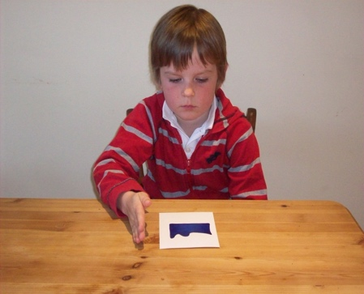
- Shape Recognition (SR) b) Action Recall (AR)

Figure 2: Average proportion of correct responses for Shape Recognition and Action Recall Tests as a function of group. Error bars represent +/- 1 SE.

Figure 3: Bivariate correlations between Shape Recognition/Action Recall and the Pyramids and Palm trees Test (PPT) as a function of group. For ease of reference, ASD and non-ASD groups are plotted separately.
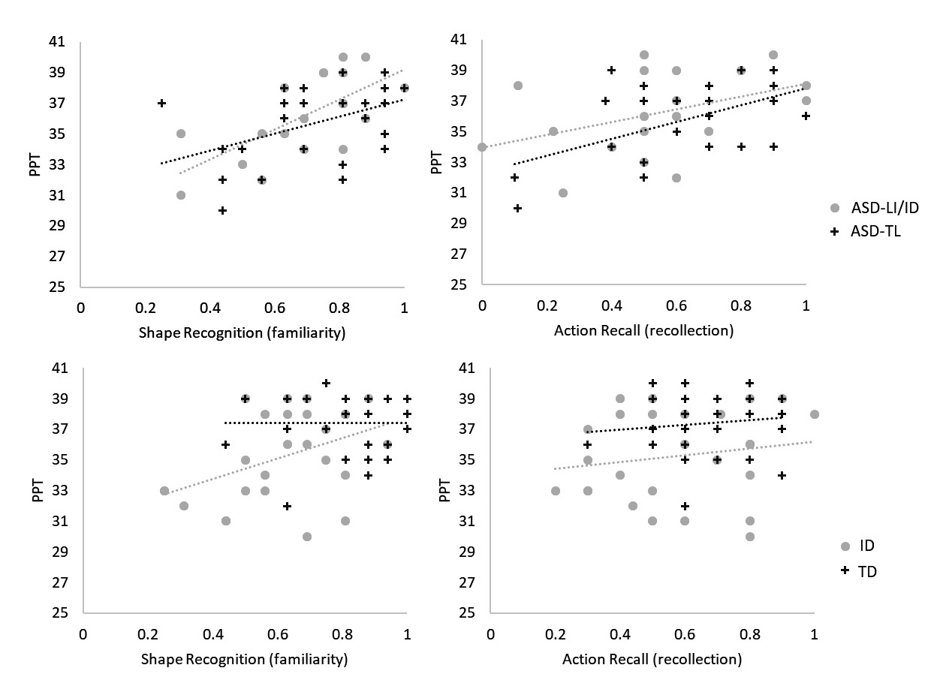

Figure 4: FCC and FCNC materials showing 3 out of 12 items and the order of the experimental procedure

FCC Condition FCNC Condition
1st Study Phase: 1st Study Phase:
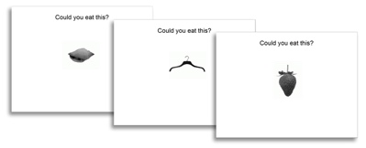
2nd Study Phase: 2nd Study Phase:
5-minute filler task 5-minute filler task
Test Phase: Test Phase:
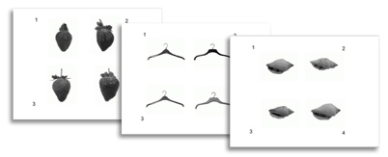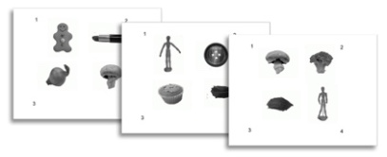

Figure 5: Average proportion of correct responses for FCC and FCNC Tests as a function of group. Error bars represent +/- 1 SE.

Figure 6: Bivariate correlations between FCC / FCNC and the Pyramids and Palm trees Test (PPT) as a function of group. For ease of reference, ASD and non-ASD groups are plotted separately.
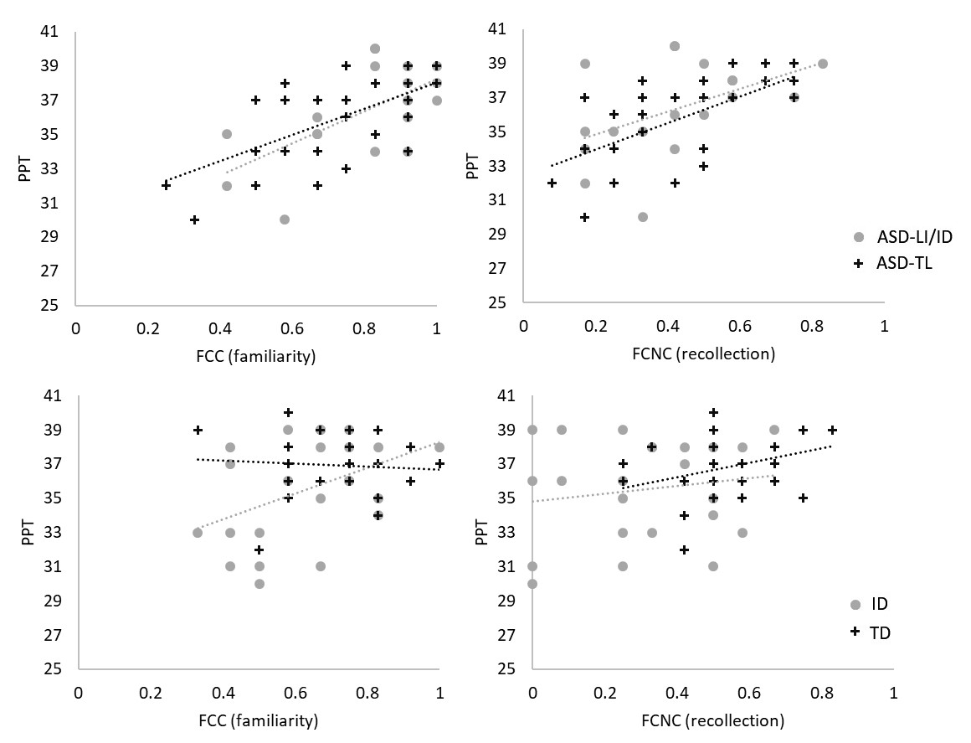
Table 1: Descriptive statistics for the four participant groups in Experiment 1.
 | ASD^{LI/LD} (N = 19) |  | ASD^{TL} (N = 26) |  | TD (N = 32) |  | LD (N = 26)
 | M (SD) | Range | M (SD) | Range | M (SD) | Range | M (SD) | Range
Age (mths) | 181 (22) | 123-218 | 109 (16) | 75-136 | 99 (9) | 81-114 | 176 (22) | 136-214
VIQª | 65 (6) | 55-75 | 105 (12) | 91-135 | 110 (11) | 90-142 | 62 (5) | 55-74
CPM^{b} | 26 (8) | 7-36 | 24 (8) | 8-36 | 25 (6) | 10-36 | 17* (7) | 6-27
CEFT^{c} | 16 (6) | 3-24 | 15 (6) | 5-25 | 15 (5) | 7-24 | 8* (4) | 1-17

ª Verbal IQ as measured by the WASI Vocabulary and Similarities subtests.
^{b} Raven’s Coloured Progressive Matrices; Scores range from 0 – 36
^{c} Children’s Embedded Figures Test; Scores range from 0 – 25
* Mean for LD was significantly lower than for the other groups

Table 2: Correlates of familiarity (shape recognition) and recollection (action recall) in each of the four participant groups.

Group | Test | Rec. | VIQ | CPM | PPT | CEFT
ASD^{LI/LD} | Familiarity | .488* | .274 | .717** | .674** | .704**
 | Recollection |  | .229 | .139 | .423 | .166
ASD^{TL} | Familiarity | .420* | .317 | .476* | .442* | .642**
 | Recollection |  | .191 | .179 | .516** | .608**
LD | Familiarity | .476* | .438* | .529** | .418* | .523**
 | Recollection |  | .593** | .456* | .166 | .215
TD | Familiarity | .190 | -.020 | -.019 | .008 | -.086
 | Recollection |  | -.202 | .103 | .121 | .118
*. Correlation is significant at the 0.05 level (2-tailed).
**. Correlation is significant at the 0.01 level (2-tailed).

Table 3: Descriptive statistics for the four participant groups in Experiment 2.
 | ASD^{LI/LD} (N = 18) |  | ASD^{TL} (N = 26) |  | TD (N = 24) |  | LD (N = 23)
 | M (SD) | Range | M (SD) | Range | M (SD) | Range | M (SD) | Range
Age (mths) | 180 (26) | 123-218 | 109 (16) | 75-136 | 98 (11) | 81-114 | 175 (22) | 136-213
VIQª | 65 (6) | 55-75 | 105 (12) | 91-135 | 107 (7) | 95-119 | 62 (5) | 55-74
CPM^{b} | 28 (5) | 16-36 | 24 (8) | 8-36 | 23 (4) | 10-28 | 18* (7) | 6-27
CEFT^{c} | 17 (6) | 3-24 | 15 (6) | 5-25 | 15 (5) | 7-23 | 9* (5) | 1-17

ª Verbal IQ as measured by the WASI Vocabulary and Similarities subtests.
^{b} Raven’s Coloured Progressive Matrices; Scores range from 0 – 36
^{c} Children’s Embedded Figures Test; Scores range from 0 – 25
* Mean for LD was significantly lower than for the other groups

Table 4: Correlates of familiarity (FCC) and recollection (FCNC) in each of the four participant groups.
Group | Test | Rec. | VIQ | CPM | PPT | CEFT
ASD^{LILD} | Familiarity | .635** | .112 | .526* | .627** | .747**
 | Recollection |  | .173 | .369 | .469* | .565*
ASD^{TL} | Familiarity | .363 | .262 | .377 | .601** | .652**
 | Recollection |  | .305 | .301 | .643** | .358
LD | Familiarity | .212 | .358 | .501* | .430* | .563**
 | Recollection |  | .400 | .125 | .157 | .439*
TD | Familiarity | -.162 | -.305 | .256 | -.074 | .161
 | Recollection |  | .025 | -.151 | .371 | .020
*. Correlation is significant at the 0.05 level (2-tailed).
**. Correlation is significant at the 0.01 level (2-tailed).

The relevant pair-wise comparisons of individuals who participated in both experiments are as follows: ASD^{LI/LD} (t = 1.13; df = 17; p = .273; Cohen’s d = .28 ); ASD^{TL} (t = 0.92; df = 25; p = .367; Cohen’s d = .10); LD (t = 0.58; df = 22; p = .596; Cohen’s d = .12); TD (t = 3.08; df = 23; p = .005; Cohen’s d = .71);

