20XX-01-XXXX
A New Pathway for Prediction of Gasoline Sprays using Machine-Learning Algorithms
Author, co-author (Do NOT enter this information. It will be pulled from participant tab in MyTechZone)
Affiliation (Do NOT enter this information. It will be pulled from participant tab in MyTechZone)

Abstract
The fuel spray process is of utmost importance to internal combustion engine design as it dominates engine performance and emissions characteristics. While designers rely on computational fluid dynamics (CFD) modeling for understanding of the air-fuel mixing process, there are recognized shortcomings in current CFD spray predictions, particularly under super-critical or flash-boiling conditions. In contrast, time-resolved optical spray experiments have now produced datasets for the three-dimensional liquid distribution for a wide range of operating conditions and fuels. By utilizing such a large amount of detailed experimental data, the machine learning (ML) techniques have opened new pathways for the prediction of fuel sprays under various engine-like conditions. The ML approach for spray prediction is promising because (1) it does not require phenomenological spray models, (2) it can provide time-resolved spray data without time-stepping simulation, and (3) its evaluation has only a tiny fraction of the computational cost of a CFD simulation. In this study, an Artificial Neural Network (ANN) was applied for gasoline spray prediction under realistic engine conditions. Experimental data obtained under seven different fuels and three ambient conditions, totaling 21 different cases, were fed into a training procedure to investigate fuel effects on spray morphology. The quantitative validation results showed that the ANN is capable of predicting spray performance with nine input features, including fuel properties and ambient conditions. The ANN model fully trained on the experimental dataset showed greater accuracy in capturing the details of plume dynamics especially under flash-boiling conditions than the current state-of-the-art CFD model. While the ANN model cannot yet function or replace CFD in a full engine simulation, the ANN can be used now as a convenient design tool incorporating vast physical conditions.
Introduction
The adoption of gasoline direct injection (GDI) has brought various advantages in engine performance [1][2][3]. Current state-of-the-art GDI technology enables greater turbulence intensity, higher compression ratio, and sophisticated injection strategies than the conventional port fuel injection (PFI) approach. While under the situation of constantly increasing stringent fuel economy standards, the GDI technology has grown to 55% of the US market in 2020 [4]. The GDI engines are known to have 15% greater fuel efficiency when they are compared to PFI engines [5]. On the other hand, since the injector is located inside the combustion chamber, there is limited time to form a homogeneous fuel-air mixture before the combustion process with the potential issue of increasing particulate matter (PM) emissions caused by spray-wall interactions [6][7]. Undesired fuel properties or inappropriate injection parameter settings will deteriorate the combustion process thus the comprehensive understanding of plume dynamics has gained importance to realize the GDI concept in modern vehicles. However, the analysis of spray and air-fuel mixing is rather complicated as it involves compressible multi-phase turbulent flow. The highly transient nature of the spray boundary makes the capture of the relevant dynamics challenging. Typical jet velocity of gasoline fuel is ~100m/s at 200bar injection pressure [8][9]. Additional complexities arise from its spatial scales that modern gasoline injectors have, i.e., ~170μm of nozzle orifice with ~350μm of the counterbore hole [10]. The spray formation process is also dependent on thermodynamic conditions and fuel properties. For instance, spray breakup and mixing processes are very different under atmospheric, flash-boiling, and supercritical conditions [11][12].
To promote the understanding of gasoline plume dynamics, advanced non-intrusive measurements using lasers, x-rays, and high-speed LED, have been applied. In the study of Sphicas et al., the mechanism of spray collapse was elucidated by high-speed (100kHz) particle image velocimetry [13]. The interaction between plume collapse and the flow field around plumes was well captured in full temporal evolution. Especially, the axial velocity measured in this study provides primary validation data for computational fluid dynamics (CFD) modelers in the Engine Combustion Network (ECN) community. Meanwhile, x-ray extinction radiography was also applied for quantitative plume measurement [14]. This computed tomography (CT) is based on the line-of-sight measurements, however, since it has sufficient power and negligible scattering issues, it does not suffer from concerns associated with high optical density in the near nozzle region. For this reason, plume direction at a plane close to the nozzle tip (2mm downstream) could be measured. Detailed quantification including needle motion and hole-to-hole variation in injection mass was also enabled by x-ray diagnostics. However, the data was restricted to a non-heated ambient condition as well as certain limited planes. To overcome this technical issue, a novel approach using high-speed LED has been developed [15]. This technique utilizes the extinction method to acquire line-of-sight projected liquid volume (PLV) in multiple viewing angles to construct three-dimensional information of liquid volume fraction (LVF). It was proven capable of capturing the spatio-temporal (67.2 kHz) plume dynamics under various engine-like ambient conditions.
There have also been significant efforts to understand spray dynamics using CFD. As the most practical CFD approach, Lagrangian simulations have been considered. Previous research by Paredi et al., demonstrated the prediction of spray and air-fuel mixing process of GDI spray under ECN Spray G conditions [16]. The CFD results showed good agreement with experimental results from various institutes. The authors proposed the calibration and validation of a comprehensive set of spray sub-models. Meanwhile, based on the study of Payri et al., it is noted that the Lagrangian simulations under flash-boiling condition require extensive parameter tuning and lack robustness, which limits their scope and predictive capability [17]. In terms of the Eulerian approach, the Homogeneous Relaxation Model (HRM) has been widely utilized for both diesel and gasoline sprays [18][19]. The model uses the mass, energy, and momentum conservation laws and a phase transition equation, which is determined by a time scale of the phase change. The HRM model showed its performance in capturing string cavitation and general tendency in flash-boiling sprays, however, recent studies showed a discrepancy between experimental results in quantitative comparison [20][21][22]. Saha et al., performed a parametric study of HRM constants using ECN Spray G configuration [21]. The results showed that void fraction did not have an influence on spray prediction, however, the time scale constant ($ϑ_{o}$) had a dominant impact on vapor distribution. Larger values of time scale constant hindered flashing because a large relaxation time scale indicates that more time is required to reach the equilibrium vapor quality. Based on this fact, Hwang et al., investigated near-nozzle spray characteristics under various flash-boiling conditions using a single axial spray [22]. The comparison between the experiment and CFD showed that the CFD results still underestimated vapor fraction even with 100 times smaller time scale constant under flare flash-boiling (${P_{a}}/{P_{v}}$=0.07, $P_{a}$: ambient pressure, $P_{v}$: vapor pressure) conditions. To overcome this challenge, Arienti et al., proposed a novel approach to evaluate the relaxation time of vapor bubble growth [23]. The results showed that the new model improved the prediction of flash-boiling sprays compared to the standard model. Particularly at flare flash-boiling conditions, the predicted increase in gas cooling caused by rapid vapor production was shown to be more consistent with the observed boil-off.
Parameters | ic8 | di-isobutylene | olefinic | e30 | e00 | alkylate | cycloalkane | ic8ib2 | EEE gasoline
Density @15°C [kg/m³] | 698.7 | 736.2 | 722.9 | 752.7 | 674.2 | 686.8 | 755.5 | 719.4 | 744
Viscosity (ν) @40°C [mm²/s] | 0.574 | 0.541 | 0.477 | 0.695 | 0.493 | 0.580 | 0.430 | 0.859 | 0.429
Vapor pressure @90°C [kPa] | 70.9 | 74.2 | 170.6 | 286.8 | 246 | 128.7 | 237.6 | 64.28 | 287
Heat of vaporization [kJ/kg] | 271 | 295 | 337 | 565 | 339 | 309 | 393 | 333 | 349
Distillation parameter [a.u.] | 0 | 0.171 | 0.626 | 0.883 | 0.848 | 0.398 | 0.792 | 0.079 | 0.848
Unlike model-based CFD approaches, machine-learning (ML) has emerged as an alternative method to predict spray dynamics [24][25][26]. High-fidelity measurements and simulations are constantly accelerating the massive production of data across all fields. The analysis of such big data through a machine-learning algorithm is offering novel breakthroughs in a wide variety of disciplines. As one promising solution to overcome the limitations of the model-based spray research, ML especially artificial neural networks (ANN) have been utilized to predict spray characteristics. The ANN does not include phenomenological models, so predictions seem not to be affected by extreme ambient conditions such as under supercritical or flash-boiling conditions. In the work of Koukouvinis, ANN was applied to predict the evolution of transcritical diesel sprays [27]. Under supercritical conditions, it is known that the evaporation does not obey to classical atomization but instead resembles more diffusive turbulent mixing, so the modeling of such spray conditions is very challenging [12]. However, the ANN successfully predicted mixture fraction and spray penetration length within 5% of error compared to the experiment. The performance of a pixel regression model to predict spray dynamics under flash-boiling conditions can be found in a recent study of Hwang et al [28]. In this study, a predictive model was developed using linear regression method to predict flash-boiling sprays. The linear regression approach adopts the simplest fitting equation possible, so it is computationally efficient and fast. However, it is also deemed as too simplistic to capture complex flow dynamics. Direct image of projected liquid volume (PLV) was utilized for training under 21 different conditions (7 fuels, 3 ambient conditions). The training with wide range of fuel properties and ambient conditions was sufficient to provide a model for the fuels that have input conditions within the range of the training data set. The 3D spray constructed using PLV information at three different viewing angles elucidated the details in plume dynamics under flash-boiling conditions. Even though the linear regression model underestimated local LVF profile, it clearly showed complete plume collapse under flare flash-boiling conditions. The spray length and width measured in the predicted PLV image indicated a maximum 7.3% error compared to the experiment. In terms of spray combustion, Zhang et al. applied ANN and flamelet generated manifolds (FGM) for ignition delay time and lift-off length predictions of a diesel spray flame using an ECN Spray H injector [29]. In the aforementioned study, the ANN library PyTorch was linked to the CFD library OpenFOAM and the validation was conducted based on large eddy simulation (LES) results. The prediction by ANN showed good agreement with other simulation results in terms of macroscopic spray characteristics, evaporation rate, and mass fraction of chemical species, despite using eight times less memory compared to the conventional CFD method.
Table 1. Test-fuel properties [30].
In the present study, the primary objective is to evaluate the potential of ANN to predict detailed quantitative information for multi-hole gasoline sprays under various ambient conditions by comparing its performance with the current state-of-the-art CFD modeling approach. For the training, experimental data using seven different fuels (single component iso-octane to multi-component EEE gasoline fuel) under ECN G1, G2, G3, and G3HT (G3 with T_{amb}:120℃) conditions were utilized. Not only line-of-sight measurement parameters such as liquid penetration length and width but also three-dimensional local LVF prediction are compared between ANN and CFD simulation results.
Experimental Methods
Test Fuel and Injector
Total of nine different fuels (seven of them were utilized for training, two were used for ANN validation) with significantly different fuel properties were utilized. The fuel properties are shown in Table 1 [30]. One of the main criteria for the test fuel was to maintain a high-octane number (for high engine efficiency) and to have a wide range of fuel properties, especially with regards to vapor pressure and distillation temperature. The fuels include: single component iso-octane (ic8), multi-component surrogate di-isobutylene (1-hexene 4%, n-heptane 12.1%, iso-octane 44.2%, toluene 20.1%, and di-isobutylene 19.6% by volume), multi-component fuel with olefin molecular structure, e30 blend (gasoline 70%, ethanol 30% by volume), three-component e00 (ic8 46%, n-pentane 36%, n-undecane 18% by volume), high-cycloalkane, alkylate, two-component ic8ib2 (ib8 80%, iso-butanol 20% by volume), and EEE certification gasoline. The contrast in distillation profiles is illustrated in Fig. 1(a).
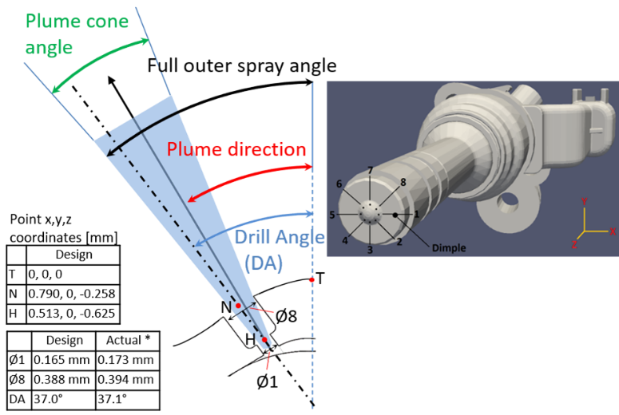
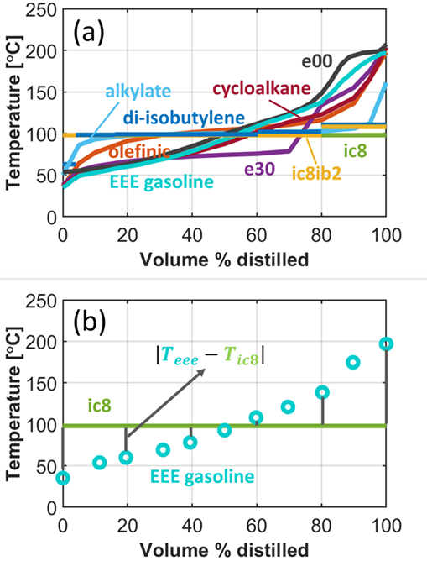
The ic8 is a single component fuel with a boiling temperature of 98 ℃ while EEE is a multi-component fuel that has hundreds of different species, so it shows a wide spectrum of distillation temperatures from 34.3 ℃ to 204.4 ℃. A large number of light species in fuels contributes to high vapor pressure as confirmed in Table 1. To obtain a format that can be easily integrated into the machine-learning algorithm, the distillation curve was processed to have a single representative value by summing up the differences in distillation temperature between a test fuel and ic8 (reference fuel) from distilled volumes of 0% to 100% with a 20% step size as presented in the following equation, eq-1 [28].
Fig. 2. Cut-plane image of ECN spray G injector with dimensions (inset figure shows the 3-D rendering of the injector with primary orientation) [10].

Fig. 1. (a) Distillation curves of tested fuels and (b) example of distillation-parameter calculation [30].

$$Distillation parameter=\frac{\sum_{i=0}^{5}{\left|T_{test fuel@20∙i}-T_{ic8@20∙i}\right|}}{318.5 [℃]} (eq-1)$$
where, T is distillation temperature $[℃]$ at a specific distilled volume, and 318.5$℃$ is an arbitrary constant to normalize the distillation parameter. Fig. 1(b) shows an example of EEE fuel that has a wide range of distillation temperatures. The resulting distillation parameters are reported in Table 1. In addition to the distillation parameters, fuel density [kg/m³], viscosity [mm²/s], vapor pressure [kPa], ambient to vapor pressure ratio (P_{a}/P_{v}) [n.a.], heat of vaporization [kJ/kg], ambient temperature [K], ambient density [kg/m³], and ambient pressure [kPa], which are the actual measurement data from [30], were set as input features for the machine-learning algorithm.
The test fuels were injected with an ECN Spray G injector (AV67-028), a solenoid type GDI injector that has eight axisymmetric nozzles [10]. The details of the test injector are presented in Fig. 2. Each nozzle was designed to have a counterbore shape, which has an inner orifice diameter of 165µm and a stepped diameter of 388µm. The nozzles were drilled with an angle of 37° from the center axis of the nozzle tip. Consistency of fuel injection profile related to previous studies was kept by using a standard ECN Spray G injector driver. The electronic command of 680μs was generated by an external triggering system and the signal was delivered to the injector driver. The injection pressure was kept at 200bar during the entire test matrix.

Constant Flow Vessel System
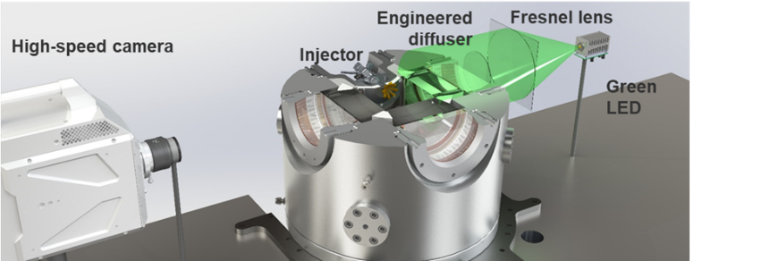
High-speed imaging was carried out in a constant flow vessel at Combustion Research Facility, Sandia National Laboratories. A schematic of the vessel system is shown in Fig. 3. Nitrogen flow with constant velocity in the vessel enabled fast scavenging of the residual air-fuel mixture so statistically converged data from 300 injections could be obtained with an injection frequency of 0.5 Hz. This is a much faster repetition period compared to a constant volume chamber that needs pre-burn or cyclic scavenging of the residual fuel-air mixture. To visualize the spray, two optical windows made of quartz were installed in parallel to provide optical access for line-of-sight extinction imaging. The ECN Spray G injector was mounted on a port placed in the mid-distance of the windows and its temperature was regulated at 90 ℃ by circulating hot water in the injector jacket. Fuel spray was then injected into the ambient of constant pressure adjusted by nitrogen flow rate, which, in turn, was regulated by an electro-pneumatic flow controller. Low-pressure flash-boiling condition was achieved by operating a custom-built vacuum pump. The vessel pressure was measured at three different points by pressure transducers. The nitrogen flow entered the vessel through its lower side and flowed through a heating coil located at the bottom of the spray vessel surrounded by an insulator piece. Afterwards, the flow passed through a diffuser to enhance uniformity in the velocity and temperature field in the spray region. Using 24 thermocouples positioned above and below the spray region, the temperature distribution was monitored during the experiment. The temperature at the target spray region was well controlled within 1 ℃ in the entire experiment.
Fig. 3. High-speed extinction imaging setup in a constant flow vessel.

High-speed Extinction Imaging
The liquid spray was identified using diffused back illumination extinction imaging. A high-speed green light-emitting diode (LED), Fresnel lens (150mm, f=150mm), engineered diffuser (20°), and bandpass filter (center wavelength: 527nm, bandwidth: 20nm, full width-half max: 22nm) were utilized. A high-speed digital video camera (Photron, SA-Z) equipped with a prime lens (Nikkor, 50mm f/1.8) was used to capture images of spray development in the vessel. The green LED was operated with a 24ns command signal (~220ns LED flash time) duration to freeze the spray in the visualized frame. The imaging was performed at a shutter speed of 67,200 frames per second (fps) with an image resolution of 512 by 512. The aperture of the lens and exposure time of the high-speed camera was set to 2.8 and 13.27μs, respectively. The engineered diffuser supplied a homogeneous light field and suppressed beam steering by evaporation or temperature field in the vessel. This imaging technique is designed to collect extinction only by the fuel in its liquid phase, yet not from the respective vapor. Normalized by incident light intensity (and other optical parameters), the side-view extinction imaging can become quantitative for projected liquid volume (PLV) as explained in the next section. Further details of the spray vessel and optical setup can be found in [31].
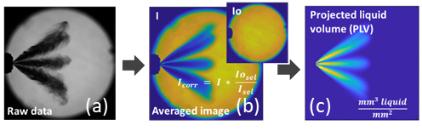
Image Processing
Fig. 4. Procedure to acquire Projected Liquid Volume (PLV) map, (a) raw extinction image, (b) normalized image, and (c) PLV.

Extinction imaging is recommended by the ECN community for spray characterization because it can provide more quantitative information for liquid fuel concentration than conventional Mie-scattering imaging associated with lighting and scattering uncertainties. Using the measured optical thickness, droplet size, and extinction coefficient, the projected liquid volume (PLV) along a line of sight can be derived for direct comparison with CFD results. The optical thickness in a spray region can be calculated based on the Beer-Lambert law as follows:
$$τ=-\ln\left(I/{I_{o}}\right) (eq-2)$$
where I is attenuated light intensity due to interaction with the liquid spray, and I_{o} is incident light intensity without any extinction. This level of transmission intensity is reasonable for detection of the spray outline above the noise floor of the camera, but the vapor-phase beam steering needs to be considered and accounted for using engineered diffusers [32]. The measured optical thickness τ is correlated to the PLV, which is the integral of liquid volume fraction (LVF) along the cross-stream direction y, as follows:
$$PLV= τ\frac{π{d^{3}}/6}{C_{ext}}=\int_{-y_{∞}}^{y_{∞}}{(LVF)∙dy} (eq-3)$$
Mie scattering and extinction theories were applied in eq-3, along with assumptions that droplet diameter d and extinction coefficient C_{ext} (which depends upon d) do not vary along the line of sight [33]. The PLV indicates how much liquid volume corresponds to a certain projected area, so it has a unit of mm³(liquid)/mm². The PLV can easily be calculated from CFD simulations for direct comparison to experimental results. However, the experimentalists must evaluate parameters such as d and C_{ext} to estimate PLV. In particular, C_{ext} is a function of droplet size, wavelength of light, and collection angle of the receiving optics. Fortunately, droplet diameter measurements have been performed using Spray G injector by General Motors and Shanghai Jiao Tong University by phase-doppler interferometry (PDI) [34]. The measurements show a Sauter mean diameter (SMD) near 7μm with fair uniformity across the plume during injection, and the C_{ext} was calculated as 72.70⁻⁶ mm² with a droplet diameter of 7μm using MiePlot available at [35].
Fig. 4 summarizes the image-processing techniques described above to assess its distinct features. Starting from the brightness of an image under evaluation (Fig. 4(a)), ensemble-averaged by 300 injections, normalization was performed using a background image absent of spray (Fig. 4(b)). Subsequently, the PLV map (Fig. 4(c)) was calculated using Eq. (3). A single threshold for PLV was chosen to indicate the extent of liquid penetration and width. The ECN community recommends thresholds of 0.2·10⁻³ or 2·10⁻³ mm³(liquid)/mm² [31]. In this study, the lower threshold value of 0.2·10⁻³ mm³(liquid)/mm² was used to binarize PLV maps. In the binarized image, liquid penetration length was measured at the farthest axial distance from the nozzle at the primary viewing angle (0° rotation angle), and the spray liquid width was measured at z=15mm based on the coordinate system of Fig. 2. The measured liquid penetration length and width from various conditions were fed into the ANN algorithm to predict with new inputs that were not included in the training process.
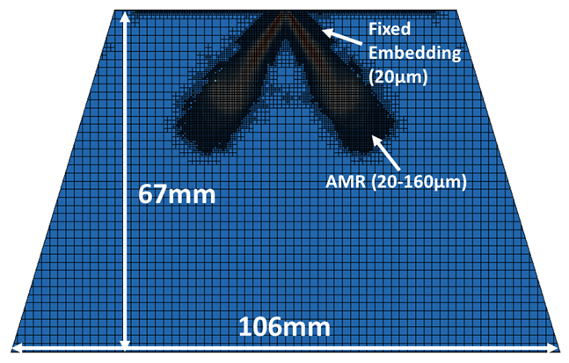
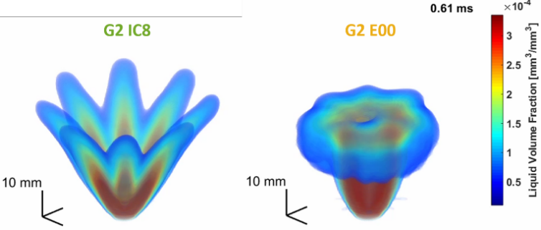
PLV data were taken at three different viewing angles to construct a 3D spray by a CT algorithm known as inverse Radon transform. Fig. 5 indicates the 3D reconstructed spray morphology of ic8 and e00 under G2 condition. The reconstruction was carried out using a built-in ‘iradon’ function in MATLAB. Since the PLV data were available at three viewing angles, i.e., the data within 0°, 11.25°, and 22.5°, the rest of the instances required to produce a 180° rotation matrix were derived through interpolation and mirroring as discussed in detail in [15]. Then the pattern was copied for the angled greater than 22.5° based on the symmetric assumption. Finally, after a projection map from 0° to 180° is generated, the CT algorithm was applied to build the spray pattern at a certain location. More details of the 3D reconstruction routine can be found in [15], including confirmation of the process using synthetic model data for liquid volume fraction. The local LVFs derived from the CT algorithm were used as a training set for the ANN model. It is noted that this approach is different than the previous attempt to predict LVF based on 3D CT of PLV map [28].
Fig. 6. CONVERGE simulation domain (fixed embedding and AMR were applied).

Fig. 5. Three-dimensional LVF of ic8 and e00 under G2 conditions.

Computational Fluid Dynamics Setup
Lagrangian parcel spray simulations using CONVERGE (v3.0) were performed under G1 (T_{amb}: 573K. P_{amb}: 6 bar, ρ_{amb}: 3.5kg/m³), G2 (T_{amb}: 333K. P_{amb}: 0.5 bar, ρ_{amb}: 0.5kg/m³), and G3 (T_{amb}: 333K. P_{amb}: 1 bar, ρ_{amb}: 1.01kg/m³), conditions. The injector specifications for the 8-hole nozzle are given in Fig. 2. The detailed setting for simulation and computational domain is presented in Table 2 and Fig. 6, respectively. The injector has a nozzle drill angle of 37°, however, 34° plume direction angle was used as a default value based on the near-nozzle x-ray measurement [14]. With 34° of plume direction angle, spray cone angle was tuned to match experimental data accordingly. For e00 G2 condition, plume cone angle of 40° was set based on the previous study, and then plume direction angle was modified to match experimental data [31]. It is noted that predictive models for plume direction angle and plume cone angle are required to set primary inputs.
Table 2. CFD Simulation setup.
Item | Level
Fuel | ic8 and e00
Total cell number | 6,800,000
Max cell resolution [μm] | 125
Turbulence model | RANS* (Standard k-ε)
KT time constant (B1) and | 5.0
RT break-up model size constant (C_{RT}) | 1.0
Parcel number | 70,000/plume
Simulation time | ~5ms after start of injection
Total calculation hour [h] | ~2 / case (64 CPUs)
Conditions | G1, G2, G3
Plume direction angle | G1 (34) G2 (34) G3 (34) ic8  G1 (34) G2 (34) G3 (34) e00
Plume cone angle | G1 (34) G2 (32.47) G3 (34) ic8  G1 (30) G2 (40) G3 (30) e00
Simulations were performed for Spray G conditions using ic8 and e00 at ambient conditions matching the experiment. Beginning with blob injection at the size of the nozzle, O’Rourke dispersion, Kelvin-Helmholtz (KH) and Rayleigh-Taylor (RT) models were used to capture turbulent dispersion, primary and secondary breakup, respectively, while the Corrected Distortion model was used for evaporation [36]. For G2 flash-boiling condition, the Adachi empirical flash boiling model was utilized [37]. An injection rate profile provided by ECN was used for the simulation [34]. The simulation time was extended up to 2ms after start of injection (SOI) to include timings during and after injection available in the experiment.
Machine-learning Methods
A multilayer feed-forward ANN in the MATLAB software was utilized as a means of non-linear regression to predict spray dynamics. The building block of an ANN is the layers and artificial neurons that represent the smallest processing element [38]. More specifically, feed-forward ANN is composed of three types of layers: one input layer, one output layer, and one or more hidden layers between the input and output layer. A neuron in hidden layers can have one or more inputs of x_{i}, which come from the neurons in the input layer or a previous layer. These inputs then are multiplied with weights w_{i} to be summed and shifted by a bias w₀, resulting in an intermediate single valued result to pass through an activation function $f(⋅)$ that maps the intermediate result in desired range, e.g. 0 to 1 or -1 to 1. The output y can become an input to the next layer. The overall equation is shown below.
$$y=f\left(w_{0}+\sum_{i=1}^{N}{w_{i}x_{i}}\right) (eq-4)$$
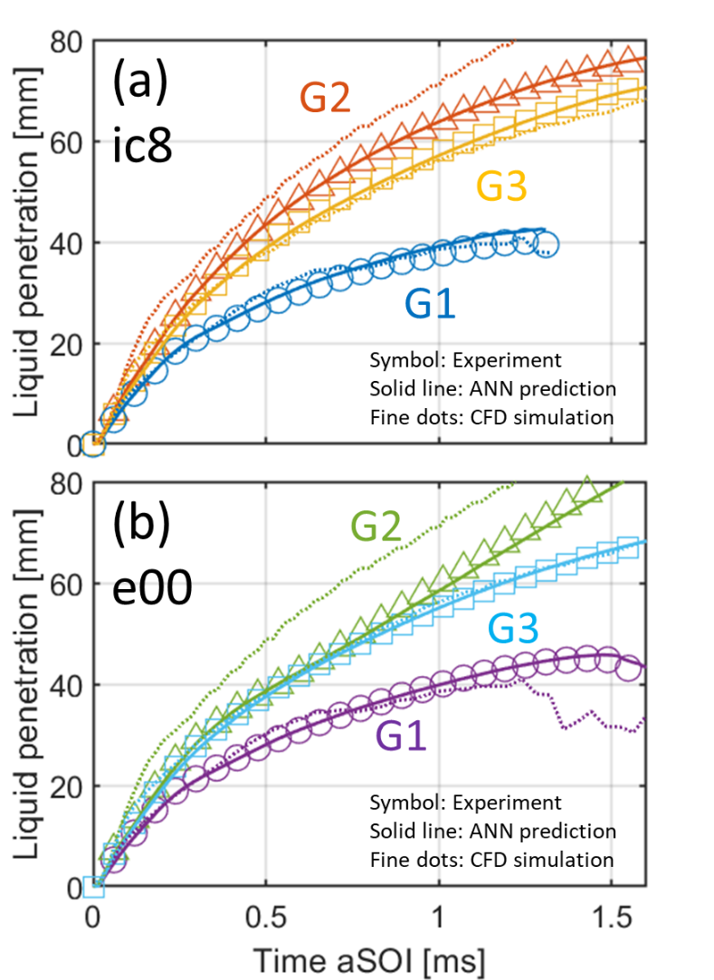
The activation function can be in various forms that are differentiable such as linear, hyperbolic, tangent, and sigmoid. In the present work, sigmoid is used as an activation function for all hidden layers and linear for the output layer because it demonstrated the best performance in terms of prediction. The training on measured liquid data was performed using nine inputs such as the distillation parameters, fuel density [kg/m³], viscosity [mm²/s], vapor pressure [kPa], ambient to vapor pressure ratio (P_{a}/P_{v}) [n.a.], heat of vaporization [kJ/kg], ambient temperature [K], ambient density [kg/m³], and ambient pressure [kPa]. The training was conducted with a maximum iteration number of 2,000 with an early stopping function. The early stopping function can facilitate the training process by checking the error on the validation set that is held off from the training set so as to interrupt the process when the validation error increases or does not improve for a certain number of consecutive iterations. Throughout the process, the weights and biases that give the best validation results are stored and maintained. Most of the training showed a minimum before the initial 200 iterations and converged to give an optimized model, so the early stopping of 50 consecutive iterations was shown to be sufficient in this work. The output covers the PLV distribution sequence from 0 to 2.0 ms after the start of injection. It was essential to perform the so-called training where the weights and biases of all involved neurons are learned in iterations before deploying the ANN for prediction. This training task was carried out as an optimization process where the objective was to minimize the error in predicting the desired output for the input vector of a training dataset. Oftentimes, the trained network does not properly respond to novel, unobserved inputs outside of the training dataset, which are called “underfitting” and “overfitting” issues. These issues can be addressed by constructing a proper size of the network and hyperparameter tuning. Furthermore, regularization techniques can be applied to the training not only to minimize the training error but also to minimize the weights themselves in the assumption that the true underlying function has a degree of smoothness. In this work, we employed the Bayesian regularization technique that seeks a balance between two objectives that minimize the training error while keeping the weights small by estimating the objective function parameters based on the Bayes rule, which leads to a better prediction than non-regularized optimizations [39]. Different combinations of dataset ratios for training, validation, and testing were explored. The best performance was found in 90%, 5%, 5% for training, validation, and test data set, respectively. Meanwhile, a parametric investigation showed the best agreement with 2 hidden layers that have 2 and 5 neurons. An example of regression quality is shown in Appendix for liquid penetration prediction.
Fig. 7. Comparison of liquid penetration length between experiment, CFD, and machine learning predictions under G1, G2, and G3 conditions for (a)ic8 and (b) e00 fuels.

Results and discussion
Liquid Penetration Length and Width
Liquid penetration length and width have been considered as primary parameters for CFD validation since they provide overall information in spray morphology. The liquid penetration length and width were measured in the primary viewing angle with a PLV threshold of 0.2·10⁻³ mm³(liquid)/mm². The liquid penetration length was defined as the axial farthest length from the nozzle and the width was measured at z=15mm from the nozzle. It has to be reminded that the liquid penetration length and liquid width were measured from an ensemble-averaged image of 300 injections. In CFD results, the liquid penetration length and width were measured with an identical definition using PLV. The liquid volume fraction on each computational cell was projected into a plane to sum up the values as described in eq-3. The comparison of liquid penetration length between experiment, CFD, and ANN is shown in Fig. 7. It is emphasized that the experimental results of ic8 and e00 were not included in the training data set but used only for comparison against the ANN prediction. Experimental result, CFD simulation, and ANN predictions are presented by symbols, dotted line, and solid line, respectively.
It is interesting that the liquid penetration length was longest under the G2 condition regardless of the fuels. Despite enhanced vaporization for flash-boiling sprays, the evaporation cooling and plume collapse augmented the spray momentum at its leading edge so that the liquid penetration length increases compared to non-boiling condition [31]. The prediction of liquid penetration length especially for flash-boiling sprays is very crucial for engine design since the large momentum of collapsed plumes can lead to fuel impingement on the surface of the combustion chamber. Fuels with higher vapor pressure such as e00 in this study are known to suffer more from plume-to-plume interactions under flash-boiling conditions due to their greater plume growth. This is the reason for continuous increase in liquid penetration for e00 even after 1.5ms after start of injection. Meanwhile, liquid residual time is also important since larger values correspond to higher of fuel impingement on the piston and the combustion chamber. As e00 fuel has large number of heavy species as shown in the distillation curve of Fig. 1(a), it requires a longer time period to achieve full evaporation. For example, ic8 fuel had full evaporation at 1.3ms after start of injection, however, the liquid e00 fuel was still observed after 1.5ms.
In terms of prediction accuracy, it is shown that the CFD results had a good agreement for both fuels under G1 and G3 condition where plumes have fairly constant plume direction angle. However, under flash-boiling conditions associated with complicated plume dynamics, as confirmed in Fig. 5, the accuracy of CFD prediction is deteriorated. In the previous research, CFD parameter settings for plume direction angle and plume cone angle have been tuned in comparison to experiment [9]. While the CFD simulation for the G2 condition has been attempted for several years in the ECN community, prediction of the spray topology under flare flash-boiling conditions is still challenging even by multi-physics CFD simulations with tuning parameters allowed. With regards to the predictive capability of the ANN methodology good agreement with experimental results was accomplished and, in fact, under all examined conditions. Contrary to the CFD simulation which needs numerous sub-models, the ANN does not rely on those underlying physical assumptions but using neural network it directly finds the specific relationship between inputs and outputs. Thus, the prediction even under flash-boiling condition could maintain its accuracy. The ANN showed better prediction not only for the liquid penetration length but also for the liquid residual time. The maximum discrepancies in entire test matrix between the ANN predictions and the experimental data regarding the liquid penetration length for ic8 and e00 during the injection period were 2.9 mm (6.9% error) and 1.8 mm (2.3%), respectively. This error turned out to be smaller than our previous attempt to acquire the liquid penetration length based on the predicted PLV map [28]. This implies that using penetration data derived from the experimental image can save a lot of computational cost for parameter prediction, however, it should be noted that in this method, the ANN was not used to predict entire PLV map to measure spray parameters, so the prediction is limited within a range of training dataset (liquid penetration, width at 15mm, LVF at 15mm, and plume direction angle at 15mm).
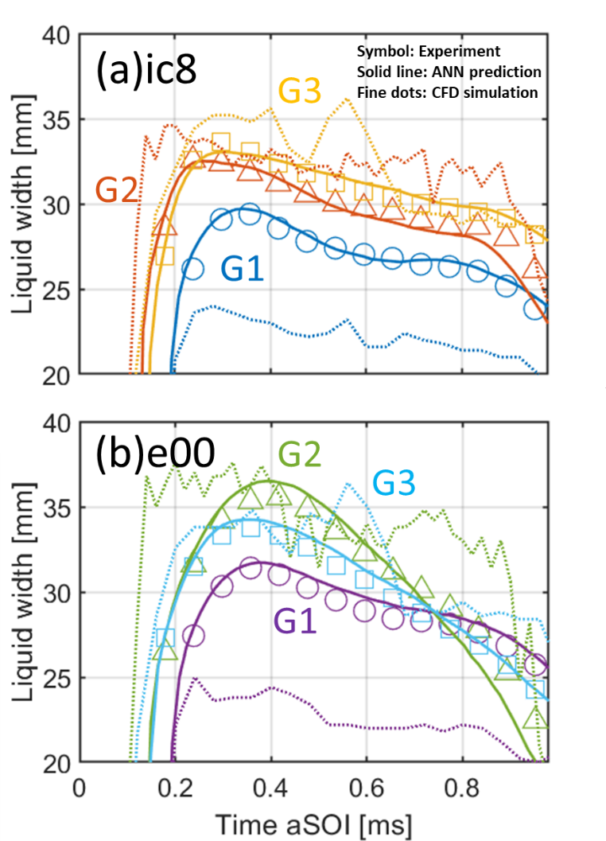
The results for liquid width measured at z=15mm are shown in Fig. 8. It is noted that this is not a single plume width but the maximum spray outline width in the entire spray domain. The results are presented in the same manner as the penetration length. As discussed above, the flash-boiling sprays have longer penetration length due to the discrete plume collapsing to the injector centerline thus the narrower liquid width observed under flash-boiling condition for both fuels. The liquid width under the G1 condition showed the smallest values due to higher ambient density and faster evaporation under elevated temperature, whereas the liquid width under the G2 condition was smaller than the G3 condition. The e00 fuel had the largest value at the beginning of the injection event due to the formation of a large recirculation zone in the leading edge, however, the liquid width had a rapid decrease as complete collapse occurred.
Fig. 8. Comparison of liquid width (at z=15mm) between experiment, CFD, and machine learning predictions under G1, G2, and G3 conditions for (a)ic8 and (b) e00 fuels.

Liquid width results can provide additional morphological information. Under the G2 condition, the liquid width from the CFD simulation appears relatively flat compared to decreasing trend with time shown in the high-speed imaging experiment. This is a sign that CFD does not capture plume collapse towards the injector axis and underestimates flash-boiling evaporation by showing longer liquid penetration and wider liquid width. Detailed comparison of local LVF will elucidate the plume dynamics in the next section. On the other hand, the CFD simulation overestimated evaporation under the G1 condition showing a much shorter liquid width compared to the experimental results. The ANN prediction showed a consistent trend compared to the experiment regardless of fuels and ambient conditions. The maximum discrepancies in the entire test matrix between the ANN predictions and the experimental data regarding the liquid width for ic8 and e00 during the injection period were 0.6 mm (2% error) and 0.8 mm (2.22%), respectively.
Liquid Volume Fraction (LVF)
The comparison of averaged LVF through the plume center of the 3D spray, as enabled by CT reconstruction, is shown in Fig. 9. The LVF result presented here was acquired at 15mm from the nozzle in the xy plane (refer to Fig. 2) but at different timing after the start of injection. LVF data from the CFD simulation were also analyzed at an identical axial location and timing. It is emphasized here the LVF acquired in the experiment is a quantitative parameter so direct comparison between experiment and CFD simulation was facilitated. However, measured local LVF at the core of spray plume may suffer from optical thickness, multiple scattering, and droplet diameter. For example, at z=15mm, the experimental measurements still have a certain level of uncertainties in LVF at the center of plume thus we kept the major analysis at z=30mm to present the comparison under all conditions. Again, the ANN prediction shown in this figure is not based on the raw image prediction but post-processed LVF data from the experiment.
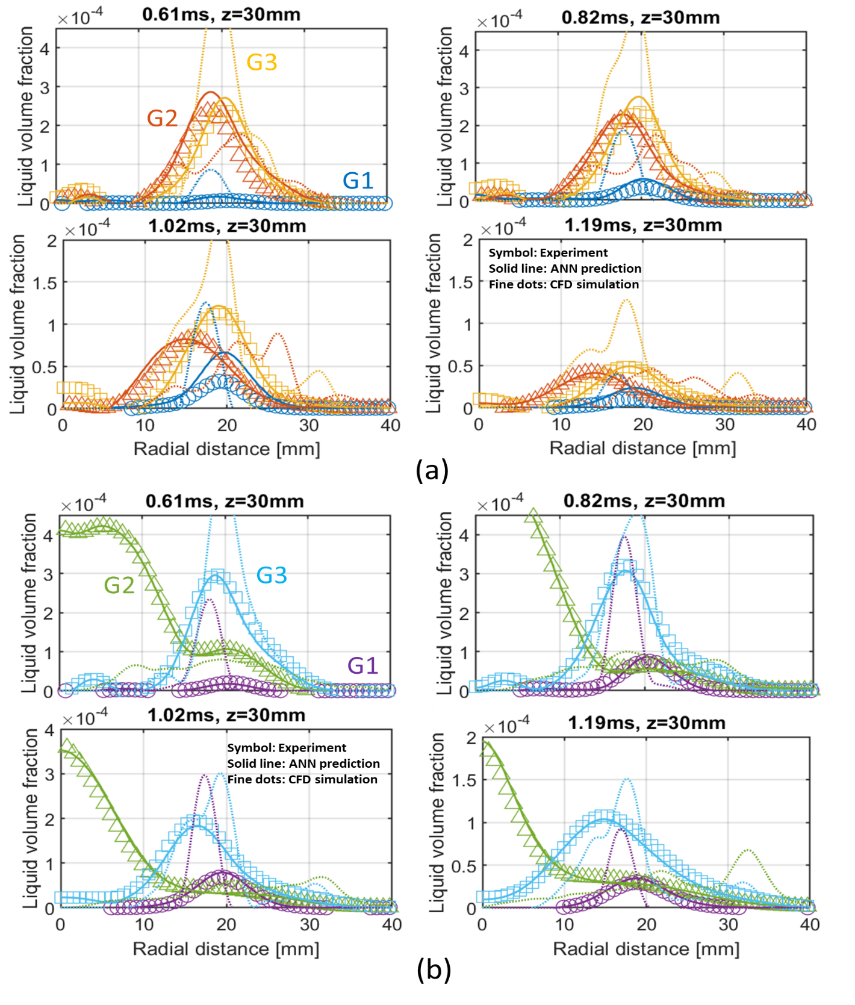
The overall spray behavior shown in the line-of-sight measurement can be confirmed in detail with LVF information. Ic8 showed overall lower LVF than e00 that has not only light but also heavy species. Ic8 had plume movement mainly under the G1 and G2 conditions and it showed stable plume location under the G3 condition. On the other hand, as predicted in the line-of-sight measurement, e00 fuel had significant plume merging under the G2 condition due to severe plume to plume interaction. In terms of prediction accuracy, the ANN algorithm was able to precisely capture the plume dynamics. It had a certain level of error in LVF prediction at 0.37ms for the G2 condition of e00, however, the ANN was able to predict the complete plume collapse. This result showed a better performance in terms of prediction accuracy and calculation cost compared to the previous approach that used linear regression model to predict PLV maps in 301 by 301 image resolution and 3D CT routine to acquire local LVF [28]. On the contrary to the previous linear regression model that showed larger discrepancy on the LVF profile, the ANN approach in this study showed better agreement on the level of LVF. On the other hand, CFD simulation results showed a higher peak of the LVF compared to the experimental result. The peak of the LVF under G1 condition was at least 2.5 times larger than the experiment regardless of fuels. This corresponds to an experimental result with minimum 2.5 times larger droplet diameter assumption in PLV measurement. Considering the fact of the narrower liquid width predicted by the CFD in the previous section, it becomes apparent that adjustment is needed in the plume cone angle or the evaporation model to enhance its accuracy. Meanwhile, under the G2 condition the detection of plume movement by the CFD simulation seems challenging as much lower LVF values and stationary plume profiles were obtained. This result indicates that the validation of CFD simulation should be accompanied not only by the macroscopic spray characterization using liquid penetration length and width, but also local spray profile such as LVF. In the meanwhile, the CFD simulation showed relatively good agreement with the experiment under the G3 condition that is a fairly moderate ambient condition compared to G1-high temperature/pressure, and G2-flash-boiling conditions. However, still under G3 condition, the maximum error of LVF prediction by CFD was up to 63% compared to the experiment.
Fig. 9. Comparison of LVF (at z=15mm) between experiment, CFD, and machine learning predictions under G1, G2, and G3 conditions for (a)ic8 and (b) e00 fuels. The LVF profile (through plume center) on each plume was averaged for all 8 plumes.

Plume Direction Angle
Understanding the plume direction is essential to assess air-fuel mixing in an engine cylinder. The plume direction angle is also an important boundary condition for CFD simulations, thus the evaluation of plume direction angle was carried out from 3D spray results. The plume direction angle was defined as an angle between the axis corresponding to the plume center and the inject or axis at z=15mm. The plume center was selected at the 99% peak LVF position (refer to Fig. 9) to eliminate bias induced by the skewed shape of plumes. The results corresponding to plume direction angle with time after start of injection (aSOI) are shown in Fig. 10.
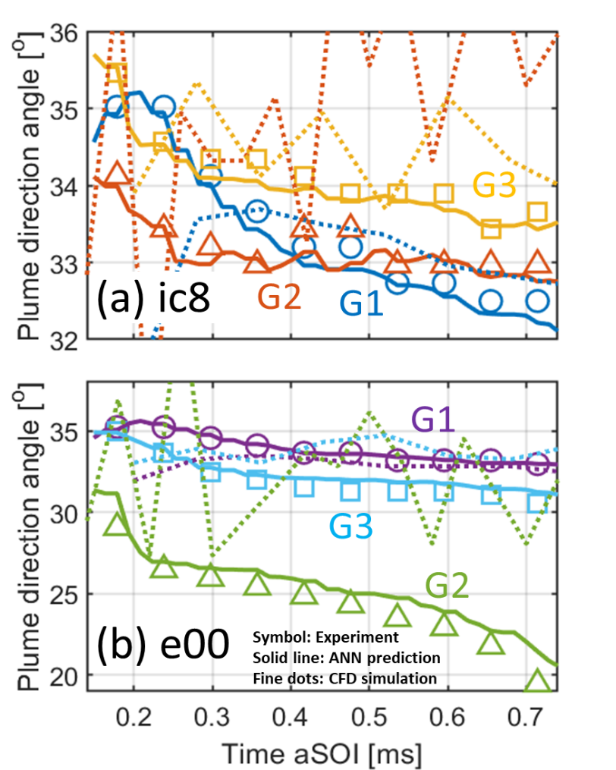
As confirmed in the LVF results, the plume direction angle under the G3 condition remained larger than the G2 condition regardless of the fuel, however, the plume direction angle of e00 at G3 was smaller than that of ic8 due to its high vapor pressure which still causes mild flash-boiling under the G3 condition. Under the G2 condition, both fuels showed plume collapse, so the plume direction angle was maintained low values especially for e00 that had a complete collapse. The plume direction angle from CFD showed fluctuations due to the nature of parcel simulation, however, it showed fair agreement on limited conditions such as G1 and G3 indicating an error within 1°. Meanwhile, ANN showed the best match under all conditions. Even under flare flash-boiling for the e00 G2 condition, it was able to precisely predict the plume direction angle. This result implies that the ANN can be utilized as a tool to provide initial validation data where experimental data is absent.
Fig. 10. Comparison of plume direction angle between experiment, CFD, and machine learning predictions under G1, G2, and G3 conditions for (a) ic8 and (b) e00 fuels.

Discussion on ANN Utilization
Quantitative comparisons between experiment, CFD simulation, and ANN on GDI spray showed that ANN can be used as a good interpolation tool. However, it should be noted that ANN cannot replace full function of CFD simulation because ANN is highly dependent on the training dataset and the prediction with out of input dataset range will not work correctly. Meanwhile, it is noted that a well-trained ANN can be placed between experiment and CFD simulation to complete a good feedback loop. For example, (1) ANN can be utilized to provide initial insights for computationally expensive CFD simulation, (2) ANN can enhance CFD simulation by providing reasonable CFD input data such as initial plume direction/cone angles, and rate of injection, (3) provide validation data for initial evaluation of CFD result where experiment has not carried out, (4) since ANN model itself is very small, it can reduce cost related to transfer between experimentalist and modelers for CFD validation.
Summary/Conclusions
In this study, a multilayer feed-forward Artificial Neural Network (ANN) was utilized to predict gasoline spray dynamics under engine-like conditions. A series of CFD simulations using CONVERGE software was also carried out to compare results. The predictions from ANN and CFD were compared to high-speed extinction imaging performed in a constant-flow vessel under ECN defined G1, G2, G3 conditions. Nine different fuels were injected using an ECN Spray G 8-hole injector. The ANN algorithm was capable of predicting not only line-of-sight measurement data but also 3D liquid volume fraction (LVF) and plume direction angle. The major findings from this study can be summarized as follows.
- Despite the simplicity in the structure of the ANN, reliable predictions were achieved. The ANN algorithm using experimental data such as liquid penetration length, width, and LVF could save computational time and cost compared to the previous attempt to acquire those parameters by predicting the PLV image.
- Prediction of spray dynamics including liquid penetration length, width, local LVF, and plume direction angle by ANN showed good agreement with experimental data. It showed better accuracy in prediction than CFD simulation especially under the flare flash-boiling condition. The absence of physical models turned out to be one of the strengths of ANN.
- The ANN approach showed a potential for data interpolation, validation data for CFD, and suggestion of reliable input values for CFD. This implies that the ANN can be used to reduce a significant amount of computational time and cost compared to CFD simulations that needs sequentially accumulated data to predict spray evolution in the subsequent time step. It has to be emphasized that the ANN should be utilized as an auxiliary tool of CFD since the prediction is limited to the training dataset unlike CFD that yields every parameter in the 3D domain.

References
1. Duronio, F., Vita, A. De, Montanaro, A., and Villante, C., “Gasoline direct injection engines – A review of latest technologies and trends. Part 2,” Fuel 265(December 2019):116947, 2020, doi:10.1016/j.fuel.2019.116947.
2. Yu, C.H., Park, K.W., Han, S.K., and Kim, W.T., “Development of theta II 2.4L GDI engine for high power & low emission,” SAE Tech. Pap., 2009, doi:10.4271/2009-01-1486.
3. Oh, H. and Bae, C., “Effects of the injection timing on spray and combustion characteristics in a spray-guided DISI engine under lean-stratified operation,” Fuel 107:225–235, 2013, doi:10.1016/j.fuel.2013.01.019.
4. EPA, “The 2020 EPA Automotive Trends Report,” Epa (March):1–12, 2020.
5. Saliba, G., Saleh, R., Zhao, Y., Presto, A.A., Lambe, A.T., Frodin, B., Sardar, S., Maldonado, H., Maddox, C., May, A.A., Drozd, G.T., Goldstein, A.H., Russell, L.M., Hagen, F., and Robinson, A.L., “Comparison of Gasoline Direct-Injection (GDI) and Port Fuel Injection (PFI) Vehicle Emissions: Emission Certification Standards, Cold-Start, Secondary Organic Aerosol Formation Potential, and Potential Climate Impacts,” Environ. Sci. Technol. 51(11):6542–6552, 2017, doi:10.1021/acs.est.6b06509.
6. Luijten, B., Adomeit, P., Brunn, A., and Somers, B., “Experimental investigation of in-cylinder wall wetting in GDI engines using a shadowgraphy method,” SAE Tech. Pap. 2, 2013, doi:10.4271/2013-01-1604.
7. Whitaker, P., Kapus, P., Ogris, M., and Hollerer, P., “Measures to Reduce Particulate Emissions from Gasoline DI engines,” SAE Int. J. Engines 4(1):1498–1512, 2011, doi:10.4271/2011-01-1219.
8. Sivathanu, Y., Lim, J., Muliadi, A., Nitulescu, O., and Shieh, T., “Estimating velocity in Gasoline Direct Injection sprays using statistical pattern imaging velocimetry,” Int. J. Spray Combust. Dyn. 11:1–8, 2018, doi:10.1177/1756827718778289.
9. Sphicas, P., Pickett, L.M., Skeen, S., Frank, J., Lucchini, T., Sinoir, D., D’Errico, G., Saha, K., and Som, S., “A Comparison of Experimental and Modeled Velocity in Gasoline Direct-Injection Sprays with Plume Interaction and Collapse,” SAE Int. J. Fuels Lubr. 10(1):184–201, 2017, doi:10.4271/2017-01-0837.
10. https://ecn.sandia.gov/gasoline-spray-combustion/computational-method/mesh-and-geometry/
11. Liu, W., Lu, Y., Kang, Y., Yan, J., and Lee, C.F., “Macroscopic characteristics of flash-boiling spray focused on plume interaction,” Int. J. Heat Mass Transf. 170:120999, 2021, doi:10.1016/j.ijheatmasstransfer.2021.120999.
12. Crua, C., Manin, J., and Pickett, L.M., “On the transcritical mixing of fuels at diesel engine conditions,” Fuel 208:535–548, 2017, doi:10.1016/j.fuel.2017.06.091.
13. Sphicas, P., Pickett, L.M., Skeen, S.A., and Frank, J.H., “Inter-plume aerodynamics for gasoline spray collapse,” Int. J. Engine Res. 19(10):1048–1067, 2018, doi:10.1177/1468087417740306.
14. Duke, D.J., Kastengren, A.L., Matusik, K.E., Swantek, A.B., Powell, C.F., Payri, R., Vaquerizo, D., Itani, L., Bruneaux, G., Grover, R.O., Parrish, S., Markle, L., Schmidt, D., Manin, J., Skeen, S.A., and Pickett, L.M., “Internal and near nozzle measurements of Engine Combustion Network ‘Spray G’ gasoline direct injectors,” Exp. Therm. Fluid Sci. 88(December 2016):608–621, 2017, doi:10.1016/j.expthermflusci.2017.07.015.
15. Weiss, L., Wensing, M., Hwang, J., Pickett, L.M., and Skeen, S.A., “Development of limited-view tomography for measurement of Spray G plume direction and liquid volume fraction,” Exp. Fluids 61(2):1–17, 2020, doi:10.1007/s00348-020-2885-0.
16. Paredi, D., Lucchini, T., D’Errico, G., Onorati, A., Pickett, L., and Lacey, J., “Validation of a comprehensive computational fluid dynamics methodology to predict the direct injection process of gasoline sprays using Spray G experimental data,” Int. J. Engine Res. 21(1):199–216, 2020, doi:10.1177/1468087419868020.
17. Payri, R., Marti-Aldaravi, P., Abboud, R., Bautista, A.,"Numerical analysis of GDI flash boiling sprays using different fuels," Energies, 14, 5925, https://doi.org/10.3390/ en14185925
18. Neroorkar, K., Shields, B., Grover, R.O., Plazas Torres, A., and Schmidt, D., “Application of the homogeneous relaxation model to simulating cavitating flow of a diesel fuel,” SAE Tech. Pap., 2012, doi:10.4271/2012-01-1269.
19. Rachakonda, S.K., Wang, Y., Grover, R.O., Moulai, M., Baldwin, E., Zhang, G., Parrish, S., Diwakar, R., Kuo, T.W., and Schmidt, D.P., “A computational approach to predict external spray characteristics for flashing and cavitating nozzles,” Int. J. Multiph. Flow 106:21–33, 2018, doi:10.1016/j.ijmultiphaseflow.2018.04.012.
20. Baldwin, E.T., Grover, R.O., Parrish, S.E., Duke, D.J., Matusik, K.E., Powell, C.F., Kastengren, A.L., and Schmidt, D.P., “String flash-boiling in gasoline direct injection simulations with transient needle motion,” Int. J. Multiph. Flow 87:90–101, 2016, doi:10.1016/j.ijmultiphaseflow.2016.09.004.
21. Saha, K., Som, S., and Battistoni, M., “Investigation of homogeneous relaxation model parameters and their implications for gasoline injectors,” At. Sprays 27(4):345–365, 2017, doi:10.1615/AtomizSpr.2017016338.
22. Hwang, J., Yasutomi, K., Arienti, M., and Pickett, L.M., “Numerical Investigation of Near Nozzle Flash-Boiling Spray in an Axial-Hole Transparent Nozzle,” SAE Tech. Pap. 2020-April(April):1–17, 2020, doi:10.4271/2020-01-0828.
23. Marco, A., Hwang, J., Pickett, L., and Shekhawat, Y., “A thermally-limited bubble growth model for the relaxation time of superheated fuels,” Int. J. Heat Mass Transf. 159, 2020, doi:10.1016/j.ijheatmasstransfer.2020.120089.
24. Raissi, M., Perdikaris, P., and Karniadakis, G.E., “Physics-informed neural networks: A deep learning framework for solving forward and inverse problems involving nonlinear partial differential equations,” J. Comput. Phys. 378:686–707, 2019, doi:10.1016/j.jcp.2018.10.045.
25. Ikeda, Y. and Mazurkiewicz, D., “Application of neural network technique to combustion spray dynamics analysis,” Lect. Notes Comput. Sci. (Including Subser. Lect. Notes Artif. Intell. Lect. Notes Bioinformatics) 2281:408–425, 2002, doi:10.1007/3-540-45884-0_30.
26. Han, Z., Hossain, M.M., Wang, Y., Li, J., and Xu, C., “Combustion stability monitoring through flame imaging and stacked sparse autoencoder based deep neural network,” Appl. Energy 259(November 2019):114159, 2020, doi:10.1016/j.apenergy.2019.114159.
27. Koukouvinis, P., Rodriguez, C., Hwang, J., Karathanassis, I., Gavaises, M., and Pickett, L., “Machine Learning and transcritical sprays: A demonstration study of their potential in ECN Spray-A,” Int. J. Engine Res., 2021, doi:10.1177/14680874211020292.
28. Hwang, J., Lee, P., Mun, S., Karathanassis, I.K., Koukouvinis, P., Pickett, L.M., and Gavaises, M., “Machine-learning enabled prediction of 3D spray under engine combustion network spray G conditions,” Fuel 293:120444, 2021, doi:10.1016/j.fuel.2021.120444.
29. Zhang, Y., Xu, S., Zhong, S., Bai, X.-S., Wang, H., and Yao, M., “Large eddy simulation of spray combustion using flamelet generated manifolds combined with artificial neural networks,” Energy AI 2:100021, 2020, doi:10.1016/j.egyai.2020.100021.
30. McCormick, R.L., Fouts, L.A., Fioroni, G.M., Christensen, E.D., Ratcliff, M.A., Zigler, B.T., Sluder, S., Szybist, J.P., Ciatti, S., Bays, J.T., Pitz, W., Mehl, M., Dec, J.E., and Miles, P.C., “Co-Optimization of Fuels &amp; Engines: Properties of Co-Optima Core Research Gasolines,” (August), 2018.
31. Hwang, J., Weiss, L., Karathanassis, I.K., Koukouvinis, P., Pickett, L.M., and Skeen, S.A., “Spatio-temporal identification of plume dynamics by 3D computed tomography using engine combustion network spray G injector and various fuels,” Fuel 280(July):118359, 2020, doi:10.1016/j.fuel.2020.118359.
32. Westlye, F.R., Penney, K., Ivarsson, A., Pickett, L.M., Manin, J., and Skeen, S.A., “Diffuse back-illumination setup for high temporally resolved extinction imaging,” Appl. Opt. 56(17):5028, 2017, doi:10.1364/ao.56.005028.
33. Pickett, L.M., Genzale, C.L., and Manin, J., “Uncertainty quantification for liquid penetration of evaporating sprays at diesel-like conditions,” At. Sprays 25(5):425–452, 2015, doi:10.1615/AtomizSpr.2015010618.
34. https://ecn.sandia.gov/gasoline-spray-combustion/target-condition/primary-spray-g-datasets/
35. http://www.philiplaven.com/mieplot.htm
36. Dahms, R.N. and Oefelein, J.C., “The significance of drop non-sphericity in sprays,” Int. J. Multiph. Flow 86:67–85, 2016, doi:10.1016/j.ijmultiphaseflow.2016.07.010.
37. Adachi, M., McDonell, V.G., Tanaka, D., Senda, J., and Fujimoto, H., “Characterization of fuel vapor concentration inside a flash boiling spray,” SAE Tech. Pap. (412), 1997, doi:10.4271/970871.
38. Fernandes de Mello, R. and Antonelli Ponti, M., “Machine Learning: A Practical Approach on the Statistical Learning Theory,” Mach. Learn. 373, 2018.
39. Foresee, F.D. and Hagan, M.T., “GAUSS-NEWTON APPROXIMATION TO BAYESIAN LEARNING ** School of Electrical and Computer Engineering,” Network 1930–1935, 1930.

Contact Information
Joonsik Hwang, e-mail:hwang@me.msstate.edu
Acknowledgments
The authors would like to thank Tim Gilbertson, Alberto Garcia, Brian Patterson, Keith Penny, Nathan Harry, Aaron Czeszynski, Chris Ingwerson, Laurie Bell, Paul Abers, and Peter Cable for their dedicated support for the research facility. The spray experiment was performed at the Combustion Research Facility (CRF), Sandia National Laboratories, Livermore, CA. This research was conducted as part of the Co-Optimization of Fuels & Engines (Co-Optima) project sponsored by the U.S. Department of Energy (DOE) Office of Energy Efficiency and Renewable Energy (EERE), Bioenergy Technologies and Vehicle Technologies Offices. Sandia National Laboratories is a multi-mission laboratory managed and operated by National Technology and Engineering Solutions of Sandia, LLC., a wholly owned subsidiary of Honeywell International, Inc., for the U.S. Department of Energy’s National Nuclear Security Administration under contract DE-NA0003525. We gratefully acknowledge EU Horizon-2020 Marie Skłodowska-Curie Global Fellowships AHEAD (IK, Grant No. 794831) and UNIFIED (PK, Grant No. 748784) for supporting an international visiting program of Ioannis K. Karathanassis and Phoevos Koukouvinis at the Sandia National Laboratories. We also appreciate additional funding by the UK’s Engineering and Physical Sciences Research Council (EPSRC) grant EP/K020846/1
Appendix
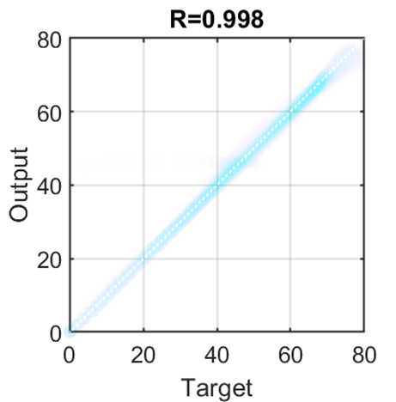
Fig. 11 indicates coefficient of determination for the training of liquid penetration length. It can be seen that the prediction by ANN was performed with training score of 0.99.
Fig. 11. Regression quality for prediction of liquid penetration length.

Definitions/Abbreviations
ANN | Artificial neural network
aSOI | after start of injection
CFD | Computational fluid dynamics
CT | Computed tomographic
ECN | Engine Combustion Network
EGR | Exhaust gas recirculation
FGM | Flamelet generated manifolds
GDI | Gasoline direct-injection
HRM | Homogeneous relaxation model
KH | Kelvin-Helmholtz
LED | Light-emitting diode
LES | Large eddy simulation
LTGC | Low-temperature gasoline combustion
LVF | Liquid volume fraction
MSE | Mean squared error
P_{a} | Ambient pressure [Pa]
PDEs | Partial differential equations
PDI | Phase-doppler interferometry
PFI | Port fuel injection
PIV | Particle image velocimetry
PLV | Projected liquid volume [mm³(liquid)/mm²]
PM | Particulate matter
P_{v} | Vapor pressure [Pa]
RT | Rayleigh-Taylor
PLV | Projected liquid volume [mm³(liquid)/mm²]
RANS | Reynolds averaged Navier-Stokes
Re | Reynolds number
$$ρ$$ | Density [kg/m³]
$$t$$ | Time [s]
$$τ$$ | Optical thickness

