Experimental and numerical evaluation of an elongated plate-fin heat sink with three sections of stepwise varying channel width.

I.K. Karathanassis^{a, b,*}, E. Papanicolaouª, V. Belessiotisª and G.C. Bergeles^{b}

ª Solar & other Energy Systems Laboratory, Institute of Nuclear and Radiological Sciences & Technology, Energy and Safety, National Centre for Scientific Research DEMOKRITOS, Aghia Paraskevi, 15310 Athens, Greece

^{b} Laboratory of Innovative Environmental Technologies, School of Mechanical Engineering, National Technical University of Athens, Zografos Campus, 15710 Athens, Greece

* Corresponding author at: Solar & other Energy Systems Laboratory, Institute of Nuclear and Radiological Sciences & Technology, Energy and Safety, National Centre for Scientific Research DEMOKRITOS, Aghia Paraskevi, 15310 Athens, Greece.
E-mail address: ikarathanassis@ipta.demokritos.gr (I. K. Karathanassis).

Abstract. The performance of a novel design of a three-section plate-fin heat sink employing channels of stepwise decreasing hydraulic diameter is numerically and experimentally evaluated. Prototype heat-sink and inlet-outlet manifold configurations have been manufactured and characterized, in terms of thermal resistance and induced pressure drop, in a closed fluid loop experimental rig and for flow rates in the range of 20-40mL/s. The flow development and particularly the secondary flow pattern inside the heat sink are investigated by means of a numerical three-dimensional model. The findings of the study establish that the induced pressure drop, which does not exceed 1000 Pa for the considered flow rates, is primarily attributed to the flow friction in the third-heat sink section, which is of microscale dimensions and the effect of the inlet-outlet manifold system is very small (0.5%of the total). In terms of heat transfer, the effect of buoyancy in the first heat-sink section has a beneficial impact on thermal performance maintaining the thermal resistance constant, at a value approximately equal to 0.015K/W, regardless of the flow rate of the cooling fluid. Heat transfer is also enhanced in the successive sections due to the effect of contraction-induced longitudinal vortices. Finally, it is proven that the heat sink wall exhibits a more uniform temperature distribution with the decrease of the Reynolds number.

Nomenclature

a wall thickness to channel width ratio
A area
AR aspect ratio
c_{p} specific heat

D_{h,i} hydraulic diameter of heat-sink section i (i=1-3)
f friction factor
Grashof number of heat-sink section i (i=1-3)
H height
h heat transfer coefficient
k thermal conductivity
L length, m
m fin parameter
N number of channels
Nu_{i} Nusselt number of heat-sink section i (i=1,2)
p pressure
Q heat rate
q’’ heat flux
Re_{i} Reynolds number in heat-sink section i (i=1-3)
Ri_{i} Richardson number of heat-sink section i (i=1-3)

R_{th} thermal resistance
T temperature
T* non-dimensional temperature
t_{s} solid substrate thickness
volumetric flow rate
W width
w flow axial velocity
w* non-dimensional axial velocity

x,y,z streamwise, vertical and spanwise coordinate respectively
X* non-dimensional spanwise coordinate
Y* non-dimensional height-wise coordinate
Z* non-dimensional streamwise coordinate

Greek symbols

β volumetric thermal expansion coefficient, K⁻¹
η_{fin} fin efficiency
μ dynamic viscosity
ν kinematic viscosity
ρ density
ω vorticity , s⁻¹
ω* non-dimensional vorticity

Subscript

bal balance
cal caloric
conv convective
ch channel
cs cross section
f fluid
el electric
FD fully developed
hs heat sink
HTR heat transfer
i inlet
init initial
max maximum
mult multimeter
proj projection
ref reference
s solid
therm thermal
tot total
VW variable width
w wall

Keywords: cooling, secondary flow, microchannels, heat transfer enhancement, CPVT.

1. Introduction

One of the main objectives of modern engineering design is device miniaturization. The need for more compact and lightweight components is urgent in various engineering applications, ranging from electronic circuits and combustion engines to concentrated solar power systems. From a thermal management point of view, the decrease in the dimensions of the heat-generating source constitutes a challenge for the designer of efficient cooling configurations as the heat flux that needs to be dissipated increases rapidly.
A common technology suitable for the extraction of excess heat is the use of extended surfaces. A review of the most common configurations with different geometrical layouts of extended surfaces, such as annular, elliptical, longitudinal and pin fins, can be found in Nagarani et al. [1]. The basic flow and heat transfer characteristics regarding forced convection in longitudinal channels, both in the meso- and micro scales, of various cross-sections can be found in the review article of Mehendale et al. [2]. The recent trend regarding plate-fin heat sinks is to utilize liquid as working fluid instead of air, in order to increase the maximum heat flux that can be extracted. Jajja et al. [3] evaluated the thermal performance of different heat sinks suitable for electronics’ cooling with channel widths in the range 0.2-1.5mm. The heat sinks were made of copper and had the same fin thickness and channel height. The measurements showed that a thermal resistance of 0.033 K/W was achieved by the high channel density heat sink for a volumetric flow rate of 1 L/min. The thermal performance of a minichannel heat sink has also been experimentally investigated in two-phase flow conditions by Wang et al. [4]. The experiments showed that the bubbles which were created due to fluid boiling were accumulated in the channel cross-section, reduced its wettability and thus the dissipated heat flux. Loh and Chu [5] compared experimental data for the pressure drop induced by minichannel heat sinks of different geometrical parameters against numerical predictions and commonly used theoretical correlations. It was concluded that both numerical results and Darcy correlations are valid for the prediction of the induced pressure drop.
Khandlikar and Bapat [6], after reviewing the literature on jet impingement, microchannel and spray cooling, state that the use of microchannels is at the moment the most viable option for high-flux removal. Particularly, Ebadian and Lin [7] reviewed different technologies suitable for high heat flux removal, such as jet impingement, microchannel flow and spray cooling. It is stated that a heat flux removal up to 1430 W/cm² can be achieved by the use of microchannels, however the associated pressure drop penalty is also emphasized by the authors. In the review article by Agostini et al. [8], it is also concluded that the major drawback of microchannel cooling is the high required pumping power, while there are also major concerns on the reliability of impingement jet coolers due to the erosion of the heat-sink material in the jet impingement region. Single phase liquid forced convection is the most commonly applied flow condition in microchannel heat sinks [9]. The preferred manufacturing materials for the devices are copper, aluminum and silicon. A recent article by Dey et al. [10] reviews various experimental studies discussing the thermohydraulic performance of microchannel heat sinks; it is reported that the experimental data regarding flow and heat transfer in microchannels, expressed through the friction factor and the Nusselt number respectively, are not yet coherent and in some cases considerable deviations from the classical theory have been observed. Most probably, the effect of surface roughness on the flow conditions in the microscale region is considered as a possible cause for the discrepancies.
As stated in [11], heat transfer can be enhanced though disruption of the thermal boundary layer development, increase of turbulence and initiation of secondary flow. Various techniques used for heat transfer enhancement through the modifications on ﬂow conditions or on the geometrical layout are reported in the review article by Jacobi and Shah [12]. Few configurations that combine the flow features of different cooling techniques have been proposed and evaluated. Ryu et al. [13] report the optimization procedure of a manifold microchannel heat sink, where the microchannel array is vertically fed with cooling fluid through larger manifold channels. Their optimal configuration achieved a thermal resistance value of 0.031 K/W, which was stated to be half the value of the thermal resistance achieved by a conventional microchannel heat-sink design of similar geometrical parameters. A heat sink configuration based on the design concept of Ryu et al. [13] that forces the coolant to multiple flow diversions has been designed, optimized and fabricated by Escher et al. [14,15]. The upper and lower layers of the heat-sink comprise an array of ducts with opposite tapered ends and an array of parallel microchannels, respectively. The upper layer serves as a manifold system, in order to branch the cooling fluid through continuous rectangular slots into the lower layer that is in contact with the heat source. The multiple fluid impingements and the large heat transfer area lead to values for the thermal resistance as low as 0.09 cm² K/W, however with a considerable pressure drop penalty of 0.22 bar for a 2x2 cm² specimen and flow rate of 1.3 L/min.
Barrau et al. [16] manufactured and evaluated a cooling device that employed a rectangular slot impingement jet and microchannels under turbulent flow conditions. It was illustrated that the stepwise reduction of the channel width had a beneficial impact on the heat performance in terms of thermal resistance and temperature uniformity. In a further study [17], a parametric numerical analysis was conducted in order to determine the effect of the heat sink geometrical parameters on the longitudinal temperature distribution of the solid material. Riera et al. [18] with coworkers from the same research group as in [16] manufactured a similar cooling configuration with additional channel sections of decreasing hydraulic diameter. The consecutive sections, however, were separated by mixing chambers as straight-through channels could probably not be machined. For a coolant flow rate of 16 mL/s and heat flux of 50 W/cm², the heat sink was measured to achieve a thermal resistance 2.35·10⁻⁵ m²·K/W with a uniform wall temperature as the standard deviation did not exceed 6ºC.
Cooling is a major concern regarding the design of concentrating photovoltaics, as the integration of an efficient heat dissipating configuration can have a beneficial impact on the system electrical efficiency. A wide variety of designs for cooling configurations that could be proven suitable for the cooling of solar cells are presented in the review articles by Du et al. [19] and Royne et al. [20]. Besides, Micheli et al. [21] especially reviewed the cooling options for concentrating photovoltaics that are made available through micro and nano-technology, such as micro-fins (or micro-channels) configurations, micro heat pipes and the use of carbon nanotubes suspension in the cooling fluid. Royne and Dey [22] proposed an active cooling system for densely packed cells comprising a grid of impinging jets. An optimization methodology, based on analytical models, was formulated in order to determine the layout and the geometrical parameters of the cooling nozzles that maximize the cell electrical output. Rahimi et al. [23] experimentally evaluated the performance of a water-cooled silicon cell module. Microchannels of hydraulic diameter 0.667 mm were machined onto a Plexiglas plate, which was subsequently bonded to a module with overall area 13x26 cm². Indoor testing using a solar simulator of 1000 W/m² showed that the cell power output increased by 30% for a volumetric flow rate of the coolant equal to 198 mL/min.
The cooling device proposed in this study is primarily directed for use at a linear concentrating photovoltaic/thermal (CPVT) system designed and manufactured by the authors; it combines a number of heat enhancing techniques such as the inducement of secondary flow due to the convective conditions and to the geometrical layout, disruption of the thermal boundary layer development and microchannel flow. The main objective of the present work is to characterize the thermal and hydrodynamic performance, in order to prove the cooling effectiveness, of the present novel heat-sink configuration with three sections that employ rectangular channels of decreasing hydraulic diameter. An experimental evaluation is conducted so as to establish the actual performance of the heat sink, along with a numerical evaluation in order to illustrate the distinct flow phenomena that occur within the device. The experimental results are in good agreement with the numerical predictions regarding both flow and heat transfer quantities. The design and performance of a specially designed inlet-outlet manifold are also discussed. The following sections present the geometry of the heat sink and the manifold, the developed test rigs and experimental procedures with their associated experimental uncertainty, the formulation of the numerical models and finally the obtained results and conclusions regarding flow and heat transfer and the efficiency of the designed heat sink.

2. Geometry

2.1 Heat sink

The heat sink under investigation has overall dimensions equal to (L x W x H) 600 x 64.9 x 10.6 mm³ and its geometrical layout is shown in Fig. 1a. Channels of decreasing hydraulic diameter (and respectively increasing aspect ratio) occupy the three distinct sections of the heat sink, which are of equal length, and their number is doubled at each consecutive section. The concept behind this design is to decrease the temperature gradient along the heat-sink length, as it was proposed by Barrau et al. [16]. The manufacturing drawings of the heat sink are depicted in Fig. 1b, while its main geometrical parameters are summarized in Table 1. It must be noted that the section length L_{i} was treated as a (free) design variable and set as equal for the three sections, in order to facilitate manufacturing, whereas the channel dimensions were determined using a multi-objective optimization procedure described by the authors in [24], with the manufacturing constraints posed regarding the channel and fin minimum dimensions being also taken into account. The channel dimensions that were finally selected for the manufacturing of the heat sink constitute the optimal trade-off between enhanced thermal and hydrodynamic performance. Due to the stepwise decrease in channel width, in conjunction with the fact that the channel height remains constant, the channels at the third section of this Variable Width (or VW for brevity in what follows) configuration have small width (D_{h,3}=1.06mm) along with a very high aspect ratio (AR≈19). Therefore, aluminum was selected as the fabrication material, due to its good corrosion resistance and its high durability that allows the channels to be machined of aluminum rods using a high-precision milling machine. In addition, the material mechanical properties enable the arc-welding of the top cover, which is necessary for sealing the heat sink, onto the two outer fins without causing any deformation to the parts. To the authors' knowledge, this is the first time that the fabrication of such an elongated plate-fin heat sink has been made possible and been reported in the open literature. The heat sink has namely also a large overall length-to-width ratio (L/W≈9), apart from employing micro-channels of such high aspect ratio (AR). Inflow and outflow chambers of length 50mm were created upstream and downstream of the channel region, respectively, in order to achieve a gradual transformation from or to hydraulic circuit and the heat sink, thus minimizing pressure losses and creating almost uniform inlet flow distribution into the channel region.

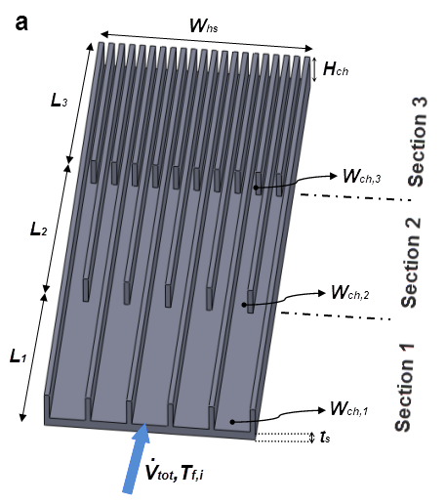

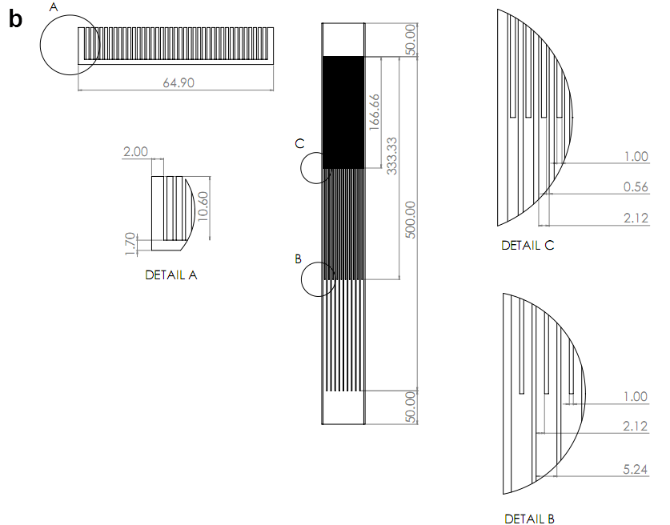
Fig. 1. Geometry of the three-section plate-fin heat sink configuration under investigation: (a) 3-D layout, (b) manufacturing drawings.

Table 1. Geometrical parameters of the heat-sink configuration.
Overall length L_{hs} [mm] | 600.00
Overall width W_{hs} [mm] | 64.90
Section Length L₁=L₂=L₃ [mm] | 166.60
Substrate thickness t_{s} [mm] | 1.70
Fin thickness W_{w} [mm] | 1.00
Channel Height H_{ch} [mm] | 10.60
1st Section channel: W_{ch,1}-AR₁-D_{h,1} [mm] | 5.24-2.02-7.01
2nd Section channel: W_{ch,2}-H_{ch,1}-D_{h,1} [mm] | 2.12-5.00-3.53
3rd Section channel: Wch,1-Hch,1-Dh,1 [mm] | 0.56-18.93-1.06
Number of channels: 1st - 2nd -3rd section | 10 - 20 - 40

2.2 Inlet-outlet manifold

In order to distribute the coolant to the channel region and subsequently re-collect it to a single flow stream at the exit and direct it back to the closed-circuit tubing, manifold nozzles were designed and manufactured. The nozzles, apart from the practical fact that their cross-section must gradually vary from circular to rectangular, to match both the tubing of the test rig and the heat sink, are also required to produce even distribution of the coolant to the channels and to induce a minor pressure loss penalty. The design was based on the concept that the main contour of the fluid flow layout can be determined by a number of characteristic cross-sections, as depicted in Fig. 2a, with the nozzle final shape resulting as a “shell” by subsequently adding the necessary wall thickness. It must be noted that the nozzle rectangular cross sectional area must exactly match that of the heat-sink configuration and thus the form of the nozzles is such that comprises both expanding and contracting topologies.
A parametric analysis based on numerical three-dimensional models of the nozzles was conducted in order to designate acceptable designs suitable for the constructed heat sinks. The analysis was limited to the inlet nozzles, as possible perturbations to the flow prior to the channels entrance could affect the performance of the heat sinks as well. The outlet nozzles were manufactured identical to the respective inlet ones.
Flow separation is possible to occur at the cross-sectional expansion, as the circular inlet of the nozzle changes to a rectangular cross-section of high aspect ratio. The nozzle design exhibits a characteristic “throat” in that region, as depicted in Fig. 2a. It was established through the numerical models that if the first control cross-section downstream of the circular inlet is a square with side length equal to the inlet diameter, then flow separation does not occur at the nozzle “throat”. Furthermore, the radius of curvature at the throat region should be approximately equal to 20mm. The diameter of the circular inlet was selected to approximately match that of standardized tubes in order to facilitate the interconnection to the flow loop. In order to constitute the manufacturing of the nozzles feasible, the gradual decrease of the nozzle height as the outlet is approached must occur in a linear manner. The same applies for the increase in the nozzle width. In addition, the height gradient should be kept close to 5º. Considering the specified gradient, the length between the square control cross section and the nozzle outlet can be explicitly specified.
The inlet/outlet nozzles were machined out of aluminum rods according to the manufacturing drawings shown in Fig. 2b. Each nozzle was manufactured as two symmetrical separate parts in a CNC milling machine, as shown in Fig. 2c. Guides were placed at the top faces of the parts, so that they can be precisely aligned, and the parts were bonded together using an epoxy adhesive resin (Araldite 2014-1), as the alternative option of welding was not feasible due to the small thickness of the nozzle walls. The nozzles were carefully aligned and bonded to the heat sink, using the same adhesive resin, which also provided waterproofing.

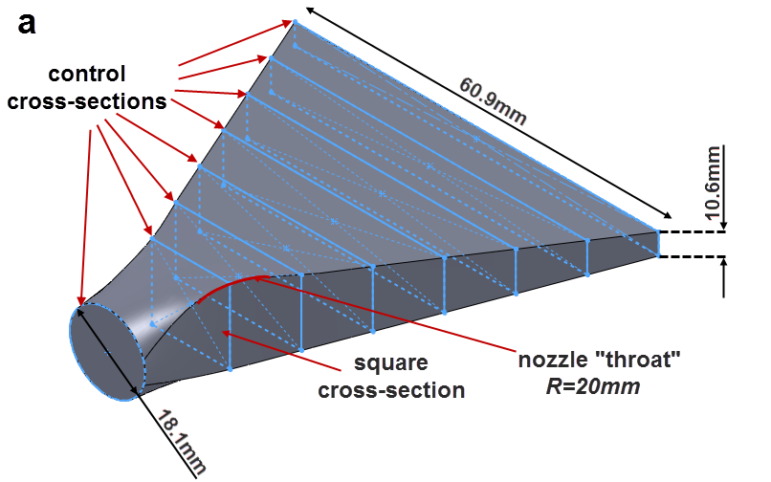
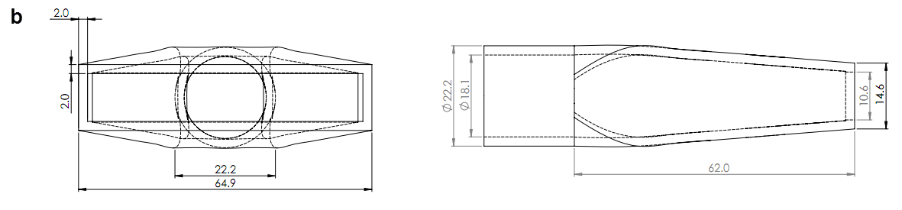

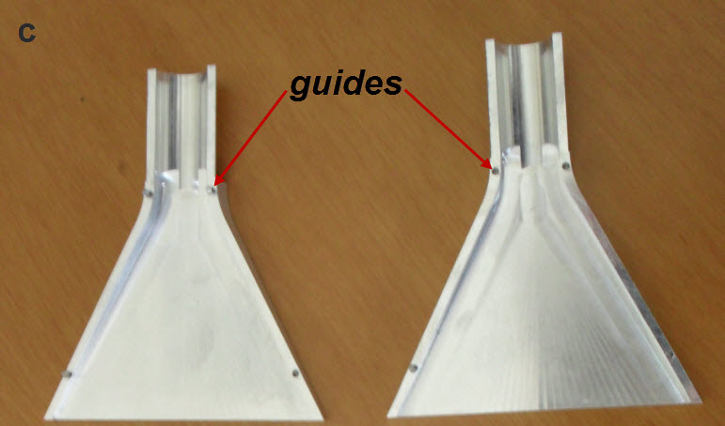

Fig. 2. Geometry of the inlet-outlet manifold: (a) design technique, (b) manufacturing drawings, (c) manufactured parts.

3. Experimental procedure

3.1 Flow loop and test rigs

The cooling device was evaluated in a closed flow loop (Fig. 3a), where water was circulated with the use of a gear pump manufactured by Speck. The water flow rate was measured with a ring piston flow meter manufactured by Aqua Metro and could be properly adjusted through a flow regulator. Since the cooling device is intended for incorporation in a CPVT system with an aperture are of 1m², which is suitable for the production of domestic hot water, it was taken into account that the volumetric flow rate that represents realistic operating conditions, as stated by the EN12975-2 standard [25], for solar thermal collectors is equal to 20 mL/s per m² of aperture area. In addition, it was proven in [26] that increase in the cooling fluid flow rate leads to decrease of the heat transfer enhancement to pressure drop ratio, in VW plate-fin heat sinks and thus operation at relatively low flow rates is preferable. The heat sink was finally decided to be evaluated in the volumetric flow rate range of 20-40mL/s, in order to illustrate the effect of flow rate on heat transfer and pressure drop, while also being able to measure accurately the wall and fluid temperature values. A 50 μm filter was also inserted in the tubing prior to the test device, in order to prevent the possible clogging of the channels from impurities.
The temperature of the fluid that enters the test-device was adjusted to a specified set-point, with the use of a water-conditioning unit that housed a number of resistors and mantle heat exchangers. A separate cooling unit was hydraulically connected to the water-conditioning unit through an additional closed flow loop that provides the “cold stream” of the heat exchanger (tap water). The flow in the “cooling” flow loop is regulated through pneumatic valves and the control signal for the valves is provided by a PLC where the temperature set-point is specified. As depicted in Fig. 3a the experimental setup allows the simultaneous evaluation of two test devices, however a bypass tube was placed at the second spot, in order to evaluate a single test-device. The water temperature within the circuit was monitored at several positions through Pt100 sensors and appropriate signals were sent either to the pneumatic valves, in order to allow the cooling-fluid stream to flow within the mantle heat exchangers (denoted as HEX in Fig. 3a) and thus reduce the working fluid temperature, or to the heaters, when increase of the fluid temperature was required. Prior to entering the test device, the working fluid temperature was homogenized inside the mixing tank, while an expansion tank is also included in the flow circuit to ensure that the working fluid pressure is maintained constant.
The pressure drop induced by the heat sink was measured using a diaphragm differential pressure transducer manufactured by Endress+Hauzer AG. In order to obtain a measurement, two probe fittings were inserted to the hydraulic circuit in proximity to the heat sink inlet and outlet and the pressure transducer was connected to the circuit through flexible tubes. A number of fittings and connectors interceded inevitably between the probe and the heat-sink inlet (or outlet) manifold and consequently the pressure drop in these sections had to be measured separately, in order to be able to determine the pressure drop that accounts for the heat sink length and the manifold system alone. However, in order to have a straightforward comparison to the numerical predictions the pressure losses due to the flow entrance into the multi-channel core (and respectively the pressure recovery due to the exit into the outlet chamber) must also be determined. As it was not possible to directly measure the pressure in these specific regions, theoretical predictions were used and the experimental data were appropriately adjusted. Besides, the contribution of the inlet-outlet regions to the overall induced pressure drop is much smaller in comparison to that of the channel core region. The correlations used for the calculation of the pressure loss (or recovery) due to the flow transition into and out of the channel core are of the following general form, referring to either flow contraction or expansion [27]:

(1)

where A is the cross-sectional area, and K is the non-recoverable loss coefficient values of which for typical geometries can be found in [27]. Besides the pressure losses in the manifold system were numerically predicted.
The heat sink thermal performance was evaluated under constant heat flux conditions with the requirement of negligible heat losses. In order to impose the constant heat flux at the bottom surface of the heat sink, a heating device was constructed, which comprises two symmetrical aluminum plates of total dimensions equal to (L x W) 500mm x 65mm so as to exactly match the active area of the heat sink. The two plates, which bear four equidistant parallel grooves, were bolted together and rod resistors having a nominal diameter of 6mm were housed in the through holes that were created. The nominal resistance value and the active length of the resistors were equal to 96Ω and 500mm, respectively. Thermally conductive paste was applied at the interface between the resistors and the aluminum plate in order to facilitate heat transfer. The heat sink and the heating device were clamped together using bolts and placed inside an insulating container made of bakelite with an additional interior insulating layer of Armaflex with thickness greater than 4cm. A cut-view of the test section is depicted in Fig. 3b. The resistors were connected in parallel and a voltage divider was used in order to adjust the input power. The input power was set approximately equal to 850W, which is close to the expected heat rate in the actual CPVT system.
Two four-wire Pt100 thermometers were used for the measurement of the fluid temperature at the inlet and the outlet of the heat sink. Each sensor was housed in a configuration which allows the insertion of the probe opposite to the main flow and furthermore enables fluid mixing prior to the measurement. In order to illustrate the temperature distribution at the heat sink bottom wall, holes of diameter 0.9mm were drilled into the substrate and a series of Type T thermocouples were placed along the heat sink length, as depicted in Fig. 3c. The voltage and current in the electrical circuit were measured using a volt-meter and a shunt resistor (R=1mΩ) respectively and thus the input power was determined.
The experimental results presented in the following sections were obtained by following the procedure as discussed here. A constant flow rate and fluid inlet temperature were assigned and once these values remained constant for a time interval of at least 5 min, the resistors were turned on. With the resistors on, values of the bottom wall temperature, the fluid temperature at the heat sink inlet and outlet and the volumetric flow rate were recorded every 5s. The experimental data resulted as averaged values for time intervals of at least 5 min under steady state conditions, namely provided that the temperature values varied less than ±0.2K. The sensors signals were directly measured using an Agilent data logger. Measured values were being processed and stored to a computer using the Agilent VEE software.

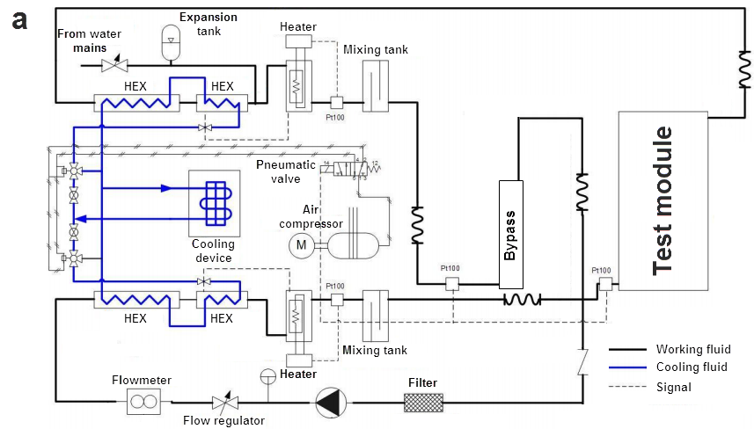

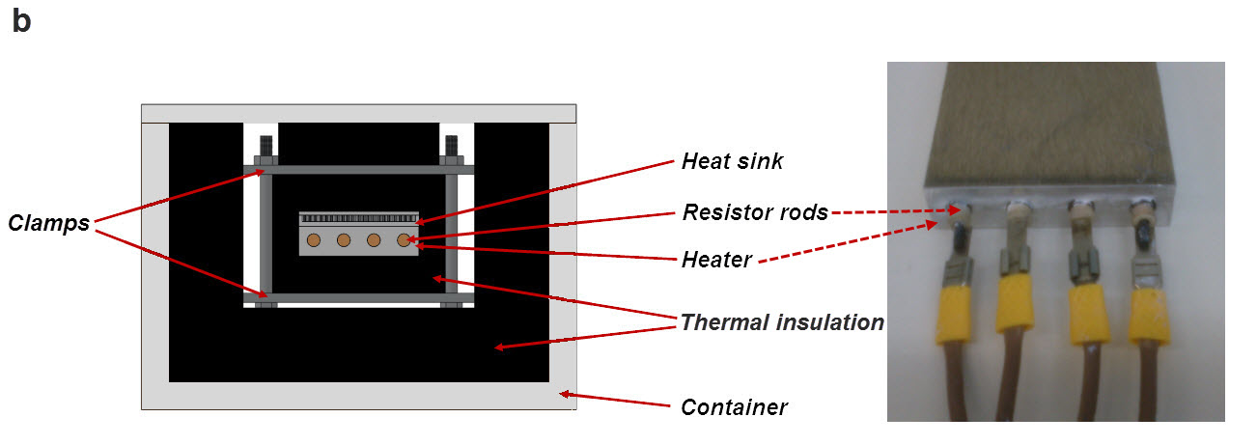

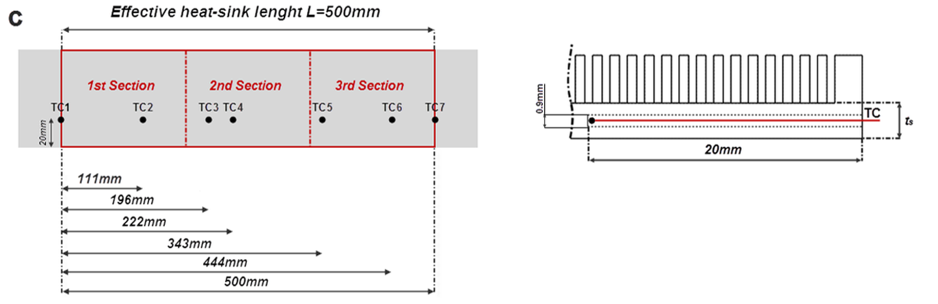

Fig. 3. Schematics of the experimental rig: (a) water conditioning unit and flow loop, (b) cross-section of the test module and heating elements. (c) Locations of the thermocouples.

3.2 Uncertainty of the experimental data

The uncertainties in the values of all the measured quantities are given for a confidence level equal to 95% and summarized in Table 2. An uncertainty analysis based on propagation of errors, as described in [28], has been conducted in order to determine the resulting uncertainty of the calculated quantities. Considering that a result R is calculated from a set of measured quantities x_{i}, ; then the uncertainty in the calculated value is equal to:

(2)

where is the uncertainty associated with the measurement of the values x_{i}. The uncertainty associated with the calculated quantities can be given in relative (as a percentage) or absolute form, depending on the available information on the measurement uncertainty U_{x}. By making use of Eq. 2, the uncertainties associated with the calculated values are presented in Table 3. It is interesting to notice the relatively large uncertainties associated with the parameters of the third heat-sink section, due to the fact that the manufacturing precision remains constant while the channel dimensions decrease.

Table 2. Uncertainty in measured quantities.
Measured quantity | U
[m³/s] | 1.76%
T_{f} [K] | 0.054 K
T_{w} [K] | 0.5 K
V_{mult} [volts] | 0.66%
I_{shunt} [amps] | 0.00%
Δp [Pa] | 0.02%
W_{ch,1} [m] | 0.38%
W_{ch,2} [m] | 0.94%
W_{ch,3} [m] | 3.57%
W_{w} [m] | 2.00%
H_{ch} [m] | 0.19%
W_{hs} [m] | 1.67%
L_{hs} [m] | 0.20%

Table 3. Uncertainty in calculated quantities.
Calculated quantity | U
D_{h,1} [m] | 0.26%
D_{h,2} [m] | 0.79%
D_{h,3} [m] | 3.39%
A_{ch,1} [m²] | 0.43%
A_{ch,2} [m²] | 0.96%
A_{ch,3} [m²] | 3.58%
A_{hs} [m²] | 1.68%
Z* | 0.33%
u₁ [m/s] | 1.81%
u₂ [m/s] | 2.01%
u₃ [m/s] | 3.99%
Re₁ | 1.83%
Re₂ | 2.15%
Re₃ | 5.23%
Q_{el} [W] | 0.66%
q'' [W/m²] | 1.81%
T* | 0.168-0.181
ΔΤ_{f,therm.bal.} | 1.88%
f | 3.64%

4. Formulation of the numerical model

The development of two separate numerical models that represent the heat-sink configuration and the inflow-outflow nozzles, respectively, is discussed in this section. In reference to the heat sink, the scope of the simulation is to illustrate the emerging flow topology and its effect on heat transfer, whereas, regarding the manifold system, the investigation is focused on the flow field development and the pressure distribution.

  - Heat sink

The numerical model representing the actual heat sink configuration had to be restricted to an appropriate unit cell in order to render the simulations feasible, as the integration of the entire geometry comprising a multitude of channels in the model would bear a prohibitive computational cost. The computational domain includes channels of three different hydraulic diameters and thus it comprises half the width of the first-section, the full width of the second-section and twice the channel width in the final section respectively, as depicted in Fig 4. Heat transfer was treated as conjugate, with simultaneous heat conduction in the solid and convection in the fluid domains, respectively. The thermophysical properties of the cooling fluid were treated as constant and evaluated at the fluid overall mean temperature, which was estimated through a global thermal balance for each one of the volumetric flow rates considered for the simulations. The effect of buoyancy was taken into account through the Boussinesq approximation [29] and the flow and temperature fields were, thus, considered coupled in all cases. In a previous study by the authors [30], it was demonstrated that the effect of buoyancy was significant in channels of low aspect ratio, such as those at the first section of the VW heat sink.
In order to simplify the flow and heat transfer model, the assumptions of steady, laminar fluid flow and heat transfer with negligible viscous dissipation and radiative heat transfer were made. The assumption of laminar flow is justified by the low Reynolds numbers that characterize the flow within the heat-sink channels, as will be presented in the results section. The continuity, momentum and energy equations reduced to a common form have been presented by the authors in [30]. Appropriate hydrodynamic and thermal boundary conditions were imposed for the governing equations. A uniform velocity profile was imposed at the domain inlet, which was calculated by the values of the flow rate and the channel cross-sectional area, while the average static pressure was taken equal to zero at the channel outlet. A no-slip boundary condition was imposed on the fluid-wall interface, while a symmetry boundary condition (or adiabatic wall in the case of heat transfer) was applied on both the outer vertical planes of the domain. Furthermore, all the rest outer surfaces of the domain (front, back and upper sides), apart from the bottom side, were also treated as adiabatic (Fig. 2). The upper side is considered adiabatic as the top cover of the actual device is welded only on the two outer fins and thus there is no thermal bond between the cover and the inner fins. At the bottom surface, a constant heat flux was applied equal to the power input divided by the heat sink active area. A constant fluid temperature was specified at the channel inlet, while at the outlet the temperature values were extrapolated using a constant gradient. For the sake of brevity, further details regarding the imposition of the boundary conditions were omitted and can be likewise found in [30]. Finally, continuity of both temperature and heat flux was imposed at the fluid-solid interface. The set of governing equations were solved using the finite volume based solver ANSYS CFX (v.13) [31]. A convergence criterion of 10⁻⁶ was set for the root mean square (RMS) mass, momentum and energy absolute residuals.

Fig. 4. Computational domain for the numerical model.

  - Inlet-outlet manifold

The computational domain for the inlet-outlet nozzles comprised the entire geometry (see Fig. 2a). The flow was considered to be isothermal, steady and turbulent for the range of flow rates considered, with the thermophysical properties of water evaluated at 25ºC. The Reynolds number characterizing the flow was based on the velocity and geometry of the circular cross-section of the nozzle. The three-dimensional transport equations of mass and momentum obtain a common form which can be found, e.g. in [29]. The standard k-ε model [32] was used for the calculation of the Reynlods stresses that appear in the Reynolds Averaged Navier-Stokes (RANS) equations. A uniform velocity profile was imposed at the nozzle inlet, while a zero static pressure condition was imposed at the channel outlet. The governing equations were solved using ANSYS CFX with the same convergence criteria for the mass and momentum, as in the case of the heat sink.

  - Grid independence

The computational domain of the heat sink was discretized using hexahedral elements in a non-uniform arrangement along the streamwise direction, as the grid was refined in the locations of geometry contraction (Fig. 5a). On the other hand, the grid density was kept uniform across the channel cross-section, as recommended for better resolving the buoyancy-induced recirculation (Fig. 5b) [33,34].

Fig. 5 Topology of the computational grid: (a) Detail view at the geometry contraction (second contraction) and (b) cross-sectional view.

The grid independence study was conducted assuming the highest value of the flow rate that will be considered throughout the evaluation, namely =40mL/s, which corresponds to Re₁=598. The computational grid was consecutively refined from 15.9∙10⁶ to 20.6∙10⁶ and finally to 24.9∙10⁶ elements. The relative discrepancy in the overall pressure drop of the cooling fluid was equal to 1.0% between the coarse and the intermediate grid and equal to 0.4% between the intermediate and the dense grid, respectively. In addition, as depicted in Fig. 6a, the horizontal axial velocity profiles slightly downstream of the first step-change in the channel hydraulic diameter (Z*=28.9) produced by the three grids are the same and the extent of the expected flow recirculation adjacent to the fin sidewall is well captured. The root mean square discrepancy between the values of the intermediate and dense grid is equal to 0.69%. Besides, the vertical temperature profiles at the same location (Fig. 6b) are identical for the three grids tested and the expected mixing zones in the upper and lower boundary layer regions are captured [30]. These overlapping layers of cold and warm fluid emerge due to existence of longitudinal vortices in the vicinity of the channel lower and upper walls, as will be illustrated in detail in the following paragraph. The intermediate grid consisting of 20.6∙10⁶ cells was finally selected for the production of the numerical results.

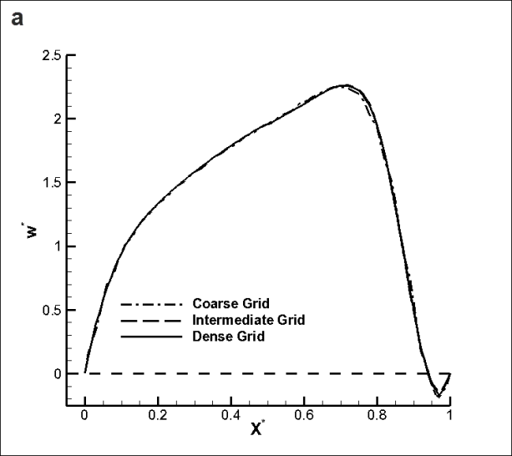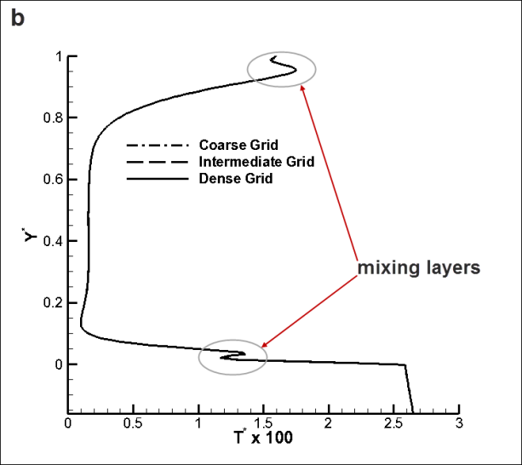

Fig. 6. Grid independency study for Re₁=598: (a) Horizontal velocity profile (Y*= 0.5) at Z*= 23.9, (b) vertical temperature profile (X*=0.5) at Z*=23.9.

Regarding the manifold nozzle, the computational domain was discretized using an unstructured grid of tetrahedral elements. The grid had a non-uniform density as smaller elements were placed at the rectangular cross section of the nozzles. In addition, layers of prismatic elements were placed in the boundary-layer region in order to capture the velocity gradients. A grid independence analysis was conducted for Re=3059 and it was established that a grid consisting 2.38⋅10⁶ elements suffices to obtain grid independent solutions.

5. Results and discussion

The results presented in the following sections were non-dimensionalized using appropriate quantities for this configuration. In reference to the spatial co-ordinates they are presented in suitable non-dimensional forms, namely X* (horizontal direction), Y* (vertical direction), Z* (streamwise direction) using respective characteristic lengths in each direction. It must be noted that regarding the comparison of the experimental data to the numerical predictions, the non-dimensional quantities introduced allow for a more clear illustration of the experimental uncertainties, as the uncertainty associated with the geometrical parameters, having an effect on heat sink performance, is also included. Quantities associated with the first heat-sink section were selected for non-dimensionalization, and this constitutes a conservative choice as the uncertainties associated with the characteristic flow quantities in the third section are considerably larger, as can be seen in Table 2.
It must be pointed out that the non-dimensional numbers that characterize the flow, which are Reynolds, Grashof and Richardson numbers are defined using the channel hydraulic diameter and are thus different for each section, as presented in Table 3. It must be noted that the Grashof number (Gr*) is defined in terms of heat flux, as suggested for constant heat flux heating [35,36], where the wall-fluid temperature difference is variable, not known in advance, and calculated using the heat flux values available by the numerical simulations. The nominal values of the Reynolds number shown in the second column of Table 3 result by evaluating the thermophysical properties of water at 25ºC and refer to the pressure drop tests. Nevertheless, in order to have a uniform representation of the results, the values of Re₁ from the third column of Table 3 (i=1) will be used in the following sections.
Table 3. Non-dimensional numbers characterizing the flow conditions within each section i of the VW configuration for all volumetric flow rates considered.
[mL/s] | Re |  |  |  |  | Gr* |  |  |  | Ri
 | i=1(nom) | i=1 | i=2 | i=3 |  | i=1 | i=2 | i=3 |  | i=1 | i=2 | i=3
15.0 | 210 | 246 | 153 | 87 |  | Only hydrodynamic evaluation
20.0 | 281 | 316 | 197 | 112 |  | 1.18E+05 | 4489 | 20.6 |  | 1.18 | 0.12 | 0.18
25.0 | 351 | 387 | 241 | 137 |  | 1.09E+05 | 4159 | 19.2 |  | 0.73 | 0.07 | 0.14
30.0 | 421 | 457 | 285 | 162 |  | 1.03E+05 | 3962 | 18.3 |  | 0.49 | 0.05 | 0.11
35.0 | 491 | 528 | 329 | 187 |  | 9.94E+04 | 3825 | 17.7 |  | 0.36 | 0.04 | 0.09
40.0 | 561 | 598 | 373 | 212 |  | 9.67E+04 | 3723 | 17.2 |  | 0.27 | 0.03 | 0.08

5.1 Flow-Manifold

Due to the geometrical form of the nozzles, flow is forced to sustain both gradual expansion and contraction and thus a non-monotonic pressure distribution is expected. As can be seen in Figure 7a, flow through the inlet nozzle results in a slight pressure recovery, due to the rapid recovery rate at the nozzle “throat” where the geometry is gradually expanding. On the other hand, the outlet nozzle induces a small fluid pressure loss, as depicted in Figure 7b. As can be seen, once again the pressure loss rate is becoming rapid in the “throat” region where the flow experiences a gradual contraction. Nevertheless, the overall effect of the manifold on the overall induced pressure drop is negligible in comparison to the contribution of the heat-sink active (channel occupied) region, as will be shown in the next paragraph.

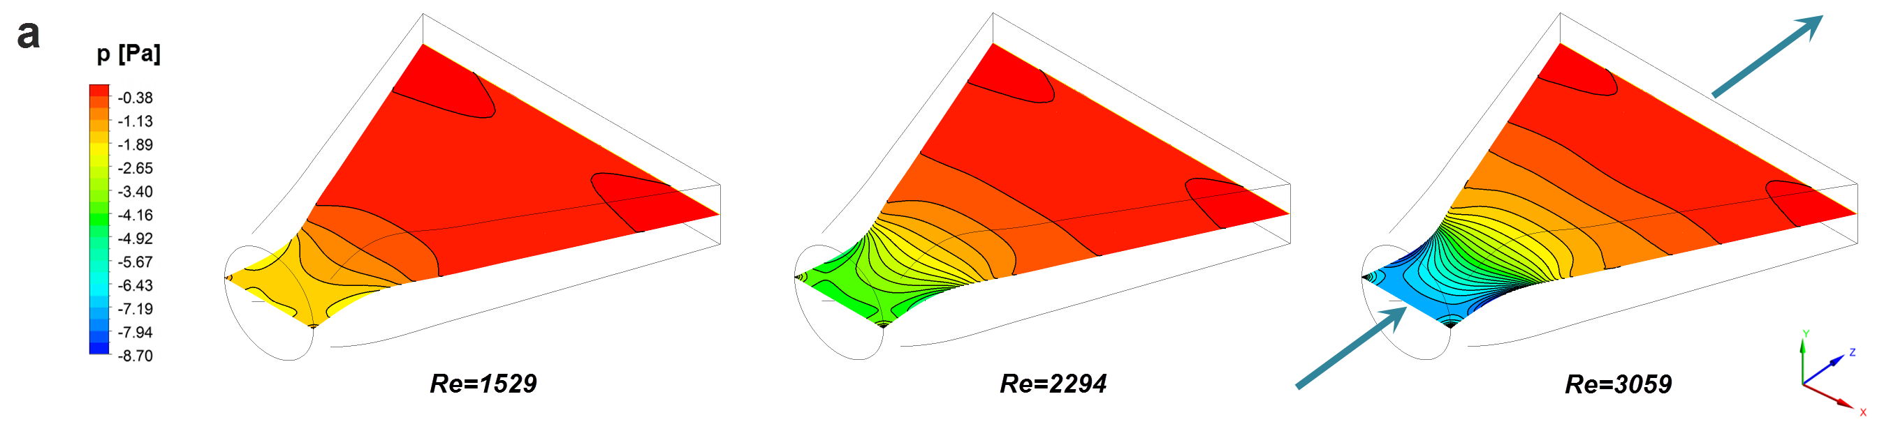
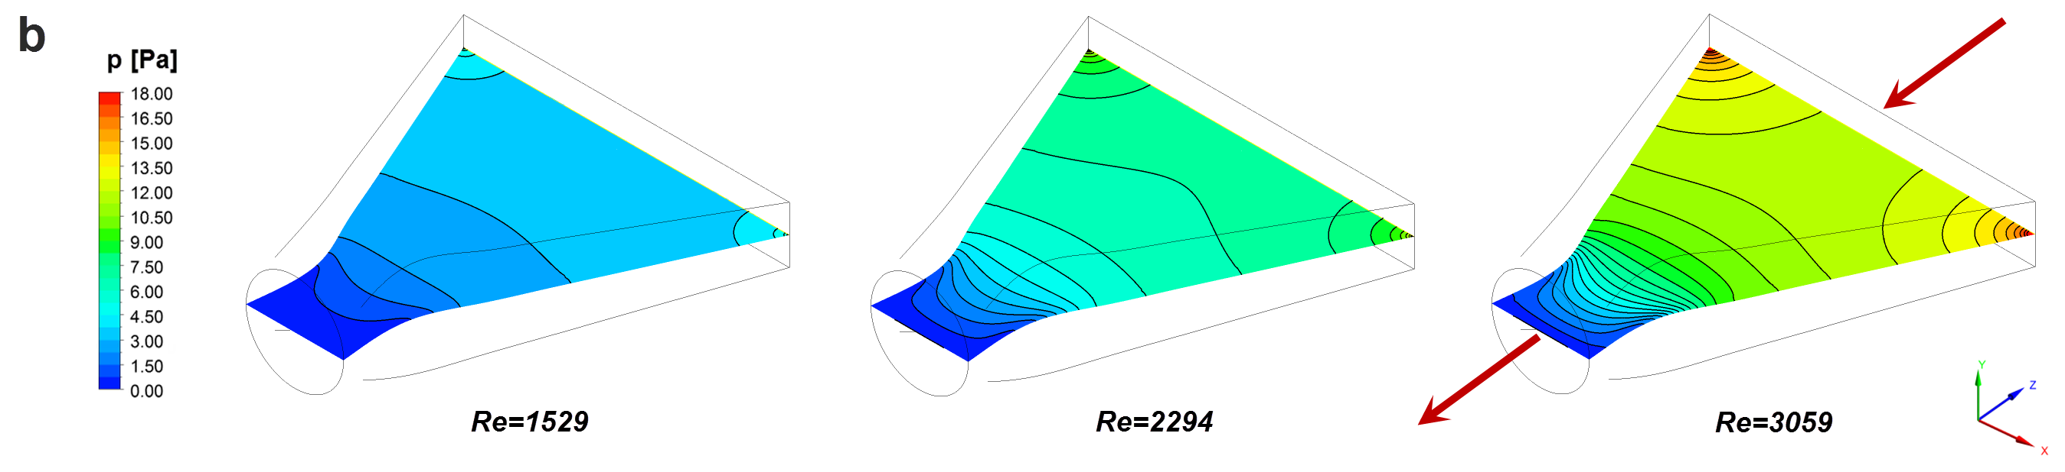

Fig 7. Pressure contour plots at the nozzle horizontal mid-plane: (a) Inlet nozzle, (b) outlet nozzle.

Fig. 8 depicts the outlet velocity profile of the inflow nozzle, while the flow field within the nozzle is depicted at the inset. It is evident, that no flow separation occurs at the critical “throat” region, where the geometry expands, and the flow remains unidirectional throughout the nozzle. Besides, the velocity profile obtains a relatively flat form over the largest part of the cross-section, with the standard deviation of the axial velocity being equal to 0.23, 0.27 and 0.29 for Reynolds number values of 1529, 2294 and 3059, respectively. It must be noted that the flow after the nozzle enters the rectangular heat-sink inlet chamber of high aspect ratio (AR=5.76) and length equal to 50.0 mm (see Fig. 1b), which tends to produce an even flatter velocity profile along the X* direction, as has been established for rectangular cross-sectioned geometries with high aspect ratios. The velocity profile should be further smoothened due to the flow resistance encountered because of the presence to the channel core and thus flow distribution in the channels is expected to be even.

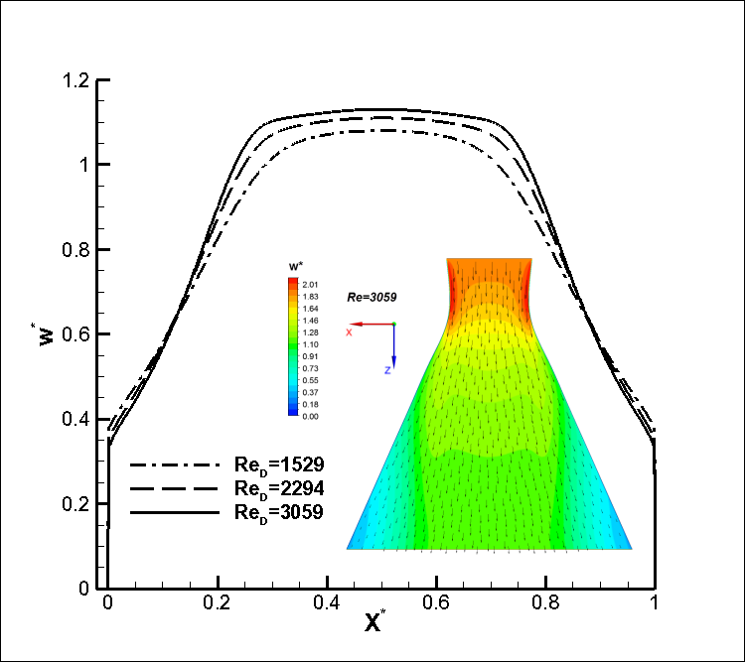

Fig. 8. Axial velocity horizontal profile at the outlet of the inflow nozzle and axial velocity contours along the horizontal mid-plane. The velocity was non-dimensionalized using the mean flow velocity within the nozzle (equal to 0.041, 0.062, 0.083 m/s for Re_{d}=1529,2294,3059, respectively).

5.2 Flow- Heat Sink

The induced pressure drop was evaluated in cold (unheated) flow conditions, in order to exclude possible effects of the varying water thermophysical properties due to heating. A constant temperature of 25ºC was set in throughout the flow loop. Fig. 9a presents the obtained values of the friction factor, indicative of the pressure drop, and the respective numerical and theoretical predictions. The numerical predictions were produced by a “cold flow” model using only the fluid computational domain, while the theoretical values were produced by considering the fluid friction in each heat sink section and the additional pressure drop due to flow contractions:

(3)

The pressure drop in the contractions (termsand)was calculated by equations similar to Eq. (1), whereas in the straight channel sections equations of the general form were used considering also the hydrodynamic development length and choosing the appropriate Fanning friction factor value f_{F} for each part of the channel. It is evident that the experimental data are in good agreement with the predictions. Τhe maximum discrepancy detected is between the theoretical predictions and the experimental data for the lowest Reynolds number (Re₁=246), which is in the order of 10%. This small deviation is probably due to the fact that the values used for the flow development length, in order to determine the term of Eq. (3) referring to the channels of the third heat-sink section (AR=18.9), had to be extrapolated from theoretical values available for channels with a lower aspect ratio. In addition, the effect of the two geometrical contractions along the heat sink length is possible to have been overestimated in the theoretical and numerical predictions, as the frontal surface of the actual fins is not perfectly rectangular due to manufacturing limitations but has rather rounded edges, and thus a smoother flow transition between sections is probable to occur.
It can be seen in Fig. 9b that the friction losses in the third, high-fin density section of the heat sink account for approximately 95% of the overall induced pressure drop in the heat sink active (channel-occupied) region, whereas the flow friction in the first two sections, as well as the flow separation in the locations of geometrical contractions have a minor contribution. As made evident by Fig. 9c the pressure losses induced outside of the heat sink active area, namely in the fittings, manifold system and inflow-outflow chambers, also have a very small effect on the overall induced pressure drop. Especially regarding the pressure drop in the manifold system which was determined numerically, the reduction of the experimental data verifies that its contribution to the overall pressure drop is negligible (0.5% of the total).

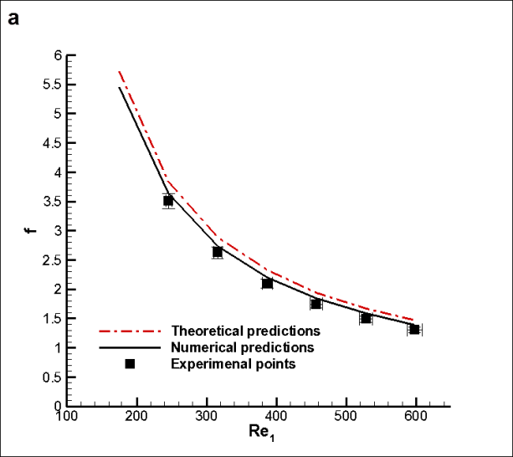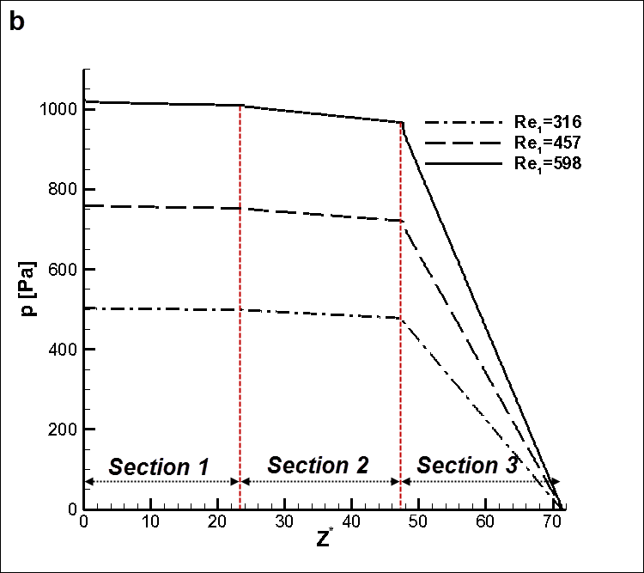

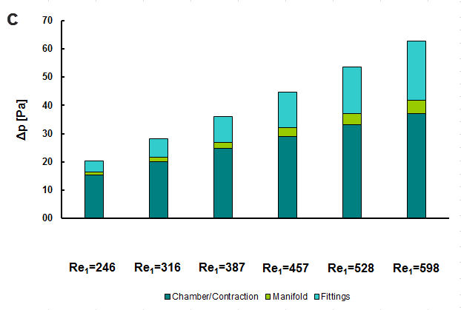

Fig. 9. Hydrodynamic performance of the heat sink: (a) Friction factor for the VW configuration, (b) longitudinal cross-sectionally averaged pressure drop distribution within the VW configuration, (c) pressure losses induced outside the heat-sink channel active region.

As may be inferred by the Richardson number values of Table 3, which quantify the ratio of buoyancy to inertial forces, for the specified value of the imposed heat flux buoyancy forces attain a significant magnitude only in the first heat-sink section especially for the lower values of the cooling fluid flow rate. This is due to the larger hydraulic diameter of the first section in comparison to the subsequent ones, as the hydraulic diameter has a significant influence on the Grashof number (Gr*~) and consequently on the magnitude of the buoyancy forces. Hence, longitudinal buoyancy-induced recirculation rolls are expected to emerge in that region. Indeed, as depicted in Fig. 10, a secondary-flow pattern is discernible even for the highest value of the Reynolds number considered. The emergence of rolls is clear evidence of the effect of natural convection on the flow field, as the heated fluid ascends toward the channel upper part. The rolls draw fluid from the upper wall to the lower heated wall and have an enhancing effect on heat transfer, as will be shown in the next section. As the Reynolds number increases, the magnitude of the rolls diminishes, as expected, and furthermore the streamwise location where the rolls obtain their maximum intensity is shifted farther from the channel inlet, as has also been observed by the authors in [30].

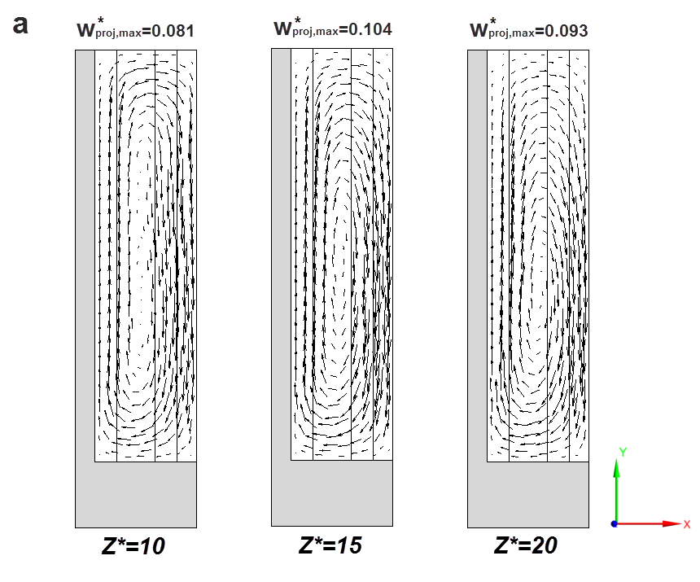
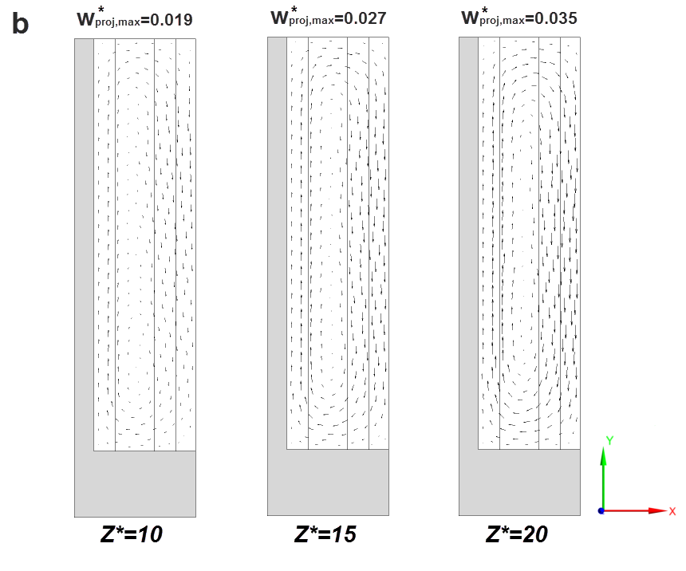
Fig. 10. Velocity vector plots indicative of the magnitude of the buoyancy induced rolls in the first heat-sink section (vector length is proportional to the axial velocity projection magnitude): (a) Re₁=316, (b) Re₁=598.

A complex secondary flow pattern emerges due to the effect of the geometrical contraction, Fig. 11, as it has also been shown by the authors in [26]. The most distinctive feature is a pair of horseshoe vortices that emerge in the upper and lower boundary layer regions. Under mixed convection conditions, the vortices become asymmetric due to the effect of the buoyancy rolls already developed upstream [30]. The vortices are created due to the main flow impingement on the frontal surface of the additional, interceding fin and its following transverse displacement and persist in the consecutive section (Fig. 11a). As the Reynolds number increases, the absolute magnitude of the vortices clearly increases as well. As is evident from Fig. 11b, the flow confinement also influences the development of the secondary flow. The longitudinal vortices, which emerge in the vicinity of the second geometrical contraction (Fig. 11b), decay almost immediately and the flow changes into a pure parallel one. It must be noted that the upper and lower vortices are of equal magnitude, as the effect of buoyancy is negligible in the second and third heat sink sections. The small width of the third-section channels (W_{ch,3}=0.56mm) renders the interaction of the secondary flow with the channel sidewalls more profound than in the second section. As it appears, this interaction leads to the rapid decay of the longitudinal vortices.

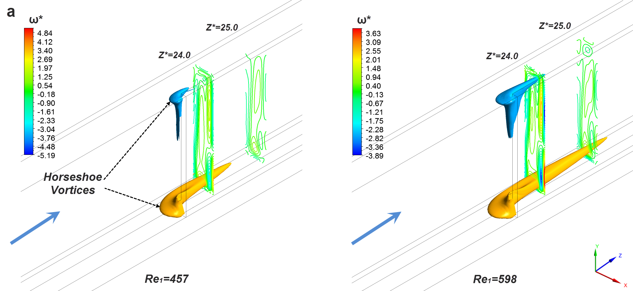

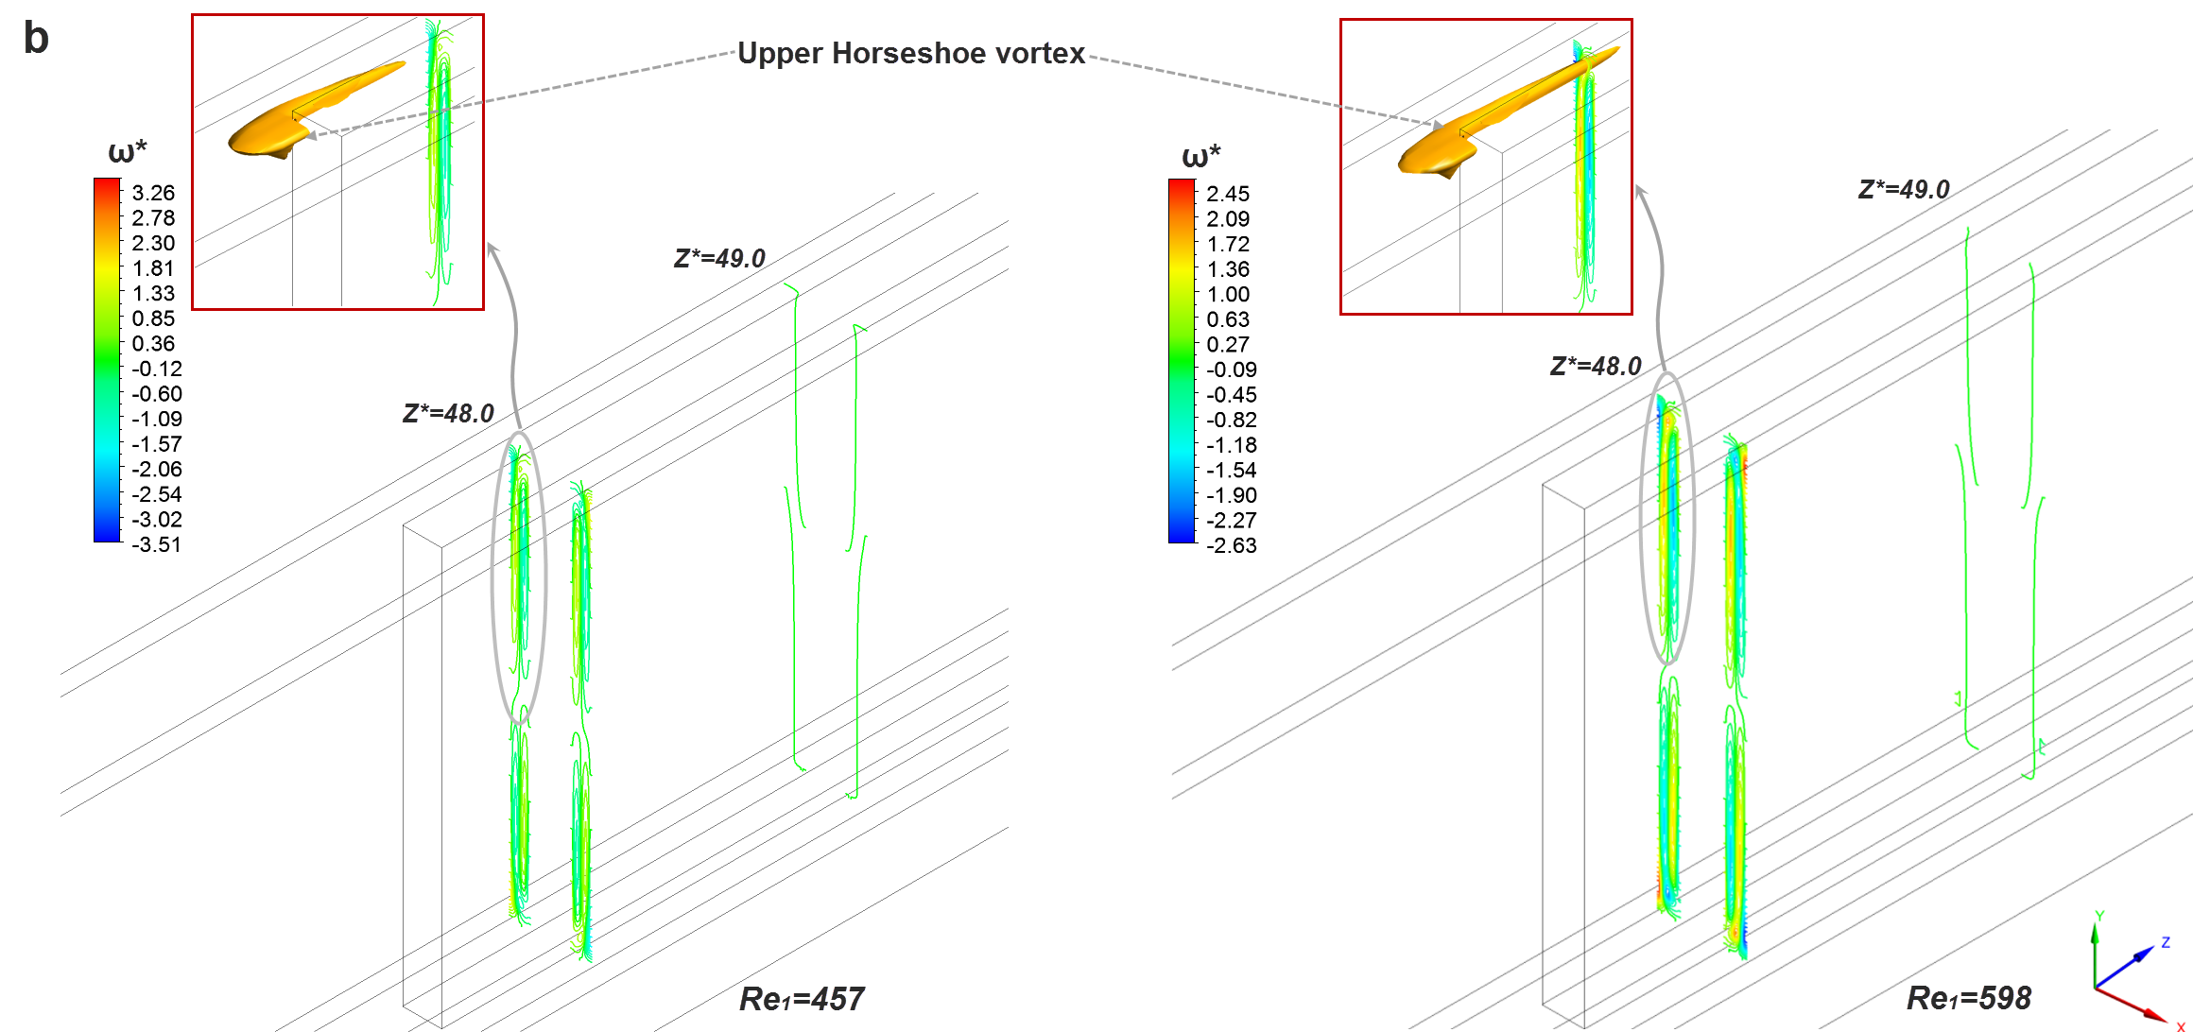
Fig. 11. Contraction-induced secondary flow pattern between successive heat-sink sections. Contour iso-surfaces (ω_{z}=12s⁻¹) and plots illustrating the topology of the horseshoe vortices: (a) First and (b) second geometrical contraction.
5.3 Heat transfer

First of all, in order to verify the soundness of the experimental data regarding heat transfer, it is essential to ensure that all the heat provided by the rod resistors (Q=VI) is extracted by the cooling fluid, i.e. that the thermal balance VI=Q=c_{p}(T_{f,o}-T_{f,i}) is valid. The measured water temperature rise ΔΤ (=T_{f,o}-T_{f,i}) through the heat sink for various flow and heat rates was compared to the theoretical values (ΔΤ=Q/c_{p}), as obtained from the aforementioned thermal balance equation. As depicted in Fig. 12, the predictions agree very well with the experimental data and it is thus verified that heat losses are negligible.

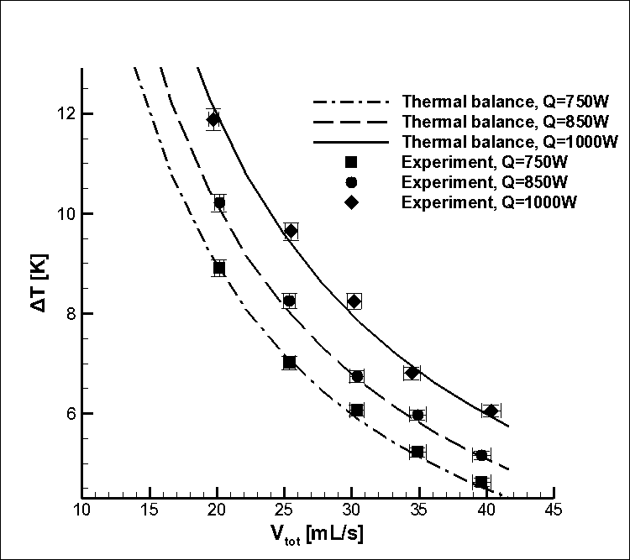

Fig. 12. Comparison of the experimental data to thermal balance predictions for various flow and heat rates.

Fig. 13 shows the bottom wall stream-wise temperature distribution for the various flow rates considered. It must be noted that the numerical predictions were calculated as average values along the unit cell width for each streamwise (Z*) location. However, it was established that there is no temperature gradient along the transversal (X*) direction. As can be seen, the experimental values and the numerical predictions follow the same trend, with the maximum temperature point being located, in all cases, at the part of the first heat-sink section upstream of the effect of the first contraction (Z*=23.7). This trend is justifiable as the first section of low-fin density is expected to have high thermal resistance due to the smaller heat transfer area. A steep, stepwise temperature drop takes place at each step-change of the channels diameter, as every heat-sink section is characterized by a different convective thermal resistance value. The addition of heat-transfer surfaces in each section in conjunction with the acceleration of the flow due to the smaller hydraulic diameter and the action of the longitudinal vortices enhance heat transfer and consequently reduce the convective thermal resistance of the second and third sections thus leading to the cooling of the substrate. In general, good agreement is evident between the predictions and the experimental data.
As also revealed by Fig. 13, the maximum wall temperature remains relatively unaffected by the variation of the Reynolds number. The mitigation of the hotspot temperature as the value of the Reynolds number decreases is due to the increasing effect of natural convection within the first heat sink section. The constant flooding of the bottom wall with cold fluid from the channel upper part, due to the action of the buoyancy rolls, enhances heat transfer in the first heat-sink section and tends to smooth the temperature distribution, especially for the lower values of the Reynolds number. This effect is of much less significance in the two consecutive sections. It is evident from the values of Table 3 regarding the first section that, as the Reynolds number decreases, the Richardson number and therefore the magnitude of the buoyancy-induced rolls increase as well (see Fig. 10), compensating for the hindering effect of the reduced flow velocity on heat transfer and maintaining the temperature distribution relatively constant. The bottom wall temperature stream-wise distribution for pure forced-convection conditions (Ri=0), i.e. for decoupled flow and temperature fields, has also been included in Fig. 13, in order to fully elucidate the effect of buoyancy on heat transfer. It is evident that the maximum wall temperature at the first heat sink section (Z*<23.7) in the forced-convection cases obtains significantly higher values in comparison to the respective mixed-convection ones as the flow rate decreases. Besides, for forced convection, the wall hotspot temperature is clearly dependent on the flow rate. On the contrary, the difference in the maximum wall temperature of the subsequent heat sink sections, where the effect of buoyancy is diminished, is substantially smaller and is attributed to the different topology of the lower horseshoe vortex, as in the mixed-convection cases the vortex is enhanced due to upstream effect of buoyancy (see Fig. 11a).

Fig. 13. Streamwise temperature distribution at the channel bottom wall (Y*=0). Comparison between the numerical model and experimental data: (a) Re=316, (b) Re=387, (c) Re=457, (d) Re=528, (e) Re=598 (flow area contractions at Z*=23.7 and Z*=47.5).

The temperature field that develops within the heat-sink is illustrated through cross-sectional contour plots at various streamwise locations along the heat sink length in Fig. 14. The effect of natural convection in the first section (Z*=20, 23) is evident for Re₁=316 (Fig. 14a), as significant temperature stratification exists with warmer fluid having been transferred to the channel upper part. A low temperature core is shown to develop near the bottom of the channel. As the Reynolds number increases, temperature stratification becomes less pronounced, the low-temperature core grows occupying increasingly larger portions of the cross-section and the temperature profile obtains a form typical of forced convection conditions. A comparison between the locations Z*=20.0 and Z*=23.0 reveals that the bottom boundary layer is subject to cooling due to the flow separation slightly upstream of the contraction [26,30]. Downstream of the flow contractions (at Z*=24.0 and Z*=49.0), the contour lines corresponding to the fluid region at the lower and upper parts of the channel are distorted due to the effect of the horseshoe vortices. Regarding the second section channel (Z*=24.0) in particular, the development of the bottom boundary layer is disrupted as cold fluid from the channel core is drawn to that region, especially as the Reynolds number increases, and thus heat transfer is enhanced.
Τhe length of the second section was found to be adequate for any disturbances in the flow and temperature fields to decay and parallel flow reestablishes prior to the next contraction. In any case, the fluid core region is pushed towards the channel top causing redistribution of thermal energy. In reference to the lateral thermal boundary layers, their thickness decreases along consecutive sections, as the flow cross-section decreases and the fluid accelerates. The temperature contours also verify that the heat-sink solid part is cooled after each step-change of the channel hydraulic diameter, as additional heat transfer areas are added. A close look at the temperature contours within the third section (Z*=49.0) reveals that these are slightly asymmetrical. This is justifiable if we consider that the development of the thermal boundary layers at the channel sidewalls is not symmetrical as well. The development of the boundary layer of the left fin wall commences at the channel inlet and remains uninterrupted, whereas regarding the right side-fin wall the thermal boundary layer originates at the entrance to the second heat-sink section, where the additional fin intercepts the oncoming fluid free stream. Thus, for a specified location, the left sidewall boundary layer is of larger thickness in comparison to the respective right one.

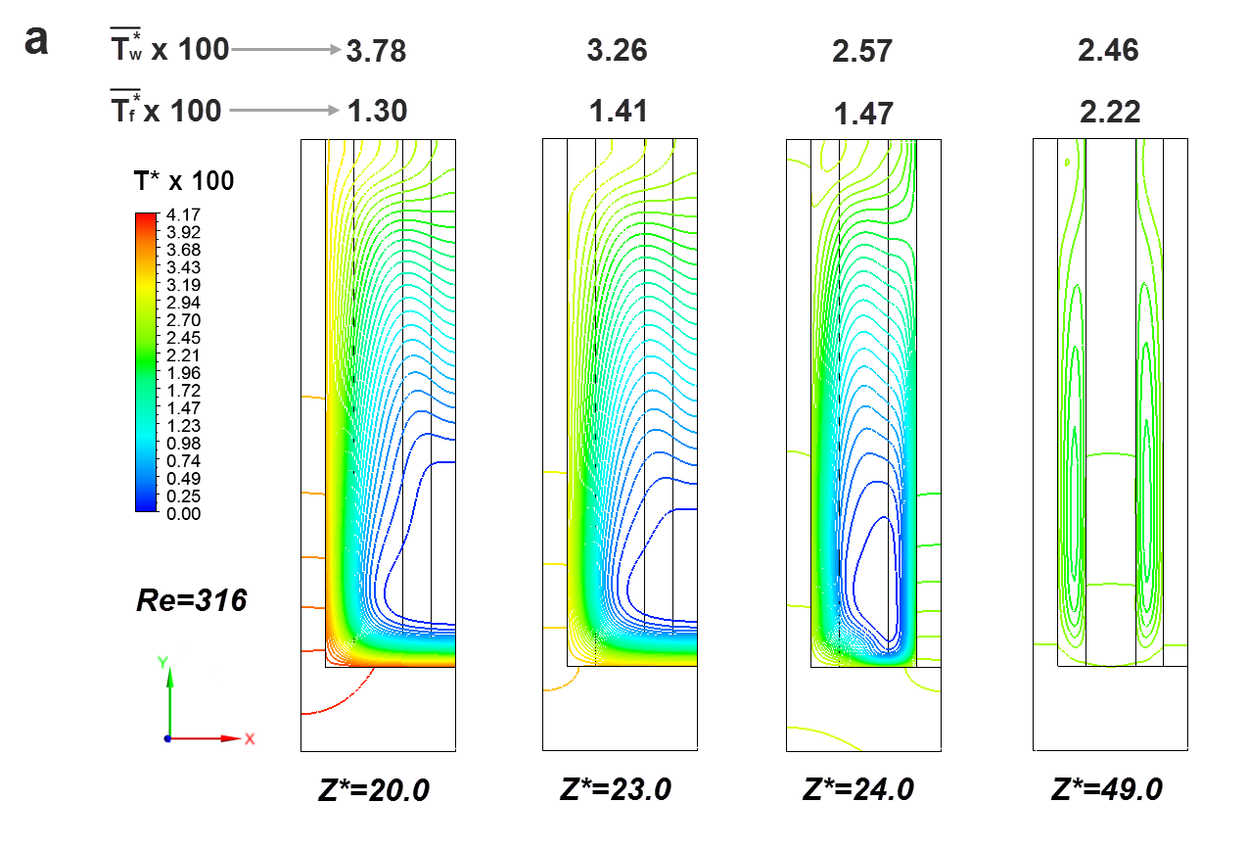
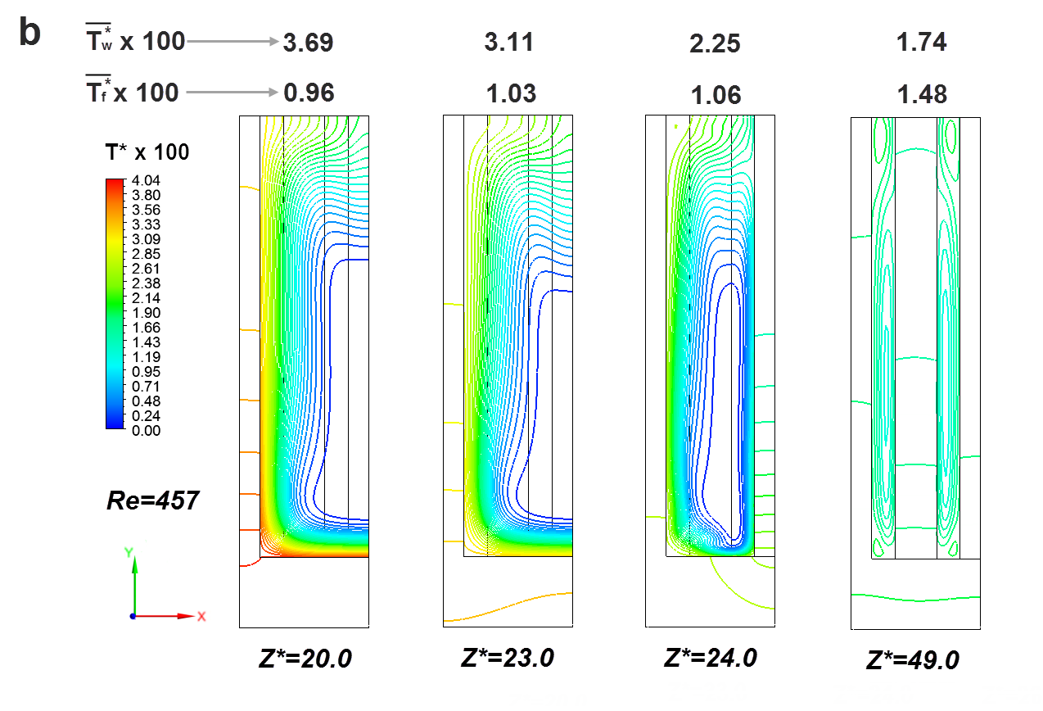
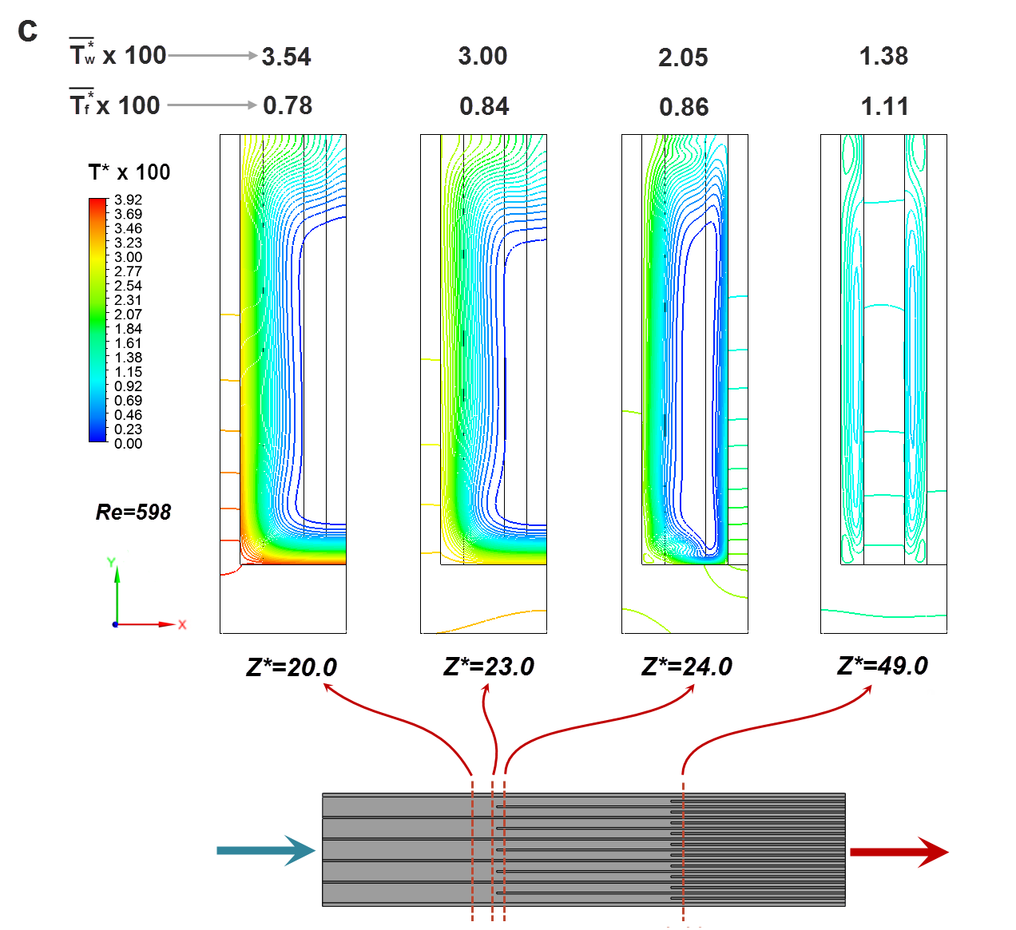

Fig. 14. Temperature contour plots at cross-flow planes of increasing streamwise coordinate in the vicinity of the two contractions: (a) Re₁=316, (b) Re₁= 457 and (c) Re₁=598.

In order to quantify the local heat transfer rate, the circumferentially averaged Nusselt number distribution is calculated using the values of the local heat flux and the temperature distribution from the numerical simulations (Fig. 15a). The definition of the Nusselt number is based on the hydraulic diameter of each heat-sink section, while the fluid bulk temperature was used as reference temperature for the calculation of the local heat transfer coefficient:

(4)

The Nusselt number distribution in the first heat-sink section (Z*<23.7) develops its own distinct form, depending on the value of the Reynolds number. For the lowest value considered, Re₁=316, the distribution exhibits a minimum point at approximately Z*=12.0, a behavior that indicative of the fact that the effect of natural convection in the first-heat sink section is significant [30] due to the large channel hydraulic diameter in the specific section. As the Reynolds number increases, the Richardson number decreases and thus the distribution shifts to a monotonic behavior, characteristic of forced convection. It is interesting to note that the overall Nusselt number is the highest for the lowest Reynolds number value, due exactly to the beneficial effect of the buoyancy rolls on heat transfer. In reference to the lower Reynolds number case (Re₁=316), the Nusselt number distribution after reaching its minimum value redevelops to a plateau of values in the order of 9.3 to 9.5, which are more than twofold the theoretical fully developed value for parallel flow (Nu_{FD}=4.50) [37].
The Nusselt number retains almost constant and high values through the larger part of the second heat-sink section, due to the action of the longitudinal vortices that cause redistribution of the thermal energy. The distribution for Re₁=316 exhibits a slightly increasing trend, which indicates that the effect of free convection is non-negligible. For the other two Reynolds numbers, the constant Nusselt number values obtained exceed the theoretical one, [37], by 46-49%.
Regarding the third heat sink section, an undershoot in the distribution is clearly discernible in the initial part of the channel. The Nusselt number subsequently recovers to a fully developed value, which is independent of the Reynolds number and is in agreement with the theoretical value (Nu_{FD}=7.24) [37]. As discussed in §5.2, the effect of the secondary flow in the third section is negligible and it is thus expected that the Nusselt number will obtain the value of a fully developed parallel flow.
As illustrated in Fig. 15b, a significant flux reversal occurs at the entrance of the third section of the heat sink (regions Aʹ in Fig. 15b) due to the step change of the channel hydraulic diameter and this is the cause for the observed undershoot of the Nusselt number values. It is evident that the flux reversal becomes more pronounced for increasing values of the Reynolds number. The fluid within the heat-sink is constantly heated, whereas the solid bottom wall experiences a rapid cooling in the locations of flow contraction. Therefore, in the boundary layer regions, the elevated fluid temperature can locally exceed the respective wall temperature and consequently the heat flow direction is reversed. On the other hand, in the regions under the influence of the horseshoe vortex (regions A in Fig. 15b) the local heat flux obtains very high values, over 4.5 times higher than the average flux value in the specific section.

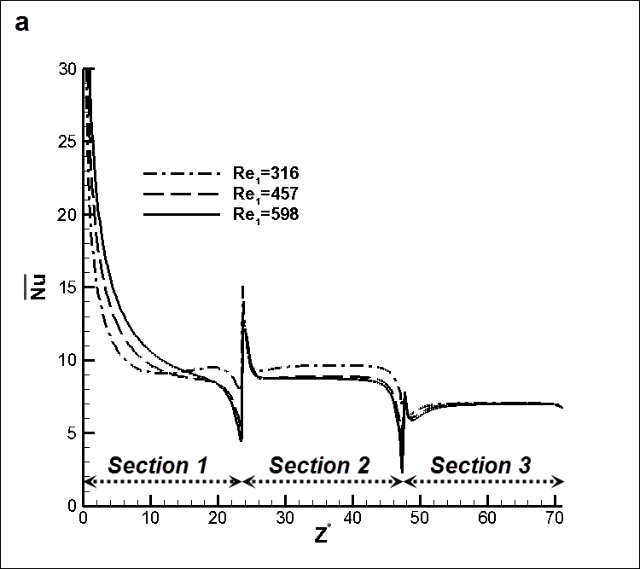

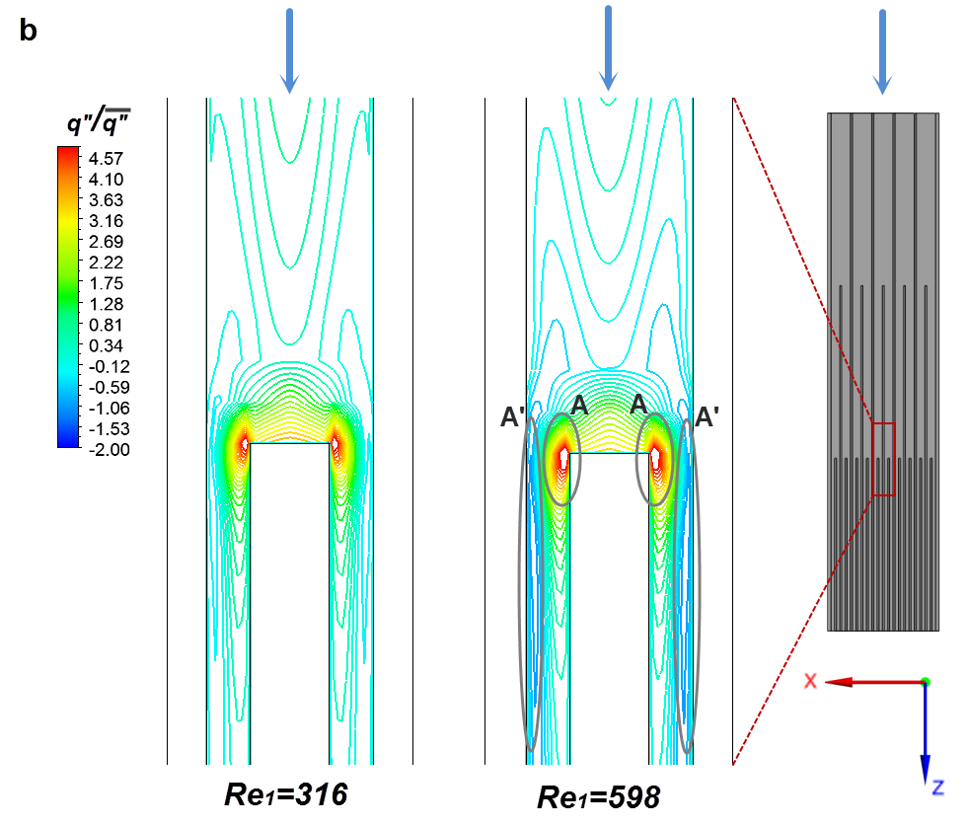

Fig. 15. (a) Distribution of the circumferentially averaged local Nusselt number for the three-section VW configuration. (b) Contour plots of the wall heat flux at the region of the second flow contraction (region Aʹ: heat flux reversal, region A: enhanced heat flux due to horseshoe vortex).

5.4 Overall performance evaluation

An indicator commonly used to characterize the thermal performance of cooling devices is the thermal resistance defined as [38]:

(5)

where R_{conv} and R_{cal} are the convective and caloric thermal resistances. The effect of the substrate conductive resistance has been excluded from the presented results, as it has no considerable effect on the overall thermal resistance. The convective thermal resistance is calculated using the overall averaged heat transfer coefficient , and the overall thermal resistance in the case of an array of rectangular channels obtains the following form:

, where (6)

where A_{HTR} is the total heat transfer area. Regarding straight microchannel heat sinks, Eq. (6) is explicitly derived from the general definition of the thermal resistance:

(7)

The hydrodynamic performance of the heat sink can be evaluated in terms of the pumping power. The values of R_{th} and P_{p}, which are calculated based on the numerical data, are presented as a function of the Reynolds number Re₁ on the same graph in Fig. 16a. As can be seen, R_{th,eq.(6)}, which is based on the wall average temperature, decreases as the Reynolds number increases due to the fact that the wall average temperature decreases as well, whereas R_{th,eq.(7)} remains relatively unaffected by the Reynolds number at a value of 0.015-0.016 K/W. It can be deduced that the heat-sink thermal resistance is overestimated by Eq. (7), as it is calculated using a single temperature value –in fact the maximum wall temperature- and therefore the average heat transfer rate is not taken into account. The required pumping power increases exponentially with the Reynolds number but in general obtains low values due to the negligible pressure drop in the first two heat sink sections. The thermal behavior of the present cooling device therefore is particularly attractive, as the wall maximum (hotspot) temperature remains relatively constant for a wide range of flow conditions. In addition, in applications such as electronics’ cooling where the effectiveness of cooling is determined by the hotspot temperature, the utilization of such a device can greatly reduce the parasitic power required for pumping.
Regarding photovoltaics cooling, temperature uniformity also has an effect on the cell-array performance. As depicted in Fig. 16b, the standard deviation of temperature decreases and thus temperature uniformity increases as the Reynolds number decreases. This is an additional attractive feature of the device, as uniform cooling can be achieved without the need to increase the coolant flow rate and thus the parasitic power.

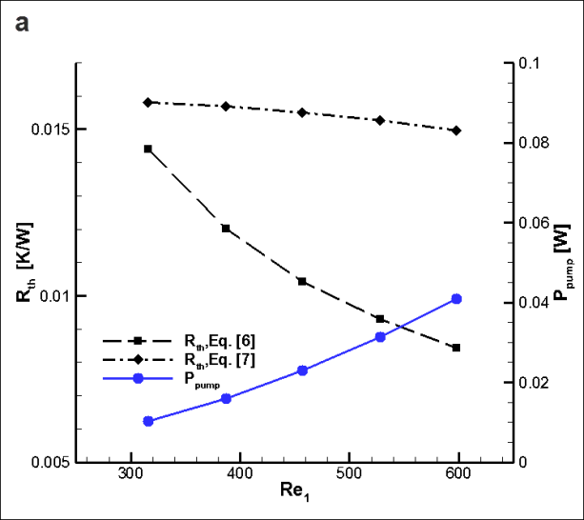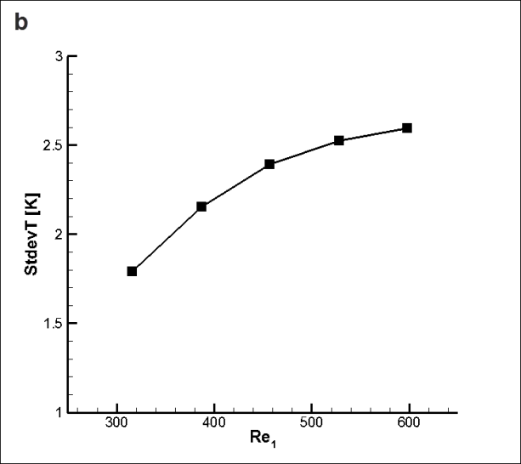

Fig. 16. Overall heat-sink performance: (a) Thermal resistance and pumping power vs. Re₁, (b) standard deviation of the temperature at the heated surface (Y*=-0.16) vs. Re₁.

In comparison to conventional plate-fin heat sinks with straight rectangular channels, the VW design would significantly outperform in terms of thermal performance a straight-fin heat sink of the same overall dimensions and channels with the dimensions considered for first section throughout its length, owing to the addition of heat transfer surfaces and the existence of longitudinal vortices. In fact, the proposed VW design would have comparable thermal performance with a fixed-width design bearing channels with dimensions similar to the third, high-fin density section of the VW device, however, with a significantly lower cooling fluid pressure drop due to the subtraction of fins in the heat sink initial part [30]. In addition, the disruption of the thermal boundary layer, which produces non-linear and thus less steep temperature increase along the heat sink length, leads to more uniform temperature on the substrate compared to a straight-fin heat sink of either higher or lower fin density. Finally, the VW design allows the regulation of the hotspot temperature for a wide range of flow rates, a feature not encountered in straight-fin configurations.

6. Conclusions

A novel, elongated plate-fin heat sink with active area 500 x 65 mm² was numerically and experimentally evaluated in this study. The heat sink comprises three sections of rectangular channels with stepwise varying widths. A closed flow loop was developed in order to experimentally evaluate its hydrodynamic and thermal performance for water flow rates in the range 20-40 mL/s. Measurements and numerical predictions aiming at obtaining the induced pressure drop and the temperature distribution of the solid wall were found to be in very good agreement with one another. It has been found that fluid friction in the third heat-sink section of microscale dimensions accounts for approximately 95% of the overall induced pressure drop, which was found to be in the range 484-961 Pa. It can be consequently deduced that the presence of the lower fin-density sections greatly mitigates the pressure drop penalty inevitably associated with such a multi-channel configuration. In addition, the pressure drop induced by the manifold system was found to be negligible.
Regarding thermal performance, it was established that the wall maximum temperature remained relatively constant regardless of the Reynolds number due to the effect of free convection in the first heat sink section. As was further illustrated through the numerical evaluation, longitudinal vortices, albeit of gradually reducing strength, emerge in the three sections of the heat sink. The onset of the secondary flow pattern has a beneficial effect on heat transfer in the first two heat-sink sections. Buoyancy rolls emerge in the first heat sink section, while contraction-induced horseshoe vortices in the subsequent sections. The Nusselt numbers obtained were found, in general, to be higher than the theoretical ones for purely parallel flow.
The heat-sink thermal resistance based on the maximum wall temperature obtained a constant value approximately equal to 0.015 K/W, while the respective value calculated using the average wall temperature was in the range 0.008-0.014 K/W depending on the flow rate. The required pumping power for circulating the cooling fluid obtained very low values, namely not exceeding 0.04 W. In conclusion, the proposed cooling device exhibits attractive overall performance that allows good control of the thermal behavior with minimum parasitic power losses and it is an excellent candidate for linear Concentrating/Photovoltaic Thermal (CPVT) systems.

Acknowledgments

The simulations were performed using the NTUA Cloud Computing infrastructure. The staff of the computer center is gratefully acknowledged for their technical support. The work was financially supported by the NTUA Special Account for Research.

References

[1] N. Nagarani, K. Mayilsamy, A. Murugesan, K.G. Sathesh, Review of utilization of extended surfaces in heat transfer problems, Ren. Sust. En. Rev. (29) 2014 604-613.
[2] S.S. Mehendale, A.M. Jacobi, Fluid flow and heat transfer at micro- and meso-scales with application to heat exchanger design, Appl. Mech. Rev. (53) 2000 175-193.
[3] S.A. Jajja, W. Ali, H.M. Ali, A.M. Ali, Water cooled minichannel heat sinks for microprocessor cooling: Effect of fin spacing, Appl. Therm. Eng. (64) 2014 76-82.
[4] H.L. Wang, H.C. Wu, K. Wang, T.C. Hung, R.J. Yang, A study of mini-channel thermal module design for achieving high stability and high capability in electronic cooling, Appl. Therm. Eng. (51) 2013 1144-1153.
[5] C.K. Loh, D.J. Chu, Comparative analysis of heat sink pressure drop using different methodologies. In: Proceedings of the Semiconductor Thermal Measurement and Management Symposium, 2004, p. 148-153.
[6] S.G. Khandlikar, A.V. Bapat, Evaluation of jet impingement, spray and microchannel chip cooling options for high heat flux removal, Heat Transfer Eng. (28) 2007 911-923.
[7] M.A. Ebadian, C.X. Lin, A review of high-heat-flux heat removal technologies, J. Heat Transfer (133) 2011 110801 1-11.
[8] B. Agostini, M. Fabbri, J.E. Park, L. Wojtan, J.R. Thome, B. Michel, State of the art of high heat flux cooling technologies, Heat Transfer Eng. (28) 2007 258-281
[9] A.M. Adham, N. Mohd-Ghazali, R. Ahmad, Thermal and hydrodynamic analysis of microchannel heat sinks: A review, Ren. Sust En. Rev. (21) 2013 614-622.
[10] R. Dey, T. Das, S. Chakraborty, Frictional and heat transfer characteristics of single-phase microchannel liquid flows, Heat Transfer Eng. (33) 2012 425-446.
[11] L. Léal, M. Miscevic, P. Lavieille, M. Amokrane, F. Pigache, F. Topin, B. Nogarède, L. Tadrist, An overview of heat transfer enhancement methods and new perspectives: Focus on active methods using electroactive materials, Int. J. Heat Mass Transfer (61) 2013 505-524.
[12] A.M. Jacobi, R.K. Shah, Heat transfer surface enhancement through the use of longitudinal vortices: A review of recent progress, Exp. Therm. Fluid Sci. (11) 1995 295-309.
[13] J.H. Ryu, D.H. Choi, S.J. Kim, Three-dimensional numerical optimization of a manifold microchannel heat sink, Int. J. Heat Mass Transfer (46) 2003 1553-1562.
[14] W. Escher, B. Michel, D. Poulikakos, A novel, high performance, ultra-thin heat sink for electronics, Int. J. Heat Fluid Flow (31) 2010 586-598.
[15] W. Escher, T. Brunschwiler, B. Michel, D. Poulikakos, Experimental investigation of an ultrathin manifold microchannel heat sink for liquid-cooled chips, J. Heat Transfer (132) 2010 081402 1-10.
[16] J. Barrau, D. Chemisana, J. Rosell, L. Tadrist, M. Ibañez, An experimental study of a new hybrid jet impingement/micro-channel cooling scheme, Appl. Therm. Eng. (30) 2010 2058-2066.
[17] J. Barrau, M. Omri, D. Chemisana, J. Rosell, M. Ibañez, L. Tadrist, Numerical study of a hybrid jet impingement/micro-channel cooling scheme, Appl. Therm. Eng. (33-34) 2012 237-245
[18] S. Riera, J. Barrau, J.I. Rosell, M. Omri, L.G. Fréchette, Experimental demonstration of a tailored-width microchannel heat exchanger configuration for uniform wall temperature, J. Phys.: Conf. Ser. (476) 2013 012075.
[19] D. Du, D. Jo, G. Kokogiannis, Thermal management systems for Photovoltaics (PV) installations: A critical review, Sol. Energy (97) 2013 238-254.
[20] A. Royne, C.J. Dey, D.R. Mills, Cooling of photovoltaic cells under concentrated illumination: a critical review, (86) 2005 451-483
[21] L. Micheli, N. Sarmah, X. Luo, K.S. Reddy, T.K. Mallick, Opportunities and challenges in micro- and nano-technologies for concentrating photovoltaic cooling: A review, Ren. Sust. En. Rev. (20) 2013 595-610.
[22] Royne A, Dey CJ. Design of a jet impingement cooling device for densely packed PV cells under high concentration. Sol. Energy (81) 2007 1014-1024.
[23] M. Rahimi, E. Karimi, M. Asadi, P. Valeh-e-Sheyda, Heat transfer augmentation in a hybrid microchannel solar cell, Int. Comm. Heat Mass Transfer (43) 2013 131-137.
[24] I.K. Karathanassis, E. Papanicolaou, V. Belessiotis, G.C. Bergeles, Design and optimization of a micro heat sink for Concentrating/Photovoltaic Thermal (CPVT) systems, Appl. Therm. Eng. (59) 2013 733-744.
[25] EN12975-2:2006 Standard, Thermal solar systems and components - Solar Collectors - Part 2: Test methods.
[26] I.K. Karathanassis, E. Papanicolaou, V. Belessiotis, G.C. Bergeles, Three-dimensional flow effects on forced convection heat transfer in a channel with stepwise-varying width, Int. J. Therm. Sci. (67) 2013 177-191.
[27] R.D. Blevins. Applied Fluid Dynamics Handbook, Van Nostrand Reinhold Company, New York, 1984, pp. 71-80.
[28] R.J. Moffat, Describing the uncertainties in experimental results, Exp. Therm. Fluid Sci. (1) 1988 3-17.
[29] ANSYS Inc., ANSYS CFX-Solver theory guide, Release 13.0, Canonsburg, PA, 2010.
[30] I.K. Karathanassis, E. Papanicolaou, V. Belessiotis, G.C. Bergeles, Effect of secondary flows due to buoyancy and contraction on heat transfer in a two section plate-fin heat sink, Int. J. Heat Mass Transfer (61) 2013 583-897.
[31] ANSYS Inc., ANSYS CFX-Solver manager user’s guide, Release 13.0, Canonsburg, PA, 2010.
[32] B.E. Launder, D.B. Spalding, The numerical computation of turbulent flows, Comp. Meth. Appl. Mech. Energy 3 (1974) 269-289.
[33] C. Nonino, S. Del Giudice, Laminar mixed convection in the entrance region of horizontal rectangular ducts, Int. J. Numer. Methods Fluids (13) 1991 33–48.
[34] A. Benderradji, A. Haddad, R. Taher, M. Médale, C. Abid, F. Papini, Characterization of fluid flow patterns and heat transfer in horizontal channel mixed convection, Heat Mass Transfer (44) 2008 1465–1476.
[35] W. Aung, Mixed convection in enclosures, in: S. Kakac, R.K Shah, W. Aung (Eds.), Handbook of Single Phase Convective Heat Transfer, first ed., Wiley, New York, 1987, pp. 15.1-15.10.
[36] J.P. Holman, Heat Transfer, McGraw-Hill, New York, 2010, pp. 335-337.
[37] R.K. Shah, A.L. London, Laminar Flow Forced Convection in Ducts: a Source Book for Compact Heat Exchangers, Academic press, New York, 1978.
[38] A. Kraus, A. Bar-Cohen, Thermal Analysis and Control of Electronic Equipment. McGraw-Hill, New York, 1983.

