Primary-school-based art therapy: Exploratory study of changes in children’s social, emotional and mental health
*Alex McDonaldª, Sue Holttum^{b} & Dr Nicholas StJ Drey^{c}

*Corresponding author: Alex McDonald
Email: alexmcdonald.arttherapy@gmail.com
ORCID: https://orcid.org/0000-0003-2137-0804
Twitter handle: @_AlexMcDonald (https://twitter.com/_AlexMcDonald)

ªAlex McDonald, SRA’sT (Art), MRes (Clinical Research), has
worked as an art therapist with children, young people and
families since 2005. She is currently an Officer and Tutor at the British Association of Art Therapists, coordinates the Art Therapy Practice Research Network, and is Co-Editor in Chief of the International Journal of Art Therapy: Inscape.

^{b}Sue Holttum, PhD, AFBPsS, C.Psychol. is a senior lecturer at the Salomons Institute for Applied Psychology, Canterbury Christ Church University, UK, and part-time Research Officer for the British Association of Art Therapists. Alongside her own research in art therapy, Dr Holttum supervises doctoral level research in applied psychology.

^{c}Nicholas StJ Drey, PhD, is a senior lecturer in Health Services
Research at the Centre for Health Services Research, School of
Health Sciences, City University of London, focusing on quantitative
methods and research ethics. Previously he worked in
academic roles in the Department of Midwifery (City University
London) and the Department of Public Health Medicine,
School of Medicine, University of Southampton. He has also
worked in the NHS in the Public Health Department of
Wessex Regional Health Authority.

ABSTRACT
AIM: This exploratory mixed methods study aimed to inform future research by investigating if teachers and children from one primary school perceived any changes in children’s social, emotional and mental health difficulties following art therapy and if so, what the children perceived as helpful about the sessions. METHODS: The study included 45 children and ten class teachers within one UK primary school. The researchers analysed routinely collected data from teachers (Strengths & Difficulties Questionnaires) and children (evaluation interviews) and triangulated the findings with data collected from a focus group with teachers. RESULTS: The findings show some indications of change with significant and medium effect sizes for positive teacher-rated changes in children’s overall stress, conduct, hyperactivity, and procsocial behaviour and a large effect on the impact of children’s difficulties on their lives. Emotional distress and peer problems showed small changes that did not reach statistical significance. The positive changes were corroborated by the teacher and children qualitative reports. Aspects of art therapy which children found particularly helpful were; making and thinking about art; expressing, thinking and learning about thoughts and feelings; and sessions being fun. CONCLUSION: The study highlighted perceived positive changes and no negative changes in children’s SEMH difficulties. However, future research is necessary to examine clinical effectiveness.
Keywords: art therapy; primary school; school-based; children; mixed method research, mental health

PLAIN LANGUAGE SUMMARY
In this article we describe a research study which aimed to explore if teachers and children perceived any changes to children’s social, emotional or mental health difficulties after the children attended art therapy within their primary school. We were also interested in learning from the children if they thought anything in particular had been helpful about their art therapy sessions.
The art therapists asked the class teachers to fill out a frequently used questionnaire about how the children were in class at the beginning and end of art therapy. The class teachers also attended a focus group so we could learn more about their general observations of the children before and after attending art therapy. The art therapists also interviewed the children to learn if they perceived any changes since coming to art therapy and if so, what in particular they thought had helped bring about these changes.
We found that statistical analysis of the questionnaire mostly agreed with what the teachers and children said and that there was generally some positive change to the social, emotional and mental health difficulties the children had been experiencing. The teachers also let us know that some of the children still had residual problems. The children emphasised that making and thinking about art along with expressing, thinking and learning about thoughts and feelings had been particularly helpful. It was also important to the children that the sessions were fun.
Thus, the conclusion of the study was that the teachers and children in this primary school perceived art therapy as helpful to the children and that it merits further research in order to develop the approach used by the art therapists and to see if it is effective in larger scientific studies including more children, schools and art therapists.

INTRODUCTION

Mental health in schools

In July 2017 the Children’s Commissioner for England published new analysis suggesting the scale of vulnerability among children in England including 800,000 children identified as suffering from mental health difficulties and indications of many more under the radar and not being seen (Children’s Commissioner, 2017). A recent national survey reported that about one in ten (9.5%) 5 to 10 year olds met the criteria for one mental health diagnosis and about one in thirty (3.4%) met the criteria for two or more diagnoses (UK Government Statistical Service [GSS], 2018). Despite this, the UK Department for Education (DfE) has highlighted a continued lack of time and capacity as problematic in supporting pupils’ mental health (DfE, 2017b). In response to a recent inquiry (Education and Health and Social & Care Committees, 2018) the UK government acknowledged the importance of prevention, early intervention, and the role played by schools, and again pledged to expand and train the children's mental health workforce in order to ensure that an additional 70,000 children per year receive evidence based treatment when in need (Departent for Health & Social Care [DHSC] & DfE, 2018).

In England there are also estimated to be over 1,229,000 children who have special educational needs and/or disability (SEND) (DfE, 2016). There were changes to the classification of type of need in 2015: the previous code of ‘Behaviour, emotional and social difficulties (BESD)’ was removed and ‘Social, emotional and mental health (SEMH)’ was introduced, although this was not intended to be a direct replacement (DfE, 2016). This study examines an art therapy service within an inner-city community primary school in an area which had the third highest rate of child poverty in London (36.8%), almost double the rate for England overall (20.1%); and the most prevalent disabilities and problems were reported to be learning disability, language difficulties, and BESD (London Borough of Hackney, 2014).

There is evidence that failure to prevent and address the underlying causes of children’s mental health problems can have significant negative effects on their wellbeing as well as having a considerable impact on society in general due to increased future costs (DoH & DfE, 2017). There is thus an imperative to develop research examining the effectiveness of interventions for primary school aged children. Art therapy is one such intervention and is already a state registered form of psychological therapy in the UK, US and Canada. There is no single approach in art therapy and it may vary in definition. The British Association of Art Therapists (BAAT) defines art therapy as a form of psychotherapy that uses art media as its primary mode of expression and communication (BAAT, 2016). Children referred to primary-school-based art therapy may have a wide range of difficulties, disabilities or diagnoses. These may include social, emotional, behavioural or mental health problems, learning or physical disabilities, life-limiting conditions, neurological conditions and physical illnesses. Art therapy is provided in groups or individually, depending on children’s needs.

School-based art therapy

Art therapy as a specific intervention within schools has been developing for some time now (Karkou, 1999) and preliminary research on how effective it is has been growing in recent years (Cobbett, 2016; Deboys, Holttum, & Wright, 2017; McDonald & Drey, 2018). This exploratory mixed methods study follows our recent systematic review of controlled studies on the outcomes of primary-school-based art therapy (McDonald & Drey, 2018), which found that the four studies included were of middling quality, and although they did not evidence clinical effectiveness, did suggest some positive effects for children struggling with classroom behaviour (Rosal, 1993), ‘oppositional defiant disorder’ and ‘separation anxiety disorder’ (Khadar, Babapour, & Sabourimoghaddam, 2013a, 2013b), and locus of control and self-concept (Rosal, 1993).

Recent theoretical developments help to articulate the underlying theoretical framework of the specific approach to art therapy examined in this study. The primary school provides a context which has already been established as responsive. This, along with good communication between teachers, parents and art therapists to elucidate art therapy processes clearly and openly are key in providing the grounding for therapeutic engagement (Deboys et al., 2017). Working within the school system also enables better cooperation between the parties involved in the life of the child (Snir et al., 2018). The soothing and nurturing quality of the art materials along with the safety and support provided by the art therapist enables the child to remain motivated and aroused without a sense of threat to survival (Czamanski-Cohen & Weihs, 2016). This is consistent with the work of Malchiodi and Crenshaw (2015), who suggest that the physical activity of art making can help children to process emotional and sensory data within an art therapy context. Inviting self-reflection using art is a less threatening way to maintain engagement in exploring emotions (Springham, Findlay, Woods, & Harris, 2012). This encourages mentalization, which is expected to develop the child’s social cognition and ability to identify and reflect upon their own emotions, and upon the emotions of others (Czamanski-Cohen & Weihs, 2016; Fonagy & Bateman,2006).

Springham and Huet (2018) have similarly theorised that art, in art therapy, is an encounter within the ostensive communication system and thus, because it involves the attachment system, can enhance mentalizing. A child engaged in art making is an emotionally engaged agent who will be able to use the art product to reflect upon their emotions, thus gaining an increased sense of agency (Czamanski-Cohen & Weihs, 2016). Building on this, psychoeducation helps children to actively manage difficulties (Lukens & McFarlane, 2004). Agency is foregrounded from early on, as formulation of reasons for and goals of art therapy enable the co-production of an intervention plan tailored to the individual and their needs (Johnstone, 2018). This is in keeping with evidence that there is a connection between children identifying art therapy aims and perceiving change (Deboys et al., 2017).

Finally, the approach is also in accordance with the British Association of Art Therapists guidelines for working with children, adolescents and families in art therapy (Taylor Buck & Hendry, 2016) and recommendations by Deboys et al. (2017) that clear target problems should be identified at the start of therapy and that it is important for sessions to be fun and enjoyable for the child, as well as embedded within the child’s system.

Study rationale and aim

This study is a response to the urgent need for effective mental health interventions for children and the dearth of research on the effectiveness of primary-school-based art therapy. However, the production of robust research on complex interventions such as art therapy first requires initial exploratory studies to inform researchers of the most appropriate intervention components, data and methodology for further experimental studies (UK Medical Research Council [MRC], 2019). Thus, an exploratory study was deemed necessary early phase research in order to examine if this approach to art therapy merits further research and development.

The aim of this exploratory mixed methods study was to examine if there were any indications of changes in children’s social, emotional and mental health (SEMH) following a specific form of art therapy within one primary school and to shed further light on how any changes may have come about. Thereafter, if the findings support future research, we aimed to use them to make recommendations to inform future studies on intervention development and clinical effectiveness.

METHODS

Study design and methodology
The study employed a mixed methods pre-post design in order to use routinely collected data and triangulate any findings. Routinely collected quantitative data in the form of teacher-rated standardised outcome measure scores were used (see ‘Data collection and analysis’). Qualitative data were also used; data on the teachers’ perceptions of the children collected through a focus group which was specifically set up for this study; and data on the children’s experiences of art therapy routinely collected through semi-structured evaluation interviews. Pawson (2013) recommends using any methods necessary for evaluating complex interventions. The present study was a preliminary attempt to establish whether certain changes are evidenced following art therapy, and to provide initial suggestions as to why they occurred. Establishing that change occurred is often best done via quantitative measures, while qualitative enquiry helps us understand some of the contextual factors involved in how and why they occurred (Pawson, 2013).

The main research question for this study was: Is there any indication of changes in children’s social, emotional and mental health (SEMH) following primary-school-based art therapy? Four subsidiary questions were used in order to investigate this:
- What were the primary reasons for referral to primary-based-based art therapy? And could the children identify why they attended?
- Were there any significant changes between the before and after Strengths & Difficulties Questionnaire (SDQ) (R. Goodman, 2000) teacher-ratings for the children attending art therapy?
- What were the class teachers’ perceptions of the children before and after art therapy?
- Did the children perceive any changes after attending art therapy? If so, what was it about art therapy that they think helped bring about these changes?

An overview of the study methodology, data collection methods and analyses can be seen in Table 1 and they are described in more detail in the following sections of the paper.

Part | Aim | Design element | Main research questions | Sample size | Data/ Measures | Analysis
Standardised outcome measure | To examine any changes in teacher-ratings of the children’s difficulties from before to after art therapy | Uncontrolled before-and-after study (UBA) | Were there any significant changes between the before and after teacher-ratings for the children attending art therapy? | 45 children | Strengths & Difficulties Questionnaire (SDQ) teacher ratings | Paired sample  t-tests with boot-strapping
Teachers’ observations | To examine if class teachers observe any changes in children after they attend art therapy | Post-intervention focus group | Did class teachers notice any changes in children’s SEMH after they attended art therapy? | 10 class teachers | Focus group transcript | Thematic analysis
Children’s experiences | To examine if children perceive any changes after attending art therapy and to identify possible mechanisms of change. | Routine service user evaluation interviews at end of each term (semi-structured) | Could children identify why they attended art therapy? Did they perceive any changes? If so, what aspects of art therapy helped bring about the changes? | 37 children | Child generated statements | Thematic analysis

Table 1: Research study design

Ethical considerations

Ethical approval for this study was granted by City University of London, School of Health Sciences Research Ethics Committee prior to data collection. The children and families gave written consent for children’s information to be used and the study was also announced on the school website. The primary school also gave written permission for all of the data to be used in the study.

Intervention

The primary-school-based art therapy service examined in this study was embedded within the organizational systems of the school. This full-time service was funded entirely by Pupil Premium Funds; UK government funding awarded to schools for each child coming from a family which meets the low-income criteria for receiving free school meals (DfE, 2017a).

The approach to art therapy examined in this study encourages a move from acting out experience towards its representation. The main principle of the approach is that this move towards representation and mentalizing is a mechanism which is psychologically protective for the child (Czamanski-Cohen & Weihs, 2016; Fonagy & Bateman,2006). The art therapist uses behavioural actions such as photographing the art making process, asking the child questions pertinent to their art making and openly noting the child’s comments in an art therapy journal, to help the child to move towards an increase in representing and naming feelings and a decrease in acting them out, in order to facilitate mentalizing.

Figure 1: Intervention treatment pathway diagram
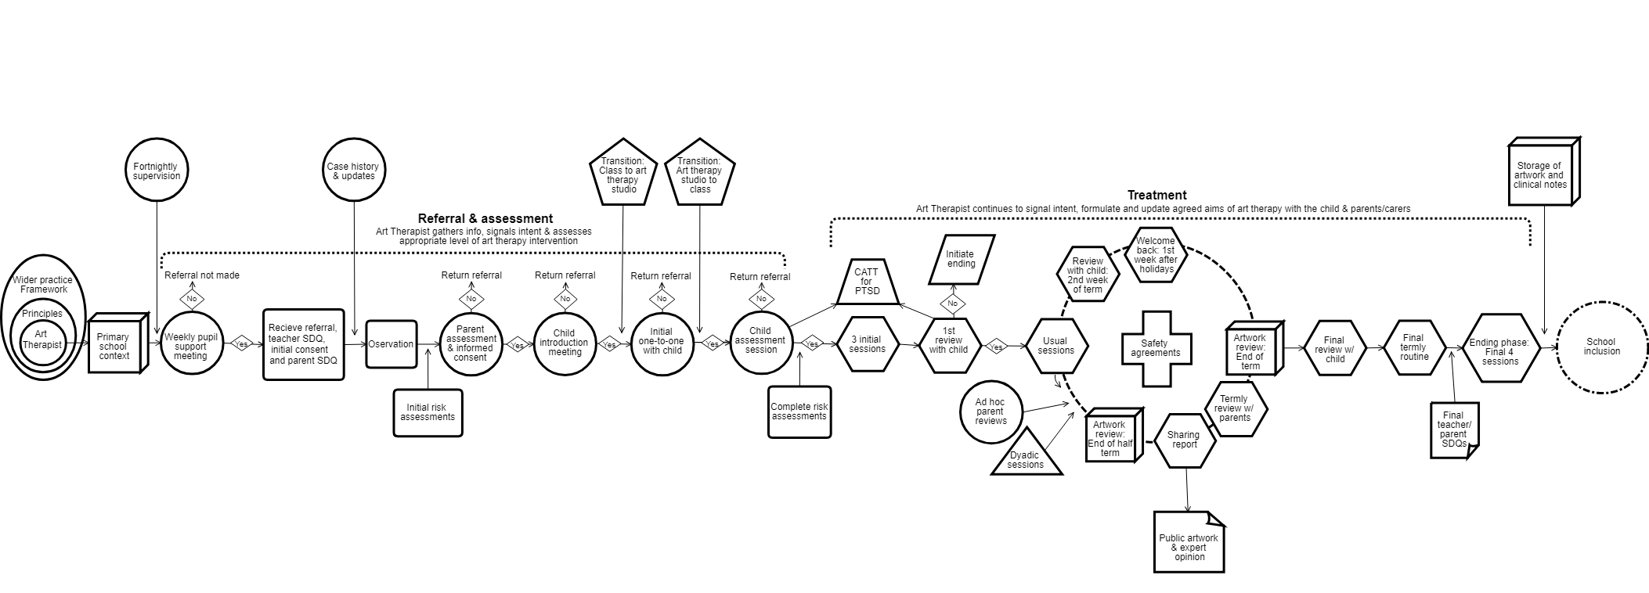

The intervention treatment pathway diagram can be seen in figure 1 and includes; setting up clear ground rules of confidentiality, safety and time boundaries with the child; psychoeducation (Lukens & McFarlane, 2004); continual assessment, formulation (Johnstone, 2018) and re-formulation of reasons for and goals of art therapy; choice between directive and non-directive art making; encouragement towards mentalizing (Fonagy & Allison, 2014); the use of an art therapy journal and photographs of the art making to increase the art therapist’s ostensive communication (Springham & Huet, 2018) of their interest in the child and intention to be helpful and to record the child’s process; and termly reviews and evaluation.

Children were referred to the service by teachers, special educational needs coordinator, senior management, or through self-referral by the child. Individual sessions were offered for up to one hour weekly on a short-term or long-term basis depending on the child’s needs. Cases were discussed at a weekly multi-disciplinary pupil support meeting held within the school, including the Special Educational Needs Coordinator, Child Protection Lead and Deputy, Behaviour Mentor, and Deputy Headteacher. All cases would also be reviewed with the child and family termly. The approach was delivered in line with the current safeguarding legislation and professional standards of proficiency (UK Health and Care Professions Council [HCPC], 2013).

The service was delivered by one lead art therapist (first author): 35 out of the 45 children included in the study were treated by the lead art therapist. The lead art therapist also supervised one newly-qualified art therapist and two final-year trainee art therapists, who treated the remaining 10 children. There may have been individual differences in the way in which the approach was delivered by the four art therapists, but all adhered to the general principles taught by the lead art therapist during clinical supervision and as outlined above. Within this study the term art therapy refers to this specific approach to primary-school-based individual art therapy.

Participants

Participants: Whole study

There were 45 children who attended art therapy over the three years of data collection (April 2012 to July 2015). The children were aged between 4 and 11 years on referral. Six other children were excluded from the study due to leaving the school shortly after referral to the art therapy service.

The criteria outlined by the school for referring children to the art therapy service were very broad; any child whose SEMH needs are impeding them from fulfilling their potential within or outwith the classroom, these needs cannot be met elsewhere, and the parents’ consent to the referral.
There were 24 male and 21 female children in the sample of 45. The data on therapy length of art therapy were slightly positively skewed, with the median length being 53 weeks, and ranging between 8 and 158 weeks. Children were not included if they had attended for less than one term. No ethnicity data were available from the school at the time of analysis.

Participants: Focus group with the teachers

Teachers who met either of the following criteria were included in the focus group:
- The teacher had been the class teacher of a child since the child was referred to art therapy
- The teacher had been the class teacher of a child who received art therapy since the beginning of the academic year

Teachers were excluded from the focus group for either of the following reasons:
- The teacher did not have any children in their class who attended art therapy
- The teacher had taken over being class teacher mid-way through the current academic year and after the child had started art therapy

There were 10 out of 15 teachers in the school who met the inclusion criteria for the focus group. All were invited, and all attended.

Participants: Children’s experiences
Children who met both of the following criteria were included in this part of the study:
- Signed consent was given by parents to publish results of the evaluation interviews
- Verbal consent was given by the children to publish the results of the evaluation interview

Children were excluded from this part of the study for either of the following reasons:
- The child left art therapy before this evaluation interview procedure was implemented

There were a few children who left art therapy before the routine evaluation interview procedure was implemented (n=7). Data from most of the children (n=37) who participated in the termly semi-structured evaluation interviews were included in the analysis. Those who did not have parental consent to publish the results did not participate (n=1). Children had the option to decline to participate in the evaluation interviews but because they were termly, all the children who attended art therapy following the implementation of the evaluation interview procedure did participate at least once.

Data collection and analysis

Strengths and Difficulties Teacher Questionnaires (SDQ)
The Strengths & Difficulties Questionnaire (SDQ) (Goodman, 2000) was used to study the main research question; Are there any significant changes between the before and after SDQ teacher-ratings for the children attending art therapy?
The SDQ is a standardised measure with versions for class teachers, parents and children. This study used the teacher questionnaires only to examine any indication of possible changes on the children’s SEMH in the classroom. The SDQ is widely used to evaluate specific interventions and studies have shown that it is sensitive to treatment effects (Mathai, John, Anderson, & Bourne, 2002). The SDQ is widely used for the assessment of mental health in children and has a five-factor structure (emotional, conduct, hyperactivity-inattention, peer, prosocial) with satisfactory reliability, whether judged by internal consistency (mean Cronbach α: .73), cross-informant correlation (mean: 0.34), or retest stability after 4 to 6 months (mean: 0.62) (Goodman, 2001).

The scores from the teacher-rated SDQs provide data which are already normed according to children in a large scale study on the British population (Goodman & Goodman, 2011). That is to say that these scores are calculated using an SDQ scoring website and are possible because of past research to determine the UK national averages to provide expected norms.

SDQ: Procedure
The SDQ was given to the teachers by the art therapist and collected the next day. The SDQ was filled in by the class teacher, following the instructions on the questionnaire, when the children (n=45) were referred to art therapy before starting sessions. The teacher then filled out the SDQ when the child finished art therapy or, if the child had not yet completed art therapy, at the time the study ended.
The first author entered the answers marked on each questionnaire into the online scoring site www.sdqscore.org which generates a report presenting the raw scores for each questionnaire (SDQscore, 2015).

SDQ: Statistical analysis
Paired t-tests were used to analyse the scores from the SDQs. Because the sample was relatively small and some of the data were skewed, bootstrapping was used, with the default setting of 1,000 bootstrap samples (Field, 2017).. An effect size statistic was also calculated. With paired t-tests, Cohen’s (1988) d represents the number of standard deviations of change from Time 1 to Time 2 (0.2 = small, 0.5 = medium, 0.8 = large). It is computed by dividing the number of scale points of change by the pooled standard deviations from the two time points.

Focus group with the teachers

Qualitative data were collected through a focus group with class teachers (n=10) and used to study the main research question; What were the class teachers perceptions of the children before and after art therapy? The focus group method was chosen in order to obtain detailed information about the teachers' observations, perceptions and opinions within the limited time and resources available.

Focus group: Procedure
The 10 class teachers included in the study were recruited by the School Learning Mentor. The teachers all signed a consent form. The focus group was held for one hour at a convenient time for the class teachers. The focus group was facilitated by an external senior art therapist who had not previously met the class teachers. The facilitator explained the boundaries and purpose of the focus group, asked the group to share their observations of the children’s SEMH and engagement with learning, and summed-up at the end of each key point to check that the teachers had been understood clearly.

Focus group: Analysis
Thematic analysis was used to analyse the qualitative data collected from the focus group. The first author transcribed the audio recording. The first and second authors then carried out thematic analysis independently. Codes and themes were derived from the data following an iterative process of familiarisation with the data, generation of codes, searching for and defining themes, and redefining the themes (Rohleder & Lyons, 2014). The first author used the second author’s themes as a quality check and used differences in interpretation to refine the final set of codes. Most themes were identical or similar (e.g. Calmer), some refinement included changes in theme names where content was the same (e.g. More able to behave appropriately in class was changed to Reduction in disruptive behaviour), and two new themes were added (e.g. Anticipating further improvement).

The children’s experiences

It is particularly important to include the service user perspective in art therapy research in order to avoid missing information that might illuminate processes and mechanisms (Holttum & Huet, 2014). Therefore, qualitative data gathered from routine evaluation interviews with the children (n=37) were used to examine if children perceived any changes after attending art therapy and to identify possible mechanisms of change.

Children’s experiences: Procedure
During the second half of each term each child was invited to share some of their expert knowledge of what it is like to be a child in art therapy with their parents and teachers in the form of an illustrated quote resulting from a semi-structured evaluation interview with the lead art therapist. If parental consent was given, the child would also be offered the opportunity to share their illustrated quote with the wider community of peers, teachers, families and the general public through publication in the school newsletter and on the school website. The semi-structured evaluation interview was comprised of four questions. The child was also invited to make artwork to illustrate their answers using an adapted ‘visual research method’ (Boden & Eatough, 2014):
- In your experience, do you think art therapy has been helpful, or not so much?
- (If so,) what exactly do you think art therapy has helped with… what did you come to art therapy to get help with?
- What changed in relation to that - how could you tell art therapy had been helpful for that?
- What was it specifically, about your art therapy sessions that was helpful for this?
- Is there anything you would like to change about the sessions to make them more helpful?

The child was invited to speak freely in response to the questions and the art therapist/researcher wrote down the words the child said verbatim. After speaking the child was invited to make an image to illustrate their answers to the questions. The art therapist used the child’s words to create coherent sentences, adding in correct grammar. The art therapist then read out the sentences one by one, with encouragement to disagree or make changes, to check with the child if the meaning of their words had been captured in the sentences. The result was one coherent statement about the child’s experience of art therapy. These interviews were part of the routine practice and aimed to offer the children an opportunity to contribute their expert knowledge to the co-production of a positive school culture. As they were not originally designed as a research method, this study uses the data to learn more about the children’s perceptions of mechanisms of change in order to inform future research, rather than as evidence of clinical effectiveness.

Children’s experiences: Analysis
All of the data provided by the termly evaluation interviews that had been published in the school newsletter or on the school website was collated and separated into responses from each child. The researcher then removed any repetitions made by the children and used thematic analysis to analyse the data. This technique was used to identify patterns in the responses given by the children, a common use of this form of analysis (Clarke & Braun, 2013). There was no need for the interviews to be transcribed as they already existed in written form as quotes. Once all of the quotes had been collated and ordered the same process of thematic analysis was followed as for the focus group (Rohleder & Lyons, 2014).

RESULTS
Reasons for referral (n=45)
Although the 45 children presented with multiple underlying issues and complex case histories, the primary reasons for referral by the school are presented in table 2.

Primary reason for referral | Number of children
Disruptive behaviour | 28
Witnessing domestic violence or murder | 7
Unhappy/withdrawn/suicidal thoughts/low self esteem | 6
Anxiety | 2
Self or close family member with life threatening illness | 2
Table 2: Teachers’ stated primary reason for referral

Strengths and Difficulties Questionnaire (SDQ) (n=45)

There were statistically significant and medium-to-large changes on all but two of the SDQ indicators and these were in the expected direction if art therapy is effective. The change in the composite score of overall stress was medium (Table 3), reflecting variation on the subscales. The change in rating of impact of the children’s difficulties on their lives represented a large effect, while medium effects were indicated on conduct, hyperactivity, and prosocial behaviour. Smaller effects, which did not reach statistical significance, were indicated for emotional and peer difficulties.

Measure | Before M (sd) | After M (sd) | Mean change | Lower CI | Upper CI | t | p | d
Overall stress | 16.02 (7.63) | 12.53 (6.60) | 3.4889 | 1.311 | 5.777 | 3.221 | .003* | 0.490
Emotional distress | 3.62 (2.24) | 3.11 (1.94) | 0.5111 | -0.089 | 1.144 | 1.662 | .106 | 0.245
Behavioural difficulties | 3.82 (2.71) | 2.71 (2.37) | 1.111 | 0.400 | 1.756 | 3.162 | .004* | 0.437
Hyperactivity | 5.44 (3.24) | 4.18 (2.75) | 1.267 | 0.512 | 2.111 | 2.959 | .005* | 0.423
Difficulties with others | 3.04 (2.47) | 2.53 (2.30) | 0.511 | -0.222 | 1.222 | 1.371 | .162 | 0.214
Kind & helpful | 6.09 (2.33) | 7.24 (2.38) | -1.156 | -1.822 | -0.490 | -3.306 | .003* | 0.491
Impact³ | 2.27 (1.74) | 0.76 (1.05) | 1.511 | 1.067 | 2.000 | 6.210 | .001* | 1.083
Notes: ³ Potential impact of any difficulties on life; M = Mean; CI = Confidence interval (bias corrected); * = significant at p < .01; d = effect size (0.2 = small, 0.5 = medium, 0.8 = large)
Table 3: Children’s scores before and after art therapy on SDQ indicators

Focus group (n=10)

In the thematic analysis, teachers reported children who attended art therapy as relating better with others, reduction in disruptive behaviour, being transformed, showing maturity, happier, using coping strategies learned in art therapy, becoming able to cope without art therapy, calmer. The teachers also reported that some children continued to have residual behaviour problems, that they were anticipating further change, and that change was not always transformation/gradual. Teachers also reported that children engaged better with school work and this will be presented in a forthcoming paper. Table 4 shows examples of statements made by the teachers in relation to each theme.

Theme  (number of teachers who made statements) | Examples of teachers’ statements (T1 etc = teacher identifier)
Relating better with others  (n=6) | ‘I have seen a big change with her and just her attitude towards the rest of the class and learning how to get on with others..’ (T4)
 | ‘I’ve noticed more trusting of adults to realise that we are here for them.’ (T6)
Reduction in disruptive behaviour  (n=5) | ‘…there has been only one or maybe two incidents over the whole year where her behaviour has been impacting on another. It’s now to do with tables [furniture], it’s not another child, that she’s hurting.’ (T4)
 | 'So we’ve certainly noticed a huge change in how much calmer he is. He’s got lots of strategies that he can use to calm himself down rather than resorting to destruction.' (T10)
Being transformed  (n=4) | ‘And there have been lots of those characters as well, that have had art therapy, have improved, and have now settled back into the class.’ (T5)
 | 'She used to have tantrums in Y4 and would start screaming ‘No no no’ and refusing to leave the class room. I think even she was doing that from a younger age but before the art therapist. Now you wouldn’t even know that it was the same child. She doesn’t kind of disrupt other children’s learning.’ (T8)
Children showing maturity  (n=4) | ‘..she was offering help and assistance to other children who had had similar sort of things (death of a close family member).. so it was really sort of mature for a girl who was very immature for her age so she’s got a lot more mature.’ (T6)
 | ‘(the art therapist) has done a lot of work on independence with him and it’s filtering through to his learning and his social skills and personal life as well..’ (T9)
Children happier  (n=4) | ‘..it sounds like a cliché, but that child is really unrecognisable now; happy most of the time..’ (T5)
 | ‘..he’s definitely come out of his shell a lot more, in the classroom and in the playground. And happier as well..’ (T8)
Children using coping strategies learned in art therapy  (n=4) | ‘..I noticed she had calmed down so much more.. because she had that time to talk about why she was so angry and why she was so upset and think about ways.. to calm down.’ (T2)
 | ‘He’s got lots of strategies that he can use to calm himself down rather than resorting to destruction.’ (T10)
Children becoming able to cope without art therapy  (n=4) | ‘(being) able to say ‘no I’m actually ready to not do this (art therapy) anymore’ that was an achievement and celebrated.’ (T5)
 | ‘..she’s actually gone to (the art therapist) and said that “I think we are ready now to finish”. And she loves the sessions but she is mature enough now to actually say that which is a massive, massive step.’ (T6)
Children calmer due to art therapy  (n=3) | ‘..she used to lash out all of the time in nursery and when she started doing art therapy she totally calmed down even though she still has issues..’ (T1)
 | ‘..we’ve certainly noticed a huge change in how much calmer he is.’ (T10)
Residual behaviour problems  (n=3) | ‘..emotions, that’s something she finds really hard. She can’t deal with it and that’s something that we kind of like need to look more into..’ (T3)
 | ‘..it’s meant that even though a lot of the time she is on her own, I’ll be able to ask her ”can so and so work with you?”..’ (T4)
Anticipating further improvement  (n=2) | ‘So she is learning to work with others and I hope that… eventually she will be in a position where she can work with other children.’ (T4)
 | ‘..it represents a huge amount of progress and I’d imagine by the end of the year, now he’s confident enough to pick the (work) sheet, he will really mean “I don’t mind, I’m going to have a go!”..’ (T5)
Not always transformation / gradual change  (n=2) | ‘..take more risks in the class room. And I think that is something that has developed over time. I think that being able to talk through their ideas with people and develop them as a group has become more apparent..’ (T9)
 | ‘..it’s not that there has been a complete change in behaviour. For some there has but for the ones that it is ongoing, it is more that strategies are now in place to stop things going from bad to worse in 30 seconds..’ (T5)

Table 4: Themes from focus group with class teachers

Children’s experiences (n=37)

The children produced colourfully illustrated quotes from the routine evaluation interviews and most expressed a sense of pride in sharing their expert knowledge. There was a culture of displaying the illustrated quotes publicly in the weekly school newsletter, in assembly and on the school website and all of the children were eager to join in. All of the statements made by the 37 children were displayed in this way and no data were unpublished. Examples of the children’s illustrated quotes can be seen below along with the themes (Fig 1 xxx to Fig xxx). The 37 children all responded to all the questions at some point during the termly reviews and most responded more than once to each question. However, each child was counted only once within each of the themes listed below.
In response to the first and second questions; In your experience, do you think art therapy has been helpful, or not so much? (If so,) what exactly do you think art therapy has helped with… what did you come to art therapy to get help with? the children stated: Feelings in general (n=10); Anger (n=9); Sad, bad, upset feelings (n=8); Stress, worry, scary feelings (n=4); Behaviour and confidence (n=4); Learning & concentration (n=4); Happy, good feelings (n=3).
Of note is a disparity between the primary reasons for referral given by teachers and the reports by the children about what they came to art therapy to get help with. The teachers’ most common reasons for referring the children were; Disruptive behaviour (n=28), Witnessing violence (n=7), and being Unhappy or withdrawn (n=6). Whereas the children’s reasons for coming to art therapy were; Feelings in general (n=10), Anger (n=9), and Sad, bad, upset feelings (n=8), with Behaviour being named by only a few (n=3).
Figures 2 and 3 show examples of the children’s statements about what art therapy was helpful for.
Figure 2

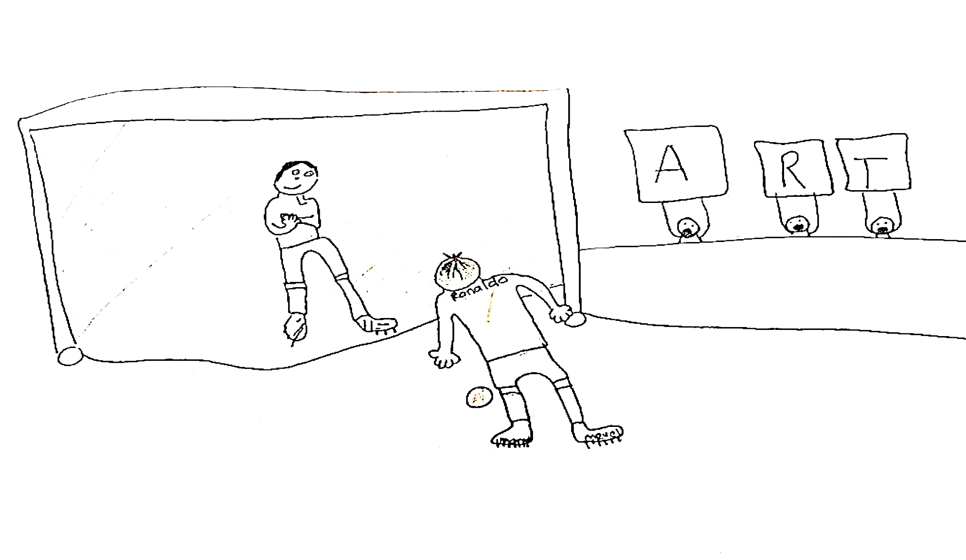
‘Art therapy helps with stress! It can help children with their feelings e.g. sad, scared or angry feelings. When you make art, it can take your mind off the bad stuff. This can help you feel safer’ (Child 34, age 10)

Figure 3

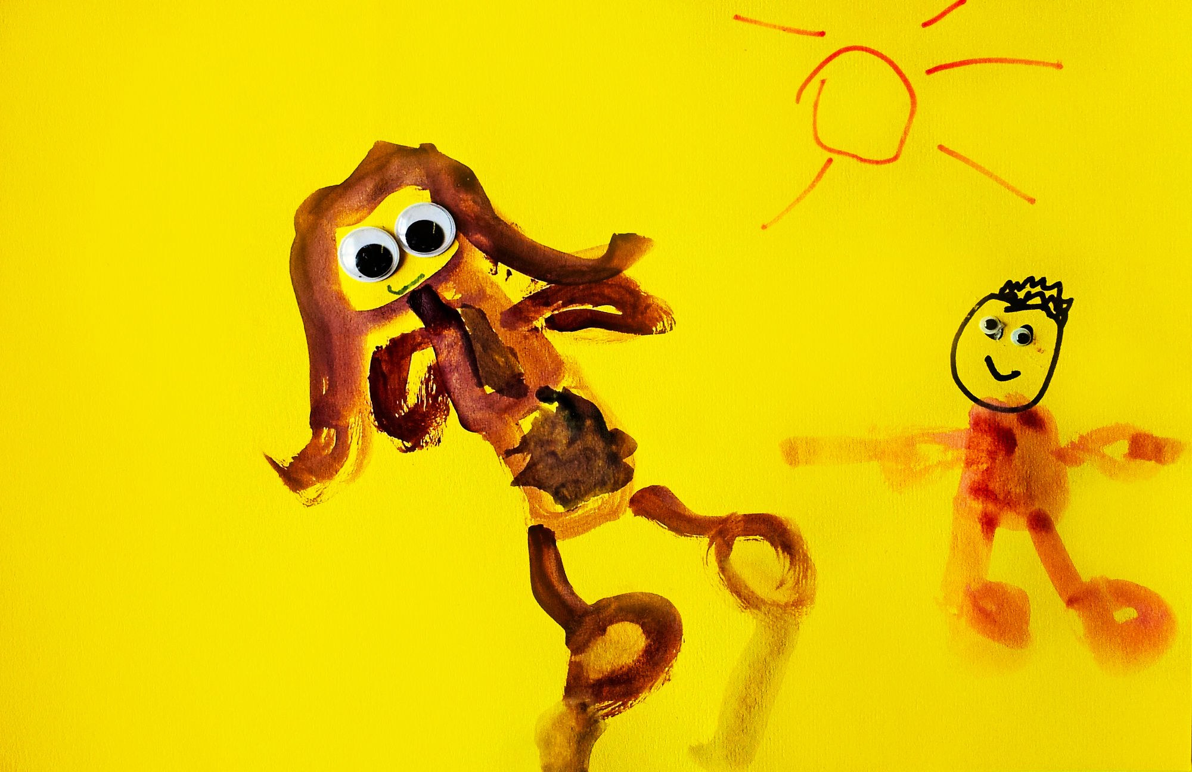
‘Art therapy is a place where you do art about your feelings’ (Child 17, age 5)

In response to the third question; What changed in relation to that - how could you tell art therapy had been helpful for that? The children stated that art therapy brings about the following changes: Calmer, more relaxed (n=15); Happier (n=14); Changed behaviour, less angry (n=7); Helped thinking, learning, listening, concentration (n=6); Helped feelings in general (n=8); More confident (n=5); Less sad, bad, scared feelings (n=5); Felt safer, supported (n=4); Can express feelings more (n=4); Better friendships (n=2); Better art making skills (n=2). Figures 3 and 4 show examples of the children’s statements about changes following art therapy.
Figure 4

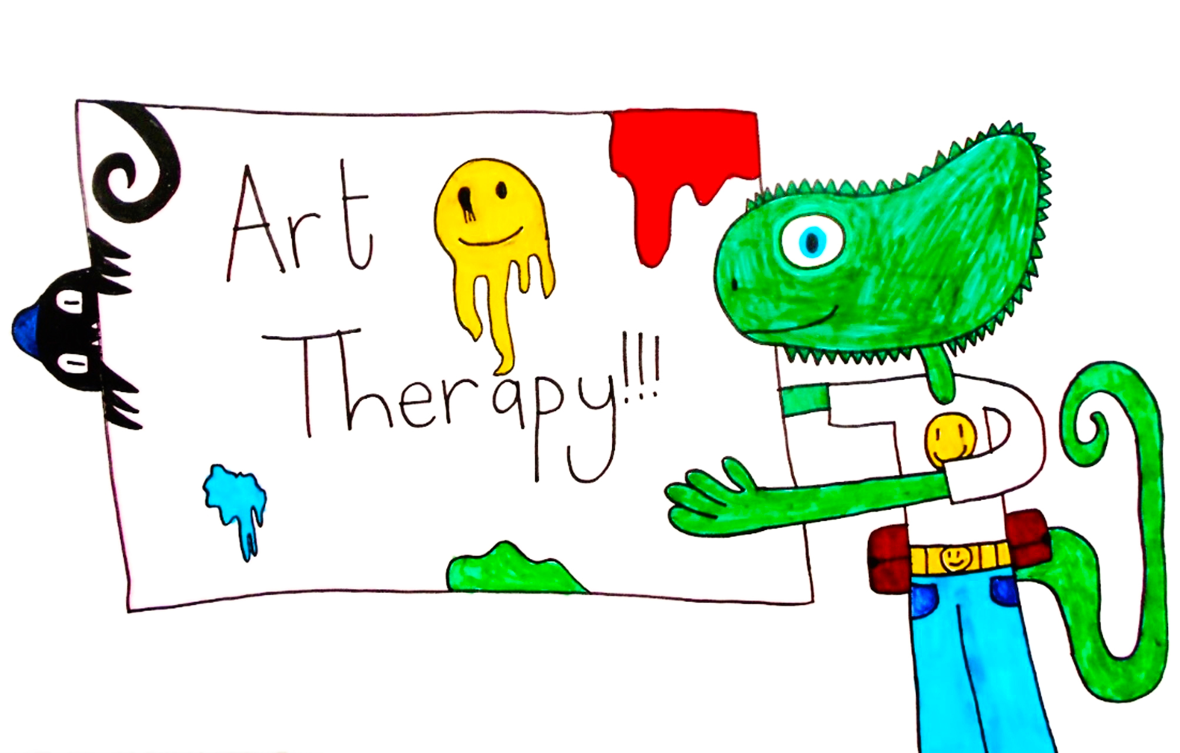
‘Art therapy helps children be calm and think well by talking about what has happened and showing their feelings by making art’. (Child 13, age 11)

Figure 5

‘In art therapy you get to make anything you want. It can help you change your behaviour and calm down’. (Child 7, age 7)

In response to the fourth question; What was it specifically, about your art therapy sessions that was helpful for this? The children stated that they found the following aspects of art therapy helpful: Making, thinking about art (n=26); Expressing, sharing, thinking, learning about thoughts and feelings (n=22); Fun, enjoyable, happy sessions (n=13); The art therapy room e.g. calm, safe, happy, colourful, play tent, regular place to come (n=13); Relationship with art therapist (n=7); Keeping feelings safe, confidential (n=6); Playing (n=5); Non-directive art making (n=4); Developing skills (n=2). Figure 5 and 6 show examples of the children’s statements about the specific aspects of art therapy which they found helpful.
Figure 6

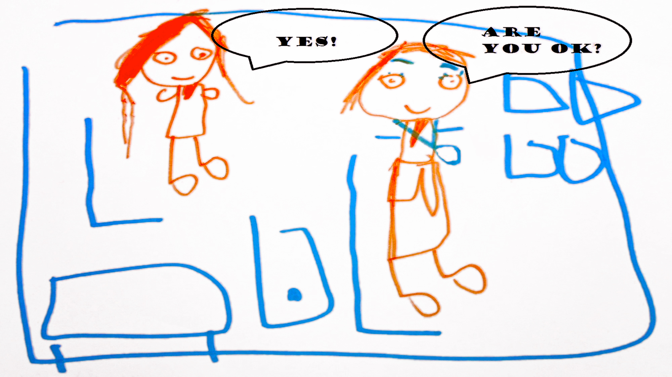
‘Art therapy helps children’s feelings by drawing pictures of what happened and asking them how they feel. Then they can overcome their feelings’. (Child 17, age 6)

Figure 7

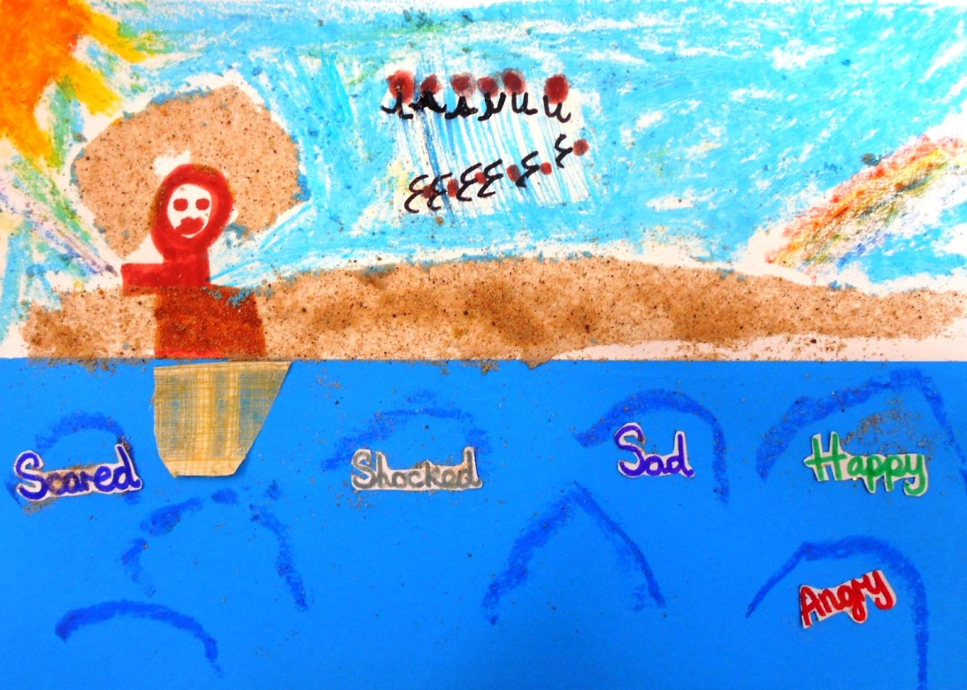
‘Art therapy can help children look after sad feelings about things that happened in their life. When you look at the art you’ve made you can actually see what feelings are in your mind and you can wash them away’ (Child 20, age 8)
Child age 6

Although, at the end of each session, the children were each invited to participate in planning the next, the evaluation interviews did not include the question; would you like to change anything about your art therapy sessions to make them more helpful? until some children had left art therapy. Thus only 24 of the children could respond to this question. These children were interviewed each term so gave numerous answers. However, each child was counted only once within each of the themes. The children stated that they would like to change: Nothing (n=16); Art materials (the children were encouraged to think about different art materials they would like to use in future sessions) (n=9); Don’t know, no answer (n=6); Change overall structure of sessions e.g. change time of session so as not to miss a particular lesson, to stay for more than an hour, to have sessions more frequently (n=5); Change structure within sessions e.g. more time for playing or talking (n=4); Changes to the room e.g. art on the walls, a playground, paint the room pink (n=3); Bring a friend (n=1).
The results of the evaluation interviews with the children have been amalgamated into Table 5 to provide an overview.

Art therapy helpful for (Questions 1 & 2) | n=37 | Perceived changes (Q3) | n=37 | Helpful aspects of art therapy (Q4) | n=37 | Like to change anything? (Q5) | n =  24
Feelings in general | 10 | Calmer, more relaxed | 15 | Making, thinking about art | 26 | Nothing | 16
Anger | 9 | Happier | 14 | Expressing, sharing, thinking, learning about thoughts and feelings | 22 | Art materials (to add to order) | 9
Sad, bad, upset feelings | 8 | Changed behaviour, less angry | 7 | Fun, enjoyable, relaxed, happy sessions | 14 | Don’t know, no answer | 6
Stress, worry, scary feelings | 4 | Helped thinking, learning, listening, concentration | 6 | The art therapy room e.g. calm, safe, happy, colourful, tent, regular place to come | 13 | Change overall structure of sessions e.g. time, length, frequency | 5
Behaviour and confidence | 4 | Helped feelings in general | 8 | Relationship with art therapist | 7 | Change structure within sessions e.g. more time for playing or talking | 4
Learning & concentration | 4 | More confident | 5 | Keeping feelings safe, confidential | 6 | Changes to the room e.g. art on the walls, a playground, paint the room pink | 3
Happy, good feelings | 3 | Less sad, bad, scared feelings | 5 | Playing | 5 | Bring a friend | 1
 |  | Felt safer, supported | 4 | Non-directive art making | 4
 |  | Can express feelings more | 4 | Developing skills | 2
 |  | Better friendships | 2
 |  | Better art making skills | 2

Table 5: Summary of themes from children’s interviews

DISCUSSION

Reasons why children attended art therapy

Although Unhappy or sad feelings appear to have been reported by both teachers and children, there was a huge disparity in relation to Behaviour, which was reported most often by teachers as the reason for referral but only rarely by children. It could be hypothesised that, due to the specific approach to art therapy examined in this study having a particular focus on psychoeducation (Lukens & McFarlane, 2004) and formulation (Johnstone, 2018), children were able to identify the feelings underlying their behaviour during the early stages of art therapy. The way in which the children were able to identify these reasons and articulate subsequent changes would support the theory that there is a perceived link between prior identified therapy aims and subsequent change for child participants (Deboys et al., 2017).

Changes in children’s social, emotional and mental health

There was some synergy between the teacher assessments of children on the SDQ (R. Goodman, 2000) and in the focus group and the children’s reports, with themes from the latter two overlapping with rated changes in difficulties. For example, the changes in behaviour as rated on the SDQ are consistent with the focus group themes of Reduction in disruptive behaviour and Transformation, and the children’s theme of Changed behaviour. These findings are also in accordance with the previous study by Rosal (1993), which suggested positive change regarding difficulties with behaviour following art therapy. These findings also support the main principle of the approach to encourage a move from acting out of experience towards its representation and the theory that this move towards representation and mentalizing is a mechanism which is psychologically protective for the child (Czamanski-Cohen & Weihs, 2016; Fonagy & Bateman,2006). Reduction in hyperactivity also appears consistent with the focus group themes Children using coping strategies learned in art therapy and Children calmer due to art therapy, and the children’s themes of Calmer, more relaxed and Helped thinking, learning, listening, concentration. Improvement in kind and helpful behaviour is also consistent with the focus group themes Relating better with others and Children showing maturity and the children’s theme Felt safer, supported. This positive impact on the children’s lives is also in accordance with children’s statements in past qualitative research (Gersch & Sao Joao Goncalves, 2006).
The relatively small change of SDQ-rated change in emotional distress appears reflected in the focus group themes Residual behaviour problems, Anticipation of further improvement, and Not always transformation/Gradual change. However, the focus group theme Children happier does align with this small change being in the direction one would expect if art therapy were effective, and it was corroborated by nearly half of the children (14 out of 37) making statements which were included in the theme Happier. Similarly, the small effect on SDQ-rated change in difficulties with peer relationships did not correspond with the focus group theme Relating better to others, which included examples given by over half of the teachers. However, only 2 of the 37 children reported perceived changes regarding their friendships. Further research is needed to investigate the reasons for such discrepancies.

Mechanisms of change

Around 70% of the children (n=26) stated that Making and/or thinking about art was the specific aspect of art therapy sessions which they found helpful. This is consistent with the theoretical framework of this approach which places art making as central to the therapeutic process in art therapy (Czamanski-Cohen & Weihs, 2016; Malchiodi & Crenshaw, 2015; Springham & Huet, 2018).
Expressing, sharing, thinking, learning about thoughts and feelings was also a common theme (n=22). The references to thinking as well as expressing may have been due to the specific approach to primary-school-based art therapy being a form of mentalizing-based art therapy (Fonagy & Allison, 2014; Springham et al., 2012) and used psychoeducation (Lukens & McFarlane, 2004) to explain the therapeutic process. Fun, enjoyable, relaxed, happy sessions were also reported to be helpful by 38% (n=14) of the children, which is consistent with the findings by Deboys et al. (2017).

There was also an emerging theme with 35% (n=13) of the children reporting on the art therapy room and naming specific aspects particularly helpful; calm, safe, happy atmosphere; children’s tent; colourful contents; and consistency of a regular place to come to. The potential benefits of an art therapy room have been considered for some time (Wood, 2000) and more recently in research that has been conducted in relation to school-based art therapy (Danieli et al., 2019). However, it is important to note that the art therapy room may not always be so significant for other art therapy services (Coles et al., 2019; Kalmanowitz, 2016).

Of note are the small numbers of children who reported on the relationship with the art therapist. This is consistent with findings by Deboys et al. (2017) who suggest that this could be because the children may lack the developmental ability to adequately describe the impact of the relationship.

Limitations

The study sample was small and from one school and the uncontrolled pre-post design also limits the conclusions that can be drawn about whether art therapy was responsible for the changes in teacher-rated Strengths & Difficulties Questionnaires (SDQ) (R. Goodman, 2000). Indeed, given that art therapy often lasted more than a year, it is possible that some changes were maturational and would have occurred without art therapy. However, the maturing process does require the right conditions to proceed optimally (Toga, Thompson, & Sowell, 2006). Also, the mixed methods design meant that it was possible to triangulate findings across the different data sources, and gain insight into possible mechanisms of change (Pawson, 2013).
The study was not experimental so was limited by a number of practical issues such as the children’s evaluation interviews already being established before the study began and not sufficiently countering bias. In particular, there may have been unrecognised pressure on the children from the school in encouraging public expressions about art therapy, such as a (possibly healthy) culture of pride in the school, of which this may have been a part. This would not necessarily prevent negative comments being recorded, but it might carry assumptions about conveying pride and positivity. Future data collection would need to be clearly independent of such cultures of public showcasing.
The ongoing relationship between the children and the lead art therapist (first author) enabled the collection of rich data on the children’s experiences. However, this also has a possibly less positive aspect, in that some children may not have wished to displease the art therapist, especially if still in therapy. Set against this was the care taken to record children’s perceptions as accurately as possible and the process of checking with them the final statements, with encouragement to disagree or change them. Finally, although the focus group was facilitated by an external senior art therapist who had not previously met the class teachers in order to minimise bias, and thus the art therapist was not present, teachers’ loyalty to the art therapist as co-workers may still have influenced their responses.

Implications for policy and practice
This study highlights perceived positive changes in children’s social, emotional and mental health (SEMH) and thus supports referrals to primary-school-based art therapy for children struggling with these difficulties. It will be helpful for commissioners of Child and Adolescent Mental Health Services (CAMHS) to note these positive changes. Similarly, it will be helpful for schools considering Pupil Premium funding (DfE, 2017a) to also note the positive changes in behaviour and concentration, and the importance children attached to having a calm, safe, regular place to come to for sessions.

The study also highlighted the aspects of art therapy which the children perceived as helpful. It will be helpful for art therapists to note the children’s emphasis on the importance of sessions being fun, enjoyable, and relaxed. And that within sessions the children found it helpful to make and think about art as well as learn and think about thoughts and feelings.

future research
Future research is necessary to further develop the intervention approach and examine clinical effectiveness. The findings from this exploratory study can now be used to inform such future research; development of the intervention approach including more children, parents, teachers and art therapists; development and testing of a logic model of the operationalisation of this embedded approach within primary schools; an examination of which methods and outcome measures would be acceptable and feasible in a full evaluation study on clinical effectiveness.

Further research would benefit from including parent-rated SDQ scores, allowing further triangulation of the findings and a broadening of the study to include the children’s presentation at home as well as in the classroom. Further research on the disparity between the teachers’ reasons for referral and the children’s understanding of their reasons for attending art therapy, is also merited.

Conclusion
This study highlighted indications of perceived positive changes in children’s social, emotional and mental health (SEMH) difficulties and the importance of making and thinking about art in facilitating the expression and processing of such difficulties in art therapy. Future studies are necessary to further develop the intervention approach and to establish clinical effectiveness. However, the promising findings suggest that this approach to primary-school-based art therapy is acceptable to take on to the next phase of research.

References
BAAT. (2016). What is Art Therapy? Retrieved August 9, 2016, from http://www.baat.org/About-Art-Therapy
Boden, Z., & Eatough, V. (2014). Understanding More Fully: A Multimodal Hermeneutic-Phenomenological Approach. Qualitative Research in Psychology, 11(2), 160–177. https://doi.org/10.1080/14780887.2013.853854
Children’s Commissioner. (2017). Children’s Commissioner On measuring the number of vulnerable children in England.
Clarke, V., & Braun, V. (2013, September 2). Teaching thematic analysis: Overcoming challenges and developing strategies for effective learning. The Psychologist. British Psychological Society.
Cobbett, S. (2016). Reaching the hard to reach: quantitative and qualitative evaluation of school-based arts therapies with young people with social, emotional and behavioural difficulties. Emotional and Behavioural Difficulties, 1–13. https://doi.org/10.1080/13632752.2016.1215119
Coles, A., Harrison, F., & Todd, S. (2019). Flexing the frame: therapist experiences of museum-based group art psychotherapy for adults with complex mental health difficulties. International Journal of Art Therapy, 1–12. https://doi.org/10.1080/17454832.2018.1564346
Czamanski-Cohen, J., & Weihs, K. L. (2016). The bodymind model: A platform for studying the mechanisms of change induced by art therapy. The Arts in Psychotherapy, 51, 63–71. https://doi.org/10.1016/J.AIP.2016.08.006
Danieli, Y., Snir, S., Regev, D., & Adoni-Kroyanker, M. (2019). Suitability of the art therapy room and changes in outcome measures in the education system. International Journal of Art Therapy, 1–8. https://doi.org/10.1080/17454832.2018.1564778
Deboys, R., Holttum, S., & Wright, K. (2017). Processes of change in school-based art therapy with children: A systematic qualitative study. International Journal of Art Therapy, 22(3), 118–131. https://doi.org/10.1080/17454832.2016.1262882
DfE. (2016). Primary type of need for pupils with a statement or EHC plan Primary type of need for pupils on SEN support.
DfE. (2017a). Schools, pupils and their characteristics: January 2017.
DfE. (2017b). Supporting Mental Health in Schools and Colleges Summary report.
DHSC, & DfE. (2018). Government Response to the First Joint Report of the Education and Health and Social Care Committees of Session 2017-19 on Transforming Children and Young People’s Mental Health Provision: A Green Paper.
DoH, & DfE. (2017). Transforming Children and Young People’s Mental Health Provision: a Green Paper. https://doi.org/979-1-5286-0061-3
Education and Health and Social, & Care Committees. (2018). The Government’s Green Paper on mental health: failing a generation.
Field, A. (2017). Discovering_Statistics_Using_IBM_SPSS_Statistics. Journal of Chemical Information and Modeling (5th ed., Vol. 53).
Fonagy, P., & Allison, E. (2014). The role of mentalizing and epistemic trust in the therapeutic relationship. Psychotherapy, 51(3), 372–380. https://doi.org/10.1037/a0036505
Gersch, I., & Sao Joao Goncalves, S. (2006). Creative arts therapies and educational psychology: Let’s get together. International Journal of Art Therapy, 11(1), 22–32. https://doi.org/10.1080/17454830600674050
Goodman, A., & Goodman, R. (2011). Population mean scores predict child mental disorder rates: validating SDQ prevalence estimators in Britain. Journal of Child Psychology and Psychiatry, and Allied Disciplines, 52(1), 100–108. https://doi.org/10.1111/j.1469-7610.2010.02278.x
Goodman, R. (2000). Using the Strengths and Difficulties Questionnaire (SDQ) to screen for child psychiatric disorders in a community sample. The British Journal of Psychiatry, 177(6), 534–539. https://doi.org/10.1192/bjp.177.6.534
Goodman, R. (2001). Psychometric Properties of the Strengths and Difficulties Questionnaire. Journal of the American Academy of Child & Adolescent Psychiatry, 40(11), 1337–1345. https://doi.org/10.1097/00004583-200111000-00015
HCPC. (2013). Arts Therapists: Standards of proficiency.
Holttum, S., & Huet, V. (2014). The MATISSE Trial-A Critique: Does Art Therapy Really Have Nothing to Offer People With a Diagnosis of Schizophrenia? SAGE Open, 4(2), 2158244014532930-. https://doi.org/10.1177/2158244014532930
Johnstone, L. (2018). Psychological Formulation as an Alternative to Psychiatric Diagnosis. Journal of Humanistic Psychology, 58(1), 30–46. https://doi.org/10.1177/0022167817722230
Kalmanowitz, D. (2016). Inhabited studio: Art therapy and mindfulness, resilience, adversity and refugees. International Journal of Art Therapy, 21(2), 75–84. https://doi.org/10.1080/17454832.2016.1170053
Karkou, V. (1999). Art therapy in education findings from a nationwide survey in arts therapies. Inscape, 4(2), 62–70. https://doi.org/10.1080/17454839908413078
Khadar, M. G., Babapour, J., & Sabourimoghaddam, H. (2013a). The effect of art therapy based on painting therapy in reducing symptoms of oppositional defiant disorder (ODD) in elementary school boys. Procedia - Social and Behavioral Sciences, 84, 1872–1878. https://doi.org/10.1016/j.sbspro.2013.07.051
Khadar, M. G., Babapour, J., & Sabourimoghaddam, H. (2013b). The Effect of Art Therapy Based on Painting Therapy in Reducing Symptoms of Separation Anxiety Disorder (SAD) in Elementary School Boys. Procedia - Social and Behavioral Sciences, 84, 1697–1703. https://doi.org/10.1016/j.sbspro.2013.07.016
London Borough of Hackney. (2014). A Profile of Hackney, its People and Place, (September), 1–31.
Lukens, E. P., & McFarlane, W. R. (2004). Psychoeducation as Evidence-Based Practice: Considerations for Practice, Research, and Policy. Brief Treatment and Crisis Intervention, 4(3), 205–225. https://doi.org/10.1093/brief-treatment/mhh019
Malchiodi, C. A., & Crenshaw, D. A. (2015). Creative arts and play therapy for attachment problems.
Mathai, John, Anderson, P., & Bourne, A. (2002). The Strengths and Difficulties Questionnaire (SDQ) as a screening measure prior to admission to a Child and Adolescent Mental Health Service (CAMHS). Retrieved April 8, 2015, from file:///C:/Users/alex/Downloads/SDQ as screening measure.pdf
McDonald, A., & Drey, N. S. (2017). Primary-school-based art therapy: a review of controlled studies. International Journal of Art Therapy, 1–12. https://doi.org/10.1080/17454832.2017.1338741
McDonald, A., & Drey, N. S. J. (2018). Primary-school-based art therapy: a review of controlled studies. International Journal of Art Therapy: Inscape, 23(1). https://doi.org/10.1080/17454832.2017.1338741
MRC. (2019). Developing and evaluating complex interventions. Medical research council.
Pawson, R. (2013). The science of evaluation : a realist manifesto. SAGE.
Rohleder, P., & Lyons, A. (2014). Qualitative Research in Clinical and Health Psychology. Palgrave Macmillan.
Rosal, M. L. (1993). Comparative Group Art Therapy Research To Evaluate Changes in Locus of Control in Behaviour Disordered Children. The Arts in Psychotherapy, 20, 231–241.
SDQscore. (2015). SDQ Scoring Site. Retrieved September 19, 2015, from http://www.sdqscore.org/Amber
Snir, S., Regev, D., Keinan, V., Abd El Kader-Shahada, H., Salamey, A., Mekel, D., … Alkara, M. (2018). Art therapy in the Israeli education system – a qualitative meta-analysis. International Journal of Art Therapy, 23(4), 169–179. https://doi.org/10.1080/17454832.2017.1409775
Springham, N., Findlay, D., Woods, A., & Harris, J. (2012). How can art therapy contribute to mentalization in borderline personality disorder? International Journal of Art Therapy, 17(3), 115–129. https://doi.org/10.1080/17454832.2012.734835
Springham, N., & Huet, V. (2018). Art as Relational Encounter: An Ostensive Communication Theory of Art Therapy. Art Therapy, 35(1), 4–10. https://doi.org/10.1080/07421656.2018.1460103
Taylor Buck, E., & Hendry, A. (2016). Developing principles of best practice for art therapists working with children and families. International Journal of Art Therapy, 21(2), 56–65. https://doi.org/10.1080/17454832.2016.1170056
Toga, A. W., Thompson, P. M., & Sowell, E. R. (2006). Mapping brain maturation. Trends in Neurosciences, 29(3), 148–159. https://doi.org/10.1016/j.tins.2006.01.007
UK Government Statistical Service [GSS]. (2018). Mental Health of Children and Young People in England, 2017 Trends and characteristics.
Wood, C. (2000). The significance of studios. Inscape, 5(2), 40–53. https://doi.org/10.1080/17454830008413089

