Abstract
Body posture and configuration provide important visual cues about the emotion states of other people. We know that bodily form is processed holistically, however, emotion recognition may depend on different mechanisms; certain body parts, such as the hands, may be especially important for perceiving emotion. This study therefore compared participants’ emotion recognition performance when shown images of full bodies, or of isolated hands, arms, heads and torsos. Across three experiments, emotion recognition accuracy was above chance for all body parts. While emotions were recognized most accurately from full bodies, recognition performance from the hands was more accurate than for other body parts. Representational similarity analysis further showed that the pattern of errors for the hands was related to that for full bodies. Performance was reduced when stimuli were inverted, showing a clear body inversion effect. The high performance for hands was not due only to the fact that there are two hands, as performance remained well above chance even when just one hand was shown. These results demonstrate that emotions can be decoded from body parts. Furthermore, certain features, such as the hands, are more important to emotion perception than others.

Keywords: Emotion recognition, hands, bodies, body perception

Statement of Relevance (150 words)
Successful social interaction relies on accurately perceiving emotional information from others. Bodies provide an abundance of emotion cues; however, the way in which emotional bodies and body parts are perceived is unclear. We investigated this perceptual process by comparing emotion recognition for body parts with that for full bodies. Crucially, we found that while emotions were most accurately recognized from full bodies, emotions were also classified accurately when images of isolated hands, arms, heads and torsos were seen. Of the body parts shown, emotion recognition from the hands was most accurate. Furthermore, shared patterns of emotion classification for hands and full bodies suggested that emotion recognition mechanisms are shared for full bodies and body parts. That the hands are key to emotion perception is important evidence in its own right. It could also be applied to interventions for individuals who find it difficult to read emotions from faces and bodies.

Introduction
The body is an important vehicle for expressing emotion and perceiving the emotions of others. Though most research on emotion perception has focused on the face, studies have shown that the recognition of emotion from bodies is equally accurate (de Gelder et al., 2015). Indeed, in certain situations, the body may be more important than the face for emotion perception; the perceived valence of a face displaying intense emotion has been shown to change according to the information displayed by the body (Aviezer et al., 2012). Several lines of evidence show similar processing mechanisms for neutral bodies and faces; the recognition of bodies, like faces, is compromised by inversion (e.g., Griffin & Oswald, in press; Reed et al., 2003; Reed et al., 2006) and bodies and faces elicit similar category-selective event-related potentials (Stekelenburg & de Gelder, 2004; Thierry et al., 2006). Further, recent research has posited that shared emotion recognition processes underlie emotion perception across modalities (Peelen et al., 2010; Kuhn et al., 2017). Most studies investigating the bodily expression of emotion, however, have used full body stimuli (e.g., Kret et al., 2011; Van Heijnsbergen et al., 2007), overlooking the contribution of individual body parts. It is unclear, therefore, whether similar mechanisms underlie the visual perception of emotion from full bodies and body parts. Thus, the present study aimed to investigate these mechanisms by comparing emotion recognition from full bodies with isolated body parts.
A parallel literature has investigated whether emotional faces are recognized as a result of holistic or analytic mechanisms (Meaux & Vuilleumier, 2016). The term holistic connotes processing which relies on the integration of features into a gestalt, whereas analytic processing depends on the encoding of individual features (Maurer et al., 2002). The operation of holistic processing in facial expression recognition is supported by studies which show reduced emotion recognition for aligned composite faces (which present emotionally incongruent information above and below the eyes) compared with misaligned composite faces (Calder et al., 2000). That this effect is disrupted when composite faces are inverted further supports the notion that emotional faces are processed holistically (Calder & Jansen, 2005). However, studies have also shown that facial features delineate distinct emotional expressions. The eyes and the mouth, for example, are relied on more heavily than other areas of the face in emotion recognition (Wegrzyn et al., 2017) and specific facial features are used by observers to identify particular emotions, such as the mouth for happiness and the eyes for anger (Smith et al., 2005). Recent research supports a dual-code view, in which both holistic and analytic processes interact differently, according to the emotion displayed (Meaux & Vuillemier, 2016).
The relationship between the mechanisms involved in processing emotional full bodies and body parts has, to date, been neglected; however, a small amount of research has shown that individual body parts do contribute to emotion perception. For example, observers are more sensitive to angry facial expressions when the head is directly facing them, rather than turned away, but they are more sensitive to averted than direct fearful expressions (Hess et al., 2007). Natural arm movements can be characterised by dimensions of activation and pleasantness (Pollick et al., 2001). Finally, isolated hand movements can be perceived as neutral or angry and elicit distinct fMRI responses, depending on the emotion displayed (Grosbras & Paus, 2006).
Just as the mouth and eyes are more important for facial emotion recognition than other features (Wegrzyn et al., 2017), it may be the case that certain body parts are more important in the communication of emotion than others, and this may also vary for different emotions. Looking at the hands may be particularly important to extract information about a range of behaviors. Gross and colleagues famously reported a single neuron in the monkey inferotemporal cortex which showed strong selectivity to hand shaped stimuli (Gross, Bender, & Rocha-Miranda, 1969). Consonant with this, Bracci et al. (2010) used functional magnetic resonance imaging (fMRI) to demonstrate separable representations of hands and full bodies in the left lateral occipitotemporal cortex and the extrastriate body area respectively. Furthermore, an analysis of footage taken from head cameras worn by babies in the first two year of their lives showed that the likelihood of hands featuring in scenes increased with age, while the likelihood of faces appearing decreased (Fausey et al., 2016). This suggests that visual processing develops to optimize the information provided by both hands and faces (Fausey et al., 2016). Finally, and intriguingly, Slepian et al. (2013) showed that observers are able to gauge the quality of a professional poker player’s poker-hand from their hand and arm movements, while facial cues are deceptive.
A recent study investigated the contribution of the arms and hands to emotion recognition by erasing them from images of full bodies (Ross & Flack, 2020). When both the arms and hands were absent from full body images, emotion recognition accuracy for fearful, angry, happy and sad postures dropped. Furthermore, the absence of just the hands reduced recognition accuracy of fearful and angry postures. Thus, an absence of information from the hands and arms has been shown to negatively affect emotion recognition accuracy. However, it is unclear whether removing these parts simply disrupts holistic processing of the body as a whole, or whether local information from isolated body parts itself could be sufficient for emotion recognition.
Accordingly, we compared emotion recognition accuracy for isolated images of hands, arms, heads and torsos with that for full bodies. We predicted, first, that people would be able to recognize emotions at above chance levels from images of isolated body parts, especially for hands. Second, because neutral bodies are perceived holistically (Reed et al., 2003; Reed et al., 2006), and full bodies present more information than isolated parts, we expected emotion recognition from full bodies to be more accurate than emotion recognition from body parts. Finally, in accordance with evidence that suggests that the hands are perceptually important (Bracci et al., 2010; Bracci et al., 2018; Fausey et al., 2016), we expected emotion recognition from the hands to be more accurate than that from the arms, heads, and torso.

Experiment 1

Method
Participants
One hundred adults (55 female), recruited from the social network of the researchers (N=3) and from the Prolific web platform (www.prolific.co; N=97), took part in this study. Ages were recorded for 99 of these participants (M = 35.55 years, SD = 12.65). The key statistical test in Ross and Flack’s (2020) study, the F-test comparing the different body parts, showed a large effect size (η_{p}² = .459). A power analysis using G*Power 3.1 (Faul et al., 2007) using this effect size, power of .8, and an alpha of .05, indicated that only 5 participants were required. As we suspected that the effect size for classifications of individual body parts would be smaller than that, we tested a substantially larger sample, which would give us power greater than .80 to detect an effect even one fifth that size. Handedness was assessed using a self-report questionnaire; 83 participants were right-handed, 13 were left-handed, and 4 were ambidextrous. Participants were physically located in the UK and had normal, or corrected to normal, vision. They were each paid for taking part. The study was approved by the Department of Psychological Sciences Research Ethics Committee at Birkbeck, University of London.

Stimuli
Front facing images of ten actors (seven female), each portraying six emotions (anger, fear, happiness, sadness, disgust and surprise), were taken from the Bochum Emotional Stimulus Set (BESST), an open-source resource featuring static images of 85 untrained Caucasian actors portraying differing emotions (Thoma et al., 2013). To create these images, Thoma et al. (2013) asked the actors to enact everyday scenarios designed to evoke one of the six featured emotions. Each emotion condition was photographed from front and side angles (camera positioned 45 degrees to the left) (Thoma et al., 2013), but here only front-facing images were used, as these have been shown to lead to more consensual emotion attributions than lateral views (Coulson, 2004). The actors were wearing black trousers and black t-shirts. Thoma et al. (2013) covered the facial expressions of these actors with grey masks so that emotion is only evident from body expressions. They presented the images in grayscale on a white background using a pixel resolution of 300 x 300 (Thoma et al., 2013).
Ten BESST actors (5, 7, 8, 10, 13, 23, 39, 53, 58 and 85) were chosen for use in the present study as their hands, arms, torsos and heads were, for the most part, unobscured by other body parts. The GNU Image Manipulation Program (GIMP) was used to prepare separate images of the hands, arms, head and torso for each of the 60 original full body images, resulting in an additional 240 images. Images of hands included wrists, arms ran from the shoulder to the wrist and images of heads included the neck. Torsos featured the trunk of the body from the waist upwards, with the hands, arms, neck and head removed (Figure 1). Where it was not practicable to separate individual body parts from others (i.e., hands from arms), the body part which was not the focus of the image was covered by a grey mask. There were 300 stimuli in total.
Stimuli were presented using Gorilla Experiment Builder (https://gorilla.sc/) (Anwyl-Irvine et al., 2020). Participants completed the experiment using their own tablet or computer (mobile phones were not permitted), in their chosen environment. Stimulus sizes varied for each participant according to screen size.
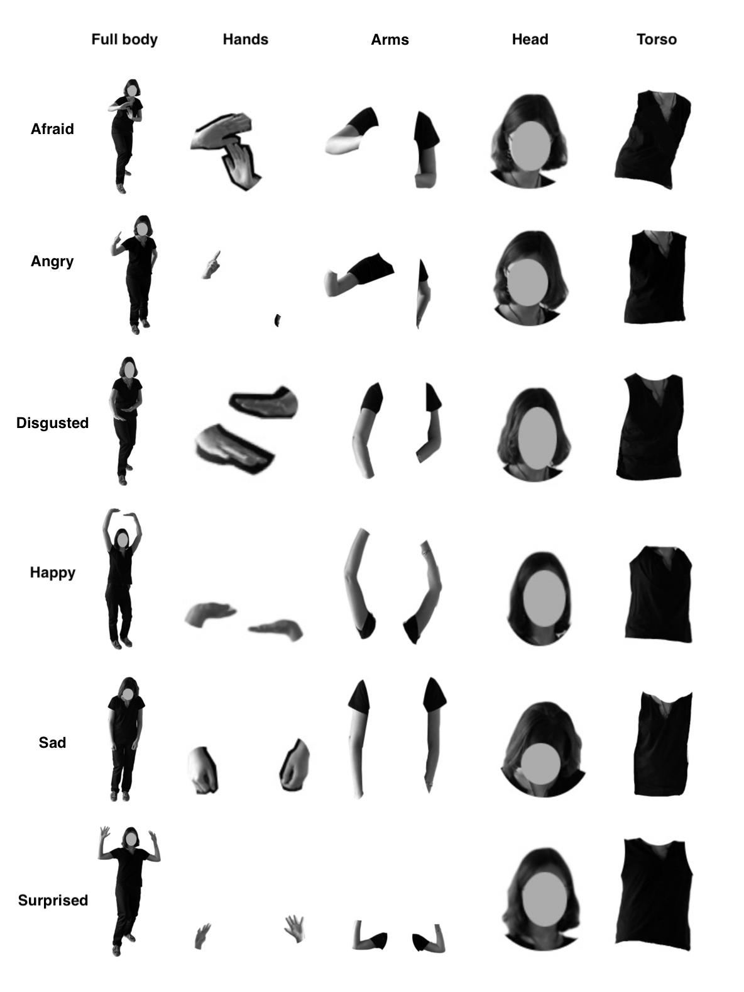
Figure 1: Example of one complete stimulus set, featuring full body, arms, hands, head and torso conditions for each of the six basic emotions. Note that the sizes of these stimuli are not to scale; the body parts were presented at the same scale in the full-body and isolated parts conditions, but have been magnified in this figure. Stimuli were modified from the BESST (Thoma et al., 2013), CC BY-ND 3.0, and are shown here with the permission of the first author.

Design
A within-subjects design was used, in which participants viewed images featuring six emotion conditions (afraid, angry, disgusted, happy, sad and surprised), and five types of body condition (full body, arms, hands, head and torso). Had participants viewed full body images and body parts from the same actors, emotion recognition in the body part conditions may have been influenced by prior presentation of the full body images. For this reason, participants were randomly allocated to two counterbalanced groups. A first group (50 participants) viewed full body images of half of the actors and individual body parts of the other half of the actors, while a second group (50 participants) viewed the full body images and individual body part images not seen by the first group. Participants made judgements about the emotion portrayed in the images.

Procedure
Individual trials began with a fixation cross, presented for either 200ms, or 450ms at random, followed by stimulus presentation. Stimuli were presented on a white background above six rectangular grey screen zones (buttons), which were labelled with six emotions: afraid, angry, disgusted, happy, sad and surprised (Figure 2). Participants were instructed to examine the image presented on the screen and select one of these buttons to indicate which emotion best described how the person depicted in the image was feeling. Participants were randomly allocated to one of two counterbalanced button conditions. Half of the participants always viewed and selected from the forced-choice emotions displayed from left to right across the screen as follows: surprised, happy, sad, afraid, angry, disgusted. The other half always viewed the emotions in the following order (left to right): afraid, angry, disgusted, surprised, happy, sad. Stimuli remained on the screen until participants had made a judgement about the depicted emotion. A fixation cross appeared immediately after each decision. Each participant viewed 150 stimuli, in two blocks of 75 stimuli each, presented in a random order. The stimuli consisted of 30 full body images, 30 pairs of hands, 30 arms, 30 heads and 30 torsos. For each of these 30 images, 5 images depicted each of the six basic emotions. The experiment took approximately fifteen minutes to complete.
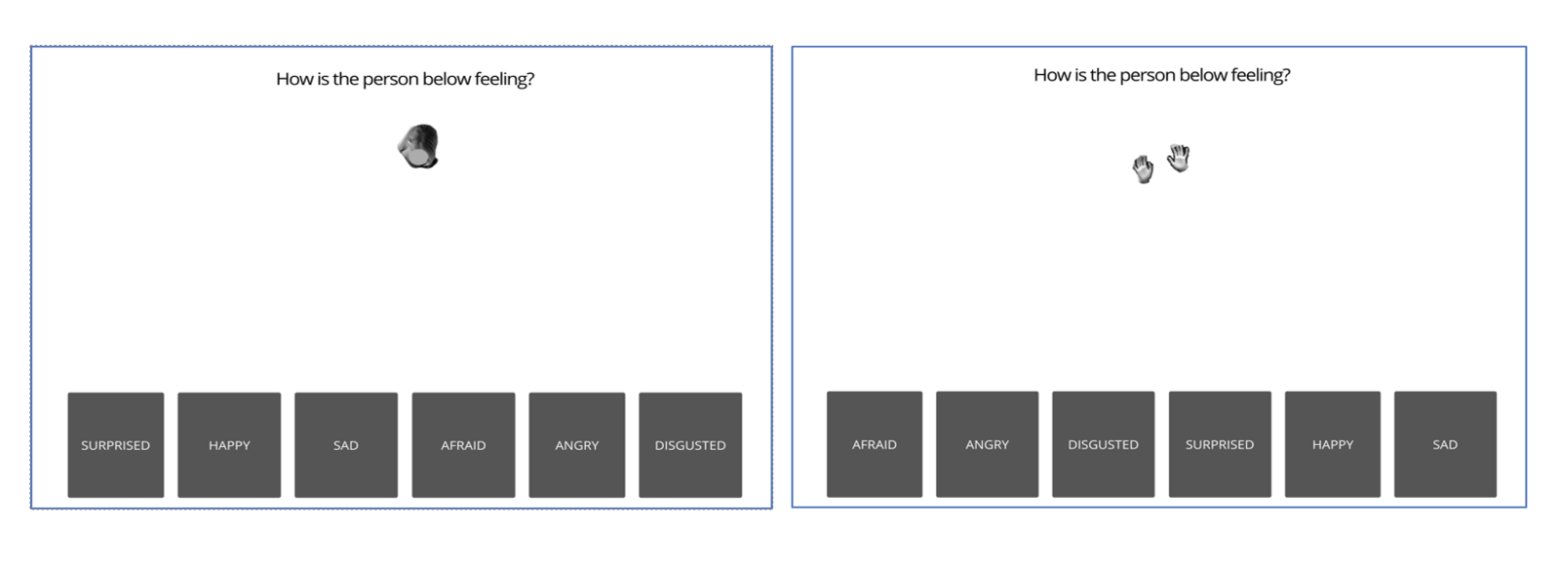
Figure 2: Two examples of stimulus presentation with forced-choice buttons below. The participant was shown a stimulus of either a full body or an isolated body part and asked to classify the emotion felt by the person by clicking one of six buttons (surprised, happy, sad, afraid, angry, or disgusted). The order of these buttons was counterbalanced across two groups of participants.

Results and Discussion
Emotions Can be Classified from Isolated Body Parts
We first investigated whether participants could successfully classify emotions from isolated body parts. We calculated the average percentage accuracy of correct responses for each participant, collapsing across the six emotions depicted (afraid, angry, disgusted, happy, sad and surprised) (Figure 3). Collapsing across the different emotions avoids potential emotion attribution biases, such as difficulties with recognising fear, or tendencies towards misclassifying anger (Kret & de Gelder, 2013). Any bias to judge ambiguous emotions as having one specific emotion (e.g., happy) could make accuracy for that emotion appear artificially high, which artificially reducing accuracy for other body parts. Since there are the same number of trials of each of the six emotions, a bias to respond “happy” cannot produce above-chance performance overall, as the increased accuracy on happy trials will be balanced by decreased accuracy on the other five emotions. For example, at the extreme that the participant responds “happy” on every trial, their accuracy would be exactly at chance. Bias here will shift performance in the direction of chance, but critically cannot produce above chance performance.
For each stimulus type, we used a one sample t-test to compare performance with the likelihood that participants selected the correct forced-choice emotion by chance (i.e., 1/6 = 16.67%), using the Holm-Bonferroni correction for multiple comparisons. Accuracy was higher than chance for full-bodies (M = 64.7, 95% CI[62.2, 66.8]), t(99) = 41.49, p < .001, d = 4.149, though somewhat less than the 85.8% accuracy for these same images in the study of Thoma and colleagues (2013). Critically, performance was also above-chance for individual body parts, including the hands (M = 50.1, 95% CI[47.6, 52.7]), t(99) = 26.31, p < .001, d = 2.631; arms (M = 33.0, 95% CI[30.9, 35.1]), t(99) = 15.29, p < .001, d = 1.529; heads (M = 28.1, 95% CI[26.8, 29.4]), t(99) = 17.15, p < .001, d = 1.715; and torsos (M = 18.1, 95% CI[17.0, 19.3]), t(99) = 2.53, p = .013, d = 0.253. These results demonstrate that isolated body parts contain enough information for participants to successfully identify emotions.
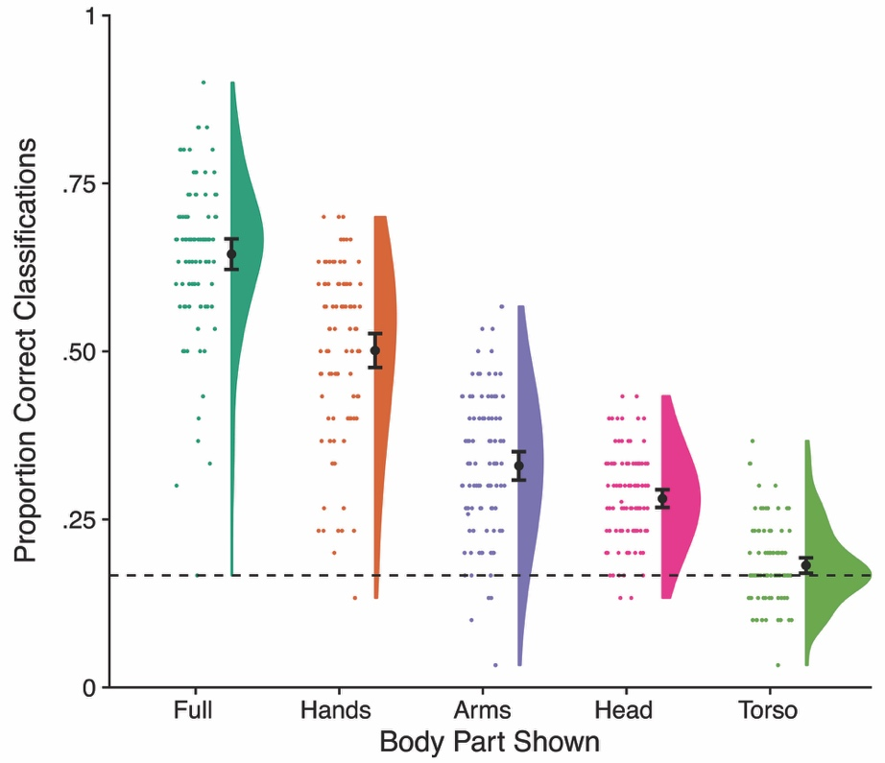
Figure 3: Classification accuracy for each of the stimulus types, shown using raincloud plots (Allen et al., 2021) made in R 4.1.1. Points show data from individual participants, while curves show the probability density function. The dashed horizontal line indicates chance performance (i.e., 1/6 = .167). Black circles indicate the mean and error bars the 95% confidence interval. Classification was most accurate for full body stimuli, but was significantly above chance for each of the individual body parts.

To compare emotion recognition accuracy across body parts, we conducted a one-way repeated measures ANOVA with body-part condition (full body, arms, hands, head, and torso) as the within-subjects variable, using JASP software (JASP Team, 2022). As Mauchly’s test showed that the assumption of sphericity had been violated, the Huyhn-Feldt correction was applied. There was a significant main effect of body condition, F(3.70, 366.43) = 513.75, p < .001, η_{p}² = .838. Post-hoc pairwise comparisons, using the Holm-Bonferroni correction for multiple comparisons (10 comparisons), showed significant differences between each pair of body parts (all ps = < .001). Unsurprisingly, recognition in the full body condition was significantly higher than in the four body part conditions. More interestingly, accuracy was higher for the hands than for the arms, t(99) = 14.28, p < .001, d_{z} = 1.428; head, t(99) = 17.18, p < .001, d_{z} = 1.718; or torso, t(99) = 26.02, p < .001, d_{z} = 2.602.

Accuracy with the Hands is Not an Artefact of Emblematic Gestures
One potential reason why emotions might be recognized better from hands than for other body parts is the presence of emblems, hand gestures with conventional meanings (Goldin-Meadow, 1999). Three of the stimuli in the present study are potential hand emblems. One of these images showed a fist pressed against an open palm, demonstrating anger. Two were thumbs up gestures, demonstrating positivity. The results for these three stimuli were removed from the dataset and the analysis was repeated. Emotion recognition accuracy scores for the hands condition without the gestures (M = 48.0, 95% CI[45.4, 50.6]) was modestly lower than with them, t(99) = 14.80, p < .001, d = 1.480.
Critically, however, results with the emblems excluded were similar to the previous analyses, showing that the pattern of results reported above is not due to the presence of hand emblems. Accuracy for the remaining hands was again above chance (M = 48.0, 95% CI[45.4, 50.6]), t(99) = 24.20, p < .001, d = 2.420. An ANOVA showed clear differences between body parts, F(3.69, 365.48) = 484.12, p < .001, η_{p}² = .830. Post-hoc comparisons using the Holm-Bonferroni correction for multiple comparisons showed that this significant main effect reflected significant differences in recognition accuracy between all five body conditions (all ps = < .001). Therefore, even without emblems, emotion recognition accuracy in the hands condition remained significantly higher than in the arms condition, t(99) = 12.21, p < .001, d_{z} = 1.221, head condition, t(99) = 15.19, p < .001, d_{z} = 1.519 and torso condition, t(99) = 23.73, p < .001, d_{z} = 2.373.

Analysis of Reaction Times
To analyse reaction times (RT), we calculated mean RT separately for correct and incorrect trials for each body part for each participant, excluding individual trials where RT was greater than 10 sec (1.89% of trials). These data are shown in Table 1. An ANOVA showed a significant main effect of accuracy, F(1, 98) = 85.01, p < .001, η_{p}² = .462, with faster RTs on correct than on incorrect trials. There was also a main effect of body part, F(2.97, 293.61) = 40.70, p < .001, η_{p}² = .291, which was modulated by a significant interaction of body part and accuracy, F(4, 396) = 14.79, η_{p}² = .130.
This significant interaction indicates that the difference in RT between correct and incorrect trials itself differs between body parts. To explore this effect, we calculated the reduction in RT on correct trials (i.e. incorrect – correct) separately for each body part, as shown in the bottom row of Table 1. There were significant speedups with accuracy for full bodies, t(99) = 10.48, p < .0001, d_{z} = 1.048; hands, t(99) = 7.41, p < .0001, d_{z} = 0.741; arms, t(99) = 3.99, p < .0001, d_{z} = 0.399; and heads, t(99) = 3.39, p < .001, d_{z} = 0.339. In contrast, there was no significant speedup for torsos, t(99) = 0.74, p = .462, d_{z} = 0.074.
Table 1: Mean (and SD) of Reaction Times (sec) in Experiment 1
 | Full | Hands | Arms | Head | Torso
Correct | 2.334 (0.548) | 2.492 (0.626) | 2.483 (0.758) | 2.095 (0.667) | 2.207 (1.105)
Incorrect | 3.034 (0.911) | 2.997 (0.978) | 2.779 (0.965) | 2.308 (0.854) | 2.265 (0.975)
RT Difference | 0.700 (0.668) | 0.505 (0.681) | 0.296 (0.742) | 0.213 (0.629) | 0.057 (0.773)

Representational Similarity Analysis of the Pattern of Confusions
Finally, in order to probe the underlying representational structure, we investigated the patterns of confusions between different emotions for the different body parts. Figure 4 shows mean confusion matrices for each of the five image types, generated using MATLAB (Mathworks, Natick, MA). These matrices show similar recognition patterns in the full body and the hand conditions: happiness, fear, sadness and anger were recognised with a high degree of accuracy, while disgust was regularly confused with fear in both full body and hand conditions. The confusion matrices for the other body parts seem less similar to the matrix for full bodies. In the head condition, sadness was recognised accurately in a high proportion of the relevant trials, whilst happiness was recognised moderately accurately, but was mistaken for surprised to a similar extent. A similar, but less marked pattern was seen in the arms condition. The confusion matrices for the head and torso conditions showed a marked tendency to judge all emotions as happy, and to a lesser extent as sad. This may reflect happiness and sadness being the conceptually most simple emotions, meaning that they are the most natural default in conditions where participants are uncertain about the emotion displayed.
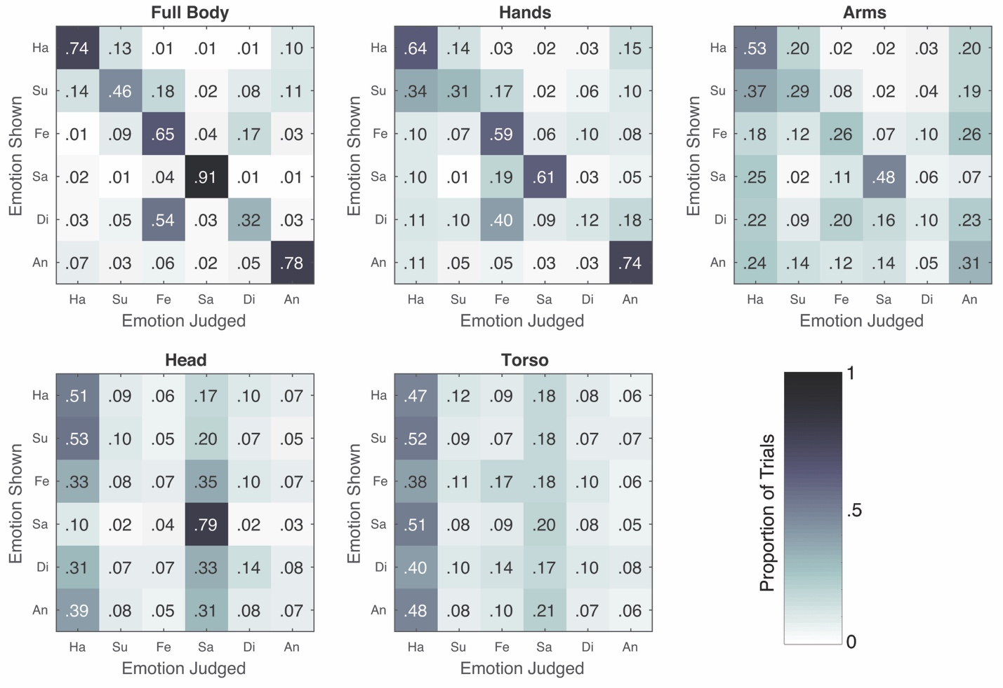
Figure 4: Confusion matrices for each body part condition. Every cell shows the proportion of trials in which each emotion judgement (x axis) was made for each of the displayed emotions (y axis), averaged across all 100 participants. Ha = happy, Su = surprised, Fe = fear/afraid, Sa = sad, Di = disgusted, An = angry.

To quantify these effects, we used representational similarity analysis (Kriegeskorte et al., 2008) to assess the similarity of the patterns of confusions across pairs of body parts. For each participant and each pair of body parts, we calculated the Pearson’s correlation between the 30 off-diagonal elements (i.e., the errors). A representational similarity matrix showing the similarities of confusion matrices between each pair of body parts is presented in the left panel of Figure 5. In order to compare each of the four isolated body parts to the full body, we conducted a more focused analysis on the top row of this representational similarity matrix (Figure 5, right panel). One-sample t-tests comparing the mean Fisher-transformed correlations to 0, provided evidence that confusions were systematically related to those seen in the whole body for both hands (M = .389), t(99) = 13.57, p < .001, d = 1.357, and arms (M = .146), t(99) = 6.89, p < .001, d = 0.689, but not for the head (M = .006), t(99) = 0.34, p = .738, d = .034, or the torso (M = .008), t(99) = 0.35, p = .727, d = .035.

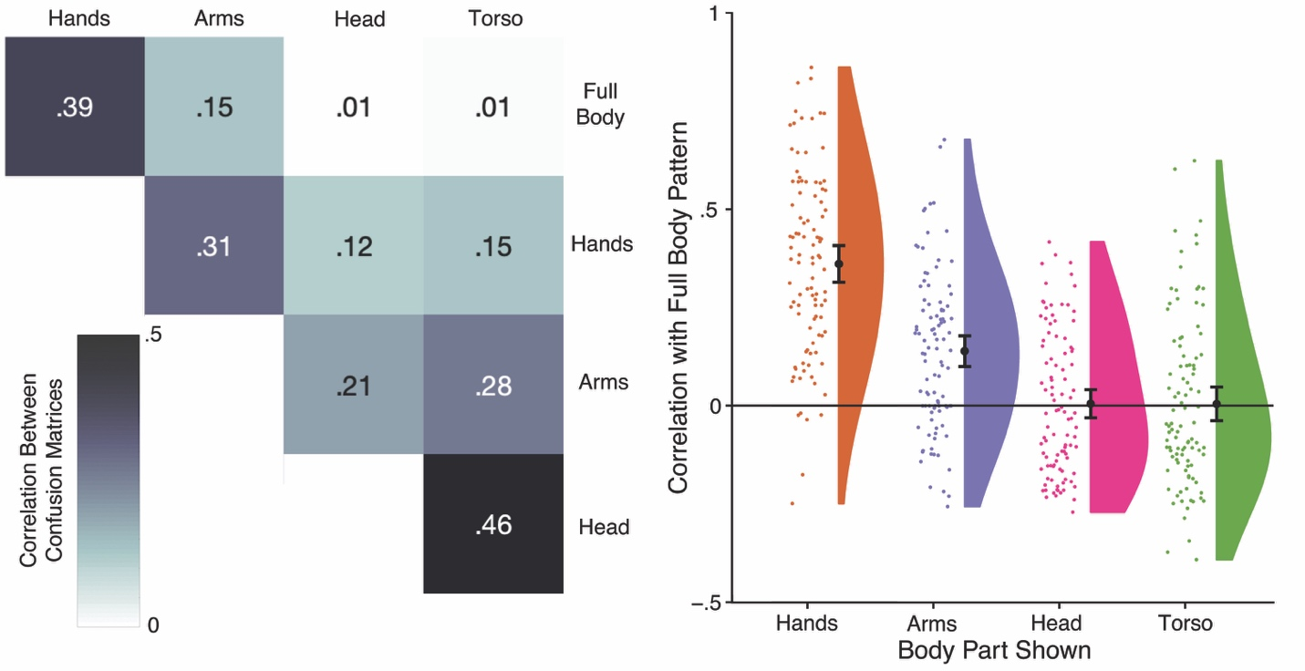
Figure 5: Representational similarity analysis of confusions between emotions. Left panel: Mean correlations between the off-diagonal elements of confusion matrices for pairs of stimulus types. Right panel: raincloud plots showing the correlation of each isolated body part with the pattern of confusions for full body stimuli (i.e., the top row of the matrix in the left panel); each dot shows correlation for one participant.

An ANOVA showed clear differences between these four body parts, F(2.53, 250.60) = 76.62, p < .001, η_{p}² = .436. Post-hoc t-tests comparing each pair of body parts, using the Holm-Bonferroni correction for multiple comparisons, showed that the pattern of confusions for the hands was more similar to the full bodies than was either the arms, t(99) = 7.55, p < .001, d_{z} = 0.755, the head, t(99) = 11.46, p < .001, d_{z} = 1.146, or the torso, t(99) = 11.56, p < .001, d_{z} = 1.156. Correlations were also higher for the arms than for either the head, t(99) = 5.38, p < .001, d_{z} = 0.219, or the torso, t(99) = 4.81, p < .001, d_{z} = 0.481, which did not differ from each other, t(99) = 0.08, p = .935, d_{z} = 0.008.

Experiment 2

In face perception, extensive research has investigated the impairments in perception when faces are inverted (e.g., Yin, 1969; Diamond & Carey, 1986). Such inversion effects are considered a key sign of holistic or configural processing (Maurer et al., 2002). Several studies have shown that inversion also disrupts recognition of emotional expressions in faces (e.g., McKelvie, 1995; Prkachin, 2003; Bombari et al., 2013). Inversion effects have also been reported for bodies, for a range of judgments, including of body posture (Reed et al., 2003, 2006), identity (Robbins & Coltheart, 2012; Cazzato, Walters, & Urgesi, 2021), size (Walsh, Vormberg, Hannaford, & Longo, 2018), attractiveness (Cook & Duchaine, 2011), and orientation (Bernard et al., 2012; Schmidt & Kistemaker, 2015). Of particular relevance here, body inversion effects have also been reported for emotional expressions, for stimuli including still photographs (Thoma et al., 2020), movies (Atkinson, Tunstall, & Dittrich, 2007; Zieber, Kangas, Hock, & Bhatt, 2014), and point-light displays (Dittrich, Troscianko, Lea, & Morgan, 1996; Clarke, Bradshaw, Field, Hampson, & Rose; Atkinson et al., 2007). We therefore conducted an experiment to investigate whether similar inversion effects occur for isolated body parts. Experiment 2 was identical to Experiment 1 except that stimuli were inverted.

Methods
Participants
One hundred adults (61 female) were recruited from Prolific. Participants ranged from 18 to 69 years of age (M = 36.2 years, SD = 11.6). None had participated in Experiment 1. The sample size was designed to exactly match that of Exp 1. Handedness was assessed using a self-report questionnaire; 84 participants were right-handed, 10 were left-handed, and 4 were ambidextrous. Participants were physically located in the UK and had normal, or corrected to normal, vision. They were each paid for taking part.

Stimuli and Procedure
All stimuli procedures were identical to Experiment 1 except that stimuli were rotated by 180°.

Results and Discussion
Emotions Can be Classified from Isolated Body Parts, Even When Inverted
As in Exp 1, we first compared classification accuracy for each body part to chance performance, collapsing across the six emotions depicted, as shown in Figure 6. Accuracy was again higher than chance for full-bodies (M = 55.4%, 95% CI[52.8, 58.1]), t(99) = 28.62, p < .0001, d = 2.862. Similarly, performance was again higher than chance levels for individual body parts, including hands (M = 37.7%, 95% CI[35.1, 40.3]), t(99) = 16.09, p < .0001, d = 1.609; arms (M = 28.0%, 95% CI[26.1, 29.9]), t(99) = 11.72, p < .0001, d = 1.172; and heads (M = 21.2%, 95% CI[19.8, 22.5]), t(99) = 6.46, p < .0001, d = 0.646. Performance for torsos was not significantly different from chance (M = 15.8%, 95% CI[14.6, 16.9]), t(99) = -1.51, p = .134. These results replicate the finding from Experiment 1 that participants can classify emotion accurately from isolated body parts, and show further that this is true even when the stimuli are inverted.
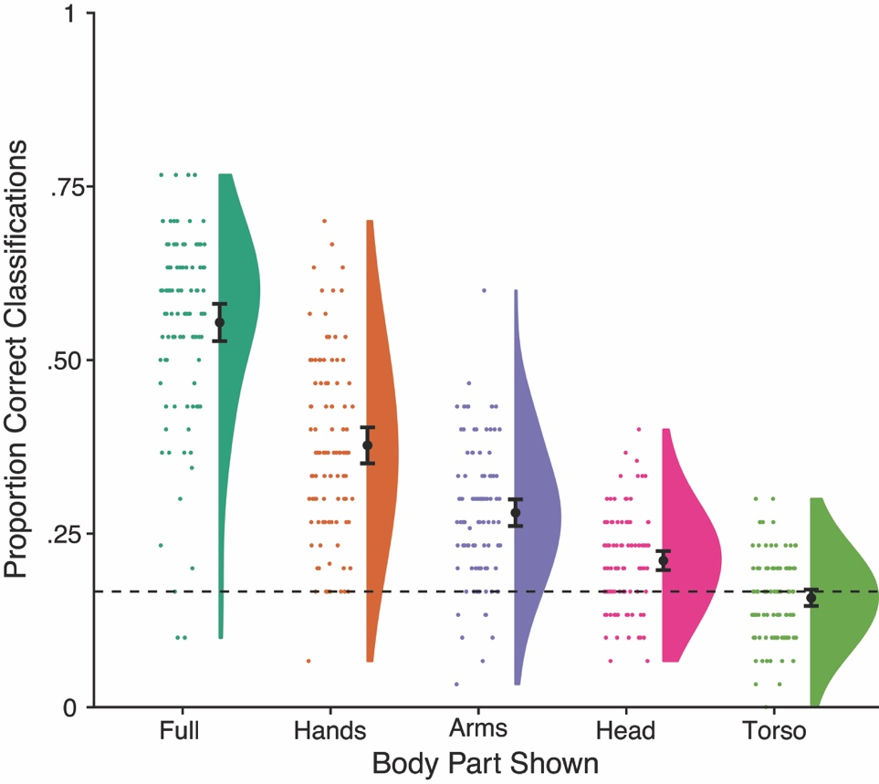
Figure 6: Classification accuracy for each of the stimulus types when inverted in Experiment 2. Performance was above chance for full bodies, as well as for hands, arms, and heads. However, performance was significantly reduced compared to Exp 1 in which stimuli were upright. Error bars are 95% confidence intervals.

A one-way ANOVA on accuracy showed that performance differed significantly across body parts, F(3.41, 337.73) = 306.61, p < .0001, η_{p}² = .756. Post-how pairwise comparisons, using the Holm-Bonferroni correction (10 comparisons), showed significant differences between each pair of body parts (all ps < .001). As in Experiment 1, accuracy was higher for full body stimuli than for any of the individual parts and, more interestingly, for the hands than for arms, t(99) = 8.13, p < .0001, d_{z} = 0.813; heads, t(99) = 11.69, p < .0001, d_{z} = 1.169; or torsos, t(99) = 15.23, p < .0001, d_{z} = 1.523.
We next compared the results from upright stimuli in Exp 1 and inverted stimuli in this experiment using a mixed ANOVA with body parts as a within-subjects factor and orientation as a between-subjects factor. As in both orientations individually, there was a significant main effect of body part, F(3.52, 696.03) = 791.21, p < .0001, η_{p}² = .800. More importantly, there was a significant main effect of orientation, F(1, 198) = 59.10, p < .0001, η_{p}² = .230, with lower accuracy for inverted than for upright stimuli. There was also a significant interaction of body part and orientation, F(3.52, 696.03) = 10.15, p < .0001, η_{p}² = .049. Inversion produced reductions in classification accuracy for all five types of stimuli: full bodies, t(198) = 5.09, p < .0001, d = 0.720; hands, t(198) = 6.81, p < .0001, d = 0.963; arms, t(198) = 3.43, p < .001, d = 0.485; heads, t(198) = 7.29, p < .0001, d = 1.030; and torsos, t(198) = 2.85, p < .005, d = 0.403.

Analysis of Reaction Times
Reaction times were calculated as in Experiment 1 (2.37% of trials excluded as outliers for being > 10 sec), and are shown in Table 2. One participant was excluded from analyses as they had no correct trials for torso stimuli, so RT could not be calculated. An ANOVA showed a significant main effect of accuracy, F(1, 98) = 47.35, p < .001, η_{p}² = .326, with faster RTs on correct than on incorrect trials. There was also a main effect of body part, F(3.33, 326.40) = 83.18, p < .001, η_{p}² = .459, which was modulated by a significant interaction of body part and accuracy, F(4, 392) = 16.68, η_{p}² = .145.
We again explored this interaction by comparing the speedup for correct responses for each body part separately. There were significant speedups for correct trials for full bodies, t(98) = 9.71, p < .0001, d_{z} = 0.971; hands, t(98) = 2.76, p < .01, d_{z} = 0.276; and arms, t(98) = 3.60, p < .0005, d_{z} = 0.360. In contrast, there was no significant speedup for heads, t(98) = 1.50, p = .137, d_{z} = 0.150; or torsos, t(98) = -0.56, p = .577, d_{z} = 0.056.

Table 2: Mean (and SD) of Reaction Times (sec) in Experiment 2
 | Full | Hands | Arms | Head | Torso
Correct | 2.495 (0.896) | 2.539 (1.034) | 2.280 (0.946) | 1.982 (0.906) | 1.927 (1.142)
Incorrect | 3.146 (1.198) | 2.738 (1.153) | 2.513 (1.175) | 2.073 (1.003) | 1.891 (0.919)
RT Difference | 0.650 (0.670) | 0.199 (0.722) | 0.232 (0.645) | 0.091 (0.603) | -0.036 (0.644)

Representational Similarity Analysis of the Pattern of Confusions
Confusion matrices for Exp 2 are shown in Figure 7. The patterns are very similar to those seen in Exp 1 with upright stimuli. To quantify this similarity, we calculated the correlation between the 30 off-diagonal elements (i.e., the errors) for the grand mean confusion matrices in the two experiments, separately for each body part. These showed a very high correspondence for full bodies, r(28) = .973, p < .0001; hands, r(28) = .922, p < .0001; arms, r(28) = .841, p < .0001; heads, r(28) = .937, p < .0001; and torsos, r(28) = .941, p < .0001.

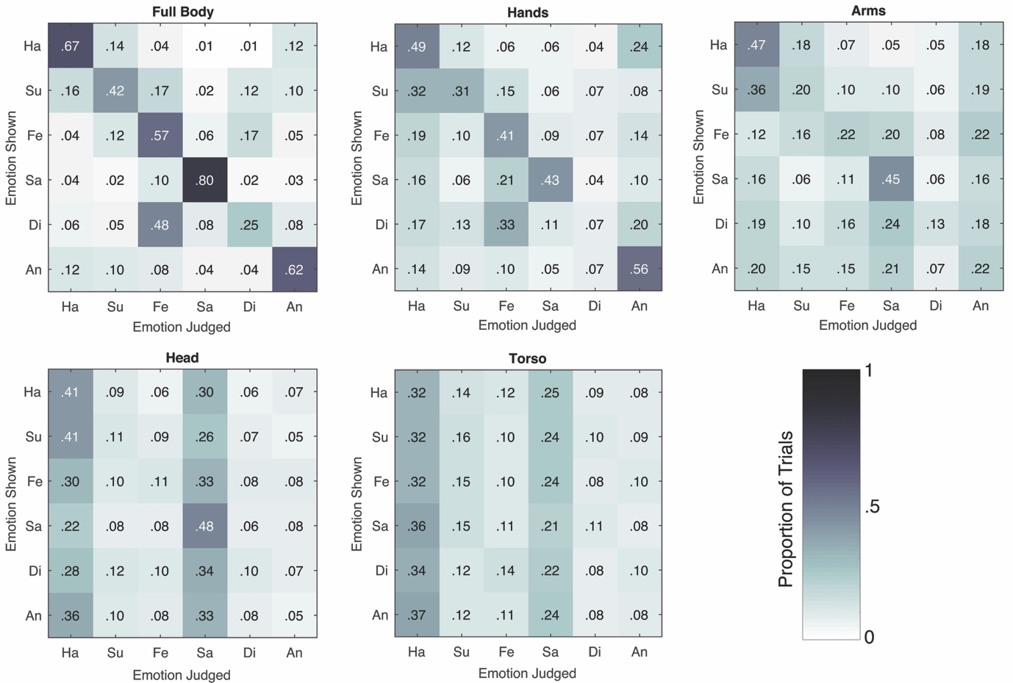
Figure 7: Confusion matrices for each body part condition in Exp 2 using inverted stimuli, averaged across participants. Ha = happy, Su = surprised, Fe = fear/afraid, Sa = sad, Di = disgusted, An = angry.

The left panel of Figure 8 shows a representational similarity matrix showing the similarities in confusion matrices for pairs of body parts (like in Experiment 1). One sample t-tests comparing the mean Fisher-transformed correlations to 0 provided evidence that confusions were systematically related to those seen in the whole body for both hands (M: .262), t(99) = 9.33, p < .0001, d = 0.933, and arms (M: .146), t(99) = 6.77, p < .0001, d = 0.677. In contrast, there was no significant relation for heads (M: -.002), t(99) = -0.09, p = .929, d = 0.009, or torsos (M: -.012), t(99) = -.54, p = .590, d = 0.054.

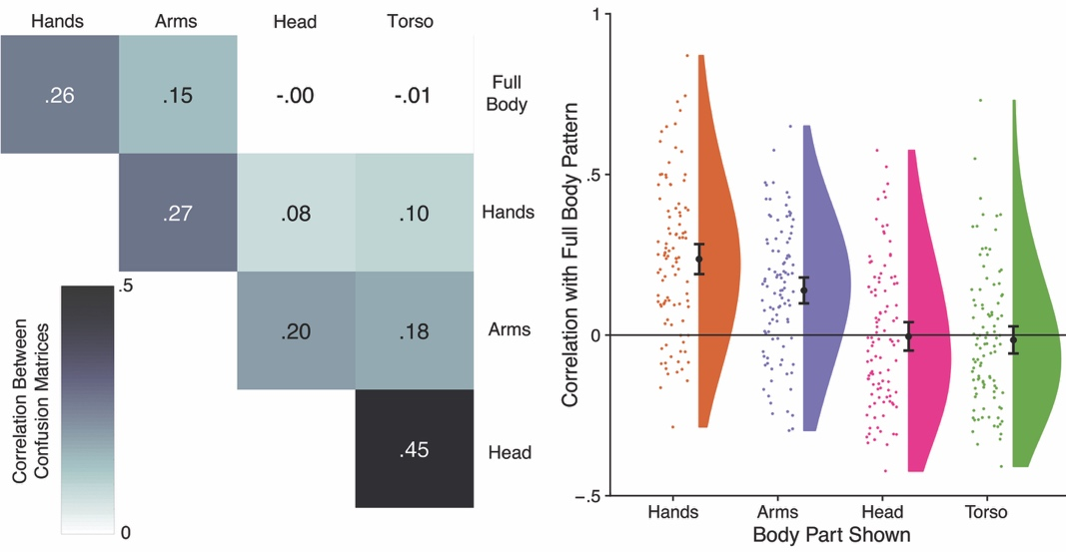
Figure 8: Representational similarity analysis of confusions between emotions for inverted stimuli in Exp 2. Left panel: Mean correlations between the off-diagonal elements of confusion matrices for pairs of stimulus types. Right panel: raincloud plots showing the correlation of each isolated body part with the pattern of confusions for full body stimuli (i.e., the top row of the matrix in the left panel). Error bars are 95% confidence intervals.

An ANOVA showed clear differences between these four body parts, F(2.52, 249.63) = 36.22, p < .001, η_{p}² = .268. Post-hoc t-tests comparing each pair of body parts, using Holm-Bonferroni correction for multiple comparisons, showed that the pattern of confusion for the hands was more similar to the full bodies than were the patterns for arms, t(99) = 3.52, p < .001, d_{z} = 0.352; heads, t(99) = 7.00, p < .0001, d_{z} = 0.700; and torsos, t(99) = 7.92, p < .0001, d_{z} = 0.792. Correlations were also higher for arms than for heads, t(99) = 5.37, p < .0001, d_{z} = 0.537; and torsos, t(99) = 6.88, p < .0001, d_{z} = 0.688. There was no difference between heads and torsos, t(99) = 0.40, p = .692, d_{z} = 0.040.
We next investigated the effects of inversion with a mixed ANOVA with body parts as a within-subjects factor and orientation as a between-subjects factor. Consistent with the results in each experiment individually, there was a significant main effect of body part, F(2.53, 28.11) = 107.65, p < .0001, η_{p}² = .352. There was also a significant main effect of orientation, F(1, 198) = 4.64, p < .05, η_{p}² = .023, with lower correlations with inverted than upright stimuli, as well as a significant interaction of body part and orientation, F(2.53, 28.11) = 5.19, p < .005, η_{p}² = .026. To investigate this interaction, we conducted post-hoc t-tests using Holm-Bonferroni correction, testing the effects of inversion separately for each of the four body parts. Inversion led to a reduction of the similarity between confusion for full bodies and hands, t(198) = -3.61, p < .001, d = 0.510. In contrast, however, no significant effects of inversion were found for arms, t(198) = -0.03, p = .978, d = 0.004; heads, t(198) = -0.28, p = .783, d = 0.039; or torsos, t(198) = -0.63, p = .528, d = 0.089.

Experiment 3
In the first two experiments, performance was substantially higher for hands (and arms) than for heads and torsos. One potential reason for this is the fact that the hands and arms are duplicated on each side of the body, so that there were two hands and two arms, but only one head and one torso. This could aid performance by simply providing more information, since twice as many body parts are shown. In addition, it is also possible that the relative position of the two hands may provide information about overall body posture, enabling the viewer to perceptually ‘fill in’ the rest of the body posture through a process of amodal completion. To investigate this possibility, we conducted an experiment in which we varied whether both hands were presented (as in Experiments 1 and 2) or just the left or right hand was presented.

Methods
Participants
Fifty-six (37 female) were recruited from Prolific. Participants ranged from 21 to 74 years of age (M = 38.6 years, SD = 12.3). None had participated in either of the other experiments. The sample size was based on an a priori power analysis to have power of .95 to detect a medium effect size (Cohen’s d=0.5) with alpha of .05, using G*Power 3.1. Handedness was assessed using a self-report questionnaire; 44 participants were right-handed, 10 were left-handed, and 2 were ambidextrous. Participants were physically located in the UK and had normal, or corrected to normal, vision. They were each paid for taking part.

Stimuli
Stimuli were similar to those used in Experiment 1, except that for some stimuli one of the two hands was removed. We thus had three types of stimuli: two hands, left hand, and right hand. Images from eight BESST actors were used (5, 8, 10, 13, 23, 39, 58, and 85). These were chosen because the hands were not in physical contact, meaning that each hand could be deleted without affecting the other hand. For each actor, we thus had three image types (both hands, left hand, right hand) for each of the six emotions, resulting in 144 images in total. Examples are shown in Figure 9.
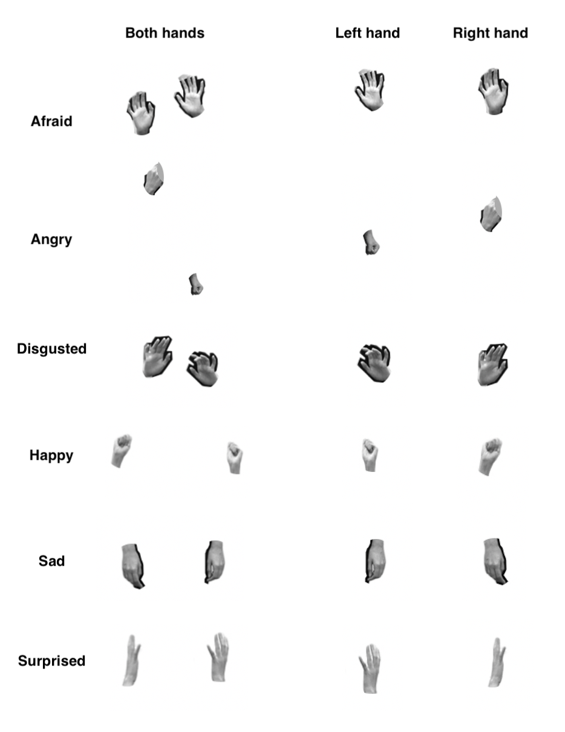
Figure 9: Examples of stimuli used in Exp 3.

Procedure
Procedures were similar to Exp 1. Each participant viewed 72 stimuli. Participants were randomly assigned to two counterbalance groups. One group saw the two hand stimuli from four actors and the one hand stimuli from the other four actors, while the other group saw the other stimuli. Thus, participants never saw the two hand versions of the one hand stimuli they judged. As in Exp 1, the order of the response buttons was also counterbalanced across participants. Two hand stimuli were centred on the screen. One hand stimuli were presented in exactly the same position as the two hand stimuli, except that either the left or the right hand was erased from the image.

Results and Discussion
Emotions Can be Classified from Isolated Hands
Figure 10 shows classification accuracy for the three stimulus types in Exp 3. Consistent with the results of the first two experiments, performance for the two hand stimuli was substantially above chance (M: 44.6% correct, 95% CI[41.5, 47.7]), t(55) = 17.70, p < .0001, d = 2.365. Critically, performance remained above chance for the one hand stimuli, both for the left hand (M: 38.7% correct, 95% CI [35.4, 42.0]), t(55) = 13.15, p < .0001, d = 1.758; and for the right hand (M: 35.8% correct, 95% CI[33.4, 38.2]), t(55) = 15.51, p < .0001, d = 2.073.
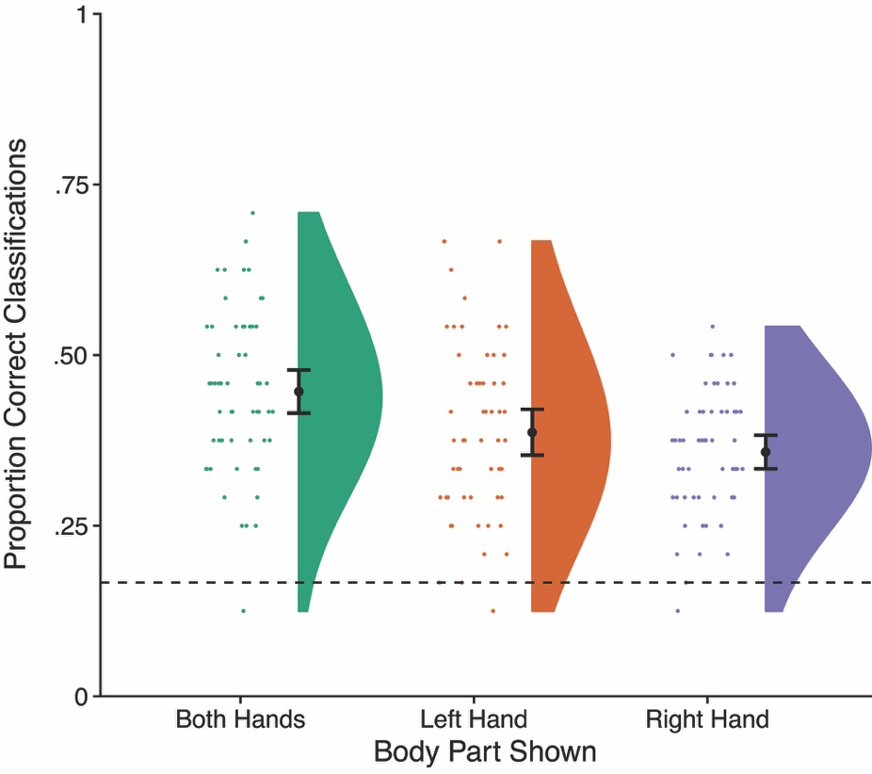
Figure 10: Classification accuracy for each of the stimulus types in Experiment 2. Performance was above chance when both hands were shown, but also when either the left or right hand was shown alone. Error bars are 95% confidence intervals.

An ANOVA showed that performance differed significantly between the three conditions, F(2, 110) = 15.23, p < .001, η_{p}² = .217. Post hoc t-tests with Holm-Bonferroni correction showed that performance was higher for the two hand stimuli than for either the left hand alone, t(55) = 3.71, p < .001, d_{z} = 0.496; or the right hand alone, t(55) = 5.25, p < .001, d_{z} = 0.702. There was no significant difference between performance in the two one hand conditions, t(55) = 1.80, p = .078, d_{z} = 0.240.

Emotion is Classified Better from Single Hands than Other Body Parts
One interpretation of the better performance of hands (and arms) than of heads and torsos in the first two experiments is that there were two hands and arms, but only a single head or torso. To investigate this possibility, we compared performance with one-hand stimuli (averaged across the left and right hand) in this experiment with heads and torsos in Experiment 1. Using independent samples t-tests, performance with one hand stimuli was substantially higher than for either heads, t(154) = 7.14, p < .0001, d = 1.191, or torsos, t(154) = 15.92, p < .0001, d = 2.657. Thus, the advantage of hands over other body parts in Experiments 1 and 2 was not an artefact of the fact that two hands were shown.

Analysis of Reaction Times
Reaction times were calculated as in the previous experiments (2.80% of trials excluded as outliers as being > 10 sec), and are shown in Table 3. An ANOVA showed a significant main effect of accuracy, F(1, 55) = 66.91, p < .001, η_{p}² = .549, with faster RTs on correct than on incorrect trials. There was no significant main effect of body part, F(2, 110) = 2.75, p = .068, η_{p}² = .048, nor an interaction, F(1.858, 102.205) = 2.95, p = .057, η_{p}² = .051.
Although the interaction did not quite reach statistical significance, for consistency with Experiments 1 and 2 we again compared the speedup for correct responses for each body part separately. There were significant speedups for correct trials for both hands, t(55) = 6.16, p < .0001, d_{z} = 0.823; left hands, t(55) = 3.53, p < .001, d_{z} = 0.472; and right hands, t(55) = 5.03, p < .0001, d_{z} = 0.673.
Table 3: Mean (and SD) of Reaction Times (sec) in Experiment 3
 | Both Hands | Left Hand | Right Hand
Correct | 2.637 (0.758) | 2.657 (0.881) | 2.635 (0.857)
Incorrect | 3.317 (1.043) | 3.004 (1.046) | 3.097 (0.975)
RT Difference | 0.679 (0.825) | 0.348 (0.737) | 0.463 (0.678)

Representational Similarity Analysis of the Pattern of Confusions
Figure 11 shows confusion matrices for the three conditions. In all three conditions, patterns of confusions were broadly similar to those seen for the hands in Experiments 1 and 2. Representational similarity analysis showed robust correlations between the patterns of confusions for all conditions, between the two hands condition and the left hand (M: .295), t(55) = 8.03, p < .0001, d = 1.073; two hands and the right hand (M: .325), t(55) = 9.26, p < .0001, d = 1.237; and between left and right hands (M: .433), t(55) = 9.81, p < .0001, d = 1.311. An ANOVA showed differences in the correlations between pairs of conditions, F(2, 110) = 4.83, p < .02, η_{p}² = .081. Post hoc t-tests with Holm-Bonferroni correction show that the pattern of confusions for left hands showed significantly greater similarity with the pattern for right hands than for two hands, t(55) = 3.20, p < .005, d_{z} = 0.427. For the right hands, there was a trend for a comparable effect, though it did not reach statistical significance following multiple comparison correction, t(55) = 2.19, p = .033, d_{z} = 0.293. There was no difference in the representational similarity of the two hands condition to the left and to the right hands, t(55) = 0.48, p = .635, d_{z} = 0.064.
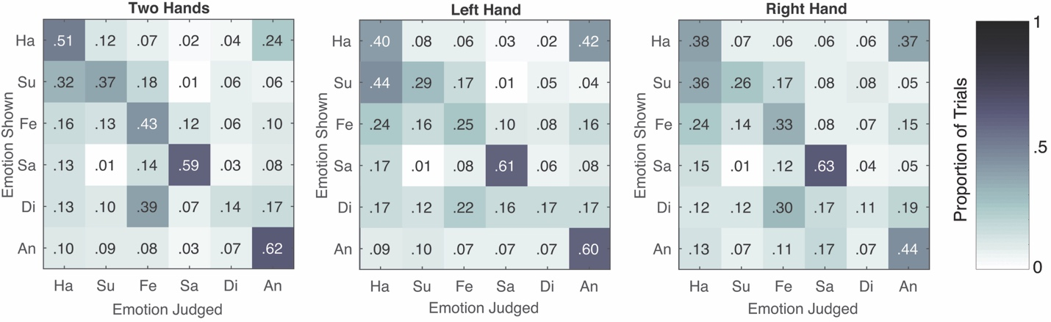
Figure 11: Confusion matrices for the three conditions in Exp 3.

General Discussion
The aim of this study was to investigate the perceptual mechanisms underlying the perception of emotions from bodies and body parts. Our results demonstrate that individual body parts alone provide sufficient information for emotion classification. In Experiment 1, we showed that recognition accuracy of emotions from images of isolated hands, arms, heads and torsos was better than chance. While emotions were recognized most accurately from full bodies, recognition performance from the hands was more accurate than for the arms, heads or torsos. Furthermore, we found similar patterns of accurate emotion classification and related patterns of errors (i.e. confusions between pairs of emotions) for the hands and full body images. In Experiment 2, we showed an inversion effect for these stimuli. Classification performance was reduced for inverted stimuli, both for full bodies and for isolated body parts. However, classification of inverted stimuli was still best for full bodies, followed by hand, and the arms, heads, and torsos. The patterns of confusions across emotions were also very similar between upright and inverted stimuli. Finally, in Experiment 3, we showed that the high performance for isolated hands does not depend on both hands being shown. Performance was modestly reduced, but remained high even when only one hand was shown.
Our finding that emotion can be decoded from isolated body parts suggests that emotion perception does not rely on information provided by the full body. Research investigating emotion perception from faces has demonstrated that holistic and analytic processes are involved in emotion recognition, and are weighted differently according to expression (Meaux & Vuilleumier, 2016). Facial features such as the eyes and the mouth have been shown to play a more prominent role in emotion perception than other features (Smith et al., 2005; Wegrzyn et al., 2017). In a comparable manner, the present study demonstrates that the hands and the arms are more important for emotion perception than other body parts. De Gelder and Poyo Solanas (2021) recently posited that emotional expressions are decoded according to midlevel features, demonstrating that the angles and degree of contraction of the limbs, for example, are central to emotion perception and are represented in regions of brain which code for motor preparation, action and affect (de Gelder & Poyo Solanas, 2021; Poyo Solanas et al., 2020). It may be that enhanced emotional categorisation of hands and arms in the current study resulted from their specification of the position and angles of the upper limbs.
Some body postures may convey multiple emotions. For example, a clenched fist may be a signal of anger, but also of happiness. Such cases may be differentiated by the overall position of individual body parts with respect to the rest of the body. It is possible that such information is more readily available in mobile appendages such as arms and hands, which could in part account for the higher classification accuracy for these parts. It is worth noting, however, that when only one hand was displayed in Experiment 3, global information about overall body configuration was likely reduced. Nevertheless, classification accuracy for individual hands remained quite high, suggesting the emotion can be decoded from local information about hands alone.
Crucially, the present study demonstrates that the hands (and, to a lesser extent, arms) are particularly effective at communicating emotion. This was reflected in terms of overall accuracy which was substantially higher for hands than for other body parts. It was also reflected in the RSA analyses, which showed that the pattern of confusions between emotions for hands was similar to that for whole bodies.

This is consistent with research showing hand-selective responses in the high-level visual cortex (Bracci et al., 2010), and especially with recent results demonstrating that this selectivity extends to communicative postures (Bracci et al., 2018). Superior emotion recognition performance from the hands in the present study builds on research on gesture, which has shown that the hands play a central role in everyday communication, complementing and extending speech (Goldin-Meadow, 1999). Seeing hand gestures in addition to speech has been shown to increase speech comprehension (Berger & Popelka, 1971; Graham & Argyle, 1975; Riseborough, 1981), learning in classroom situations (Valenzano et al., 2003; Cook et al., 2013), and word-learning by toddlers (Mumford & Kita, 2014; Wakefield et al., 2018). Even pre-verbal infants appear to direct attention in the direction of pointing gestures (Rohlfing et al., 2012). Thus, the present findings that hands communicate information about emotion complements a much larger literature showing widespread communication by the hands (cf. Kendon, 1994).
Sensitivity to information conveyed by the hands may not even be specific to humans. A large comparative literature has investigated animals’ understanding of pointing gestures. While pointing has only rarely been observed among apes in the wild (e.g., Veà & Sabater-Pi, 1998), understanding of pointing has been observed among all species of ape in captivity, including chimpanzees (Leavens, Hopkins, & Thomas, 2004; Pika & Mitani, 2006), bonobos (Savage-Rumbaugh et al., 1986), gorillas (Byrnit, 2008), orang-utans (Call & Tomasello, 1994), and gibbons (Inoue et al., 2004). Nor is such comprehension limited to primates. Sensitivity to points or similar manual gestures has been reported in dogs (Miklósi et al., 1998), horses (Maros et al., 2008), goats (Kaminski et al., 2005), and bats (Hall et al., 2011).
The comprehension of pointing by dogs is of particular interest, especially since it appears specific to the process of domestication by humans. While domesticated dogs show understanding of human points, wolves do not (Virányi et al., 2008). Striking experimental evidence that comprehension of pointing is causally related to domestication comes from the long-running study of the ‘Balyaev foxes’ in Siberia, which have been selectively bred since the 1950’s based on whether they fearlessly approached a human without showing aggression (Balyaev, 1979; Trut, 1999). Hare and colleagues (2005) showed that these foxes showed sensitivity to human pointing gestures similar to domesticated dogs. Critically, however, a control group of foxes who had been randomly bred did not show this sensitivity. This effect is remarkable given that the criteria used for selective breeding did not involve comprehension of human gestures at all, but related only to level of fear and aggression when approaching humans. Thus, sensitivity to pointing emerged as a bi-product of selection for other features entirely. It is an intriguing possibility that sensitivity to emotion in hands has co-evolved as part of a suite of social cognitive perceptual abilities alongside sensitivity to referential points of hands and co-speech gestures.
The results from Experiment 2 add to the literature showing body inversion effects for judgments of emotional expressions (e.g., Atkinson et al., 2007; Thoma et al., 2020), in addition to several other types of judgment including posture (e.g., Reed et al., 2003), identity (e.g., Robbins & Coltheart, 2012), and attractiveness (e.g., Cook & Duchaine, 2011). A recent meta-analysis of the body inversion effect (Griffin & Oswald, in press) found an overall meta-analytic effect size of Hedges’s g = 0.75. As that estimate is based on a within-subject effect-size, we converted the between-subjects Cohen’s d values we report for the effects of inversion to within-subjects Hedges’s g using the procedure and formulas Griffin and Oswald themselves used (e.g., assuming a correlation between upright and inverted of r = .57). For full bodies, this resulted in g = 0.776, very close to the average value in the literature generally, and broadly in line with averages for tasks involving judgments of identity (g = 0.92) and posture (g = 0.84). Effect sizes for hands (g = 1.032) and heads (g = 1.105) were even somewhat larger than found generally in the literature, while effects for arms (g = 0.524) and torsos (g = 0.419) were somewhat smaller. In the case of torsos, however, this smaller effect size may be due to a floor effect, as performance even with upright stimuli was only very modestly above chance. Thus, the inversion effects we report for isolated body parts are broadly in line with the magnitude of effect found in the literature for whole body stimuli.
To our knowledge, only one previous study has investigated body inversion effects for isolated body parts, rather than whole bodies. Reed and colleagues (2006) found that the body inversion effect for posture judgments was present for whole bodies, but not for isolated body parts such as arms, legs, and heads. Our results, showing clear inversion effects for emotional classifications of isolated body parts are in striking contrast to this earlier study. Multiple factors may underlie this difference. One possibility is that the same-different judgment used by Reed and colleagues may have made it easier for participants to use object-based perceptual processes to solve the task than our classification task allowed. Notably, in Reed and colleagues’ study, the body part conditions were easier than the whole body conditions, since there were fewer ways in which posture can vary in a single part than in an entire body. This can be seen in the fact that performance is higher for isolated parts than whole bodies, even when upright. This raises the possibility that a potential inversion effect for body parts could have been masked by a ceiling effect in performance. In contrast, in our study performance for the isolated body parts was harder than for full bodies (as less information was presented), and clear body inversion effects were found for all stimuli.
Yovel and colleagues suggested that the body inversion effect results from face-selective, rather than body-selective perceptual processes (Yovel, Pelc, & Lubetzky, 2010; Brandman & Yovel, 2010, 2012). This conclusion was based on findings that the body inversion effect for judgments of body posture was critically-dependent on the presence of the head, with no effects of inversion found for headless bodies (Yovel et al., 2010). Several subsequent studies, however, have reported clear body inversion effects with headless stimuli (e.g., Robbins & Coltheart, 2012; Arizpe, McKean, Tsao, & Chan, 2017; Susilo, Yovel, Barton, & Duchaine, 2013; Axelsson, Buddhadasa, Manca, & Robbins, 2022). Further, a recent meta-analysis found no overall difference in the magnitude of the body inversion effect as a function of the presence or absence of the head (Griffin & Oswald, in press). The present results provide further evidence that the presence of the head is not necessary to elicit inversion effects with body stimuli, at least for emotion judgments. Clear reductions in emotion classification performance were found for isolated hands, arms, and torsos.
Theories of embodied cognition emphasise the overlapping neural circuitry involved in perceiving and experiencing emotions (Niedenthal et al., 2007). For example, disruption of processing in the right somatosensory cortex has been found to disrupt emotion recognition (Pitcher et al., 2008), suggesting a role for tactile and proprioceptive simulation in emotion perception. Similarly, blocking facial mimicry was found to modulate conscious experience of facial expression in a binocular rivalry paradigm (Quettier, Gambarota, Tsuchiya, & Sessa, 2021). It is notable, therefore, that the hands have the highest levels of cortical magnification in somatosensory cortex among the body parts tested (Penfield & Boldrey, 1937), as well as the finest tactile spatial acuity (Mancini et al., 2014). The superior emotion recognition for the hands than for other body parts in the present study could thus reflect a larger pool of somatosensory processing resources to complement purely visual processing. Thus, performance for the hands in the present study may point towards simulation processes in the somatosensory cortex during emotion recognition.
Emotion recognition from the hands was not only more accurate than from the other body parts, but representational similarity analysis demonstrated that the pattern of errors for the hands, and to a certain extent for the arms, was similar to that for whole bodies. This similarity of underlying representational structure points towards shared computational mechanisms underlying emotion perception from hands and full bodies. Given that the hands and full bodies are represented in at least partially separate regions of the visual cortex (Bracci et al., 2010), these shared patterns point towards the operation of common emotion perception processes across the body selective visual cortex. Moreover, while holistic processes underlie the perception of global bodily form, they do not apply to the perception of body parts (Reed et al., 2006). Thus, our finding of shared patterns of recognition from hands and full bodies further suggests that emotion perception is underpinned by different processes to the perception of bodily form. Finally, Ross and Flack (2020) recently found that the absence of hands and arms from images of full bodies negatively affected emotion recognition. The present study’s findings add to these results by demonstrating that the hands communicate emotion in their own right.
There were a number of limitations to the present study. First, we used only frontal, two-dimensional images of bodies and body parts as stimuli. In natural environments emotion is perceived from dynamic, three-dimensional bodies. Thus, an absence of information from lateral angles may have impacted emotion recognition accuracy. Further, some body parts, such as torsos, may have suffered from the lack of lateral information more than others. Second, the full body images in the present study contained more pixels than the images of isolated body parts, which were taken from the full body images. This may have resulted in higher classification accuracy for the full body images. Finally, the present study used only Caucasian stimuli and UK based participants. Bodily expressions of emotion do not necessarily translate cross-culturally; while gestures of threat tend to be similar world-wide, the expression of anger differs (Matsumoto & Huang, 2013). Similarly, Kleinsmith et al. (2006) found differences in emotion labelling and intensity ratings of bodies in the US, Japan and Sri Lanka. However, it may be that the experience of bodily sensations elicited by differing emotions is culturally universal. A recent study demonstrated that the embodied experience of thirteen emotion states was consistent across participants from 101 different countries (Volynets et al., 2019). Further research might investigate the cross-cultural nature of emotional hand perception and utilise culturally diverse stimuli.
Another important limitation relates to which specific emotions people are able to recognize from each body part. Our main analyses of accuracy focused on overall classification performance collapsed across the six emotions. The reason for this is that the presence of biases to respond with specific emotions complicates interpretation of individual conditions. For example, in the head and torso conditions there were clear biases to classify stimuli as ‘happy’ and (to a lesser extent ‘sad’). Thus, the higher accuracy for happy and sad trials compared to other emotions cannot be taken at face value as indicating higher sensitivity to detect these emotions. Our results are therefore consistent with the possibility that only certain emotions can be effectively perceived from isolated body parts. However, the design of these experiments does not allow more detailed conclusions of which emotions can be perceived from which body parts.
To conclude, this study is the first to have compared emotion perception from isolated body parts with full bodies. As such, its findings make novel contributions to the literature concerning the perception of emotion and emotional body language. First, emotions can be decoded from body parts. Second, the hands appear particularly critical for the communication of emotion.

Author Contributions
Ellen Blythe: Conceptualization, Methodology, Software, Investigation, Visualization, Writing – Original Draft. Lúcia Garrido: Software, Formal analysis, Writing – Review & Editing. Matthew. R. Longo: Conceptualization, Methodology, Software, Investigation, Visualization, Writing – Review & Editing, Supervision.
Competing interests
No competing interests to declare.
Open Practices Statement
The experiment reported in this article was not formally preregistered. The data and the stimulus set have been made available on a permanent third-party archive (adapted stimuli taken from the BESST (Thoma et al., 2013) been made available with the permission of the author): https://osf.io/c9bxw/

References

Allen, M., Poggiali, D., Whitaker, K., Marshall, T. R., & Kievit, R. A. (2021). Raincloud plots: A multi-platform tool for robust data visualization. Wellcome Open Research, 4, 63. https://doi.org/10.12688/wellcomeopenres.15191.2
Anwyl-Irvine, A., Massonnié, J., Flitton, A., Kirkham, N., & Evershed, J. (2020). Gorilla in our Midst: An online behavioral experiment builder. Behavior Research Methods, 52(1), 388-407. https://doi.org/10.3758/s13428-019-01237-x
Arizpe, J. M., McKean, D. L., Tsao, J. W., & Chan, A. W.-Y. (2017). Where you look matters for body perception: Preferred gaze location contributes to the body inversion effect. Plos One, 12, e0169148. https://doi.org/ ﻿10.7910/DVN/ZSI2D1
Atkinson, A. P., Tunstall, M. L., & Dittrich, W. H. (2007). Evidence for distinct contributions of form and motion information to the recognition of emotions from body gestures. Cognition, 104, 59-72. https://doi.org/ 10.1016/j.cognition.2006.05.005
Aviezer, H., Trope, Y., & Todorov, A. (2012). Body cues, not facial expressions, discriminate between intense positive and negative emotions. Science, 338(6111), 1225–1229. https://doi.org/10.1126/science.1224313
Axelsson, E. L., Buddhadasa, T., Manca, L., & Robbins, R. A. (2022). Making heads or tails of body inversion effects: Do heads matter? Plos One, 17, e0263902. https://doi.org/ 10.1371/journal.pone.0263902
Balyaev, D. K. (1979). Destabilizing selection as a factor in domestication. Journal of Heredity, 70, 301–308. https://doi.org/10.1093/oxfordjournals.jhered.a109263
Berger, K. W., & Popelka, G. R. (1971). Extra-facial gestures in relation to speechreading. Journal of Communication Disorders, 3, 302–308. https://doi.org/10.1016/0021-9924(71)90036-0
Bernard, P., Gervais, S. J., Allen, J., Campomizzi, S., & Klein, O. (2012). Integrating sexual objectification with object versus person recognition: The sexualized-body-inversion hypothesis. Psychological Science, 23, 469-471. https://doi.org/10.1177/0956797611434748
Bombari, D., Schmid, P. C., Schmid Mast, M., Birri, S., Mast, F. W., & Lobmaier, J. S. (2013). Emotion recognition: The role of featural and configural face information. Quarterly Journal of Experimental Psychology, 66, 2426-2442. https://doi.org/ 10.1080/17470218.2013.789065
Bracci, S., Caramazza, A., & Peelen, M. V. (2018). View-invariant representation of hand postures in the human lateral occipitotemporal cortex. NeuroImage, 181, 446–452. https://doi.org/10.1016/j.neuroimage.2018.07.001
Bracci, S., Ietswaart, M., Peelen, M. V., & Cavina-Pratesi, C. (2010). Dissociable neural responses to hands and non-hand body parts in human left extrastriate visual cortex. Journal of Neurophysiology, 103(6), 3389–3397. https://doi.org/10.1152/jn.00215.2010
Brandman, T., & Yovel, G. (2010). The body inversion effect is mediated by face-selective, not body-selective, mechanisms. Journal of Neuroscience, 30, 10534-10540. https://doi.org/10.1523/JNEUROSCI.0911-10.2010
Brandman, T., & Yovel, G. (2012). A face inversion effect without a face. Cognition, 125, 365-372. https://doi.org/10. 1016/j.cognition.2012.08.001
Byrnit, J. T. (2008). Gorillas’ (Gorilla gorilla) use of experimenter-given manual and facial cues in an object-choice task. Animal Cognition, 12, 401–404. https://doi.org/10.1007/s10071-008-0200-1
Calder, A. J., & Jansen, J. (2005). Configural coding of facial expressions: The impact of inversion and photographic negative. Visual Cognition, 12(3), 495-518. https://doi.org/10.1080/13506280444000418
Calder, A. J., Young, A. W., Keane, J., & Dean, M. (2000). Configural information in facial expression perception. Journal of Experimental Psychology: Human Perception and Performance, 26(2), 527. https://doi.org/10.1037/0096-1523.26.2.527
Call, J., & Tomasello, M. (1994). Production and comprehension of referential pointing by orangutans (Pongo pygmaeus). Journal of Comparative Psychology, 108, 307–317. https://doi.org/10.1037/0735-7036.108.4.307
Cazzato, V., Walters, E. R., & Urgesi, C. (2021). Associations of observer’s gender, body mass index and internalization of societal beauty ideals to visual body processing. Psychological Research, 85, 3026-3039. https://doi.org/ 10.1007/s00426-020-01471-5
Clarke, T. J., Bradshaw, M. F., Field, D. T., Hampson, S. E., & Rose, D. (2005). The perception of emotion from body movement in point-light displays of interpersonal dialogue. Perception, 34, 1171-1180. https://doi.org/ 10.1068/p5203
Cook, R., & Duchaine, B. (2011). A look at how we look at others: Orientation inversion and photographic negation disrupt the perception of human bodies. Visual Cognition, 19, 445-468. https://doi.org/ 10.1080/13506285.2010.541892
Cook, S. W., Duffy, R. G., & Fenn, K. M. (2013). Consolidation and transfer of learning after observing hand gesture. Child Development, 84, 1863–1871. https://doi.org/10.1111/cdev.12097
Coulson, M. (2004). Attributing emotion to static body postures: Recognition accuracy, confusions, and viewpoint dependence. Journal of Nonverbal Behavior, 28(2), 117–139. https://doi.org/10.1023/B:JONB.0000023655.25550.be
de Gelder, B., de Borst, A. W., & Watson, R. (2015). The perception of emotion in body expressions. Wiley Interdisciplinary Reviews: Cognitive Science, 6(2), 149–158. https://doi.org/10.1002/wcs.1335
de Gelder, B., & Poyo Solanas, M. (2021). A computational neuroethology perspective on body and expression perception. Trends in Cognitive Sciences, 25, 744-756. https://doi.org/10.1016/j.tics.2021.05.010
Diamond, R., & Carey, S. (1986). Why faces are and are not special: an effect of expertise. Journal of Experimental Psychology: General, 115, 107-117. https://doi.org/ 10.1037//0096-3445.115.2.107
Dittrich, W. H., Troscianko, T., Lea, S. E. G., & Morgan, D. (1996). Perception of emotion from dynamic point-light displays represented in dance. Perception, 25, 727-738. https://doi.org/ 10.1068/p250727
Ekman, P. (1992). Are there basic emotions? Psychological Review, 99(3), 550–553. https://doi.org/10.1037/0033-295X.99.3.550
Faul, F., Erdfelder, E., Lang, A. G., & Buchner, A. (2007). G* Power 3: A flexible statistical power analysis program for the social, behavioral, and biomedical sciences. Behavior Research Methods, 39(2), 175-191. https://doi.org/10.3758/BF03193146
Fausey, C. M., Jayaraman, S., & Smith, L. B. (2016). From faces to hands: Changing visual input in the first two years. Cognition, 152, 101-107. https://doi.org/10.1016/j.cognition.2016.03.005
Goldin-Meadow, S. (1999). The role of gesture in communication and thinking. Trends in Cognitive Sciences, 3(11), 419–429. https://doi.org/10.1016/S1364-6613(99)01397-2
Graham, J. A., & Argyle, M. (1975). A cross-cultural study of the communication of extra-verbal meaning by gestures. International Journal of Psychology, 10, 57–67. https://doi.org/10.1080/00207597508247319
Griffin, J. W., & Oswald, F. (in press). A multilevel Bayesian meta-analysis of the body inversion effect: Evaluating controversies over headless and sexualized bodies. Psychonomic Bulletin and Review. https://doi.org/ 10.3758/s13423-022-02067-3
Grosbras, M. H., & Paus, T. (2006). Brain networks involved in viewing angry hands or faces. Cerebral Cortex, 16(8), 1087–1096. https://doi.org/10.1093/cercor/bhj050
Gross, C. G., Bender, D. B., & Rocha-Miranda, C. D. (1969). Visual receptive fields of neurons in inferotemporal cortex of the monkey. Science, 166(3910), 1303-1306. https://www.science.org/doi/abs/10.1126/science.166.3910.1303
Hall, N. J., Udell, M. A. R., Dorey, N. R., Walsh, A. L., & Wynne, C. D. L. (2011). Megachiropteran bats (Pteropus) utilize human referential stimuli to locate hidden food. Journal of Comparative Psychology, 125, 341–346. https://doi.org/10.1037/a0023680
Hare, B., Plyusnina, I., Ignacio, N., Schepina, O., Stepika, A., Wrangham, R., & Trut, L. (2005). Social cognitive evolution in captive foxes is a correlated by-product of experimental domestication. Current Biology, 15, 226–230. https://doi.org/ 10.1016/j.cub.2005.01.040
Hess, U., Adams, R. B., & Kleck, R. E. (2007). Looking at you or looking elsewhere: The influence of head orientation on the signal value of emotional facial expressions. Motivation and Emotion, 31(2), 137–144. https://doi.org/10.1007/s11031-007-9057-x
Inoue, Y., Inoue, E., & Itakura, S. (2004). Use of experimenter-given directional cues by a young white-handed gibbon (Hylobates lar). Japanese Psychological Research, 46, 262–267. https://doi.org/10.1111/j.1468-5584.2004.00258.x
JASP Team. (2022). JASP (Version 0.16.1) [Computer software].
Kaminski, J., Riedel, J., Call, J., & Tomasello, M. (2005). Domestic goats, Capra hircus, follow gaze direction and use social cues in an object choice task. Animal Behaviour, 69, 11–18. https://doi.org/10.1016/j.anbehav.2004.05.008
Kendon, A. (1994). Do gestures communicate? A review. Research on Language and Social Interaction, 27, 175–200. https://doi.org/10.1207/s15327973rlsi2703
Kleinsmith, A., De Silva, P. R., & Bianchi-Berthouze, N. (2006). Cross-cultural differences in recognizing affect from body posture. Interacting With Computers, 18(6), 1371–1389. https://doi.org/10.1016/j.intcom.2006.04.003
Kret, M. E., Pichon, S., Grèzes, J., & de Gelder, B. (2011). Similarities and differences in perceiving threat from dynamic faces and bodies. An fMRI study. Neuroimage, 54(2), 1755-1762. https://doi.org/10.1016/j.neuroimage.2010.08.012
Kret, M. E., & de Gelder, B. (2013). When a smile becomes a fist: The perception of facial and bodily expressions of emotion in violent offenders. Experimental Brain Research, 228(4), 399–410. https://doi.org/10.1007/s00221-013-3557-6
Kriegeskorte, N., Mur, M., & Bandettini, P. A. (2008). Representational similarity analysis-connecting the branches of systems neuroscience. Frontiers In Systems Neuroscience, 2, 4. https://doi.org/10.3389/neuro.06.004.2008
Kuhn, L. K., Wydell, T., Lavan, N., McGettigan, C., & Garrido, L. (2017). Similar representations of emotions across faces and voices. Emotion, 17(6), 912–937. http://dx.doi.org/10.1037/emo0000282
Leavens, D. A., Hopkins, W. D., & Thomas, R. K. (2004). Referential communication by chimpanzees (Pan troglodytes). Journal of Comparative Psychology, 118, 48–57. https://doi.org/10.1037/0735-7036.118.1.48
Mancini, F., Bauleo, A., Cole, J., Lui, F., Porro, C. A., Haggard, P., & Iannetti, G. D. (2014). Whole‐body mapping of spatial acuity for pain and touch. Annals of Neurology, 75(6), 917-924. https://doi.org/10.1002/ana.24179
Maros, K., Gácsi, M., & Miklósi, Á. (2008). Comprehension of human pointing gestures in horses (Equus caballus). Animal Cognition, 11, 457–466. https://doi.org/10.1007/s10071-008-0136-5
Matsumoto, D., & Hwang, H. C. (2013). Cultural similarities and differences in emblematic gestures. Journal of Nonverbal Behavior, 37(1), 1–27. https://doi.org/10.1007/s10919-012-0143-8
Maurer, D., Le Grand, R., & Mondloch, C. J. (2002). The many faces of configural processing. Trends in Cognitive Sciences, 6(6), 255-260. https://doi.org/10.1016/S1364-6613(02)01903-4
McKelvie, S. J. (1995). Emotional expression in upside-down faces: Evidence for configural and componential processing. British Journal of Social Psychology, 34, 325-334. https://doi.org/ 10.1111/j.2044-8309.1995.tb01067.x
Meaux, E., & Vuilleumier, P. (2016). Facing mixed emotions: analytic and holistic perception of facial emotion expressions engages separate brain networks. NeuroImage, 141, 154-173. https://doi.org/10.1016/j.neuroimage.2016.07.004
Miklósi, Á., Polgárdi, R., Tomál, J., & Csányi, V. (1998). Use of experimenter-given cues in dogs. Animal Cognition, 1, 113–121. https://doi.org/10.1007/s100710050016
Mumford, K. H., & Kita, S. (2014). Children use gesture to interpret novel verb meanings. Child Development, 85, 1181–1189. https://doi.org/10.1111/cdev.12188
Niedenthal, P. M. (2007). Embodying emotion. Science, 316(5827), 1002-1005. https://www.science.org/doi/abs/10.1126/science.1136930
Peelen, M. V., Atkinson, A. P., & Vuilleumier, P. (2010). Supramodal representations of perceived emotions in the human brain. Journal of Neuroscience, 30(30), 10127–10134. https://doi.org/10.1523/JNEUROSCI.2161-10.2010
Penfield, W., & Boldrey, E. (1937). Somatic motor and sensory representation in the cerebral cortex of man as studied by electrical stimulation. Brain, 60, 389–443.
Pika, S., & Mitani, J. (2006). Referential gestural communication in wild chimpanzees (Pan troglodytes). Current Biology, 16, R191–R192. https://doi.org/10.1016/j.cub.2006.02.037
Pitcher, D., Garrido, L., Walsh, V., & Duchaine, B. C. (2008). Transcranial magnetic stimulation disrupts the perception and embodiment of facial expressions. Journal of Neuroscience, 28(36), 8929-8933. https://doi.org/10.1523/JNEUROSCI.1450-08.2008
Pollick, F. E., Paterson, H. M., Bruderlin, A., & Sanford, A. J. (2001). Perceiving affect from arm movement. Cognition, 82(2), 51–61. https://doi.org/10.1016/S0010-0277(01)00147-0
Poyo Solanas, M. P., Vaessen, M. J., & de Gelder, B. (2020a). Computation-based feature representation of body expressions in the human brain. Cerebral Cortex, 30(12), 6376–6390. https://doi.org/10.1093/cercor/bhaa196
Prkachin, G. C. (2003). The effects of orientation on detection and identification of facial expressions of emotion. British Journal of Psychology, 94, 45-62. https://doi.org/ 10.1348/000712603762842093
Quettier, T., Gambarota, F., Tsuchiya, N., & Sessa, P. (2021). Blocking facial mimicry during binocular rivalry modulates visual awareness of faces with a neutral expression. Plos One, 11, 9972. https://doi.org/ 10.1038/s41598-021-89355-5
Reed, C. L., Stone, V. E., Bozova, S., & Tanaka, J. (2003). The body-inversion effect. Psychological Science, 14(4), 302-308. https://doi.org/10.1111/1467-9280.14431
Reed, C. L., Stone, V. E., Grubb, J. D., & McGoldrick, J. E. (2006). Turning configural processing upside down: Part and whole body postures. Journal of Experimental Psychology: Human Perception and Performance, 32(1), 73–87. https://doi.org/10.1037/0096-1523.32.1.73
Riseborough, M. G. (1981). Physiographic gestures as decoding facilitators: Three experiments exploring a neglected facet of communication. Journal of Nonverbal Behavior, 5, 172–183. https://doi.org/10.1007/BF00986134
Robbins, R. A., & Coltheart, M. (2012). The effects of inversion and familiarity on face versus body cues to person recognition. Journal of Experimental Psychology: Human Perception and Performance, 38, 1098-1104. https://doi.org/ 10.1037/a0028584
Rohlfing, K. J., Longo, M. R., & Bertenthal, B. I. (2012). Dynamic pointing triggers shifts of visual attention in young infants. Developmental Science, 15, 426–435. https://doi.org/10.1111/j.1467-7687.2012.01139.x
Ross, P., & Flack, T. (2020). Removing hand form information specifically impairs emotion recognition for fearful and angry body stimuli. Perception, 49(1), 98–112. https://doi.org/10.1177/0301006619893229
Savage-Rumbaugh, S., McDonald, K., Sevcik, R. A., Hopkins, W. D., & Rubert, E. (1986). Spontaneous symbol acquisition and communicative use by pygmy chimpanzees (Pan paniscus). Journal of Experimental Psychology: General, 115, 211–235. https://doi.org/10.1037//0096-3445.115.3.211
Schmidt, A. F., & Kistemaker, L. M. (2015). The sexualized-body-inversion hypothesis: Valid indicator of sexual objectification or methodological artifact? Cognition, 134, 77-84. https://doi.org/ 10.1016/j.cognition.2014.09.003
Slepian, M. L., Young, S. G., Rutchick, A. M., & Ambady, N. (2013). Quality of professional players’ poker hands is perceived accurately from arm motions. Psychological Science, 24(11), 2335-2338. https://doi.org/10.1177/0956797613487384
Smith, M. L., Cottrell, G. W., Gosselin, F., & Schyns, P. G. (2005). Transmitting and decoding facial expressions. Psychological Science, 16(3), 184-189. https://doi.org/10.1111/j.0956-7976.2005.00801.x
Stekelenburg, J. J., & de Gelder, B. (2004). The neural correlates of perceiving human bodies: An ERP study on the body-inversion effect. NeuroReport, 15(5), 777–780. https://doi.org/10.1097/00001756-200404090-00007
Susilo, T., Yovel, G., Barton, J. S. S., & Duchaine, B. (2013). Face perception is category-specific: Evidence from normal body perception in acquired prosopagnosia. Cognition, 129, 88-94. https://doi.org/ 10.1016/j.cognition.2013.06.004
Thierry, G., Pegna, A. J., Dodds, C., Roberts, M., Basan, S., & Downing, P. (2006). An event-related potential component sensitive to images of the human body. NeuroImage, 32(2), 871–879. https://doi.org/10.1016/j.neuroimage.2006.03.060
Thoma, P., Soria Bauser, D., & Suchan, B. (2013). BESST (Bochum Emotional Stimulus Set)-A pilot validation study of a stimulus set containing emotional bodies and faces from frontal and averted views. Psychiatry Research, 209(1), 98–109. https://doi.org/10.1016/j.psychres.2012.11.012
Thoma, P., Soria Bauser, D., Edel, M.-E., Juckel, G., & Suchan, B. (2020). Configural processing of emotional bodies and faces in patients with attention deficit hyperactivity disorder. Journal of Clinical and Experimental Neuropsychology, 42, 1028-1048. https://doi.org/ 10.1080/13803395.2020.1840521
Trut, L. N. (1999). Early canid domestication: The farm-fox experiment. American Scientist, 87, 160–169.
Valenzeno, L., Alibali, M. W., & Klatzky, R. (2003). Teachers’ gestures facilitate students’ learning: A lesson in symmetry. Contemporary Educational Psychology, 28, 187–204. https://doi.org/10.1016/S0361-476X(02)00007-3
Van Heijnsbergen, C. C. R. J., Meeren, H. K. M., Grezes, J., & de Gelder, B. (2007). Rapid detection of fear in body expressions, an ERP study. Brain Research, 1186, 233-241. https://doi.org/10.1016/j.brainres.2007.09.093
Veà, J. J., & Sabater-Pi, J. (1998). Spontaneous pointing behaviour in the wild pygmy chimpanzee (Pan paniscus). Folia Primatologica, 69, 289–290. https://doi.org/10.1159/000021640
Virányi, Z., Gácsi, M., Kubinyi, E., Topál, J., Belényi, B., Ujfalussy, D., & Miklósi, A. (2008). Comprehension of human pointing gestures in young human-reared wolves (Canis lupus) and dogs (Canis familiaris). Animal Cognition, 11, 373–387. https://doi.org/10.1007/s10071-007-0127-y
Volynets, S., Glerean, E., Hietanen, J. K., Hari, R., & Nummenmaa, L. (2020). Bodily maps of emotions are culturally universal. Emotion, 20(7), 1127-1136. https://doi.org/10.1037/emo0000624
Wakefield, E. M., Hall, C., James, K. H., & Goldin-Meadow, S. (2018). Gesture for generalization: Gesture facilitates flexible learning of words for actions on objects. Developmental Science, 21, e12656. https://doi.org/10.1111/desc.12656
Walsh, E., Vormberg, A., Hannaford, J., & Longo, M. R. (2018). Inversion produces opposite size illusions for faces and bodies. Acta Psychologica, 191, 15-24. https://doi.org/ 10.1016/j.actpsy.2018.08.017
Wegrzyn, M., Vogt, M., Kireclioglu, B., Schneider, J., & Kissler, J. (2017). Mapping the emotional face. How individual face parts contribute to successful emotion recognition. PloS One, 12(5), e0177239. https://doi.org/10.1371/journal.pone.0177239
Yin, R. K. (1969). Looking at upside-down faces. Journal of Experimental Psychology, 81, 141-145. https://doi.org/ 10.1037/h0027474
Yovel, G., Pelc, T., & Lubetzky, I. (2010). It’s all in your head: Why is the body inversion effect abolished for headless bodies? Journal of Experimental Psychology: Human Perception and Performance, 36, 759-767. https://doi.org/ 10.1037/a0017451
Zieber, N., Kangas, A., Hock, A., & Bhatt, R. S. (2014). Infants’ perception of emotion from body movements. Child Development, 85, 675-684. https://doi.org/ ﻿10.1111/cdev.12134

